COMP3133_101459108_Assignment1  
Michael Mocioiu

Postman: Signup

Login

Get all emp  
Add Emp

Get by dept/designation

Get by id

Update emp

Delete emp

MongoDBCompass  
  
User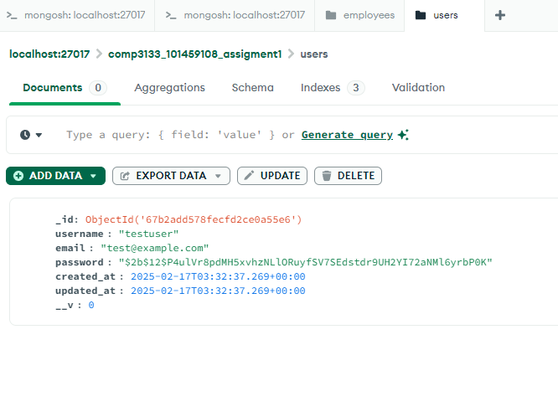

Employee

