FOR IMMEDIATE RELEASE
Contact: Dalyn A. Miller
Dalyn Miller Public Relations
617-504-6869
dalyn@dalynmillerpr.com

Stunning New Book with Delicious Recipes and
Four-Color Photos Spearheads the Next Generation
of Vegetarian Cooking and Flavors
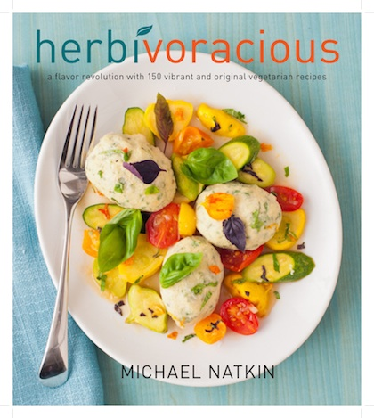
Herbivoracious
A Flavor Revolution, with 150 Vibrant and Original Vegetarian Recipes

By Michael Natkin

Vegetarian cooking has come a long way. From the auspicious beginnings of chefs such as Mollie Katzen and Anna Thomas in the 1970s to the more refined and sophisticated offerings of Deborah Madison and Mark Bittman in ’80s and ’90s, vegetarian cooking has grown up with generations of us who have become more food savvy over the years, wiser in our selections and more conscious of our surroundings. Vegetarians and non-vegetarians alike are hungry for new and different options when it comes to our meatless meals; now a new era of vegetarian cooking is upon us.
Chock-full of never-before-seen recipes!

Popular vegetarian blogger Michael Natkin’s new book HERBIVORACIOUS and its 150 recipes herald this new generation in meatless cooking and vegetarian cookbooks. This is grown-up vegetarian food, both experimental and provocative as well as visually stunning on the plate (as seen in more than 80 color photographs). These recipes are intensely flavored in a way that will appeal to readers with a sophisticated and adventurous global palate, health-conscious in a natural but not preachy manner, and above all, reflecting the author’s own prodigious originality and creativity in the kitchen—exactly the traits that have made his blog the go-to destination for new and tasty ideas in vegetarian eating. In this collection, readers will find delicious recipes such as:

- Caramelized Apple and Blue Cheese Crostini
- Persimmon, Parsley, and Olive Salad
- Indian Fry Bread Tacos
- Rice Vermicelli (Bun) with Ginger-Grapefruit Sauce
- Pappardelle with Eggplant Ragu and Fresh Ricotta
- Swiss Chard and Tomatillo Enchiladas
- Persian Rice Pilaf with a Crispy Crust
- Rustic Peach and Nectarine Crostata

Feeding the soul of this book is an understanding that vegetarian meals are good for you, tread more lightly on the planet’s resources, and are kinder to animals. Natkin provides plenty of advice on how to craft vegetarian meals that amply deliver nutrients, and the imaginative menus he presents deliver balanced and mouth-watering flavors. Not only vegetarian, the book also includes dozens of vegan and gluten-free recipes, which are clearly noted, and an introductory chapter lays out the simple steps to outfit a globally inspired pantry of seasonings and sauces that make meatless food come alive.

About the Author

Michael Natkin is the author of the immensely popular and award-winning vegetarian blog www.Herbivoracious.com. For several years, as the author of the bi-weekly column “Serious Meatless” on the Serious Eats website, he was known among foodies, vegetarians, and fellow-bloggers for a cutting-edge, light and healthy, beautiful-on-the-plate style of vegetarian cooking. He is one of only nine members on the “Chefs and Experts” panel of AOL’s Kitchen Daily and is a charter member of the “Gourmet Live Socialvores.” His blog and his recipes have been mentioned nearly a dozen times in the New York Times Diner’s Journal and he has been listed for four consecutive years on Saveur’s “Sites We Love.” He’s known in the blogging community as a crack photographer, and his photos are regularly featured on TasteSpotting, FoodGawker, and other sites. He lives in Seattle with his wife and two daughters.
• • •

HERBIVORACIOUS
A Flavor Revolution, with 150 Vibrant and Original Vegetarian Recipes
By Michael Natkin
Harvard Common Press
May 2012
$24.95 US / $29.95 CAN
Trade Cloth original with 4-color photographs throughout
ISBN-13: 978-1-55832-745-0

Also available in an enhanced e-book edition, with 20 high quality videos featuring Natkin preparing recipes from the book and demonstrating basic kitchen skills. The e-book will also offer social media functionality for sharing recipes, photos, and video on Facebook, Twitter, and blogs.

For more information, or to request a review copy of the book or an interview, please contact
Dalyn A. Miller at 617-504-6869 or via email at Dalyn@DalynMillerPR.com

