N
NORTHSTAR FACILITY PARTNERS
TECHNICAL PROPOSAL
Multi-Site Custodial &
Facility Support Services
Queensboro Transit Authority | RFP No. QTA-26-117
OUR PROMISE Every location ready. Every critical post protected. Every issue owned through verified closure.

Submitted by Northstar Facility Partners
Jordan Reyes, President | 41 Harbor Point Drive, Long Island City, NY 11101
October 27, 2026
Fictional portfolio demonstration. Northstar Facility Partners, QTA, all personnel, projects, pricing, and operating details are fictional.

COMMITMENT
Letter of Transmittal
A direct commitment to continuity, accountability, and readiness.
October 27, 2026
Queensboro Transit Authority, Procurement Division
Re: RFP No. QTA-26-117 - Multi-Site Custodial & Facility Support Services
Dear Evaluation Committee:
Queensboro Transit Authority is not purchasing one uniform cleaning program. It requires dependable service across passenger stations, administrative offices, maintenance support areas, customer and training functions, and a security-sensitive Operations Control Center where a missed post can become an operating risk.
Northstar Facility Partners proposes one accountable management system adapted to five distinct operating environments. Our plan meets every revised station-post requirement, funds a 14% relief pool, maintains a clearance-ready backup roster, and connects attendance, inspections, corrective actions, periodic work, and executive reporting in one visible control structure.
We accept the full scope as amended by Addendum No. 1. We will self-perform more than 70% of routine custodial labor, satisfy prevailing-wage, bonding, insurance, and participation requirements, and begin clearance-ready recruiting immediately upon notice of intent to award.
By February 1, 2027, every location will have a verified operating plan, every critical post will have a named qualified employee and backup, every recurring service will be scheduled, and every escalation will have a clear owner.
Respectfully submitted,
Jordan Reyes
President, Northstar Facility Partners

ORGANIZATIONAL CAPABILITIES
Built for complex, public-facing portfolios
Northstar combines field execution, workforce control, quality assurance, and transparent reporting in one accountable operating model.
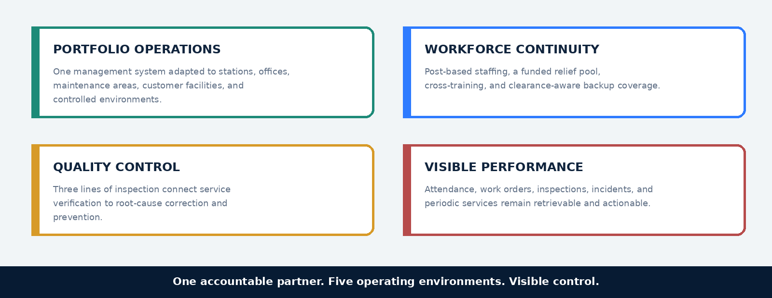
CAPACITY SIGNAL Relevant fictional portfolios range from 540,000 to 1.2 million square feet and include transit, public-facing, administrative, and support environments.

EXECUTIVE SUMMARY
Reliable service at every operating environment
QTA receives one accountable partner without forcing every facility into the same operating model.
WIN THEME Unified management. Site-specific execution. Verified readiness.

QTA PRIORITY | NORTHSTAR COMMITMENT | EVALUATOR RESULT
Continuity | Minimum posts, 14% relief, cross-trained floaters, and cleared backups | Critical positions remain filled without stripping other sites.
Consistency | Common SOPs, inspection zones, and calibrated quality reviews | Comparable standards across diverse facilities.
Responsiveness | On-site triage plus 24/7 dispatch and 90-minute surge response | Conditions are isolated, corrected, and closed visibly.
Transparency | Attendance reconciliation, issue aging, periodic-work calendar, and dashboard | QTA sees what was planned, completed, missed, and corrected.
Accountability | Dedicated Contract Manager with three cluster supervisors | One escalation path and named ownership.
631,500 SF | 20 LOCATIONS | 24/7 CRITICAL COVERAGE | 14% RELIEF POOL

UNDERSTANDING QTA
Different environments create different service risks
The portfolio must be managed as one contract and operated as five distinct service environments.
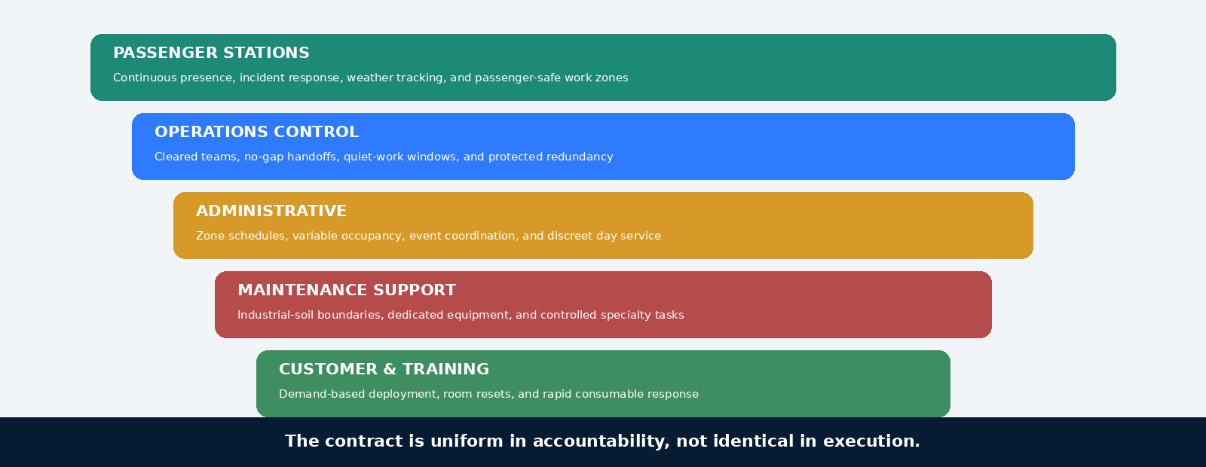

PROPOSED SOLUTION
One management system. Five operating models.
Each environment receives the labor basis and controls its risk profile requires.
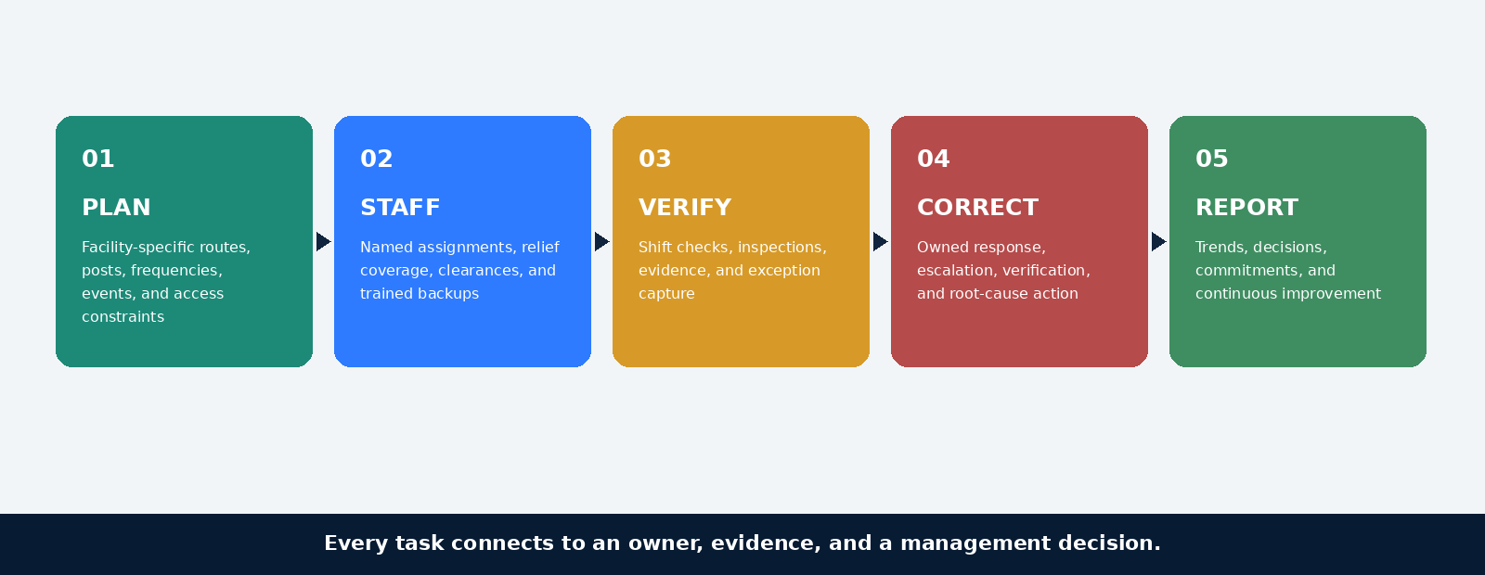
COMMERCIAL JUDGMENT Continuous public-facing and control-center coverage is modeled as posts. Offices and support spaces are modeled by task and frequency. Relief, supervision, periodic work, and emergency readiness are separately funded.

SERVICE DELIVERY
The labor model follows the work, not a generic production rate
Northstar separates continuous presence, routed task labor, periodic work, and surge response so critical coverage remains protected.
OPERATING MODEL | LABOR BASIS | CORE CONTROL
Station presence | Continuous posts plus supplemental task labor | Post verification, hourly restroom checks, dispatch, and weather plan
Control center | Dedicated cleared shift teams | No-gap handoff, controlled roster, quiet-work windows, cleared relief
Administrative | Task/frequency routes plus day porter | Zone cards, occupancy calendar, and periodic schedule
Maintenance support | Dedicated routes and controlled specialty tasks | Scope boundaries, equipment segregation, and supervisor release
Emergency / event | On-site triage plus central surge team | 15-minute acknowledgment, 90-minute dispatch, and incident closeout
SCOPE PROTECTION Northstar will document included tasks, exclusions, access restrictions, and approved quantities by facility. Work outside defined boundaries will follow QTA authorization and change control.

STAFFING AND MANAGEMENT
Named leaders remain accountable from mobilization through operations
QTA receives dedicated portfolio ownership, independent assurance, and cluster-level control close to the work.
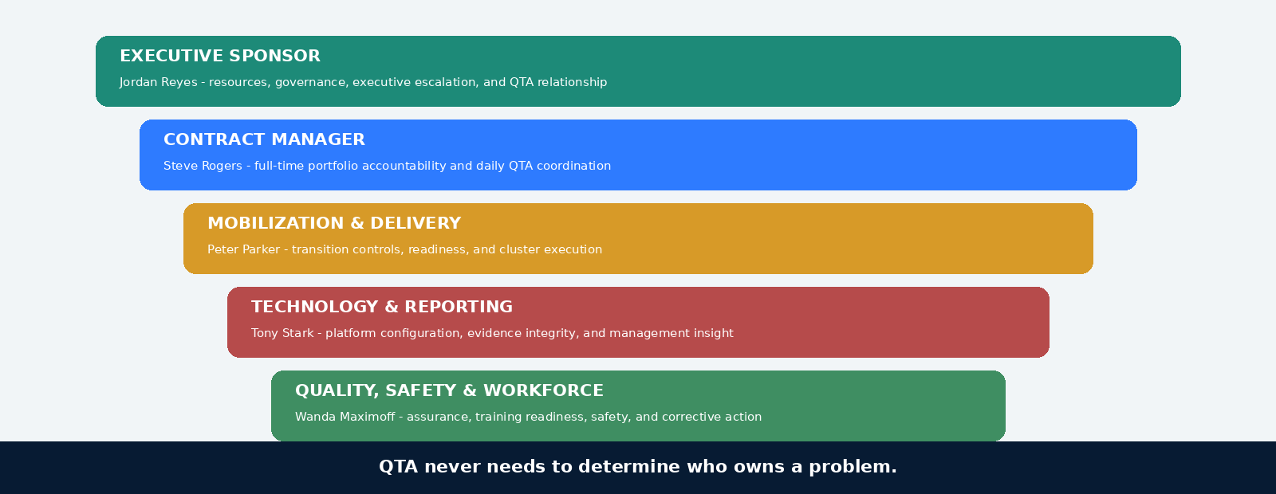

STATION AND CRITICAL COVERAGE
Minimum posts are the floor. Continuity controls protect them.
The revised Addendum requirements are funded directly, with supplemental task labor and clearance-aware backup coverage kept separate.
COVERAGE AREA | BASE COMMITMENT | PROTECTION
Station Cluster A | 4 continuous porter posts, 5 AM-1 AM | Overlapping task cleaner plus supervisor coverage
Station Cluster B | 6 continuous posts, including dedicated restroom post, 7 AM-10 PM | Two task cleaners split across peak and off-peak periods
Station Cluster C | 3 continuous porter posts, 5 AM-1 AM | Shared task cleaner; data-led weekend adjustment only with QTA approval
Operations Control Center | 2 first shift, 2 second shift, 1 overnight; all cleared | Two cleared relief employees assigned to control-center bench
Portfolio-wide | Floating supervisor during active shift overlap | Central emergency crew and on-call Contract Manager
CONTINUITY RULE Noncritical periodic work may be rescheduled with approval. Required posts are not used as the source of relief coverage.

DAILY OPERATING RHYTHM
Every shift begins with readiness and ends with ownership
The operating day converts schedules into verified service and visible exceptions.
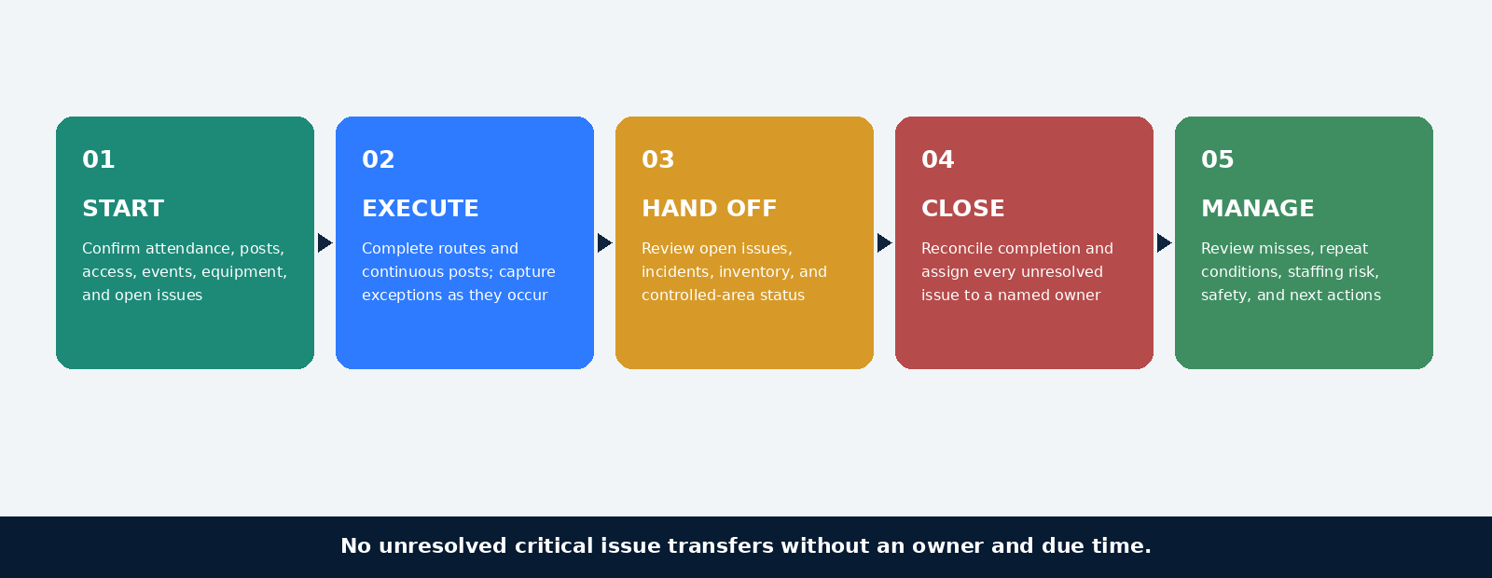

TRANSITION WITHOUT SERVICE LOSS
A 45-day plan converts award into verified readiness
Mobilization closes people, clearance, equipment, process, and continuity risks before go-live.
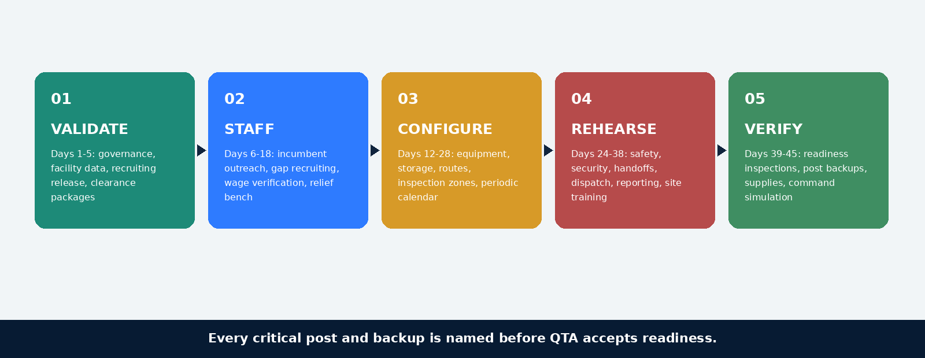
GATE | ACCEPTANCE EVIDENCE
People | Day 1 roster assigned; critical posts cleared; relief roster verified
Equipment | Assets delivered, tested, labeled, and matched to approved storage
Process | Routes, escalation contacts, periodic calendar, and incident protocols loaded
Training | Required modules complete and supervisor verification recorded
Continuity | First-week schedules, backups, and command coverage approved

QUALITY AND PERFORMANCE
Inspection becomes improvement only when the loop closes
Three lines of quality control connect immediate verification to independent assurance and systemic prevention.
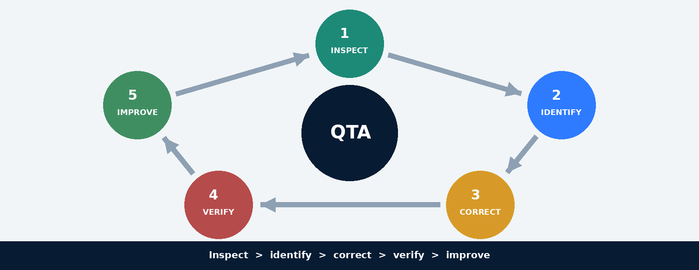
KPI | COMMITMENT | MANAGEMENT TRIGGER
Portfolio inspection | At least 92%; no site below 85% | Recovery plan begins before contractual failure
Critical response | 15-minute acknowledgment / 60-minute safe condition | Escalation at 10 and 45 minutes
Post coverage | At least 98.5% | Relief activated before uncovered time
Periodic work | At least 95% on time | Escalation seven days before risk date
Repeat complaints | No more than 5% | Root-cause review after first repeat

SAFETY, SECURITY, AND EMERGENCY READINESS
Public-facing service demands disciplined prevention and fast control
Northstar integrates site safety, clearance control, and incident command into daily execution.
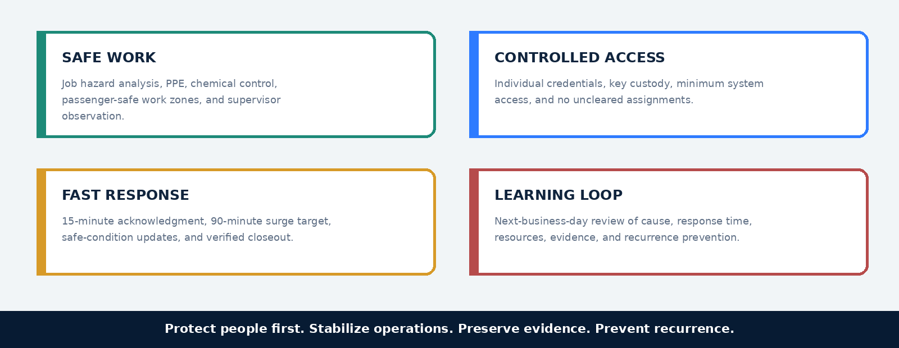

TECHNOLOGY AND REPORTING
The dashboard is not the service. It makes service gaps difficult to hide.
Northstar Service Hub connects field evidence to management action without replacing QTA authority.
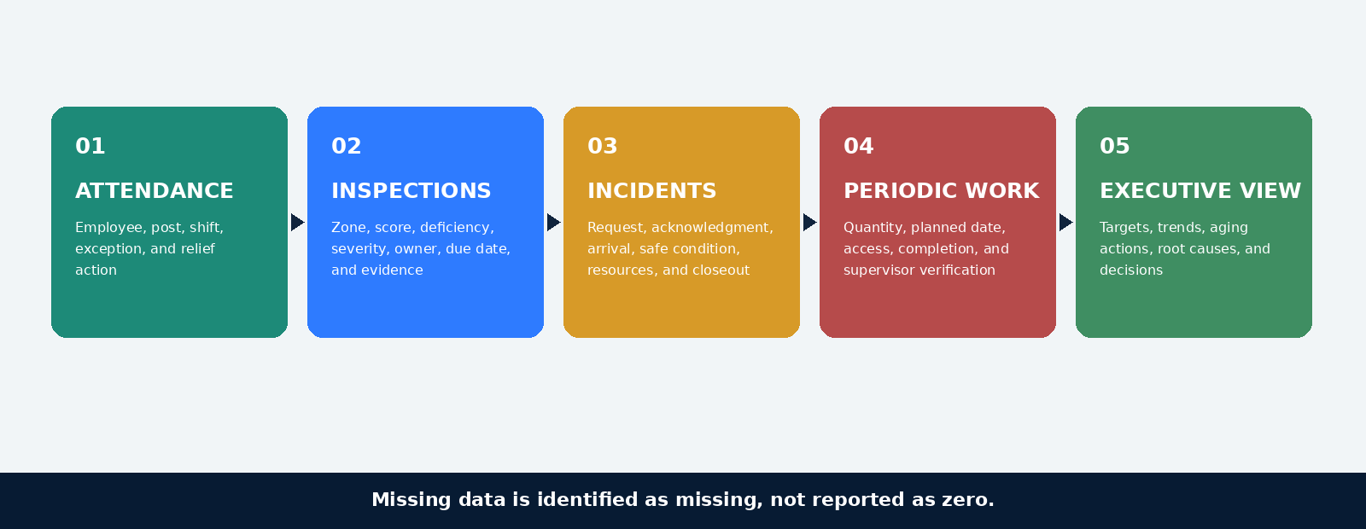
DATA PRINCIPLE Manual corrections retain an audit trail. Biometric timekeeping will not be deployed without QTA written approval and privacy review.

WORKFORCE READINESS
A prepared team is more than a filled schedule
Recruiting, clearance, training, relief, and retention controls form one readiness pipeline.
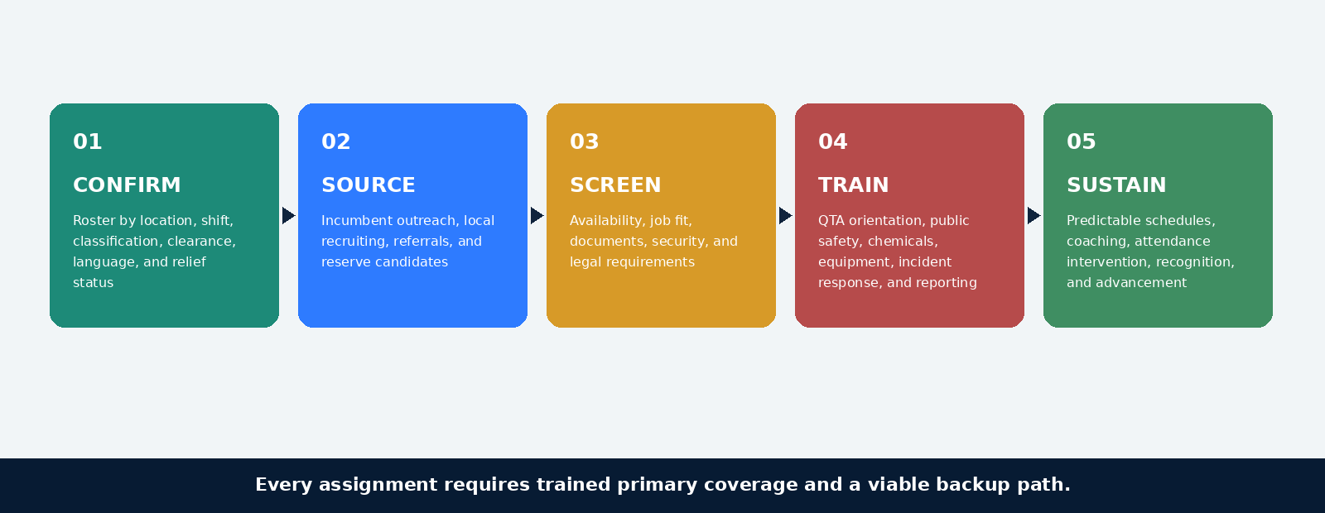
TRAINING EVIDENCE Completion records, supervisor observation, equipment qualification, site orientation, and recurring calibration remain available for QTA review.

SUSTAINABILITY AND STEWARDSHIP
Environmental performance must still clean the facility
Northstar selects methods that reduce resource use without creating rework, safety risk, or unsupported claims.
FOCUS | PRACTICE | EVIDENCE
Chemicals | Closed-loop dilution, approved product list, and microfiber color coding | Usage by location and exception log
Equipment | Battery-powered public-area tools and HEPA filtration where appropriate | Asset uptime, repair, replacement, and energy profile
Waste | Correct stream placement, waste-room controls, and contamination observation | Exception trends and QTA-designated diversion data
Water | Low-moisture carpet methods and controlled pressure/autoscrubber settings | Estimated consumption and rework avoidance
Consumables | Receipt/distribution control, par levels, and abnormal-usage review | Usage trend by facility or available occupancy proxy
RESPONSIBLE EXCEPTION When infection-control guidance, floor-system warranties, or manufacturer requirements require a nonstandard product, Northstar documents the reason, authorization, location, and return-to-standard plan.

RELEVANT EXPERIENCE
Comparable complexity proves the delivery model
The following fictional portfolios demonstrate the scale, operating conditions, and controls that transfer to QTA.
FICTIONAL CLIENT | SCALE AND ENVIRONMENT | WHAT TRANSFERS TO QTA
Hudson Regional Mobility District | 18 transit and administrative locations; 540,000 SF; 24/7 dispatch center | Passenger-facing service, cleared staff, continuous posts, and weather response
Metropolitan Learning Consortium | 27 education and training facilities; 1.2M SF | Multi-site scheduling, floor care, high-occupancy transitions, and KPI reporting
HarborWorks Public Facilities | Municipal offices, customer centers, and garages; 690,000 SF | Mixed office/industrial support, public counters, and supplier diversity
CAPACITY STATEMENT Northstar can mobilize at the required scale while preserving dedicated leadership, independent quality control, and site-specific operating plans.

KEY PERSONNEL
Experienced leaders stay accountable through go-live and steady state
Named fictional personnel have distinct decision rights, deliverables, and evidence responsibilities.
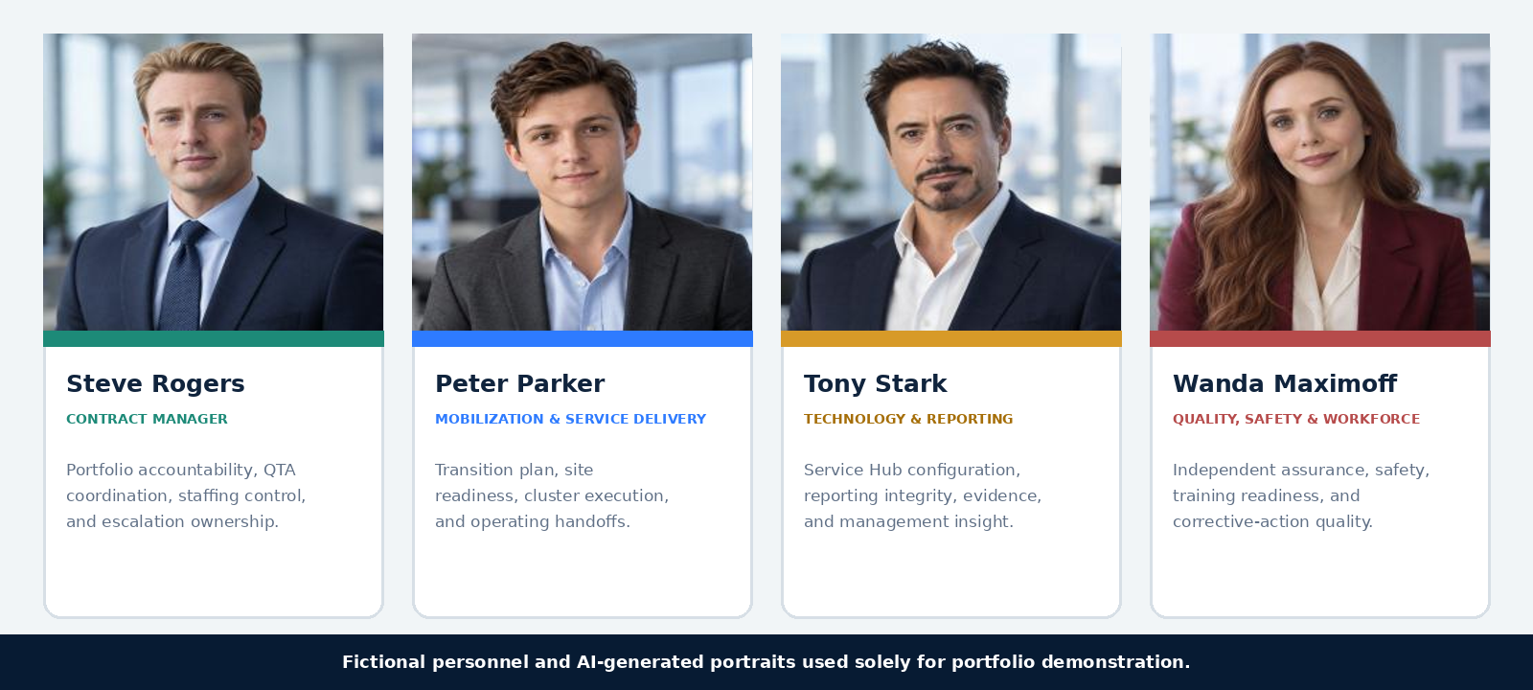
EXECUTIVE ACCOUNTABILITY Jordan Reyes provides executive sponsorship, resources, quarterly governance, and final escalation authority.

PARTICIPATION AND COMPLIANCE
Supplier diversity is integrated without diluting accountability
Northstar will self-perform more than 70% of routine custodial labor and assign commercially useful specialty work to qualified partners.
FICTIONAL PARTNER | CERTIFICATION / WORK PACKAGE | CONTROL
Harborlight Specialty Services | MWBE - periodic floor restoration and upholstery | Qualified crews, documented quantities, and Northstar QA acceptance
Valor Response Logistics | SDVOB - emergency equipment logistics and winter supplies | Staged resources, dispatch support, and inventory control
Greenline Supply Cooperative | MWBE - eligible cleaning supplies and liners | Direct fulfillment with commercially useful function verified
ADDENDUM CHANGE | PROPOSAL INCORPORATION
Portfolio revised to 631,500 SF | Cluster B task and periodic quantities updated
Minimum station posts | Every stated post funded; supplemental work separated
Wage treatment clarified | Statutory changes separated from ordinary escalation
Clearance estimate: 4-6 weeks | Early packages, redundant pipeline, and cleared relief bench
Routine deductions capped at 8% | Controls designed to avoid deductions, not rely on the cap
Bonds reduced to 50% | Bond commitment updated

COMPLIANCE AND CONTROL
Every requirement has an owner, commitment, and proof
This excerpt shows how Northstar turns solicitation language into operating evidence QTA can retrieve and verify.
REQUIREMENT | COMMITMENT | EVIDENCE
Revised station posts | Fund every mandatory post separately from task labor | Roster, schedule, time reconciliation, and relief action
Control-center clearances | No uncleared assignment; two cleared relief employees | Clearance roster, expiration tracking, and assignment audit
Mobilization | Complete 45-day transition with readiness acceptance | Integrated plan, gate evidence, and command simulation
Quality threshold | At least 92% portfolio average; no site below 85% | Inspection records, recovery plans, and closure evidence
Emergency response | 15-minute acknowledgment and 90-minute surge target | Dispatch timestamps, updates, closeout, and review
Participation | Commercially useful MWBE/SDVOB work packages | Partner scopes, invoices, quantities, and acceptance records
Self-performance | More than 70% of routine custodial labor | Payroll, schedules, assignments, and subcontract register
TRACEABILITY Requirement -> proposal commitment -> operating control -> evidence -> QTA acceptance.

VALUE SUMMARY
Every investment produces an operating result QTA can verify
Northstar concentrates resources where they protect continuity, improve visibility, and reduce repeat service failure.
INVESTMENT | QTA VALUE | HOW QTA VERIFIES IT
Funded relief pool | Required posts remain protected during absence and disruption | Post reconciliation and relief activation record
Dedicated management | Decisions and escalations have clear ownership | Issue aging, response, and closure accountability
Three-line quality control | Deficiencies become verified correction and prevention | Inspection calibration, corrective action, and repeat rate
Clearance-ready bench | Control-center continuity survives turnover and credential loss | Cleared roster and expiration pipeline
Integrated reporting | QTA sees planned, completed, missed, and corrected work | Monthly dashboard, evidence links, and management commentary
PRICE REALISM Posts, routed work, relief, supervision, periodic services, technology, and emergency readiness are visibly funded rather than hidden inside a single productivity assumption.

WHY NORTHSTAR
Ready on Day One. Accountable every day after.
QTA gains a partner designed around the realities of a public, multi-site, security-sensitive operating environment.
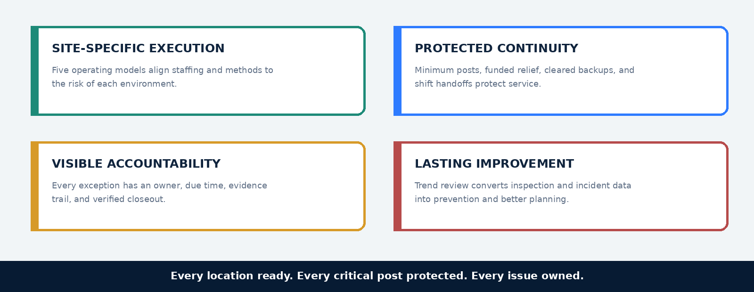
Northstar Facility Partners appreciates QTA’s consideration and is prepared to proceed with interviews, final validation, and contract readiness activities.
FICTIONAL PORTFOLIO DEMONSTRATION

