Issues I’m having with the schema and the guidelines

Current schemas are mostly formulated negatively: they tell us what’s not allowed but not what is allowed. It’s a “feature” of ODD, no way around that. I’ve found a way to derive a schema from the existing files and looked at the result. It turns out that the current schemas are much more permissive than necessary. To have a reliable validation and transformation process, I’ll need to make it stricter.

Much ambiguity in the guidelines. Need to be more formal, formal enough to be translatable to a computer program. Also, it’s better to implement things before writing about them, so we’re always on the same page. Example:

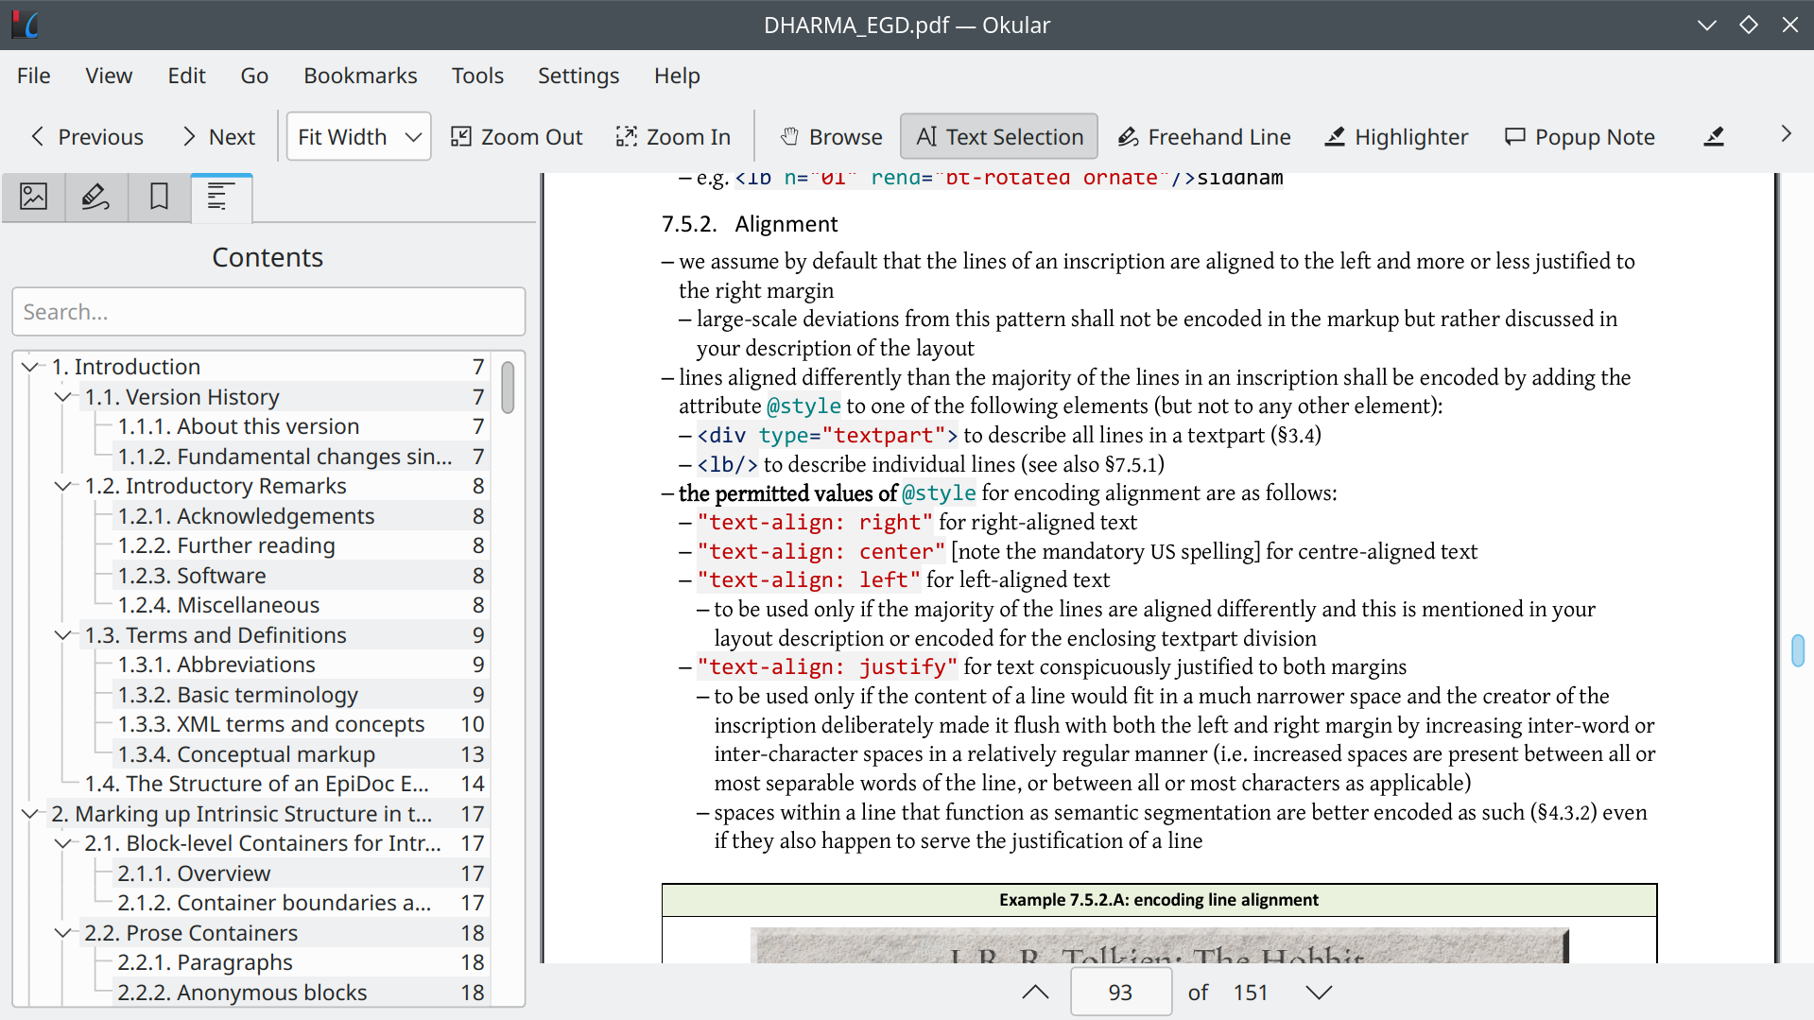

XML doesn’t really cut it

You’re trying to define several overlapping representations of the data. At least a physical one and a logical one; the apparatus might be counted as another one yet. It’s not possible to do that in XML and other SGML-derived languages, because elements can’t overlap.

TEI deals with this inconsistently:
- We have self-closing tags for pages, newlines, etc. (<pb/>, <lb/>, etc.). Thus it’s not possible to know when the page, line, etc., end, and it’s also impossible to tell the parent/child relationship between these divisions, when applicable. Is a page a child of a line, or the reverse?
- We also have matching pairs of self-closing tags, like <lacunaStart/>/<lacunaEnd/>. It’s a little better, but XML tools can’t verify this is done correctly (in fact the TEI schema doesn’t even try). This also doesn’t solve issues about tags relationships: what is the relationship between a lacuna and a page? can they overlap? is one a child of the other? etc.

To sum up, having programs work directly on the XML representation is messy. It’s not possible to query the physical structure or validate it, hacks are needed. This kinda defeats the purpose of a “native XML” database. Internally, we shouldn’t represent the data with a single tree, but with multiple ones.

EXAMPLES

Not dealing with the same kind of software.
Features we want and that are not supported by traditional databases:
* Regular expressions [RE]
* Faceted search

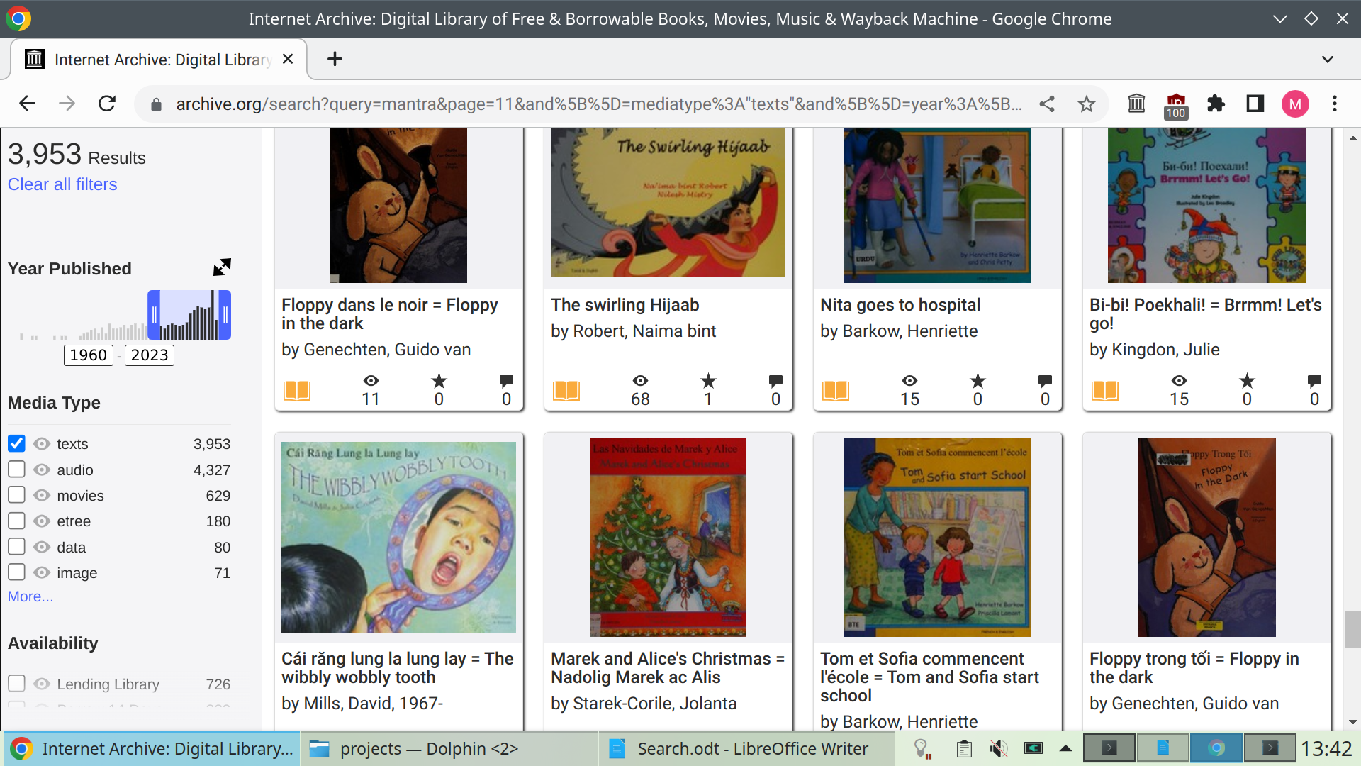

RE imply linear model. I plan to use TRE because:
Very small code base, I believe I can extend it with custom functions or operators. Approximate matching, a very rare feature (see agrep); search in linear time instead of exponential time. I’m using it on my own website.

 | SQLite | eXist-db
First stable release (v. 1.0) | 2000 (extension database, dynamic languages)  One of the most widely deployed piece of software. Computers, smartphone and other devices (avionics, cars...) | 2006
License | Public domain  No constraints on our code’s licensing | GNU LGPL  We must distribute our code under the same license
Query language | SQL  (ISO standard 1986-1992)  Used by most database vendors | Xquery  (W3C standard 2007-2014)  Used by eXist-db and MarkLogic
Programming environment | Native code, C  Builtin most programming languages environments | Java virtual machine
Model | Relational | Document-based
Explicit schema | Yes  Dynamic typing  Referential integrity | No
Database format | Single file  Stable, exhaustively documented format since 2004 | Pile of files  File format used by the underlying database library, Lucene
Basic architecture | In-process  Library : their code is embedded into ours (“push”-style).  Convenient for us, not for them | Standalone process  Framework : our code is embedded into theirs (“pull”-style).  Convenient for them, not for us
Full-text module | Built-in | Lucene (the actual database)
Purpose | “Just” a database  Single component in a wider system  Application file format  Storage + search  FTS, spatial search (https://www.sqlite.org/rtree.html) | Application platform  Wants to cover everything  Storage + search + Web server + page templates + code editor
Compiled code | 1 Mb binary  Small memory footprint | 163 Mb binary  Memory-hungry (because Java)
Regular expressions

