CLOUD COST OPTIMIZATION AUDIT
Step-by-Step Guide
How this audit was performed — reproducible in your own Azure subscription
This guide walks through every step used to produce the Cloud Cost Optimization Audit Report, from standing up the sample (intentionally wasteful) environment through to compiling the final findings and automating future reviews with PowerShell. Follow it end-to-end to reproduce the audit against your own subscription, or use individual steps as a checklist for a recurring cost review.

Prerequisites
- An Azure subscription with Contributor access to create/delete resources.
- Access to the Azure Portal (portal.azure.com).
- PowerShell 7+ with the Az module installed: Install-Module Az -Scope CurrentUser (needed for Step 9).
- ~30–45 minutes for the manual portal walkthrough (Steps 1–8); the PowerShell script in Step 9 completes the same checks in under a minute on repeat runs.

STEP 1 Create a resource group and deploy the baseline environment
Create a dedicated resource group (this audit used "Cost-Audit") and deploy a small sample environment into it: one Linux VM, one unattached managed disk, and one storage account. Keeping everything in a single resource group makes it easy to scope Cost Analysis and Advisor to exactly the resources being audited.
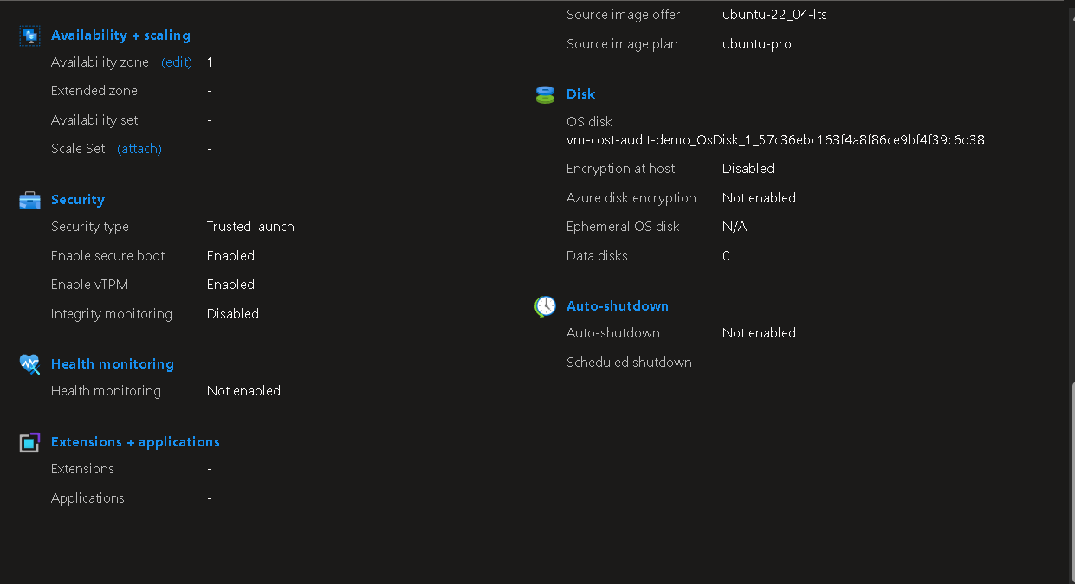
Figure 1 — VM configuration before deployment: security (Trusted launch, Secure boot, vTPM) and disk settings reviewed prior to provisioning.
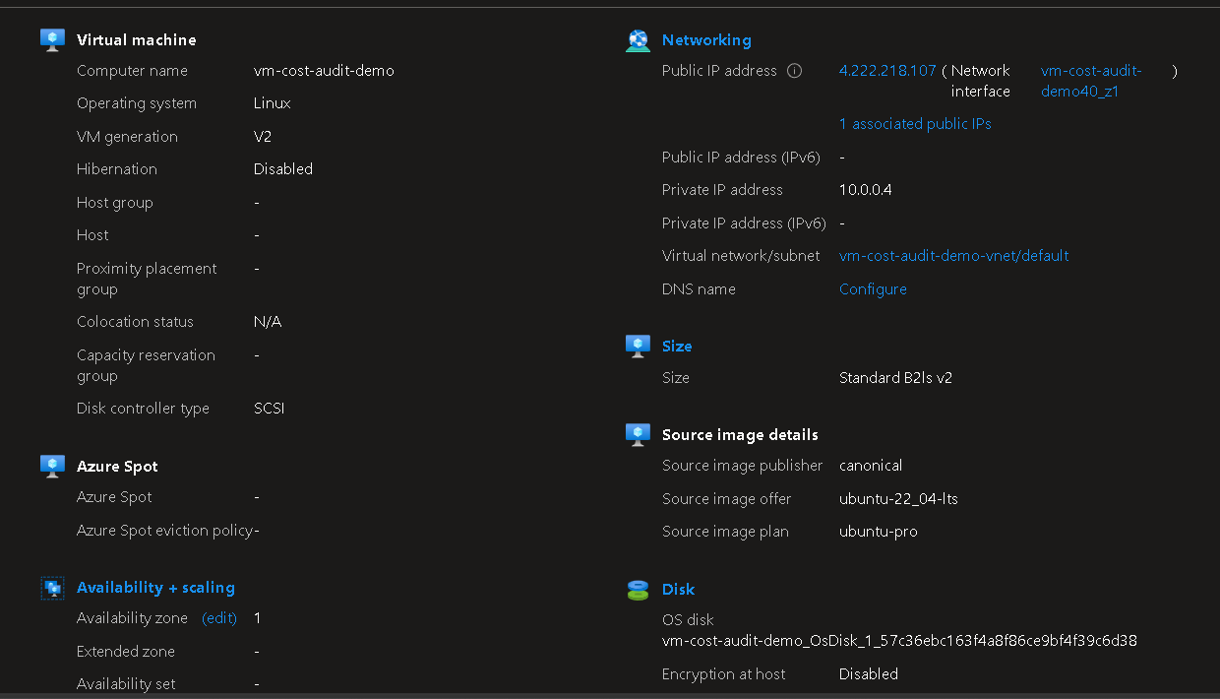
Figure 2 — VM and disk settings confirmed immediately after deployment.
Deliberately leave one managed disk unattached (not connected to any VM) — this simulates the most common form of cloud waste: a disk provisioned for a VM that was later deleted, resized, or never finished being set up.

STEP 2 Review the environment overview
Open each resource's Overview blade to confirm what was actually deployed — size, region, status — before pulling any cost or recommendation data. This baseline understanding makes it much easier to interpret Cost Analysis and Advisor output later.
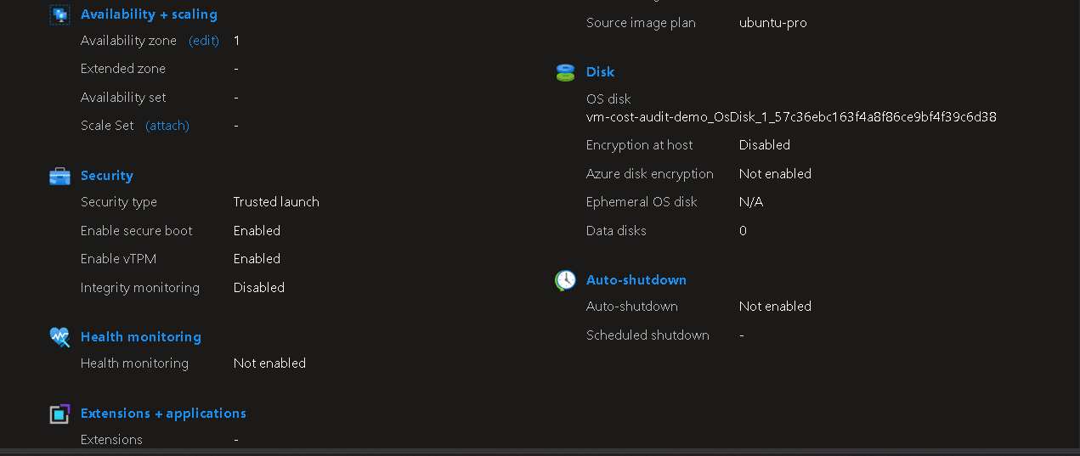
Figure 3 — vm-cost-audit-demo Overview blade: size, networking, and disk details.

STEP 3 Pull recommendations from Azure Advisor
Navigate to Advisor → Overview to see the four scored categories (Cost, Security, Reliability, Operational excellence), then drill into Advisor score and Recommendations, filtered to the Cost-Audit resource group, to see exactly which resources are flagged and why.
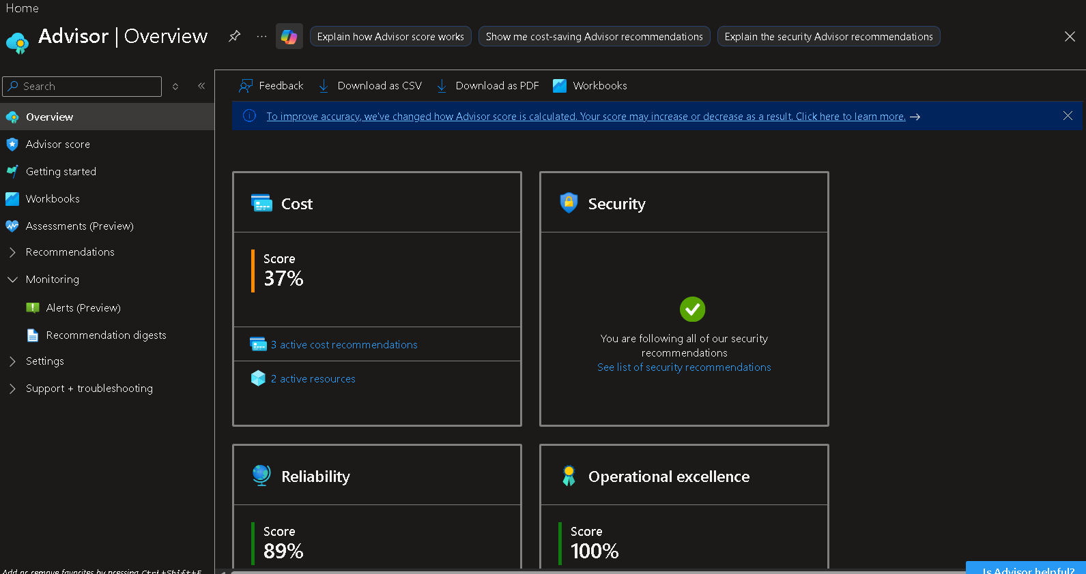
Figure 4 — Advisor Overview: Cost score 37%, Security 100%, Reliability 89%, Operational excellence 100%.
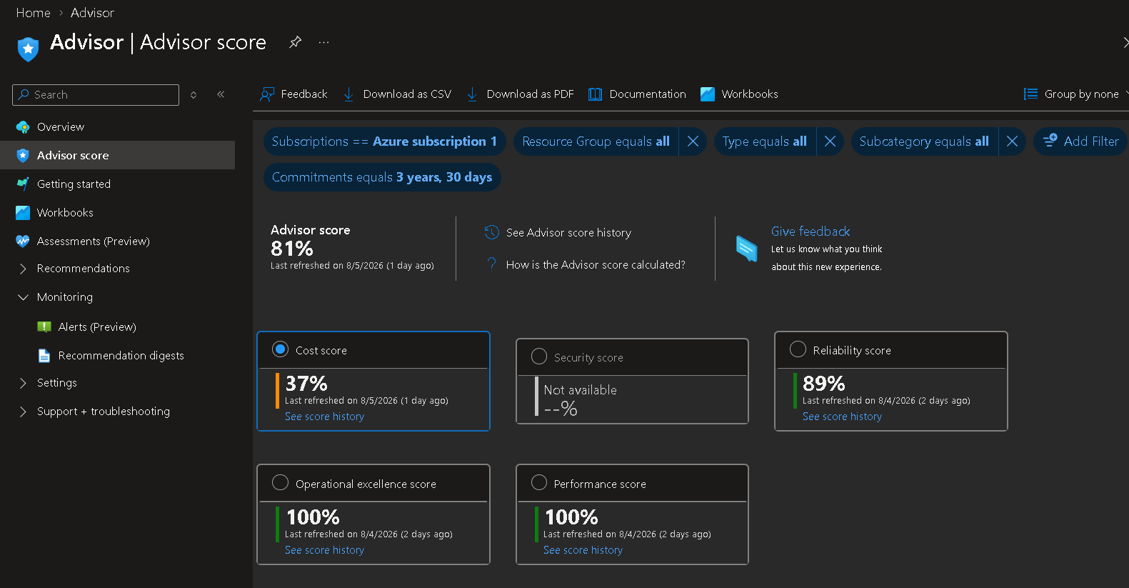
Figure 5 — Advisor score blade, filtered to Azure subscription 1: Cost score 37% is the lowest of the four.
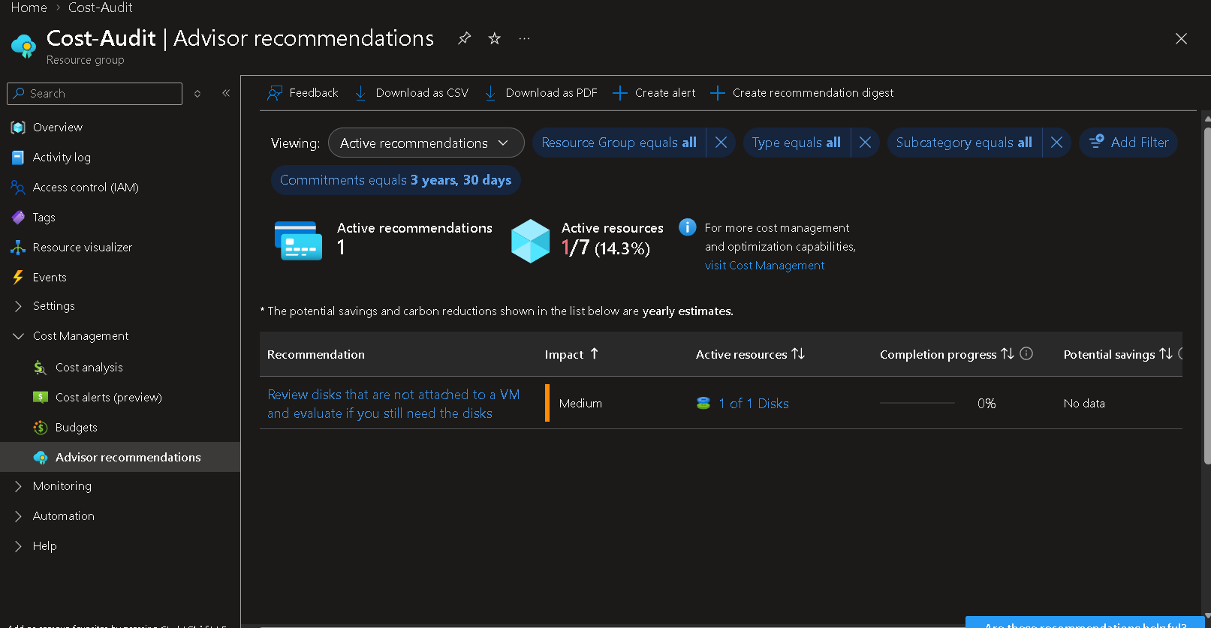
Figure 6 — Cost-Audit resource group → Advisor recommendations: 1 active recommendation to review disks not attached to a VM.

STEP 4 Review Cost Analysis
Navigate to the resource group → Cost Management → Cost analysis. Set the view to Accumulated costs for the current billing month, and check the breakdowns by Service name, Location, and Resource — this is where the single biggest cost driver becomes visible at a glance.
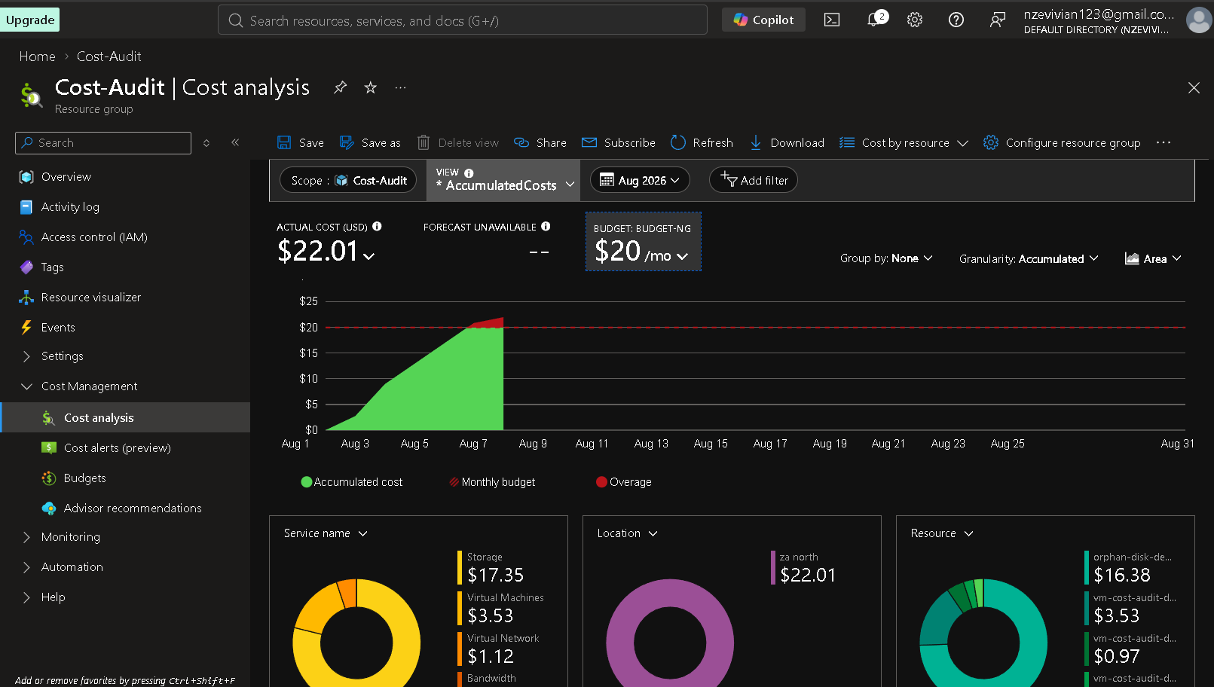
Figure 7 — Cost analysis for Cost-Audit, August 2026: $22.01 actual cost against a $20/month budget, broken down by service, location, and resource.
Note how the accumulated-cost curve crosses the budget line (red) before the month is even a third over — that's the signal to dig into the resource-level breakdown next.

STEP 5 Review usage with Azure Monitor
Open the VM → Monitoring → Metrics, add the "Percentage CPU" metric with Average aggregation, and set the time range to the last 7 days. Sustained low utilization is the clearest signal that a VM is oversized for its workload.
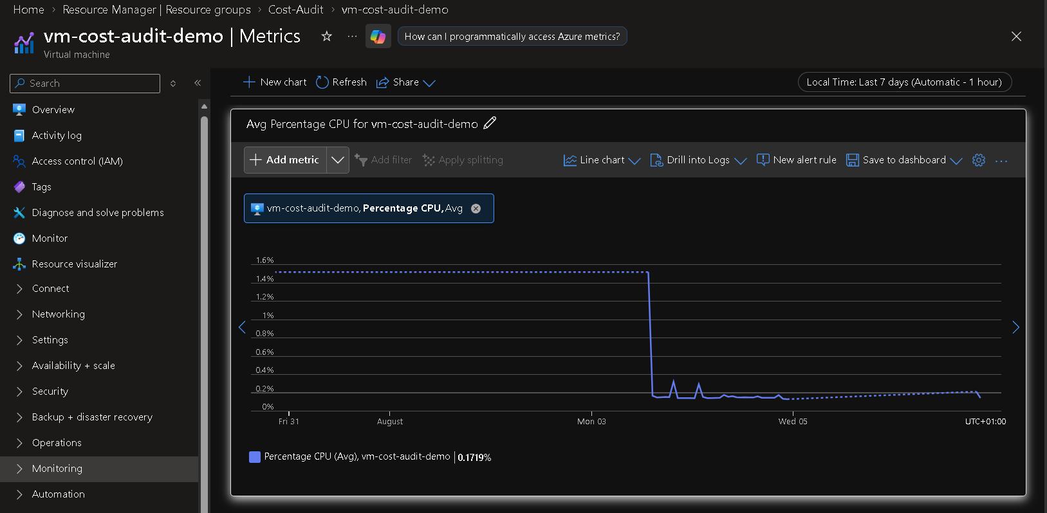
Figure 8 — Avg Percentage CPU for vm-cost-audit-demo, trailing 7 days: 0.17% average.
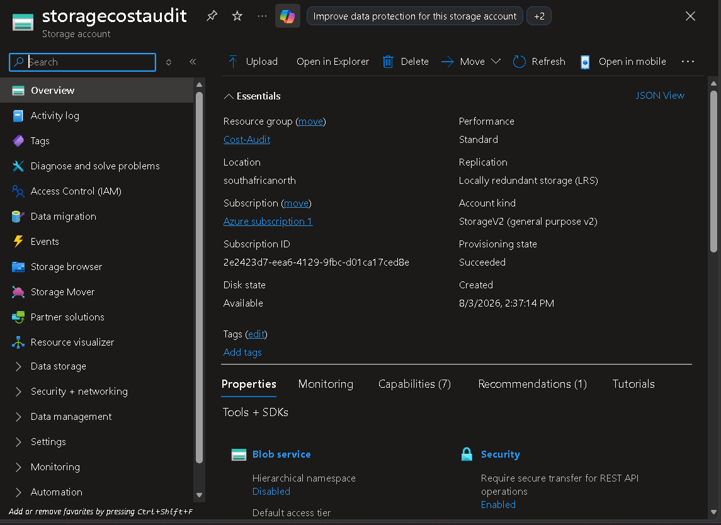
Figure 9 — Same metric view, showing the drop to near-zero once the VM was stopped mid-week.
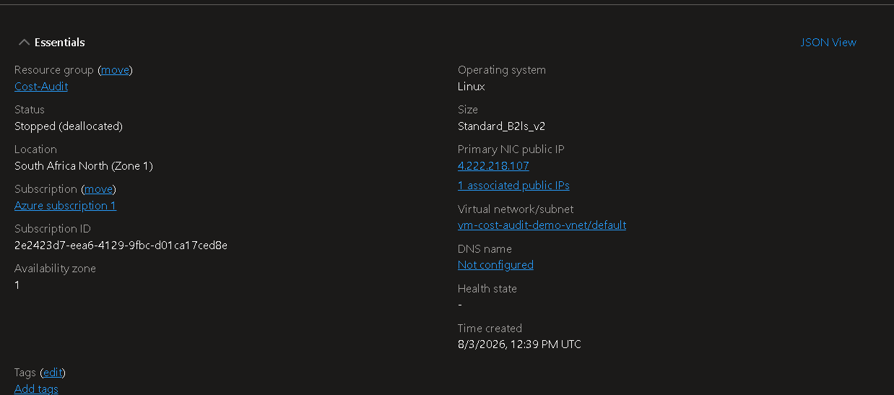
Figure 10 — VM Essentials confirming the current power state: Stopped (deallocated).

STEP 6 Storage cost audit
Open the storage account → Overview to record performance tier, replication, and account kind, then check the Blob service and Security settings for tiering, soft delete, versioning, and network access configuration — all of which affect both cost and risk.
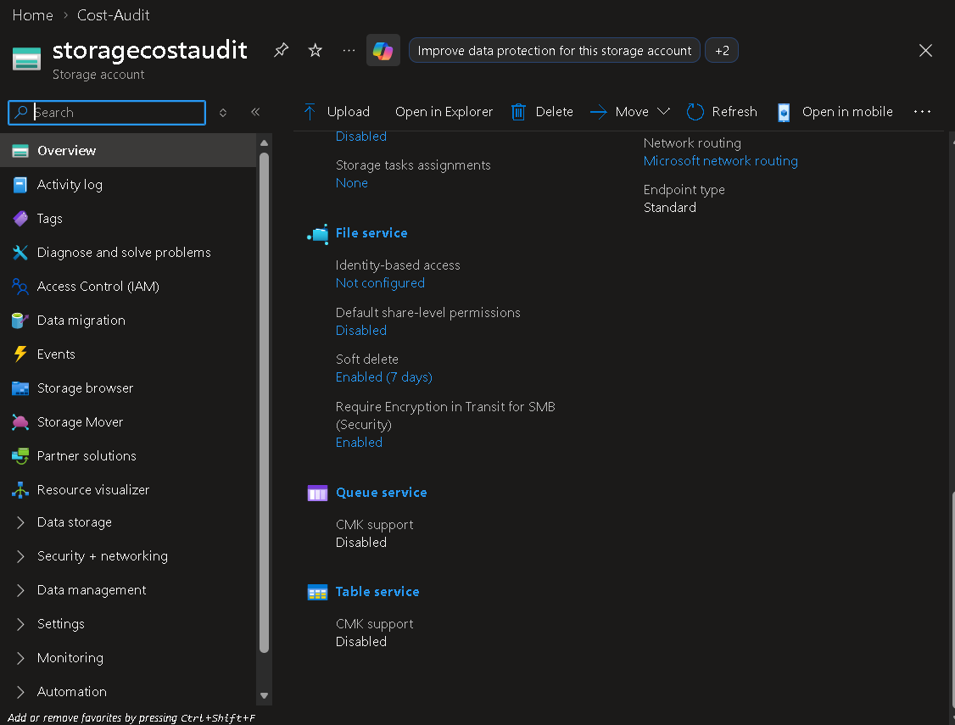
Figure 11 — storagecostaudit Overview: Standard performance, LRS replication, StorageV2 (general purpose v2), southafricanorth.
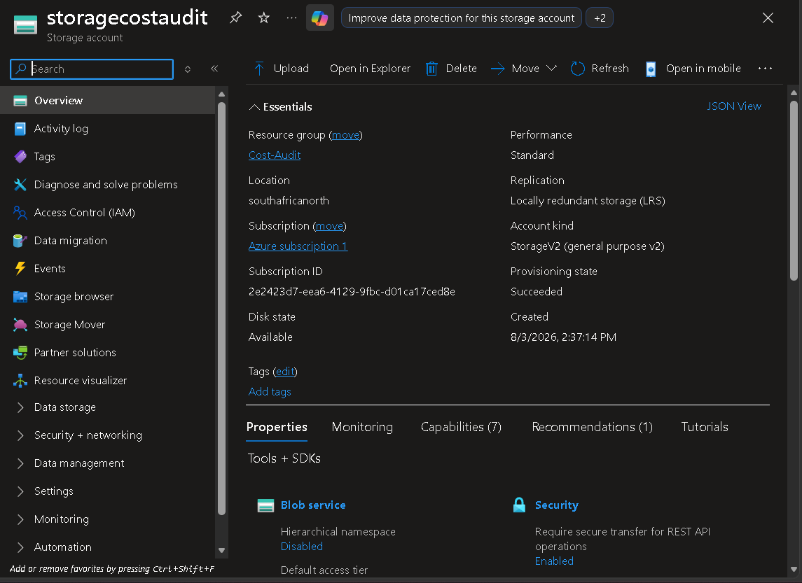
Figure 12 — storagecostaudit essentials, confirmed against the Cost-Audit resource group.
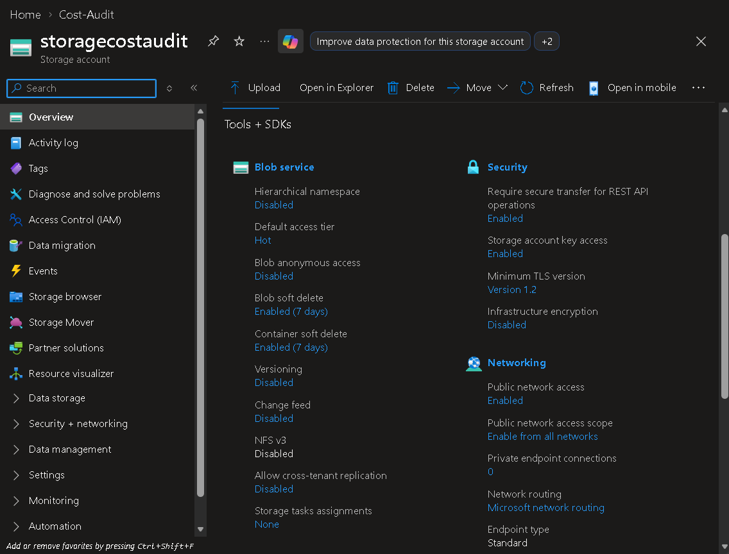
Figure 13 — Blob service and security configuration: Hot default tier, soft delete enabled (7 days), versioning disabled.

STEP 7 Identify orphaned resources
Browse to Disks (or Resource visualizer → filter by type) inside the resource group and look for any disk whose Disk state is Unattached. Cross-reference against the cost-by-resource breakdown from Step 4 to quantify the impact.
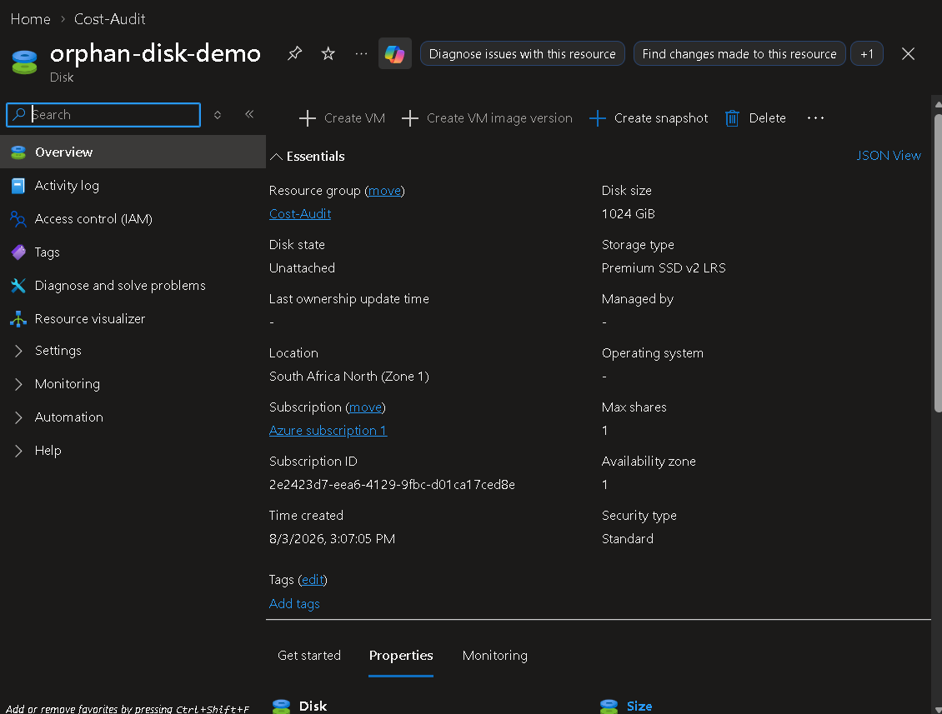
Figure 14 — orphan-disk-demo: Disk state “Unattached”, not managed by any VM.
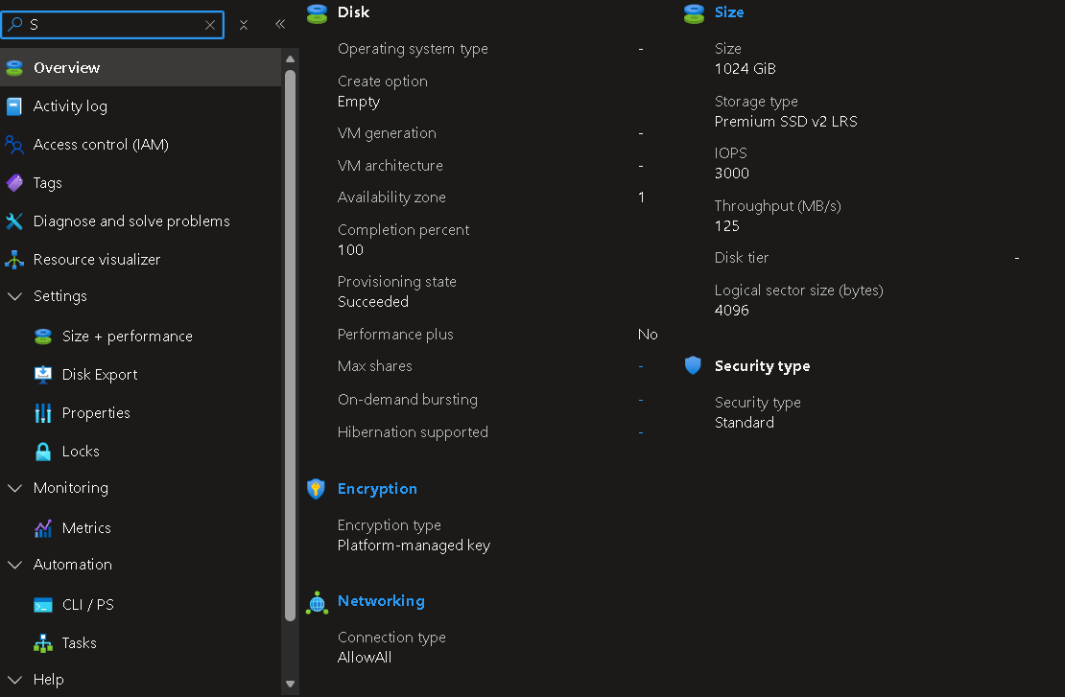
Figure 15 — Disk size (1024 GiB), performance tier (Premium SSD v2), and encryption configuration.
This single disk accounted for 74.4% of all spend in the resource group during the audit window — by far the highest-priority action item.

STEP 8 Compile findings into the audit report
With all seven areas reviewed (Advisor, Cost Analysis, VM utilization, storage configuration, and orphaned resources), compile the findings into the audit report template: Executive Summary → Methodology → Environment Overview → Detailed Findings → Recommendations → Before-and-After Comparison → Implementation Plan → Appendix. See Cloud_Cost_Optimization_Audit_Report.docx for the completed report.
- Quantify every recommendation with a real number pulled from Cost Analysis — avoid vague statements like “reduce costs where possible.”
- Prioritize recommendations by estimated $ impact, not by how easy they are to implement.
- Always include a before-and-after comparison table — it's the fastest way for a stakeholder to see the value of the audit.

STEP 9 Automate future reviews with PowerShell
Manual portal reviews don't scale as a habit. Audit-CloudCosts.ps1 (included alongside this guide) reproduces Steps 3–7 programmatically — unattached disks, low-CPU VMs, cost-by-resource, and open Advisor cost recommendations — in a single command, and can optionally remediate findings interactively.
Task | Manual equivalent | Script parameter
Find unattached disks | Step 7 | (always runs)
Find idle VMs | Step 5 | -CpuThresholdPercent / -LookbackDays
Cost by resource | Step 4 | (always runs)
Open Advisor cost recommendations | Step 3 | (always runs)
Delete confirmed orphaned disks / enable auto-shutdown | Section 9, Implementation Plan | -Remediate (interactive confirmation required)
Run it read-only first:
./Audit-CloudCosts.ps1 -ResourceGroupName "Cost-Audit"
Then, once you're comfortable with the findings, re-run with remediation enabled (still requires a per-resource “y” confirmation before anything is deleted or changed):
./Audit-CloudCosts.ps1 -ResourceGroupName "Cost-Audit" -Remediate -OutputPath ./Reports
Schedule this script to run monthly (Task Scheduler, cron + pwsh, or an Azure Automation runbook) so orphaned resources and idle VMs are caught automatically going forward, instead of relying on someone remembering to run a manual audit.

Summary Checklist
# | Step | Done?
1 | Create resource group and deploy baseline environment | ☐
2 | Review environment overview for each resource | ☐
3 | Pull recommendations from Azure Advisor | ☐
4 | Review Cost Analysis (by service, location, resource) | ☐
5 | Review usage with Azure Monitor (VM CPU metrics) | ☐
6 | Storage cost audit (tiering, replication, security) | ☐
7 | Identify orphaned / unattached resources | ☐
8 | Compile findings into the audit report | ☐
9 | Automate future reviews with Audit-CloudCosts.ps1 | ☐

