CLOUD COST OPTIMIZATION AUDIT REPORT
Capstone Project — Cloud Cost Optimization for Early-Stage Nigerian Startups
Sample Environment Audit: Microsoft Azure
Problem Context
Early-stage startups frequently overspend on cloud infrastructure due to unattached resources, oversized compute, and a lack of ongoing usage review. This audit demonstrates a repeatable process for identifying and eliminating that waste.
Subscription | Azure subscription 1
Resource Group Audited | Cost-Audit
Region | South Africa North
Audit Window | August 1 – August 5, 2026 (billing period Aug 2026)
Report Date | August 14, 2026
Prepared By | [Candidate Name]
Tools Used | Azure Advisor, Azure Cost Management + Billing, Azure Monitor, Azure PowerShell (Az module)

1. Executive Summary
This audit reviewed a sample Microsoft Azure environment (resource group Cost-Audit, subscription “Azure subscription 1”) representing a typical early-stage startup workload: one Linux virtual machine, one managed disk, one virtual network, and one general-purpose storage account. The objective was to review actual usage against provisioned capacity and cost, and to produce concrete, actionable rightsizing recommendations.
The audit found that a single unattached (orphaned) 1024 GiB Premium SSD v2 managed disk, orphan-disk-demo, was responsible for $16.38 of the $22.01 spent in the resource group in the first five days of the billing period — 74.4% of total spend — despite being attached to no virtual machine and delivering no workload value. The resource group had already exceeded its $20/month budget by day five of the month.
In addition, the sole virtual machine, vm-cost-audit-demo (Standard B2ls v2, 2 vCPU / 4 GiB RAM), showed an average CPU utilization of 0.17% over the trailing 7 days and has no auto-shutdown schedule configured — indicating it is materially oversized and running (or was running) outside of any active-use window.
Azure Advisor's Cost score for the subscription was 37%, the lowest of all five Advisor score categories (Security 100%–not available, Reliability 89%, Operational Excellence 100%, Performance 100%), confirming that cost is the primary area of concern in this environment.

Headline numbers
Metric | Value
Month-to-date actual cost (Aug 1–5, 2026) | $22.01
Monthly budget | $20.00
Budget status (day 5 of month) | Over budget by $2.01 (110% of budget)
Largest single cost driver | orphan-disk-demo — $16.38 (74.4% of spend)
Advisor overall score | 81%
Advisor Cost score | 37%
Active cost recommendations | 1 (Medium impact, 0% actioned)
VM average CPU utilization (7-day) | 0.17%

2. Problem Context
Startups — particularly early-stage teams in emerging markets such as Nigeria — commonly move fast on cloud infrastructure and rarely revisit what they provisioned once a project is “done.” Test disks are left behind after a VM is rebuilt, demo virtual machines are never scheduled to shut down, and storage accounts default to premium/hot tiers that were never right for the data being stored. Because cloud bills are usage-based and abstracted from any single visible “item,” this waste is easy to miss until the invoice arrives.
This capstone project builds and demonstrates a lightweight, repeatable cost-audit process — usage review, cost-saving recommendations, a before-and-after comparison, and a written audit report — that a resource-constrained startup team can run monthly using tools already included with their Azure subscription, at no additional cost.

3. Audit Scope & Methodology

3.1 Scope
- Resource group: Cost-Audit (subscription: Azure subscription 1, region: South Africa North)
- Resource types in scope: Virtual machine, managed disk, virtual network, storage account
- Audit window: cost data for August 1–5, 2026 (accumulated, month-to-date); compute metrics for the trailing 7 days

3.2 Methodology
The audit followed a four-step process, mirroring the MVP feature set of this project:
Step | Activity | Azure tool used
1. Usage review | Inventory all resources in the resource group; review VM CPU utilization and disk attachment state | Azure Monitor (Metrics), Resource Group Overview
2. Cost-saving recommendations | Pull automated recommendations and cross-check against manual cost analysis | Azure Advisor
3. Before-and-after comparison | Compare current month-to-date spend and Advisor score against a projected post-remediation state | Cost Management + Billing (Cost analysis)
4. Audit report | Document findings, evidence (screenshots), and a prioritized action plan | This report + accompanying PowerShell audit script

4. Environment Overview
The Cost-Audit resource group contains 7 tracked resources (VM, NIC, public IP, disk, virtual network, network security group, and storage account), of which Azure Advisor flagged 1 resource (14.3%) with an active recommendation.
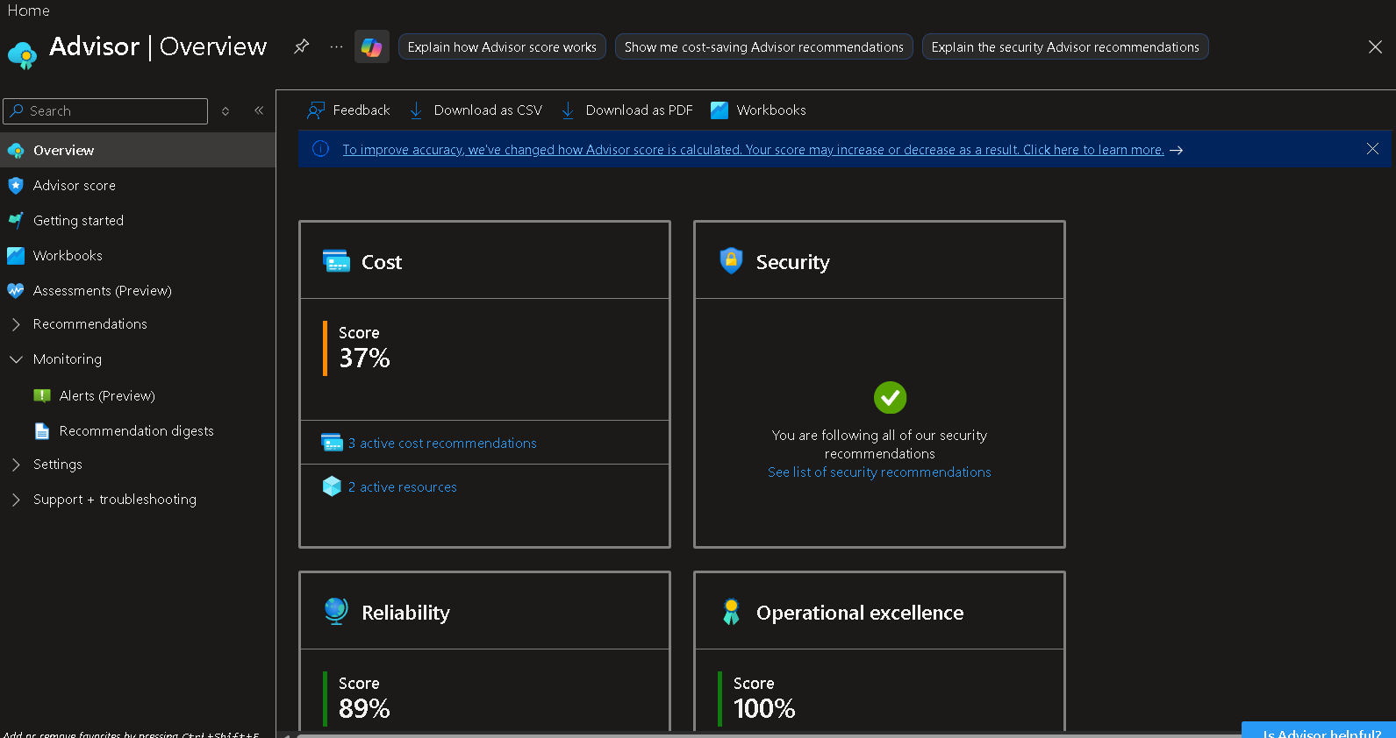
Figure 1 — Azure Advisor overview: Cost score 37%, Reliability 89%, Operational Excellence 100%, Performance 100%.

5. Tools & Approach
- Azure Advisor — automated, built-in cost/security/reliability/performance recommendations at no extra cost.
- Azure Cost Management + Billing (Cost analysis) — actual spend by service and by individual resource, against a defined monthly budget.
- Azure Monitor (Metrics) — trailing 7-day CPU utilization for the virtual machine, to validate whether provisioned size matches real usage.
- Azure PowerShell (Az module) — a repeatable script (Section 10 / Appendix) to automate this same review on a recurring, scheduled basis.

6. Findings
This section presents the detailed evidence gathered for each area of the environment, with the underlying screenshot from the Azure Portal and the corresponding data extracted from it.

6.1 Azure Advisor — Score & Recommendations
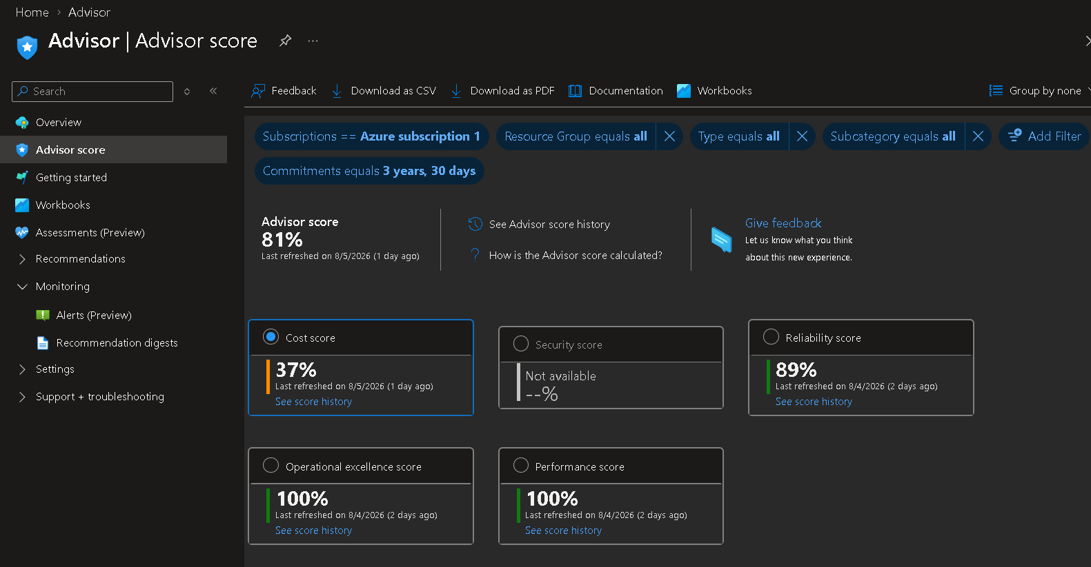
Figure 2 — Advisor score breakdown by category.
Advisor category | Score
Overall Advisor score | 81%
Cost score | 37%
Security score | Not available (no data returned for this category)
Reliability score | 89%
Operational excellence score | 100%
Performance score | 100%

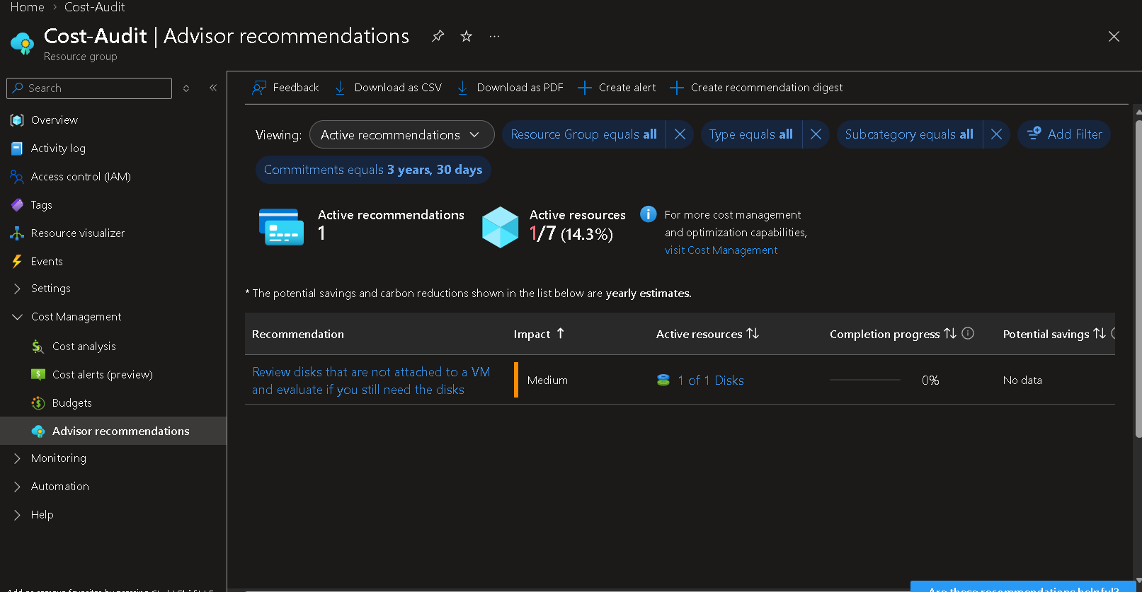
Figure 3 — Active Advisor recommendation for the Cost-Audit resource group.
Field | Value
Recommendation | Review disks that are not attached to a VM and evaluate if you still need the disks
Impact | Medium
Active resources affected | 1 of 1 disks
Completion progress | 0%
Advisor-reported potential savings | No data (Advisor could not price this automatically)
Resource-group Advisor coverage | 1 of 7 active resources (14.3%)

6.2 Cost Analysis
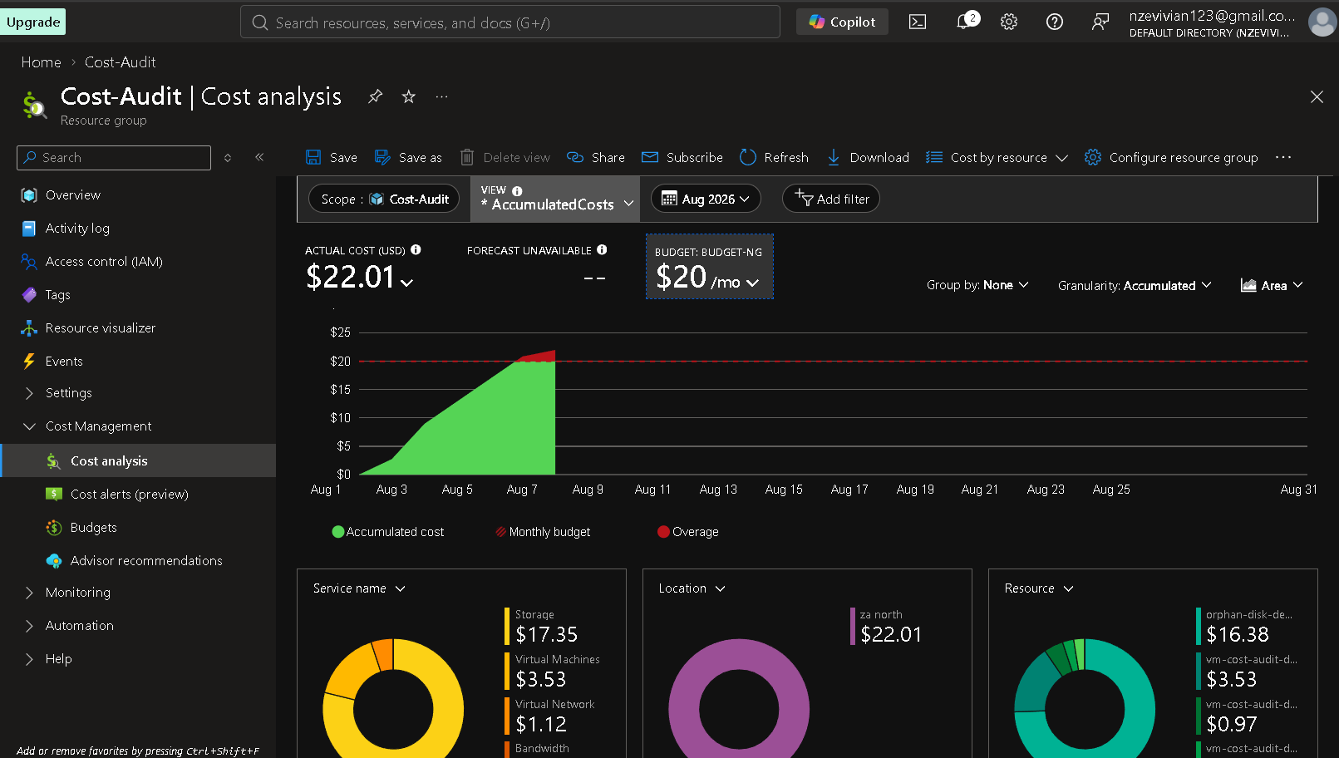
Figure 4 — Cost analysis for Cost-Audit, August 2026, accumulated view.

Spend vs. budget
Metric | Value
Actual cost (Aug 1–5, 2026) | $22.01
Monthly budget (BUDGET-NG) | $20.00 / month
Budget status | Exceeded by $2.01 (110% of budget) only 5 days into the month
Forecast | Unavailable (insufficient historical data)

Spend by service
Service | Cost (USD) | % of total
Storage | $17.35 | 78.8%
Virtual Machines | $3.53 | 16.0%
Virtual Network | $1.12 | 5.1%
Bandwidth | < $0.01 | < 0.1%

Spend by resource (top contributors)
Resource | Cost (USD) | % of total
orphan-disk-demo (unattached disk) | $16.38 | 74.4%
vm-cost-audit-demo (virtual machine) | $3.53 | 16.0%
vm-cost-audit-demo-vnet (network) | $0.97 | 4.4%
All other resources (NIC, public IP, NSG) | $0.13 | 0.6%
Observation: a single unattached disk — doing no work for the business — is responsible for nearly three-quarters of all spend in this resource group and is, on its own, the reason the monthly budget was breached in the first week of the billing cycle.

6.3 Compute (Virtual Machine) Utilization Review
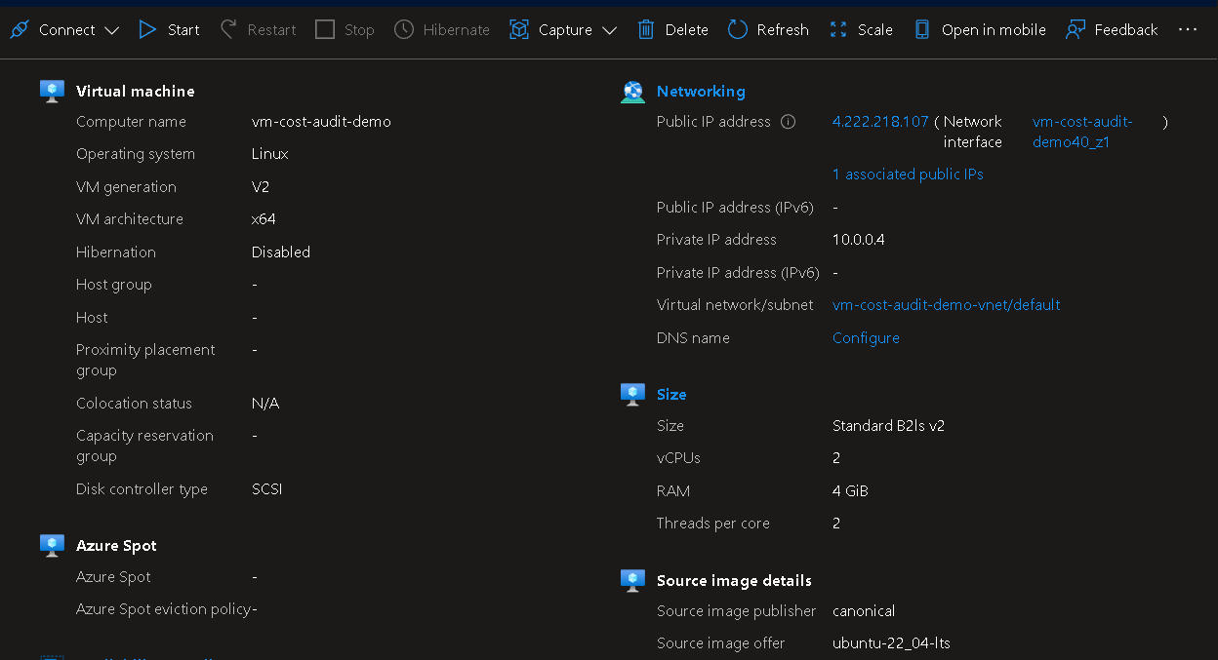
Figure 5 — vm-cost-audit-demo configuration: Standard B2ls v2, 2 vCPUs, 4 GiB RAM.
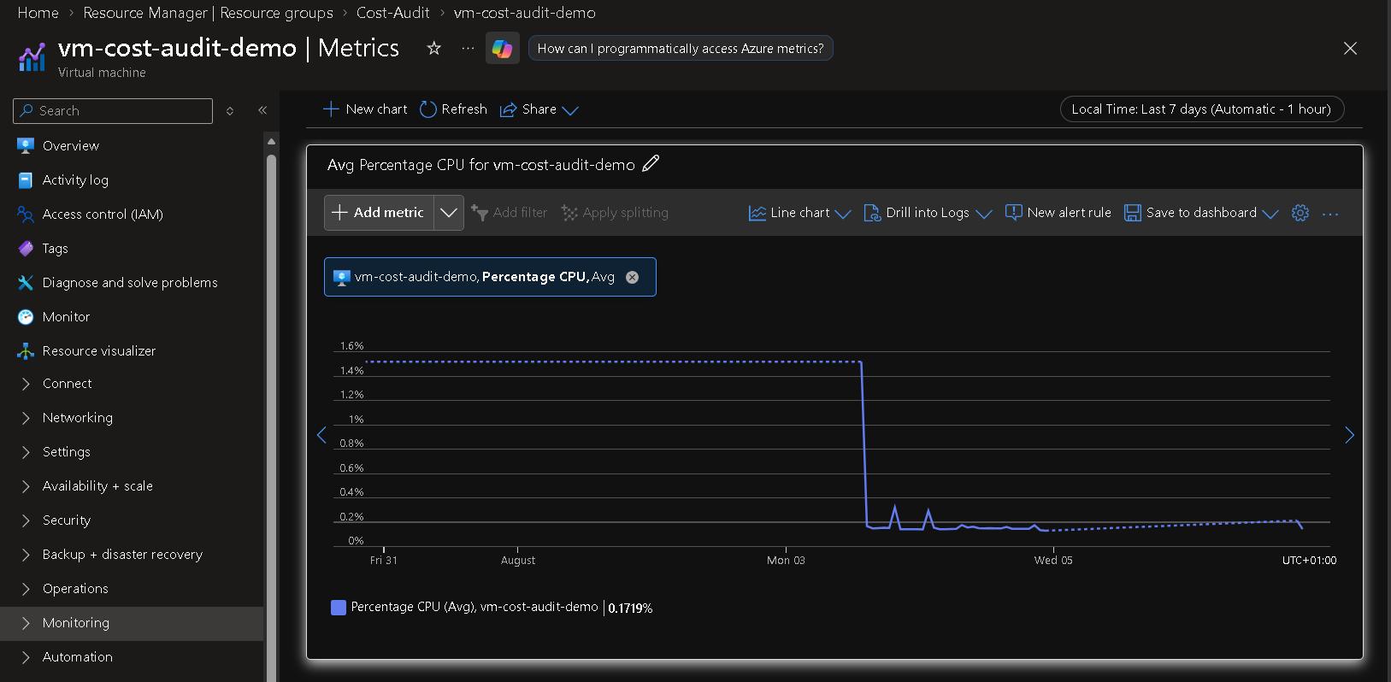
Figure 6 — Average CPU utilization, trailing 7 days: 0.1719%.
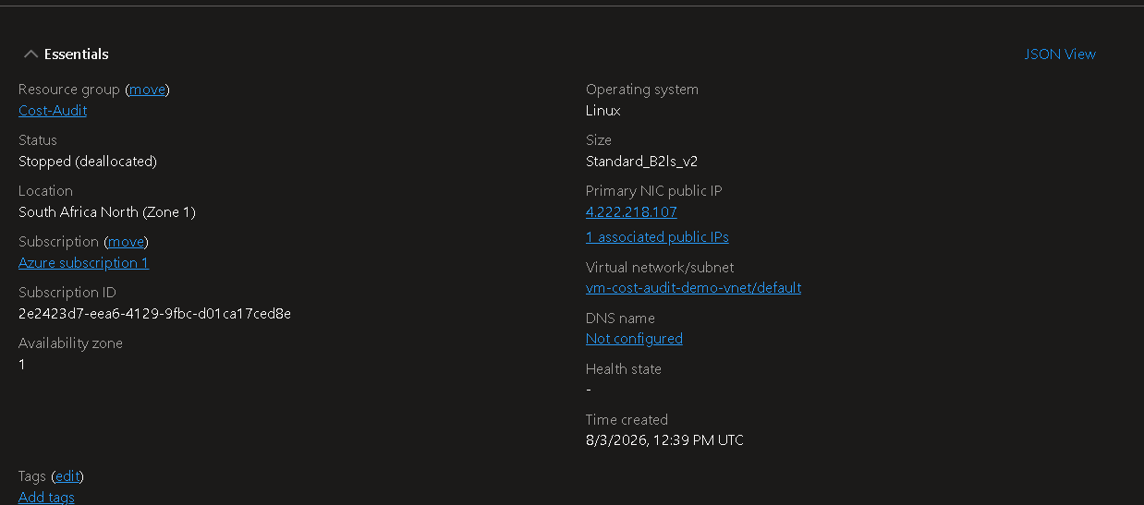
Figure 7 — VM status at time of audit: Stopped (deallocated).
Property | Value
VM name | vm-cost-audit-demo
Operating system | Linux — Ubuntu 22.04 LTS (Pro)
Size | Standard B2ls v2 (2 vCPUs, 4 GiB RAM)
Region | South Africa North (Zone 1)
Status at time of audit | Stopped (deallocated)
Auto-shutdown | Not enabled
Average CPU, trailing 7 days | 0.17%
Peak CPU, trailing 7 days | ~1.6% (prior to the VM being stopped)
Public IP | 4.222.218.107 (static allocation)
Created | August 3, 2026, 12:39 PM UTC
Observation: sustained CPU utilization below 1% indicates the VM is significantly oversized for its actual workload (idle/demo usage), and the absence of an auto-shutdown schedule means the VM would continue to accrue compute charges around the clock whenever it is running, regardless of whether anyone is using it.

6.4 Storage Account Review
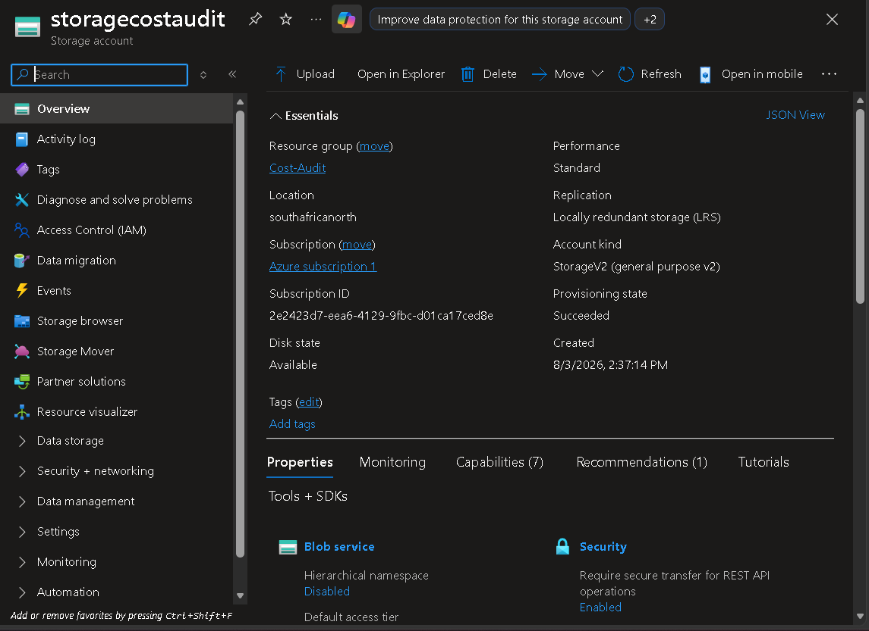
Figure 8 — storagecostaudit storage account essentials.
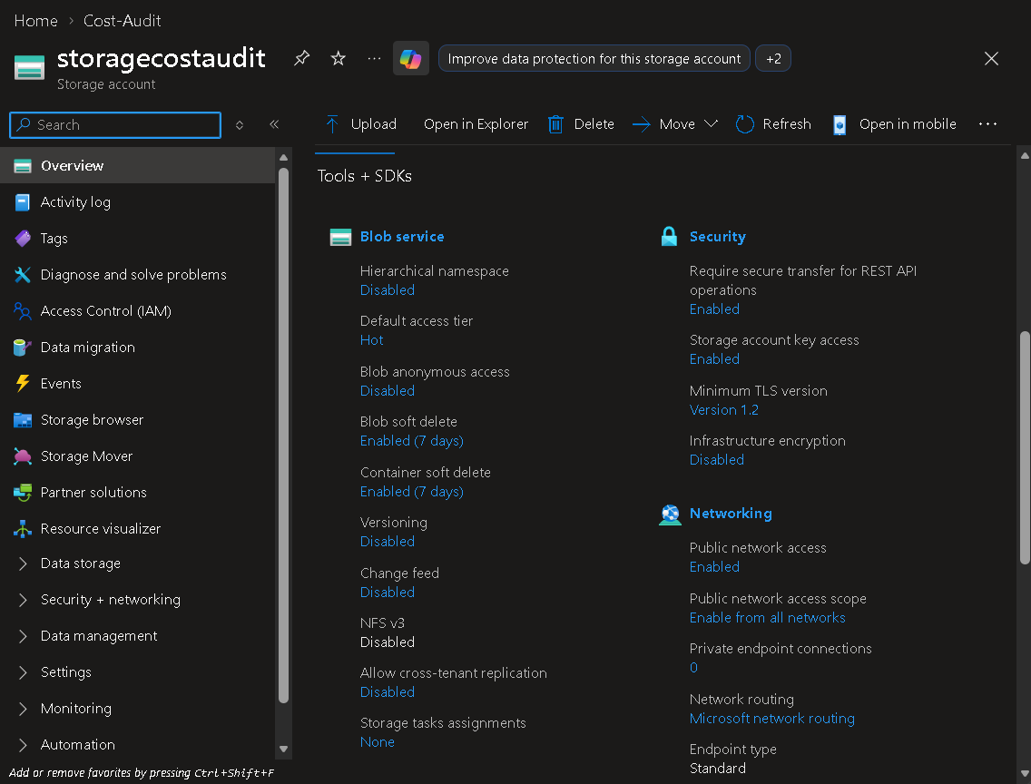
Figure 9 — Blob service and security configuration.
Property | Value
Account name | storagecostaudit
Resource group | Cost-Audit
Region | South Africa North
Performance tier | Standard
Replication | Locally-redundant storage (LRS)
Account kind | StorageV2 (general purpose v2)
Default access tier | Hot
Public network access | Enabled (from all networks)
Blob / container soft delete | Enabled (7-day retention)
Versioning | Disabled
Minimum TLS version | 1.2
Infrastructure (double) encryption | Disabled
Observation: the account is on the Hot access tier by default. Hot is the right choice only for data accessed frequently; if this account is (or becomes) a store for infrequently-accessed logs, backups, or archives, Cool or Archive tiers would materially reduce per-GB storage cost. Public network access being open to all networks is a security note worth flagging even though it is outside the cost scope of this audit.

6.5 Orphaned Resource Discovery — Unattached Managed Disk
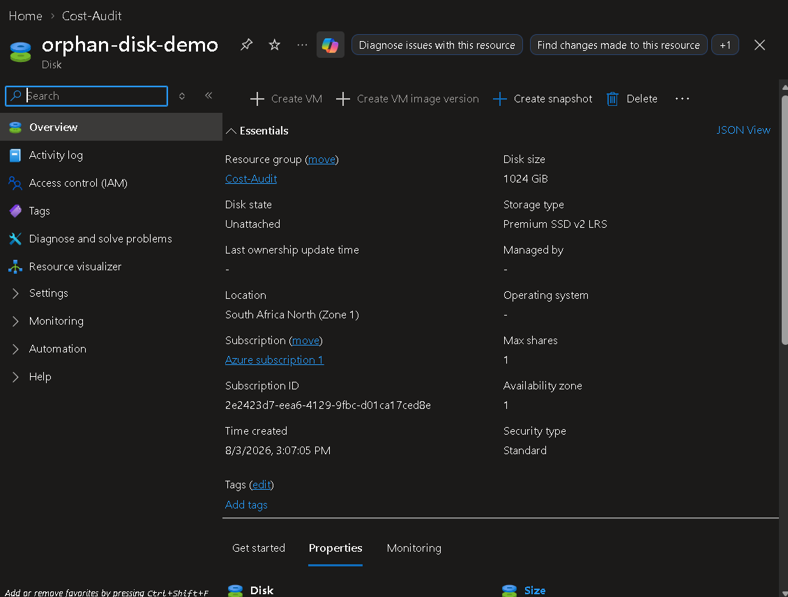
Figure 10 — orphan-disk-demo: disk state “Unattached”, no VM managing it.
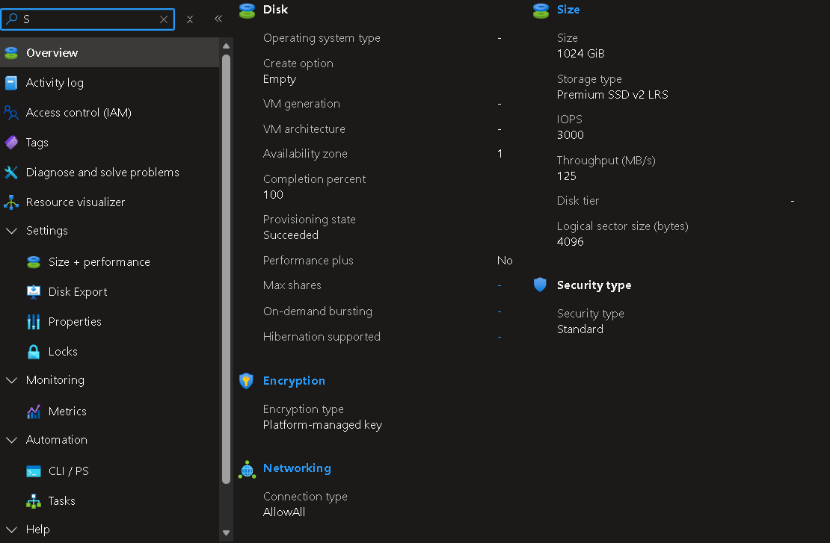
Figure 11 — Disk size, performance, and encryption configuration.
Property | Value
Disk name | orphan-disk-demo
Disk state | Unattached
Managed by (VM) | — (none)
Size | 1024 GiB
Storage type | Premium SSD v2 (LRS)
Provisioned IOPS | 3,000
Provisioned throughput | 125 MB/s
Region | South Africa North (Zone 1)
Created | August 3, 2026, 3:07 PM
Encryption | Platform-managed key
Cost impact (Aug 1–5, 2026) | $16.38 (74.4% of resource-group spend)
This disk was provisioned at 1024 GiB on the Premium SSD v2 tier — a high-performance, high-cost tier (3,000 IOPS / 125 MB/s provisioned) — and has never been attached to a virtual machine. At its observed burn rate of roughly $8/day, an unattended disk of this size and tier would accrue on the order of $240+ per month (≈ $2,900+ annualized) in pure waste if left in place. This is the single highest-priority finding in the audit.

7. Recommendations & Rightsizing Actions
# | Recommendation | Priority | Estimated impact
1 | Delete orphan-disk-demo (or snapshot/export first if data must be retained, then delete) | High | Removes $16.38 MTD / ≈ $240+ per month if left running
2 | Right-size vm-cost-audit-demo from Standard B2ls v2 (2 vCPU/4GiB) to a smaller B-series SKU (e.g., B1ls v2 / B1s) based on 0.17% avg CPU | Medium | Typically 40–60% reduction in VM compute cost at this utilization level
3 | Enable an auto-shutdown schedule on the VM for non-business hours | Medium | Cuts billable VM runtime hours for a demo/dev workload
4 | Move storagecostaudit's default access tier from Hot to Cool (or Archive) if data is infrequently accessed | Low–Medium | Cool tier storage is materially cheaper per GB than Hot; confirm against expected access pattern
5 | Set Cost Management budget alerts at 50% / 80% / 100% of the $20 monthly budget | Governance | Earlier warning before overspend, instead of discovering it after the fact
6 | Action and close out the existing Azure Advisor cost recommendation (currently 0% complete) | High | Brings Advisor Cost score up from 37%

8. Before-and-After Comparison

8.1 Cost
Metric | Before (as audited) | After (projected, once actions 1–4 above are applied)
Month-to-date spend (5 days) | $22.01 | ≈ $5.60 (removes the $16.38 orphan-disk charge)
Largest cost driver | Unattached disk — 74.4% of spend | Right-sized VM / storage — no single unmanaged resource dominates spend
Budget status (day 5) | Over budget by 10% | Well within the $20/month budget
Storage cost | $17.35 | ≈ $0.97 (orphan disk removed; storage account cost only)
Note: the “after” figures reflect removing the orphaned disk (the fully-substantiated, evidence-backed action) and are directional for VM/storage tiering changes, which depend on the workload's actual future usage pattern. They should be re-validated in Cost Management after each change is applied.

8.2 Azure Advisor Cost Score
Metric | Before | After (target)
Advisor Cost score | 37% | Materially higher once the orphaned-disk recommendation is actioned
Active cost recommendations | 1 open (0% complete) | 0 open
Resource-group Advisor coverage of flagged resources | 1 of 7 (14.3%) | 0 of 7 (0%)

9. Implementation Plan / Next Steps
- Week 1: Confirm orphan-disk-demo is not needed (check with the team / take a final snapshot if uncertain), then delete it.
- Week 1: Enable an auto-shutdown schedule on vm-cost-audit-demo.
- Week 2: Right-size the VM SKU based on confirmed workload requirements; monitor CPU/RAM for 7 days post-change.
- Week 2: Review storagecostaudit's access pattern and move to Cool tier if appropriate.
- Ongoing: Run the accompanying PowerShell audit script (Appendix, Section 10) on a monthly schedule to catch new orphaned disks, idle VMs, and budget drift before they accumulate.
- Ongoing: Review Azure Advisor Cost score and Cost Management budget alerts weekly.

10. Appendix

10.1 PowerShell Audit Automation Script
A companion script, Audit-CloudCosts.ps1, automates the core checks performed manually in this audit (unattached disks, low-CPU VMs, and month-to-date cost by resource). It is provided as a separate file alongside this report and in the accompanying README.md, and is intended to be run monthly (e.g., via Task Scheduler or an Azure Automation runbook) so this review does not depend on someone remembering to do it manually.

10.2 Screenshot Index
Figure | Source screen | Section
1 | Azure Advisor — Overview | 4
2 | Azure Advisor — Advisor score | 6.1
3 | Azure Advisor — Cost-Audit recommendations | 6.1
4 | Cost Management — Cost analysis (Cost-Audit, Aug 2026) | 6.2
5 | vm-cost-audit-demo — Overview / size | 6.3
6 | vm-cost-audit-demo — Metrics (Avg % CPU) | 6.3
7 | vm-cost-audit-demo — Essentials (status) | 6.3
8 | storagecostaudit — Overview / essentials | 6.4
9 | storagecostaudit — Blob service & security settings | 6.4
10 | orphan-disk-demo — Overview / essentials | 6.5
11 | orphan-disk-demo — Size, performance, encryption | 6.5

