**X.2. Categories**

In order to stay competitive with the other online retailers in the world today, Moogle will need to have a massive catalog of products for sale. However, users can easily become overwhelmed when faced with these products without any kind of organization or structure. To avoid this, we introduce categories. With categories, Moogle can better organize every sale item in the database by having each item belong to exactly one category. To add further detail, categories can have “subcategories” which present a more specific way to view a subset of items that are in the parent category and are able to refine a user’s search with even more accuracy. For example, if we have a category “Movies” some of its subcategories may be “DVD”, “Blu-ray”, or “Digital”. All categories will be stored under the “All” root category and a user can traverse through the category tree in order to more easily find a sale item they are looking for.

The next concern is: how exactly should we model categories in our database? A category will need to have a name (which describes the type of items that belong to that category), a unique identifier (key), and a field for its parent’s identifier (so subcategories can know who their parent is in the tree). Therefore, we model the categories as an entity set with attributes for each of these. We also know that every product will belong to exactly one category. Therefore we can set up a many-to-one relationship set between Sale Item and Category entities called “of_type” which features total participation from Sale Items entity set (because every Sale Item belong to exactly one category). An ER diagram for the Categories entity set is featured below.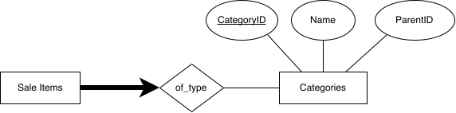

**Figure X - Entity-Relationship model for Category**