**X.12. Watch Lists**

It isn’t unusual for a shopper to find an item in the store that they’d like to purchase, but for one reason or another, are not currently able to. This could be because the customer has an insufficient amount of funds or perhaps because they wish to save the item for a later date (such as a birthday or holiday). However, as the owner of the store, it is your responsibility to ensure that this customer doesn’t forget about these items as it would result in the loss of a potential sale. For this reason, Moogle needs to utilize a “watch list’ feature that would allow users to easily keep track of the items that they wish to buy at a future time. Registered users would then be able to create multiple watch lists for separate occasions and simply add items that they find throughout the store to one or more of these lists to serve as a reminder.

Now that we can see why watch lists are an important feature of any online store, we discuss how they can be modeled in the database. We know that each watch list has a name, belongs to a specific user (and thus should be deleted when its owning user is deleted), and consists of zero or more sale items. Therefore, we can model the watch lists as a weak entity set involved in an identifying relationship with the Registered Users set. Additionally, the watch lists entity set should also be involved in a relationship set with Sale Items in order to keep track of which items the user has added to a list, as can be seen below.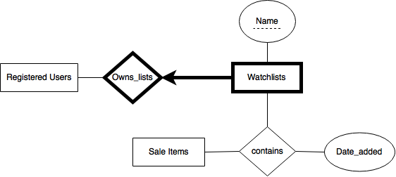

**Figure X - Entity-Relationship model for Watchlist**