CS-340 Project Two README
Grazioso Salvare Rescue Animal Dashboard
Author: Michael
Southern New Hampshire University - Client/Server Development

Project Functionality
This project delivers a MongoDB-backed Dash web dashboard for Grazioso Salvare. The application helps identify rescue dog candidates from Austin Animal Center outcome data using interactive filters, a responsive data table, a breed distribution pie chart, and a geolocation map.
Required dashboard functionality includes:
- Interactive filter options for Water Rescue, Mountain or Wilderness Rescue, Disaster or Individual Tracking, and Reset.
- A data table that dynamically updates based on the selected rescue filter.
- A geolocation chart that displays the selected animal's location.
- A pie chart showing breed distribution for the currently filtered data.
- Grazioso Salvare branding with logo linked to www.snhu.edu and a unique identifier.

Dashboard Screenshots

Starting Dashboard State
Unfiltered dashboard showing all widgets: filter options, data table, pie chart, and geolocation map.
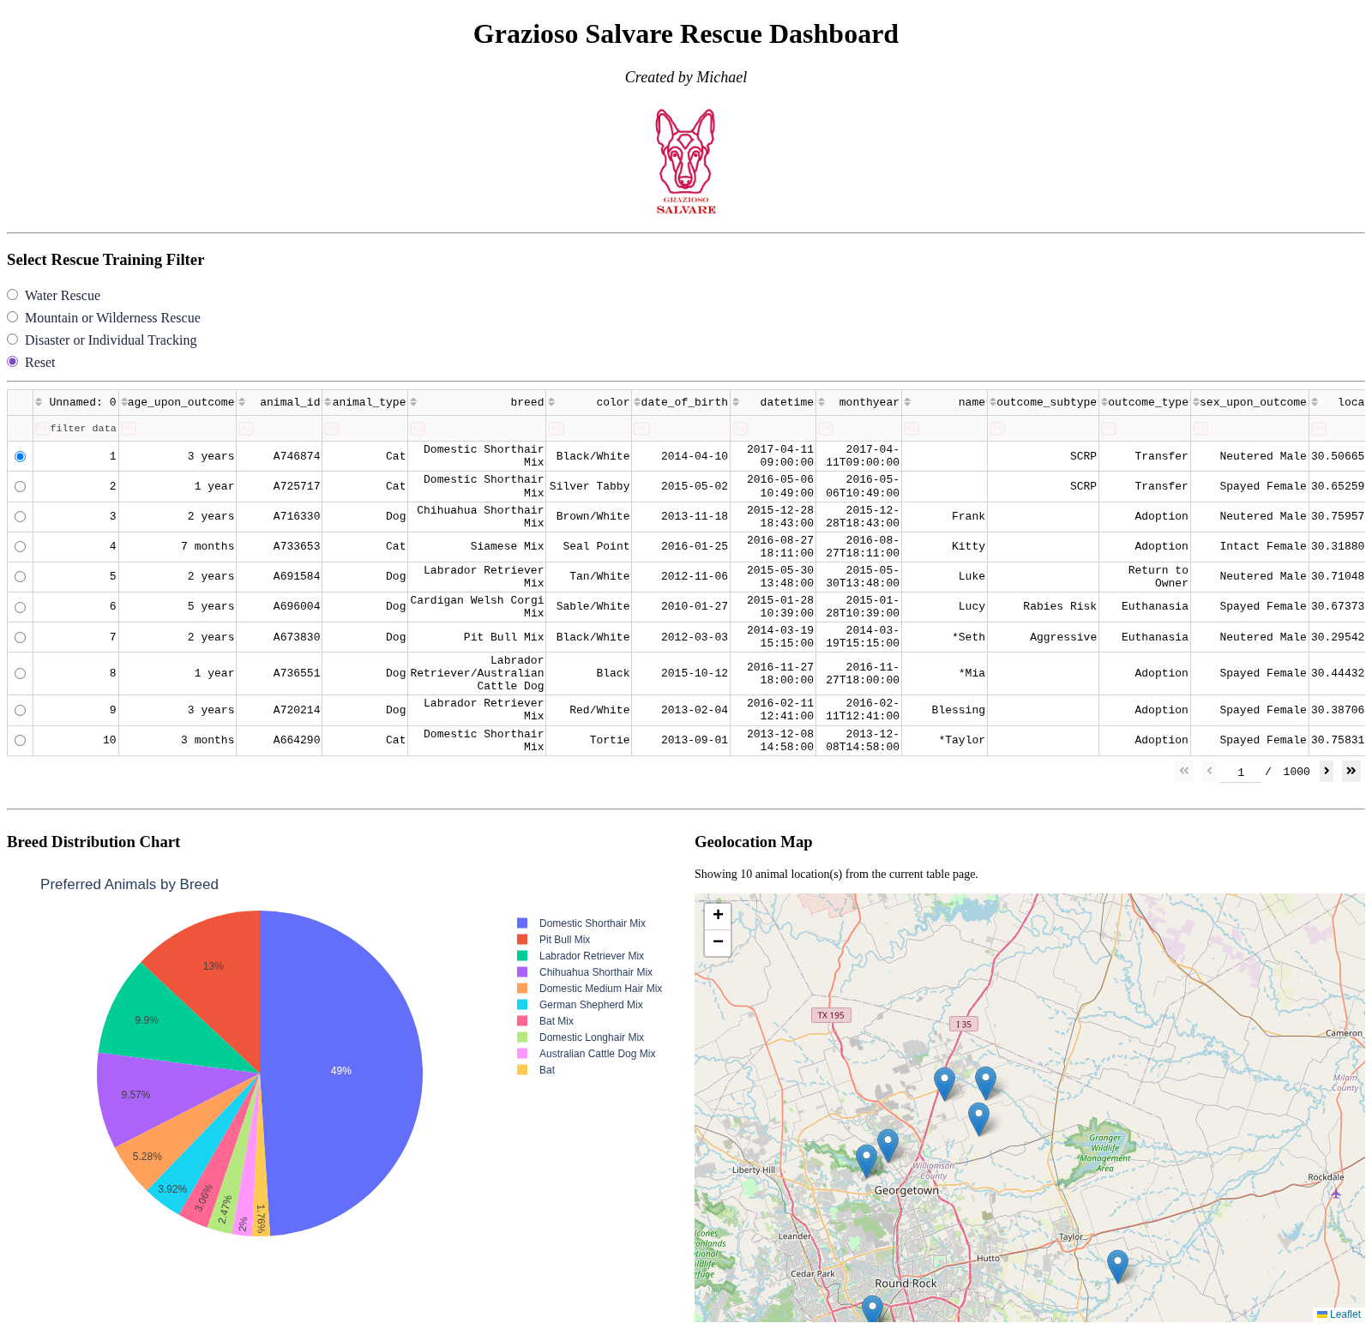

Water Rescue Filter
Dashboard filtered to dogs suitable for water rescue training.
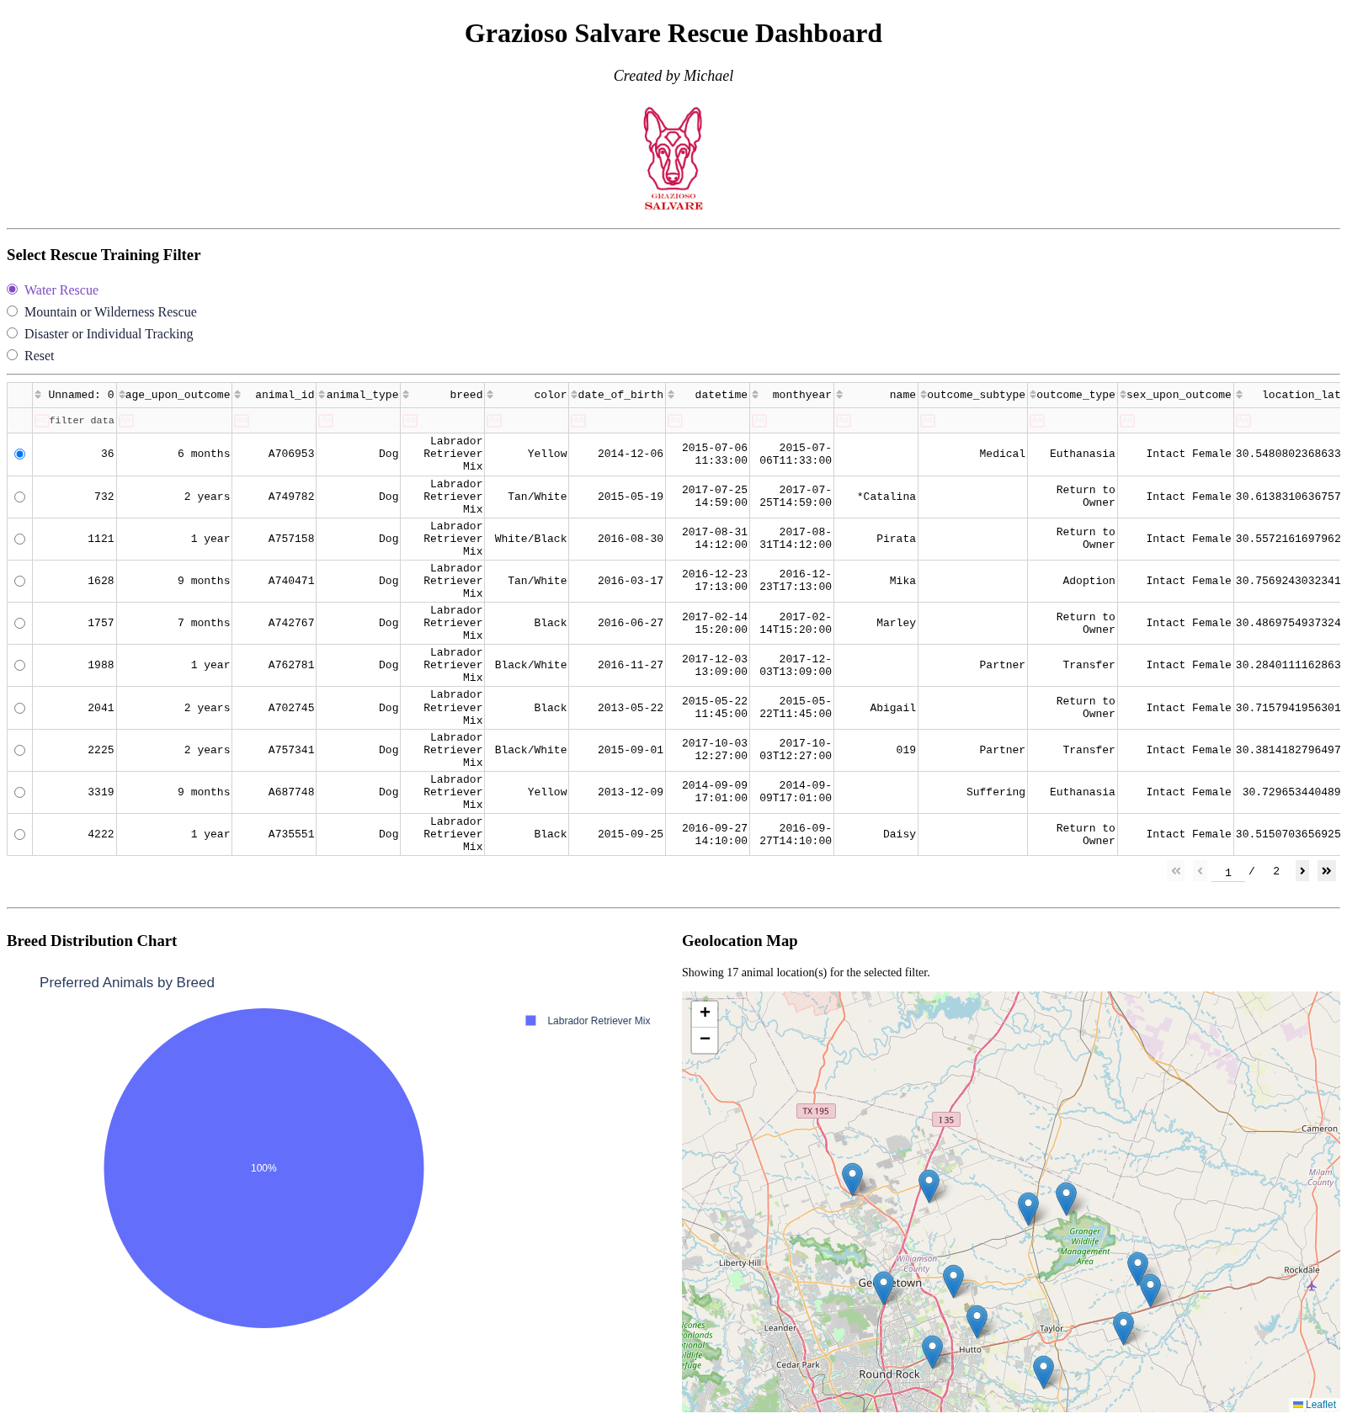

Mountain or Wilderness Rescue Filter
Dashboard filtered to dogs suitable for mountain or wilderness rescue training.
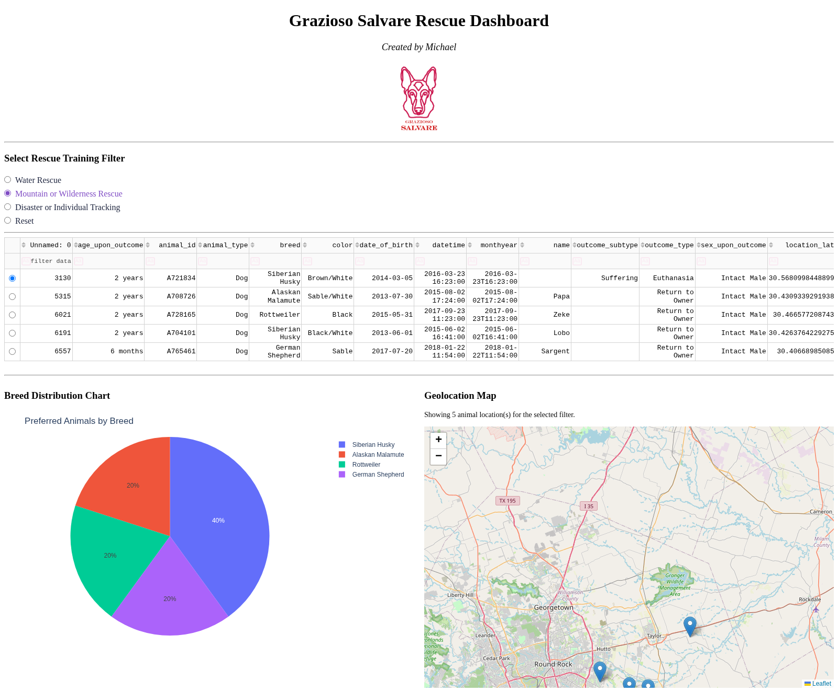

Disaster or Individual Tracking Filter
Dashboard filtered to dogs suitable for disaster or individual tracking training.
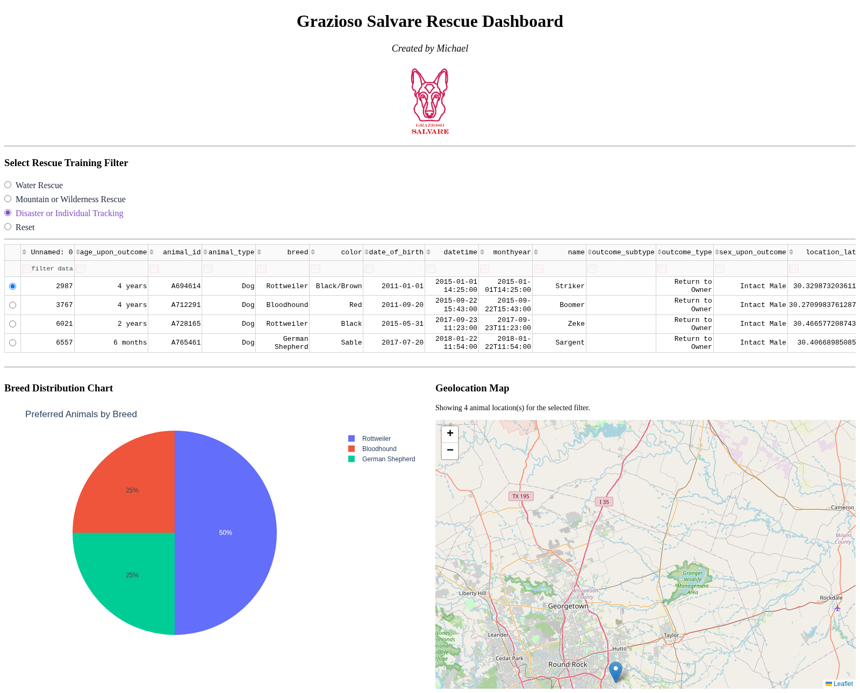

Reset Filter
Dashboard returned to the original unfiltered state.
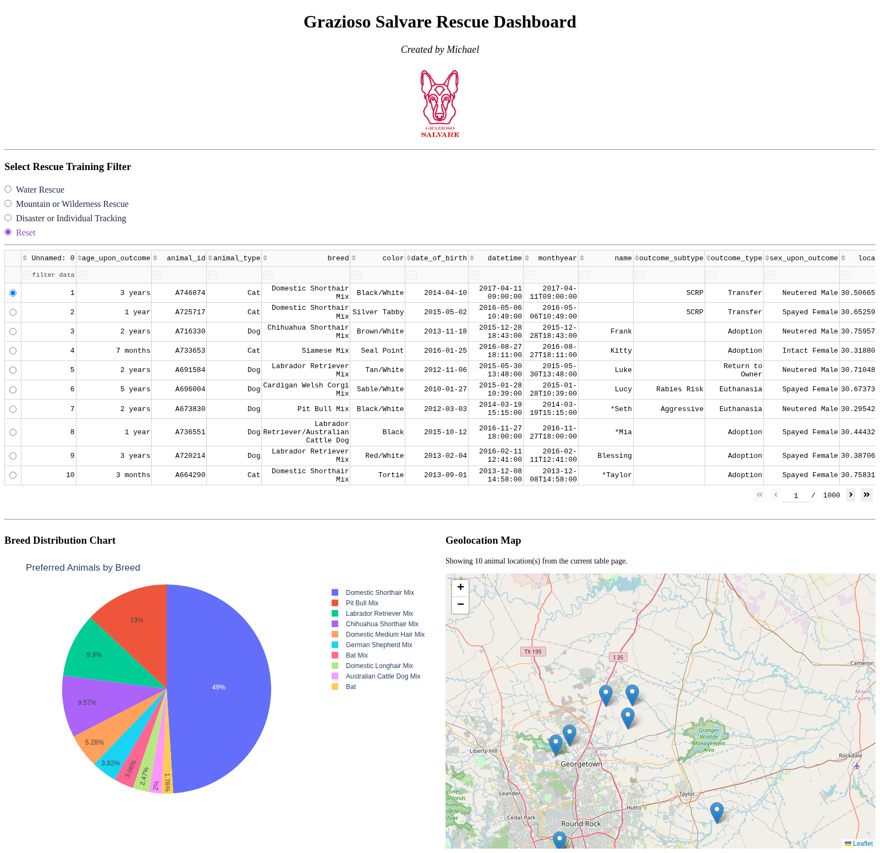

Tools and Rationale
MongoDB was selected as the model component because it stores the Austin Animal Center outcomes as flexible JSON documents. This makes it straightforward to query by breed, sex, and age fields while integrating cleanly with Python through PyMongo.
The Dash framework provides the view and controller structure for the web application. Dash Core Components and Dash DataTable create the interactive filtering controls and table, Plotly Express powers the pie chart, and Dash Leaflet renders the geolocation map.
Primary resources and software used:
- MongoDB - https://www.mongodb.com/
- PyMongo - https://pymongo.readthedocs.io/
- Dash - https://dash.plotly.com/
- Plotly - https://plotly.com/python/
- Dash Leaflet - https://dash-leaflet.com/
- Pandas - https://pandas.pydata.org/
- JupyterDash - https://github.com/plotly/jupyter-dash

Steps Taken to Complete the Project
- Reviewed the Project Two guidelines and Dashboard Specifications Document.
- Configured MongoDB and imported the Austin Animal Center outcomes CSV into the aac.animals collection.
- Developed rescue-specific MongoDB filter queries in the dashboard controller and called them through the Project One CRUD read() method.
- Built the Dash dashboard layout with logo, unique identifier, filters, data table, pie chart, and map.
- Implemented controller callbacks so all widgets update when a rescue filter is selected.
- Tested each filter option and captured screenshots for the README.
- Packaged the notebook, CRUD module, logo, and README into the submission zip file.

Reproduction Instructions
1. Install Python 3 and MongoDB. Ensure MongoDB is running on localhost:27017.
2. Create a virtual environment and install dependencies:
pip install pymongo dash jupyter-dash dash-leaflet plotly pandas
3. Import the provided CSV into MongoDB and create the aacuser account with password SNHU1234.
4. Place Grazioso Salvare Logo.png in the same directory as ProjectTwoDashboard.ipynb.
5. Open ProjectTwoDashboard.ipynb in JupyterLab and run all cells, or execute run_dashboard.py.
6. Use the radio buttons to test Water Rescue, Mountain or Wilderness Rescue, Disaster or Individual Tracking, and Reset.

Challenges and Solutions
MongoDB authentication required authSource=admin in the CRUD connection string after creating the aacuser account.
The dashboard specification required precise breed, sex, and age range filters. These were implemented using the Rescue Type and Preferred Dog Breeds table and the age_upon_outcome_in_weeks field.
Dash API changes in newer versions replaced run_server() with run(), which was updated in the notebook and test runner to ensure successful deployment.
Map and chart callbacks were connected to derived_virtual_data so the visualizations respond to both database filters and table-level sorting or paging.

AI Usage Acknowledgment: Generative AI tools were used to assist with project setup, code completion, documentation drafting, and screenshot automation. All output was reviewed and validated against the project rubric.

