**Functional Document for Ratings and Reviews**

**Technologies Used:**

**AngularJS1.5, HTML5, CSS3, JSON, SCSS, Gulp, local Storage, AJAX in Angular**

**Product Title:**



**Overall Rating and Sorting:**



1. This Stars are not clickable it’s just read only and showing the overall ratings. It is calculated as below,

Average stars out of 5 = number of stars selected by all the users (per user max 15) / no of users * 3

1. Average stars out 5 in numbers (we make it round )
2. Displaying number of users did ratings and reviews.
3. Sorting option to guest. By default “most recent” option will be displayed. Other options are “most helpful”, “highest first”, “lowest first”

**Users bucket based on stars:**

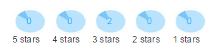

We are displaying the count based on users interest from 0 -5 stars. This is dynamically update based on user ratings.

**Ratings and Review Section:**

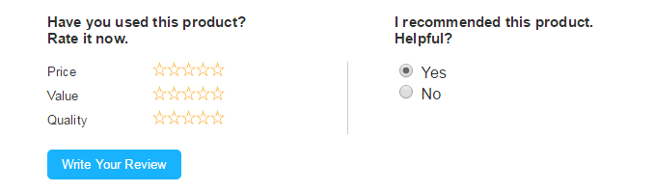

We created stars rating option for three category like Price, Value and Quality. Stars are selectable user can sect the star option here. Also the right side helpful option is provided by default “Yes” options is selected. When click the “Write Your Review” button model overlay will open and show the options to write the user comments. Model overlay image is mentioned below.

Note: If you select the stars here overlay also need to select the stars again, this is known issue ☹

**Model Overlay:**

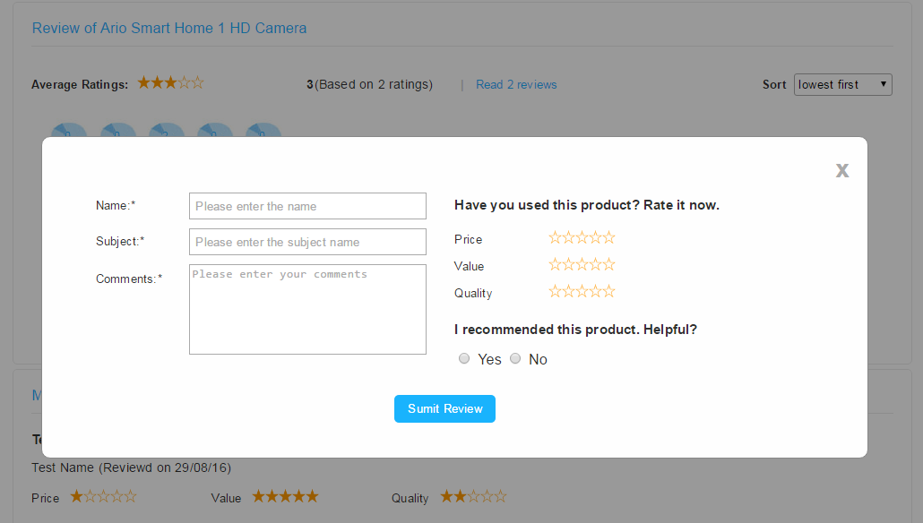

The above overlay will display once the user click the “Write your review” button. We are collecting the below informations from the guest.

1. Name: We are collecting user name (validation is added it is mandatory field).
2. Subject: This is one-liner comment about the product we are displaying this as bold text on view.
3. Comments: This is the detailed comments section which will display on the page.
4. Price, Value and Quality Rating stars are available to select.
5. Helpful suggestion option.
6. Close link will close the model without storing the data.

When user clicks the Submit button, data’s are updated with existing comments data.

**View Comments:**

View Section will display the complete comments and rating lists based on “most recent” first order. Below image is for view comments section. Stars are static user can’t change it in view section

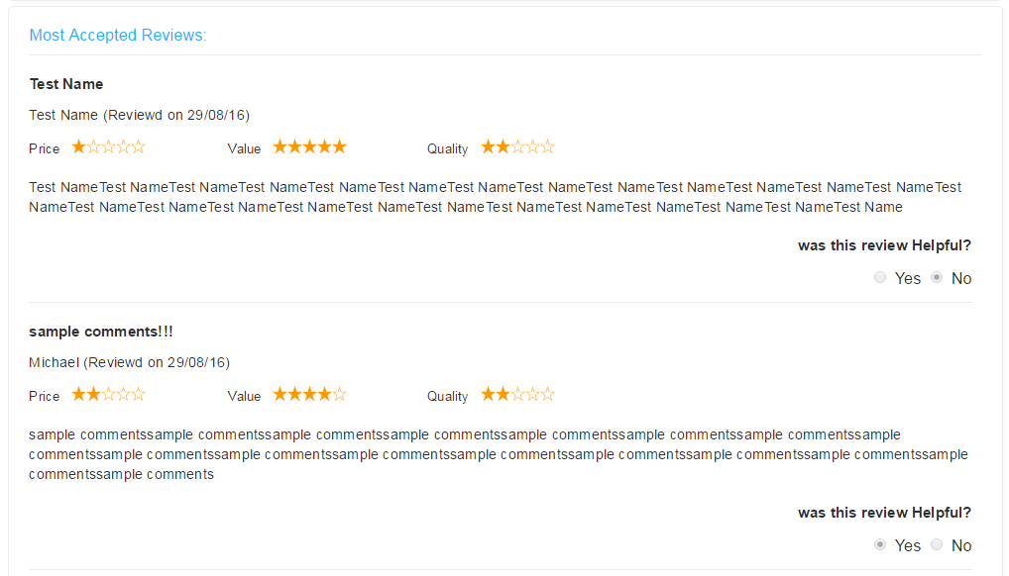

**Reusable Star ratings:**

We created the reusable code for star rating section, created angular directive for star rating section.

Same directive only used for entire site, which is differentiated through parameters.



In the above image we set read-only=”true” so this won’t be editable, used this for overall ratings and users’ comments view.

Price, Value and Quality ratings:

We called the same code with different parameters to achieve the user’s stars

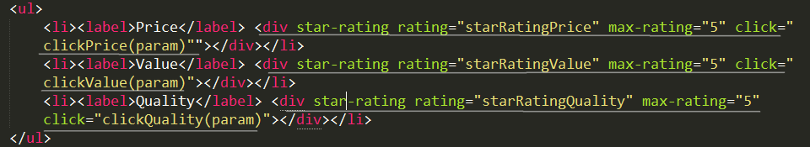

While clicking the star we trigger the ClickPrice, clickValue, ClickQuality method to store the star count values. We set it max-rating = 5 because we need 5 starts max to display, this is dynamic we can change the number to ‘n’ then it will show the n stars.

We kept the home page view, model view and star ratings view separately.

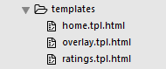

**Storing Data:**

JSON File: We stored all the site static text into the JSON file and refer the json inside the page because of this we can control all the site content in single place and without affecting other pages.

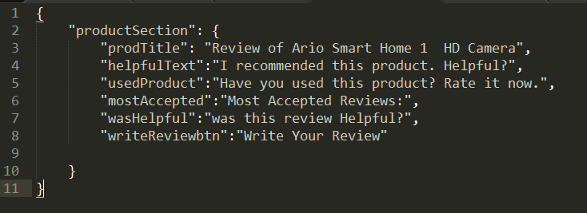

**Comments and Rating Storage:**

We used HTML5 localStorage to store all users’ comments and ratings. We are retrieving the data from localstorage and displaying it on the comments view section.

Browsers: Chrome, Firebox, IE and Safari

Devices: iPad, Galaxy S5, Nexus 5X, Nexus 6P, iPhone5, iPhone6, iPhone 6+

(I am not validated ine real devices, through online extensions validate.)

**Site Directory Structure:**

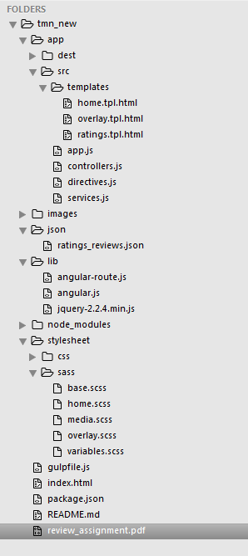

**Screenshot from devices:**

