**User Manual for Ratings and Reviews**

**Technologies Used:**

**AngularJS1.5, HTML5, CSS3, JSON, SCSS, Gulp, local Storage, AJAX in Angular**

**How to setup this Project?**

**Step 1:** Need to keep the code in local server root directory (Ex: for wamp C:\wamp\www)

**Step 2:** In command prompt do run npm install (it may take some time to install, we included all the necessary packages in package.json file while installing this will refer our package.json file)



**Package.json file:**

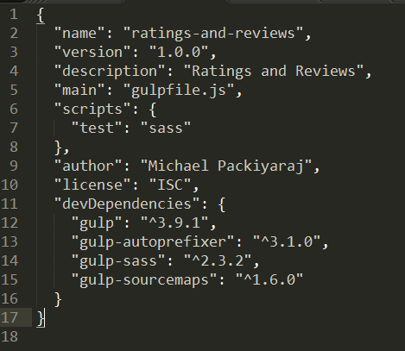

**Step3:** Now need to run the “gulp” task to trigger the build which convert the scss files to css file. We used only base.css file for site. All other files are merged and updated in base.css through gulp.



We created gulp default build so whenever any file changes happened it will run automatically no need to run gulp every time. Blow image is shows the gulp auto build message list.

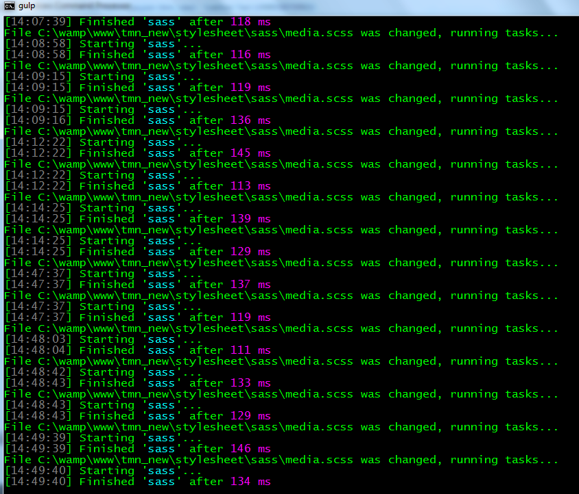

Once Gulp build is triggered you can see the site in the browser. Site path <http://localhost/tmn_new/>

Note: Initially there won’t be any comments view to display in the page bottom. First need to write a review then only we can see the review. So once you see the pages in the Browser need click the “Write your review” and add your ratings and comments.

Once you added few comments then you can do all Sorting, Overall star ratings, user count for respective stars etc…