**Assignment Instructions**

Homework 02 - Javascript and Validation

Read this entire homework description once through before proceeding.

**Required Reading**

* Chapters 4 & 5 from book (Modern Javascript: Develop and Design)

**Task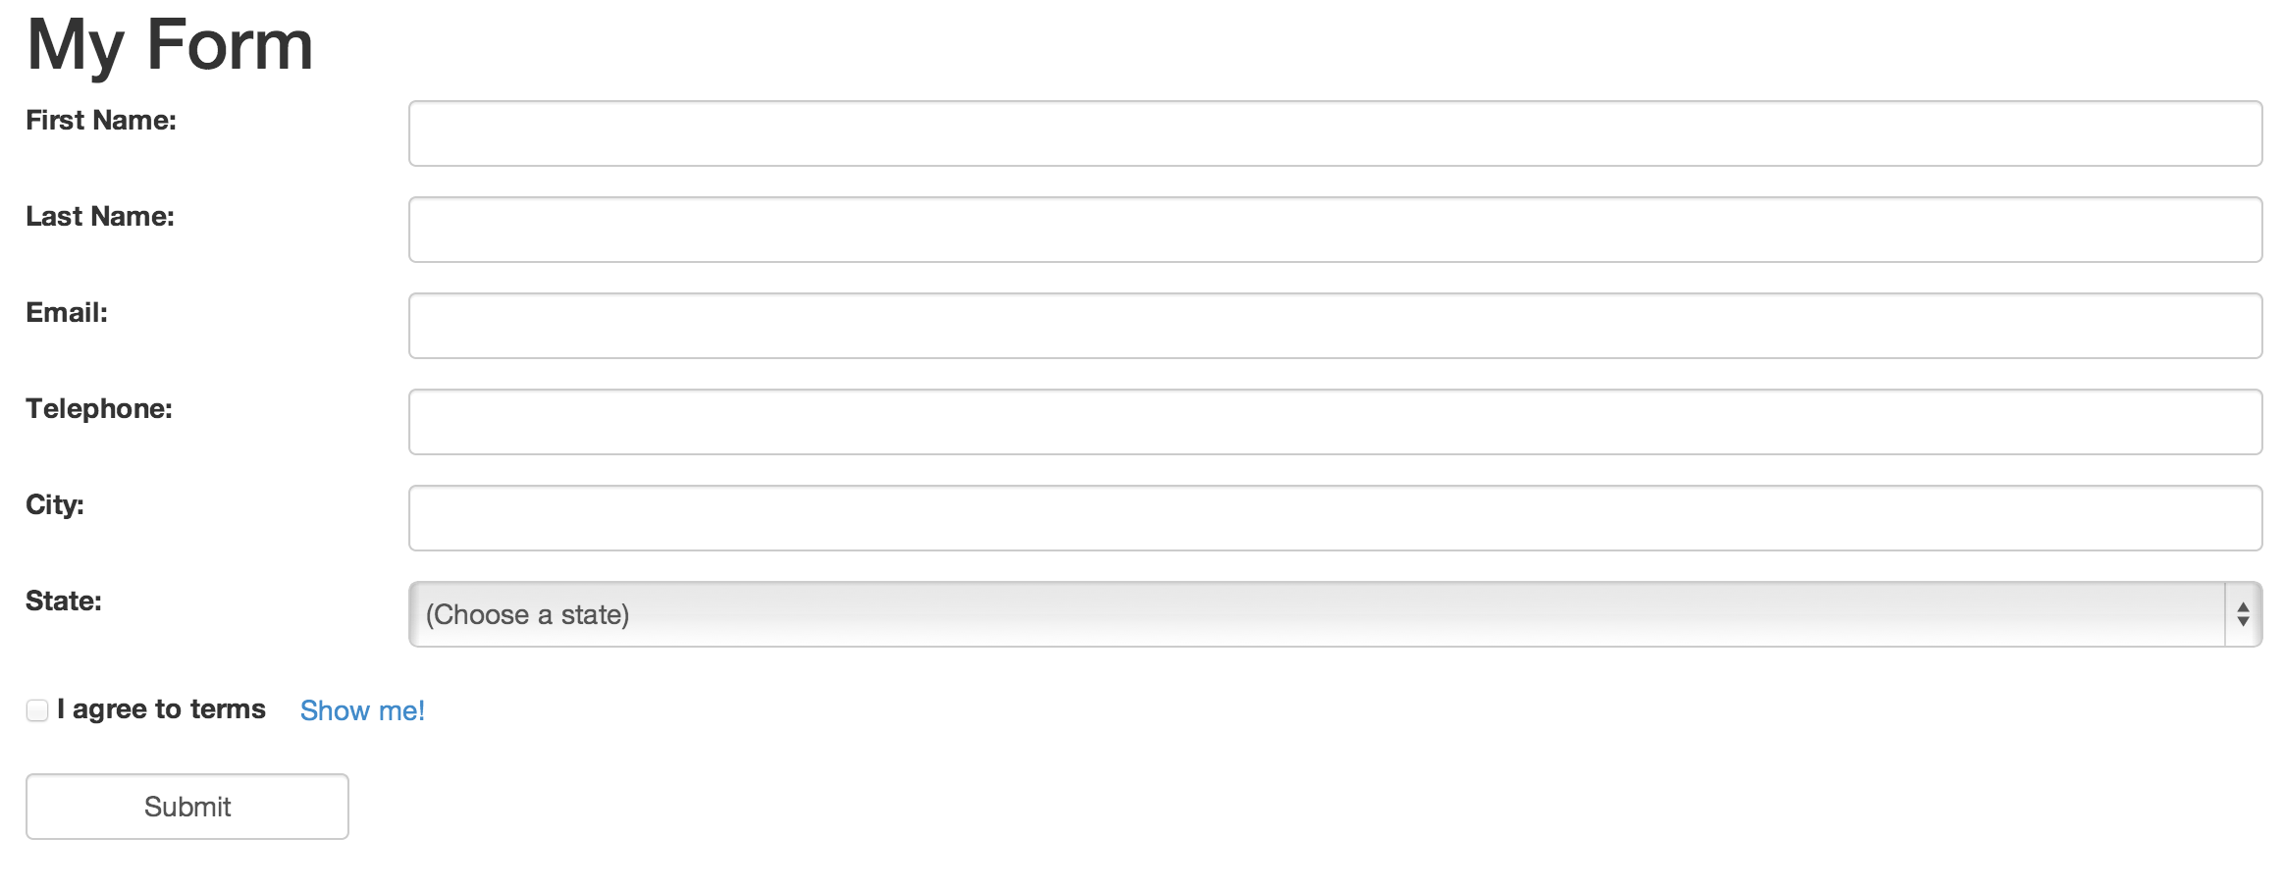  
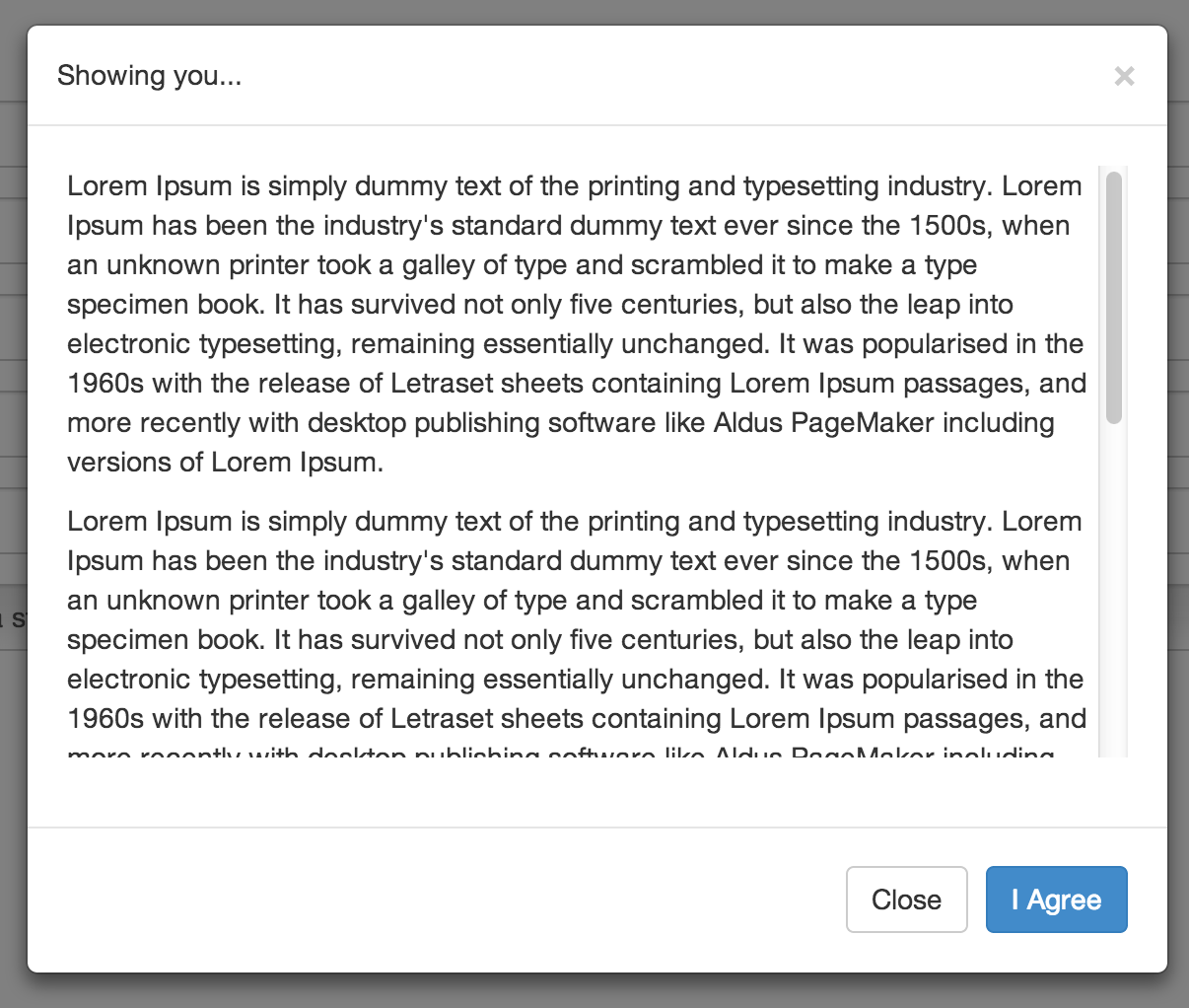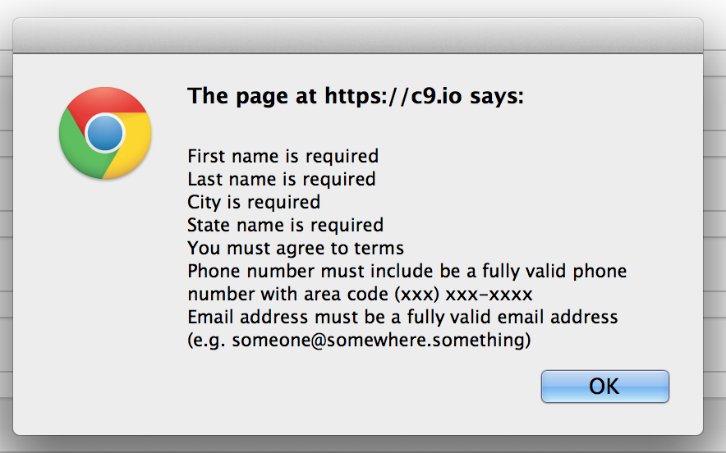**You will be creating a form with validation and an agreement to a “Terms of Service” functionality.  Please perform the task in a working Cloud 9 project and provide a 1-page write-up explaining IN BRIEF SENTENCES what techniques you used to implemented the following and why: validation, terms of service checkbox behavior, and the modal dialog popup.

Creating the form should have the following fields:

* first name (single-line text box)
* last name (single-line text box)
* email address (single-line text box)
* telephone (single-line text box)
* city (single-line text box)
* state (select list, i.e. dropdown)
* agree to terms of service (checkbox)
* submit button (type=”submit”)

Additional information regarding “agree to terms of service”:

* There should be a link/button next to the “agree to terms of service” checkbox that makes a modal dialog box appear, displaying the terms of service
* The checkbox itself should be disabled by default until you have viewed the terms of service at least once
* The “accept” button in the modal dialog box should cause the “agree to terms of service” checkbox to be checked.
* Either clicking on the link to open, or clicking the button to close the model dialog box should cause the “agree to te[rms of service” checkb](http://www.lipsum.com/" \t "_blank)ox to be enabled.

The terms of service modal dialog box should contain:

* A header with an appropriate title for the dialog
* A few paragraphs of text that would represent some sort of agreement (the text itself doesn’t matter, try getting some text at [http://www.lipsum.com/](http://www.lipsum.com/" \t "_blank))
* A footer with:
  + A button to close the dialog
  + A button to accept the terms of agreement.

The form must be validated and behave accordingly when attempting to submit:

* The following fields are simply required (should not allow blank spaces either):
  + first name, last name, city, state
* The email address is a valid address (note: this needs to have reasonable validation, not perfect validation to email address specifications)
* The telephone number is a valid U.S. phone number (10 digits with area code, allows dashes or parentheses and space for area code)
* The checkbox for “agree to terms of service” is checked
* If the form is “invalid”, show show an alert box explaining to the user what is wrong with the form and what fields have invalid data.  The form should not complete the submission if the data is invalid.

**Extra credit for:**

* Making the terms of service agreement text fit into the modal dialog so that it scrolls itself inside the box, rather than causing the entire dialog to scroll on the page.  That is, the dialog box should fit entirely within the browser, and only the terms text should scroll.  The terms text must be long enough to scroll.

**Restrictions**

Perform this task while only using Bootstrap components and simple JavaScript (i.e. built-in components to JavaScript.  The specific jQuery events from Bootstrap for the modal dialog are allowed.

**Grading Criteria**

* 9-10 points
  + All form elements are visible as described; layout is appropriate and readable, has well-defined labels, and elements/labels make sense; agree to terms link opens up dialog; dialog is well-formatted and has distinctly marked and intuitively designed buttons; field validation functions as described; validation alerts clearly explain each validation error when the form is invalid; validation code is a clearly defined function and has neat/orderly code and code formatting; terms of service modal dialog behavior functions as described
* 7-8 points
  + All form elements are visible as described; layout is appropriate and readable, has labels; agree to terms link opens up dialog; dialog contains all elements as described; most validation functions as described; validation alerts are given when data is invalid upon form submission; some functionality with terms of service modal dialog behavior may not function correctly
* 5-6 points
  + Most elements are visible as described; Layout may have design and formatting issues or be messy; agree to terms link opens up dialog; dialog contains; field validation functions as described; most validation validation alerts function correctly upon form submission; some functionality with terms of service dialog may not function correctly
* +1 for extra credit
  + You are able to use only twitter bootstrap components to build:
    - Terms text that scrolls within the dialog, allowing the dialog box to fit entirely within the browser.

**Handing in Your Work**

* Please attach your write-up as an MS Word or PDF document to your homework submission in Sakai.
* Also, please provide the URL to your public project in Cloud 9.
  + Note: DO NOT make changes to your project after your submission or the deadline.  If you want to continue experimenting, make a clone of your project.