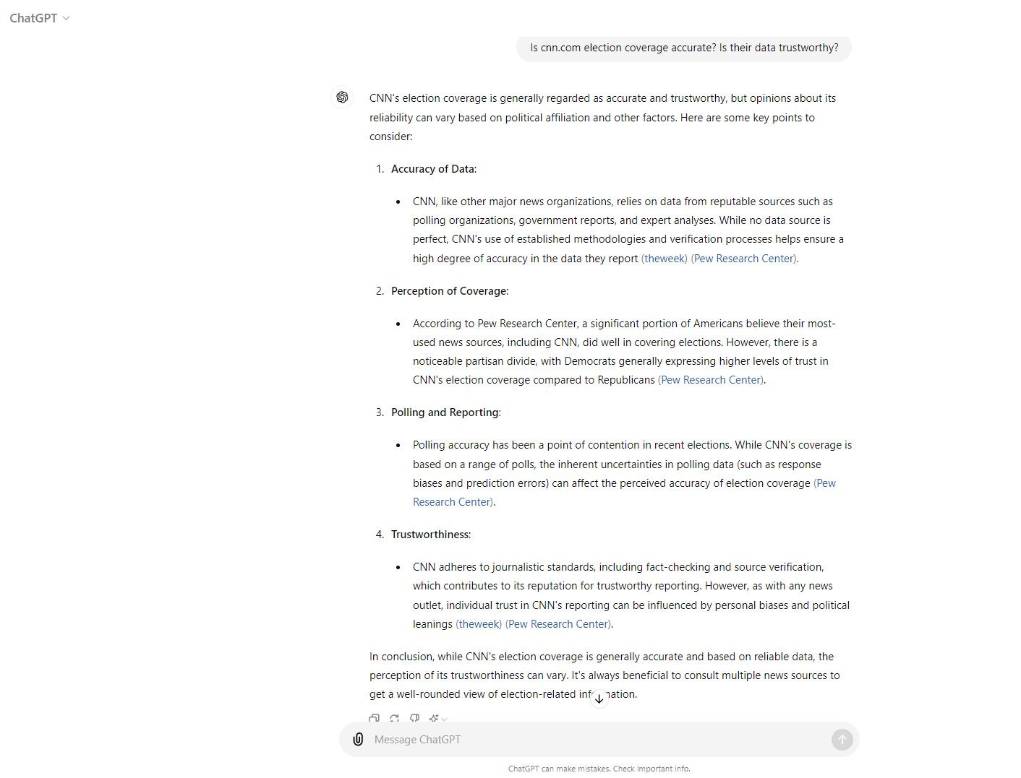



CHATGPT SCRIPT:

User Input: Is cnn.com election coverage accurate? Is their data trustworthy?

ChatGPT Response:

CNN's election coverage is generally regarded as accurate and trustworthy, but opinions about its reliability can vary based on political affiliation and other factors. Here are some key points to consider:

1. \*\*Accuracy of Data\*\*:

- CNN, like other major news organizations, relies on data from reputable sources such as polling organizations, government reports, and expert analyses. While no data source is perfect, CNN's use of established methodologies and verification processes helps ensure a high degree of accuracy in the data they report【9†source】【10†source】.

2. \*\*Perception of Coverage\*\*:

- According to Pew Research Center, a significant portion of Americans believe their most-used news sources, including CNN, did well in covering elections. However, there is a noticeable partisan divide, with Democrats generally expressing higher levels of trust in CNN's election coverage compared to Republicans【11†source】.

3. \*\*Polling and Reporting\*\*:

- Polling accuracy has been a point of contention in recent elections. While CNN's coverage is based on a range of polls, the inherent uncertainties in polling data (such as response biases and prediction errors) can affect the perceived accuracy of election coverage【10†source】.

4. \*\*Trustworthiness\*\*:

- CNN adheres to journalistic standards, including fact-checking and source verification, which contributes to its reputation for trustworthy reporting. However, as with any news outlet, individual trust in CNN's reporting can be influenced by personal biases and political leanings【9†source】【11†source】.

In conclusion, while CNN's election coverage is generally accurate and based on reliable data, the perception of its trustworthiness can vary. It's always beneficial to consult multiple news sources to get a well-rounded view of election-related information.

SOURCES USED:

9†source : <https://theweek.com/politics/2024-election-polls-accuracy>

10†source : <https://www.pewresearch.org/short-reads/2022/09/21/does-public-opinion-polling-about-issues-still-work/>

11†source : <https://www.pewresearch.org/journalism/2020/12/15/americans-generally-approve-of-their-news-sources-election-coverage-but-republicans-less-so-than-democrats/>