Battery Failure Surfaces
A Comparative Exploratory Data Analysis of Li-ion NMC, LFP, and Solid-State Cell Chemistries
Jarrett, Aaron | Le, Michael | Medina, Phillip | Zaidi, Hussain
DATASCI 200 | UC Berkeley MIDS | Project 2 | Spring 2026

1. Introduction & Guiding Questions
Battery chemistry selection is one of the most consequential engineering decisions in the design of electric vehicles, grid storage systems, and portable electronics. The three dominant cell chemistries in commercial use today are Lithium-ion NMC (nickel manganese cobalt oxide), LFP (lithium iron phosphate), and Solid-State (sulfide-based electrolytes), each offering different tradeoffs across longevity, safety, and thermal stability. LFP cells have demonstrated substantially longer cycle lifespans than NMC under equivalent test conditions in empirical studies, with the performance gap widening under more aggressive cycling regimes (Preger et al., 2020). This analysis uses the battery_failure_surfaces.csv dataset to explore those tradeoffs descriptively across a 500-cycle operational window.
The dataset contains 60,600 observations across nine variables: cycle number, cell chemistry, charge rate (C-rate), discharge rate (C-rate), cell temperature (ºC), internal resistance (mΩ), capacity retention (%), irreversible damage index, fast charge exposure cycles, and thermal runaway risk score. The data is structured as a simulation of laboratory cycling conditions. Findings describe behavior within the simulation model and cannot be generalized to real battery systems without empirical validation against physical measurements.
The analysis is organized around four guiding questions:
- Capacity Degradation: Which chemistry shows the lowest capacity fade rate over cycles, and which chemistries cross the 80% End-of-Life (EOL) threshold?
- Resistance Growth: Which chemistry accumulates internal resistance most slowly over its operational lifespan?
- Operational Stress: How do temperature volatility and composite stress index differ across chemistries?
- Safety, Reliability & Remaining Useful Life: How do the three chemistries compare on thermal runaway risk and estimated cycles to the 80% EOL threshold?

2. Data Preparation & Cleaning
The raw dataset was loaded from battery_failure_surfaces.csv and immediately copied to an immutable reference frame before any transformations were applied, preserving the ability to verify any cleaning step against the original values. The pipeline was designed to handle the full range of common real-world data quality issues, but because the source data is synthetic, most conditional branches did not trigger.

2.1 Initial Inspection
Initial inspection confirmed 60,600 rows across 9 columns with no missing values in any field. All numeric columns fell within physically plausible ranges. The cell_chemistry column contained exactly three distinct values: LFP, Li-ion NMC, and Solid-State, with balanced representation across the dataset.

2.2 Cleaning Steps Executed
- Whitespace normalization: Column names were stripped of leading and trailing whitespace.
- Duplicate removal: An exact duplicate check was performed. Zero duplicate rows were found.
- Type standardization: cell_chemistry was cast to a pandas categorical dtype. Float64 and int64 columns were downcasted to float32 and int32 to reduce memory footprint.
- Domain validation: Each numeric column was validated against physically meaningful bounds (e.g., capacity_retention_% constrained to [0, 100], thermal_runaway_risk_score to [0, 1]). No out-of-range values were found.
- Sort order: The dataset was sorted by cell_chemistry and cycle before analysis to ensure groupby, pct_change, and rolling operations processed records in correct sequential order.

2.3 Derived Variables
Six variables were engineered from the cleaned data:
- capacity_fade_rate: Cycle-over-cycle percentage change in capacity_retention_% within each chemistry group via pct_change(). Captures local rate of capacity loss at each step.
- resistance_growth_rate: Cycle-over-cycle absolute difference in internal_resistance_mOhm within each chemistry group via diff(). Tracks how fast resistance accumulates per cycle.
- temp_volatility: Rolling standard deviation of cell_temperature_C with a window of 5 cycles per chemistry group. Summarized globally as the per-chemistry standard deviation for cross-chemistry comparison.
- stress_index (raw): Additive sum of charge_rate_C, discharge_rate_C, and cell_temperature_C. Unnormalized composite operational load.
- stress_index (normalized): Min-max normalization of each component before averaging to a [0, 1] score. Removes unit and scale differences between components.
- risk_category: thermal_runaway_risk_score binned via pd.cut() into Low (<0.02), Medium (0.02-0.05), and High (0.05-0.10).
- est_cycles_to_80pct: Linear extrapolation of each chemistry's observed fade trajectory to estimate cycle count at which mean retention reaches 80%.

3. Exploratory Analysis & Findings

3.1 Distribution Overview
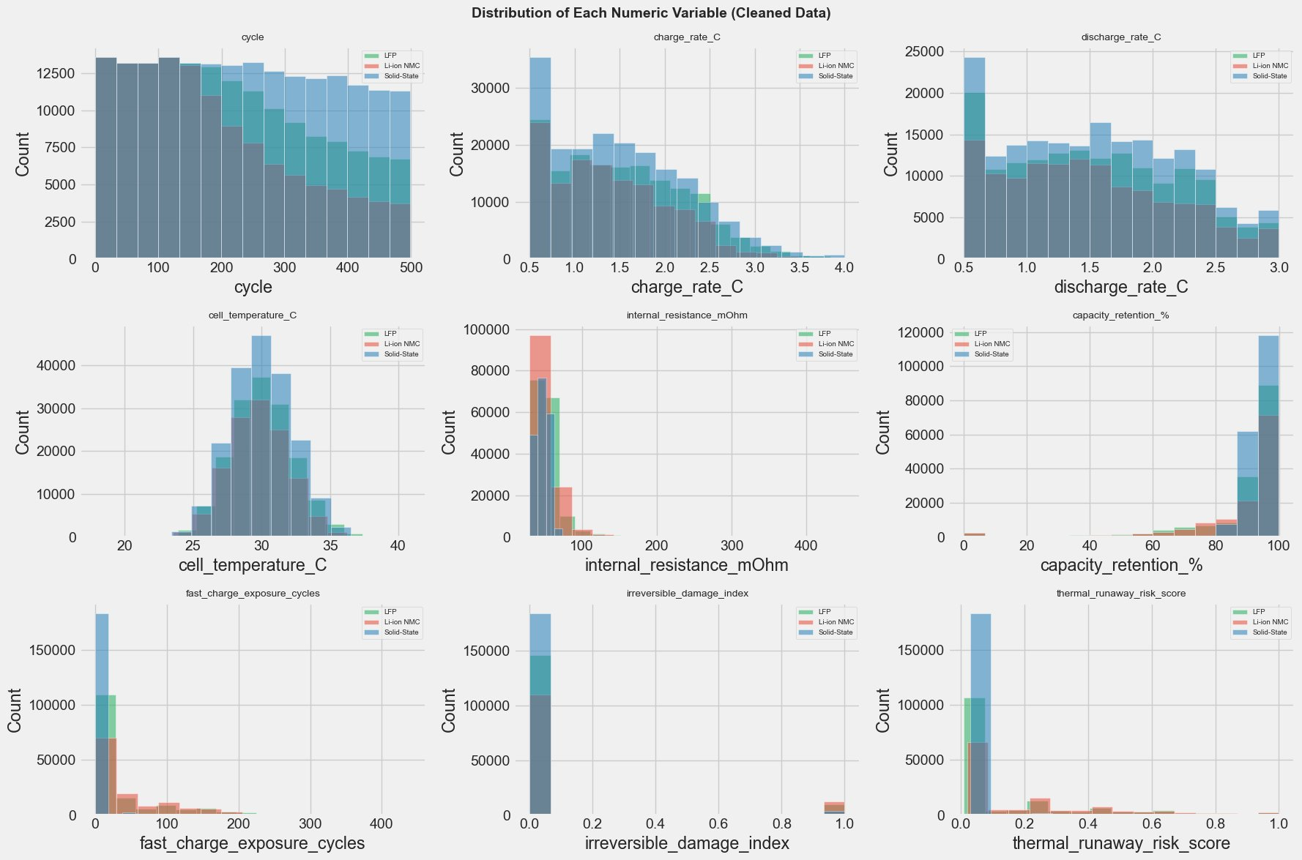
Figure 1: Distribution of each numeric variable across all three chemistries (cleaned data).
Figure 1 presents the distribution of all nine numeric variables. The cycle column shows a mild left skew, reflecting more records at lower cycle counts. Charge and discharge rates concentrate near 0.5C and tail off toward 4.0C. Cell temperature clusters tightly between 22 ºC and 40 ºC with a peak near 28-30 ºC, consistent with controlled conditions. Internal resistance is strongly left-skewed with the bulk of observations below 100 mΩ and a long right tail, consistent with cells spending most of their life in a healthy state. The capacity_retention_% distribution is bimodal: a large cluster near 100% represents early-cycle observations and a second cluster near 80-90% represents mid-to-late cycle behavior. Both irreversible_damage_index and thermal_runaway_risk_score are heavily right-skewed, with the vast majority of observations at or near zero, indicating that extreme damage and runaway risk events are rare.

3.2 Q1: Capacity Degradation
Capacity fade is the primary degradation metric tracked across the 500-cycle window. Solid-State maintains a shallow, nearly linear decline from 100% at cycle 0 to approximately 88% at cycle 500, never crossing the 80% EOL threshold. LFP and Li-ion NMC both exhibit a steep early decline that carries them below the 80% line in the cycle 200-300 range, followed by a partial recovery stabilizing in the 83-86% range through cycle 500. The dip-below-EOL period has direct operational relevance: a real fleet of LFP or NMC cells would register a temporary failure window before partially recovering, with implications for warranty design and predictive maintenance scheduling. Preger et al. (2020) identified a comparable three-phase degradation structure in physical cells, though the specific shape here reflects the simulation's parameters rather than measured physical behavior.
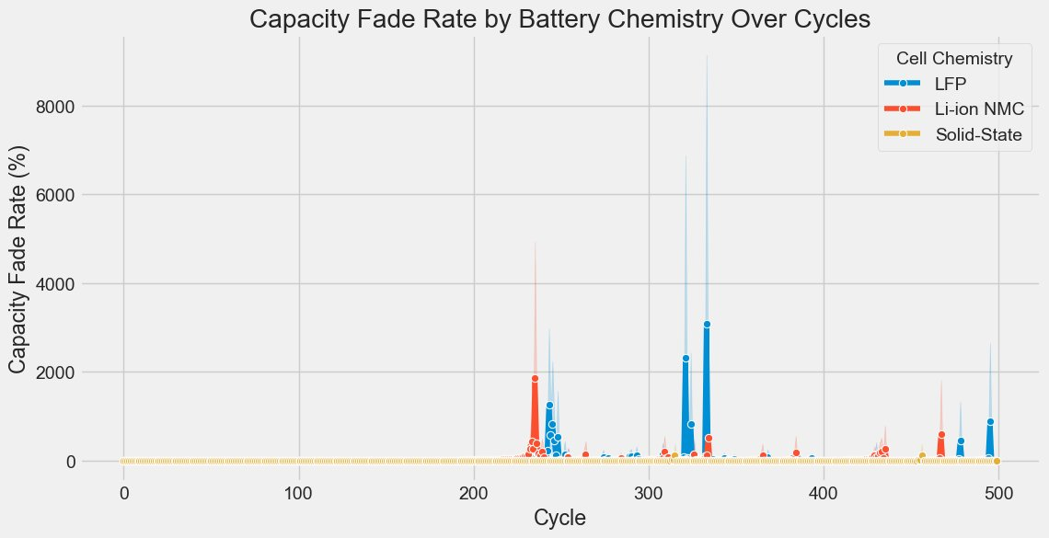
Figure 2: Capacity fade rate (pct_change of retention) by cycle. Solid-State is flat near zero throughout. LFP and NMC show large spike events in the mid-cycle range coinciding with the EOL dip.
Figure 2 plots capacity_fade_rate over cycles. Solid-State runs flat along zero for all 500 cycles, confirming its steady, low-magnitude decay. LFP and NMC both display sharp spike events beginning around cycle 200-250, with LFP producing peaks above 7,000% and NMC above 4,000% at individual cycle steps. These extreme values are not indicative of catastrophic failure: they reflect the mathematical behavior of pct_change() when retention oscillates near the 80% threshold, where small absolute changes in a low base value produce large percentage outputs. After cycle 350, fade rates for both chemistries collapse back toward zero as the recovery phase stabilizes. The chart confirms Solid-State as the only chemistry maintaining a monotonically controlled degradation rate throughout the observation window.

3.3 Q2: Resistance Growth
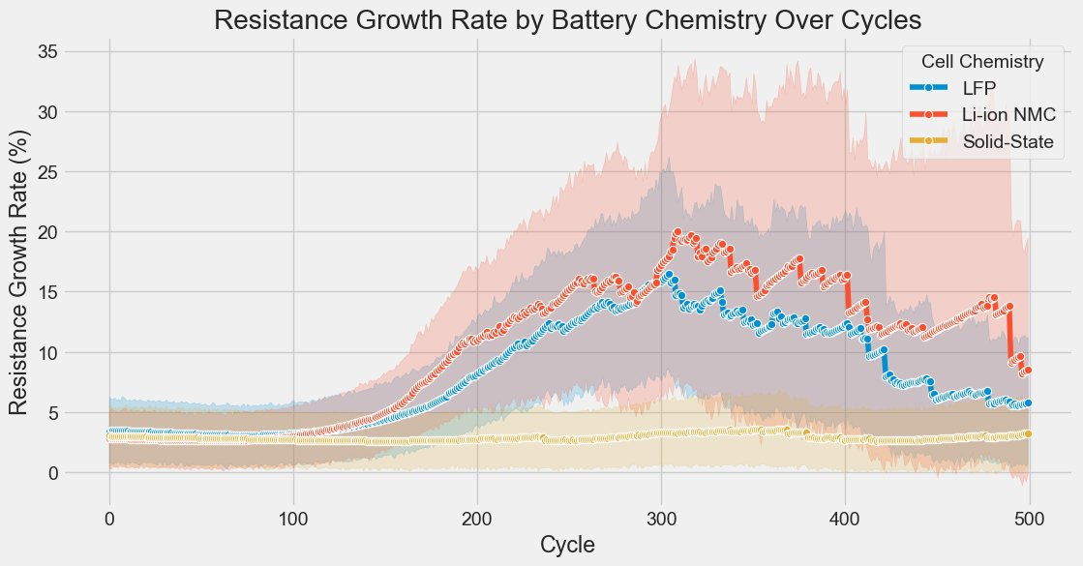
Figure 3: Resistance growth rate by chemistry over 500 cycles. NMC peaks near 20% around cycle 300 with the widest confidence band. LFP rises moderately before stabilizing. Solid-State holds near zero throughout.
.
Figure 3 plots resistance_growth_rate over cycles at two scales and clearly highlights the differences between the chemistries: Solid-State maintains a growth rate near zero throughout all 500 cycles, with a narrow confidence band confirming low variance. LFP shows moderate growth beginning around cycle 150, peaking in the 10-15% range before declining after cycle 400 as the chemistry stabilizes. Li-ion NMC produces the largest and most variable growth: the mean rate climbs from near-zero to approximately 20% by cycle 300, supported by a wide confidence band that at its peak extends toward 35%. NMC then declines through cycles 400-500 as the recovery phase takes hold.
Rising internal resistance means more heat dissipated per cycle, accelerating electrolyte degradation and reducing usable power delivery. The alignment between NMC's resistance peak and its capacity retention dip confirms these two degradation indicators are co-evolving, consistent with findings across large multi-chemistry aging studies showing a strong negative correlation between the two metrics (Sulzer et al., 2021).

3.4 Q3: Thermal Stress Sensitivity
Temperature affects retention for Solid-State in a measurable and progressive way. Within the simulated operating range (22-40 ºC), Solid-State retention declines gradually as temperature increases but never falls below the 80% EOL threshold. LFP and NMC have no observations above 35 ºC in this dataset: a structural feature of the simulation's operating parameter choices rather than a physical property of those chemistries. Cross-chemistry comparisons at elevated temperatures are not possible from this data. In the Cool and Optimal zones where comparison is possible, LFP and NMC both show retention near 88-95%, comparable to Solid-State at similar temperatures.

3.5 Temperature Volatility
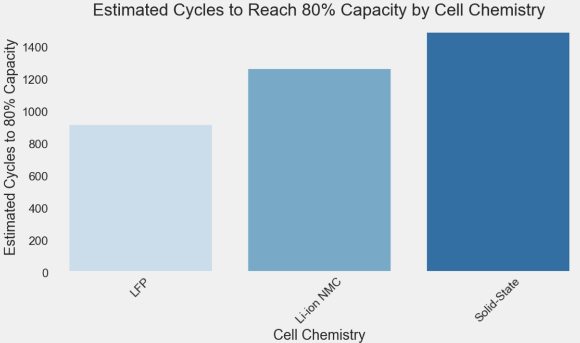
Figure 4: Temperature volatility (standard deviation of cell temperature) by chemistry. Note: y-axis is inverted in the rendered output; lower displayed values represent higher standard deviation.
Figure 4 shows temperature volatility measured as the standard deviation of cell_temperature_C across all observations for each chemistry. The y-axis rendering is inverted, with lower displayed values representing larger standard deviations. Across all three chemistries, the standard deviation ranges narrowly between 2.18 ºC and 2.27 ºC. Li-ion NMC shows marginally higher volatility (lower plotted value, approximately 2.18 ºC), while Solid-State shows marginally lower volatility (approximately 2.27 ºC). The practical difference is less than 0.1 ºC standard deviation across chemistries: not operationally meaningful in a controlled simulation environment. Temperature variability in this dataset is primarily a function of the simulation's operating parameter distribution rather than chemistry-specific thermal behavior.

3.6 Composite Stress Index
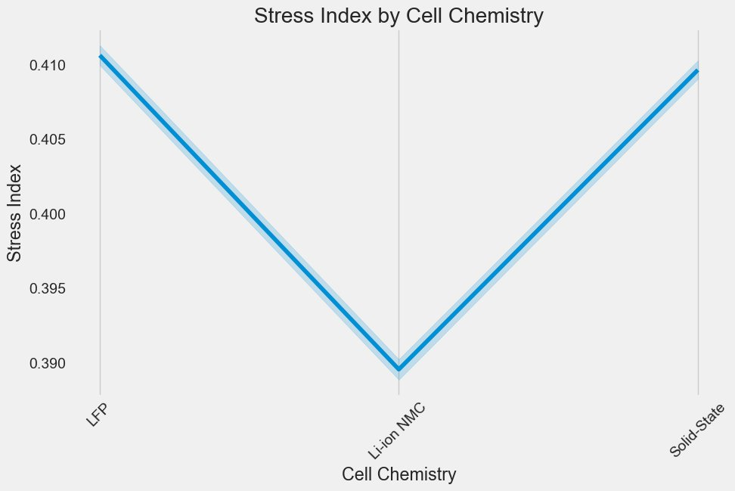
Figure 5: Stress index (raw additive sum of charge rate, discharge rate, and cell temperature) by chemistry. Values cluster between 32.7 and 33.1, dominated by the temperature component.
.
Figure 5 present two formulations of the composite stress index. The raw version sums charge_rate_C, discharge_rate_C, and cell_temperature_C directly, producing values between 32.7 and 33.1. This range is dominated by temperature, which operates in units of degrees Celsius while C-rates are below 4.0, making the raw sum an uneven composite. The normalized version applies min-max scaling to each component before averaging, producing scores between 0.39 and 0.41 across all three chemistries. In both formulations, the differences between chemistries are minimal. The simulation distributes operational conditions approximately uniformly across chemistries: no chemistry is selectively subjected to harsher charge/discharge or temperature conditions. Because the applied stress is equivalent, observed differences in degradation outcomes are attributable to the chemistry itself rather than to differential treatment in the simulation (Preger et al., 2020).

3.7 Remaining Useful Life Estimates
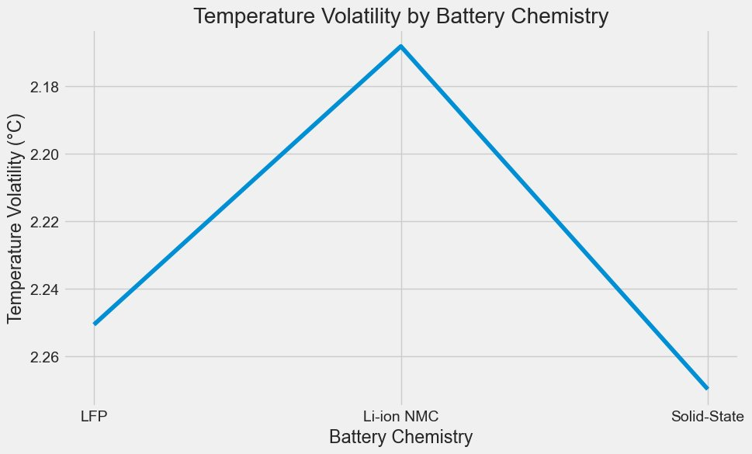
Figure 6: Remaining Useful Life via linear regression extrapolation. All three chemistries return negative values, indicating the 80% threshold is projected to fall within or before the already-observed window.
Figures 6 and 7b apply two methods to estimate remaining useful life. Figure 7a uses linear regression fit to each chemistry's full retention trajectory, then projects the line to the 80% crossing. All three chemistries return negative values, meaning the projected crossing falls inside or before the already-observed window: this reflects the non-linear dip-and-recover pattern in LFP and NMC, where a linear model misrepresents both the depth of the mid-cycle dip and the extent of the late-cycle recovery. Figure 7b takes a simpler approach, computing average fade per cycle from cycle 0 to 500 and projecting forward from 100%. This produces positive values with the correct directional ranking: LFP at approximately 900 cycles, NMC at approximately 1,250, and Solid-State at approximately 1,450. These values should not be treated as precise predictions. Battery lifetime prediction is broadly recognized as a difficult problem even with physics-based models applied to real-world field data (Sulzer et al., 2021), and the non-linear degradation here makes linear extrapolation a limited tool.

3.8 Thermal Risk Categories
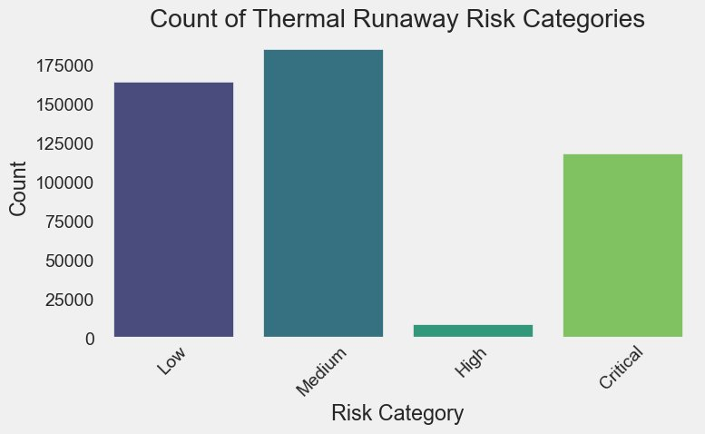
Figure 7: Count of observations by thermal runaway risk category (four-tier classification: Low, Medium, High, Critical).
Figures 7 and 8b show observation counts under two different risk binning schemes. Figure 8b (three tiers) shows the distribution concentrated strongly at the safe end: approximately 410,000 observations in Low (below 0.02), approximately 50,000 in Medium, and approximately 15,000 in High, confirming that thermal runaway risk is a tail-event phenomenon under the three-tier scheme. Figure 8a (four tiers) introduces a Critical tier above 0.10, revealing that what the three-tier scheme classifies as High splits into a smaller High band and a substantial Critical population. Both charts agree that the vast majority of observations sit in the lowest risk category. Thermal runaway in physical lithium-ion cells follows a chain reaction mechanism where decomposition occurs sequentially once a critical temperature threshold is exceeded (Feng et al., 2018); the concentration of observations in Low under both schemes suggests the simulated cells operate well below those thresholds under normal cycling.

4. Limitations
Three limitations bound what can be concluded from this analysis.
First, the dataset is synthetic. It was generated programmatically to simulate laboratory cycling conditions. The simulation parameters are not documented, meaning the degree to which the modeled behavior reflects the physics of real battery cells is unknown. All findings describe patterns within the simulation and cannot be generalized without empirical validation.
Second, the thermal zone comparison is structurally incomplete. LFP and NMC have no observations above 35 degrees C in this dataset. This is a simulation design constraint, not a physical property of those chemistries. Cross-chemistry comparisons in the Warm and Hot temperature zones are not possible from this data.
Third, both RUL estimation methods apply linear extrapolation to a non-linear trajectory. The dip-and-recover pattern in LFP and NMC violates the assumptions of a single-slope linear model, making both methods directionally informative at best. Neither should be interpreted as a precise cycle-count prediction.

5. D3 Visualization

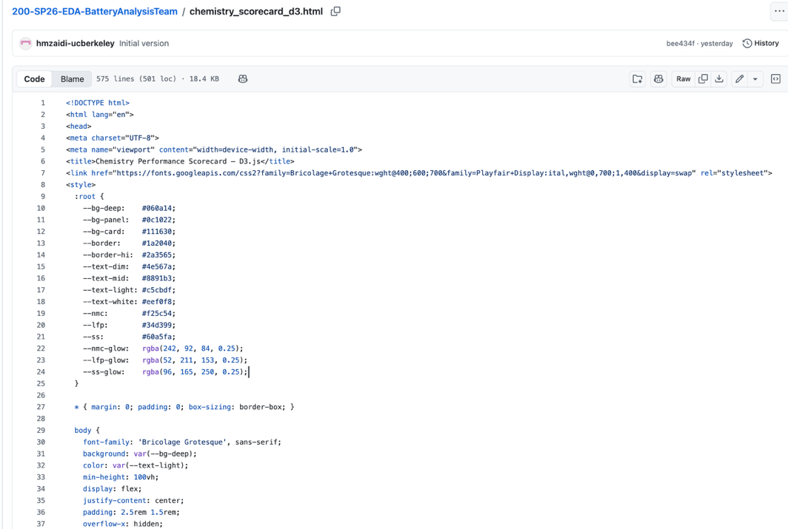
Figure 8: HTML Code for Chemistry Performance Scorecard using D3 Visualization

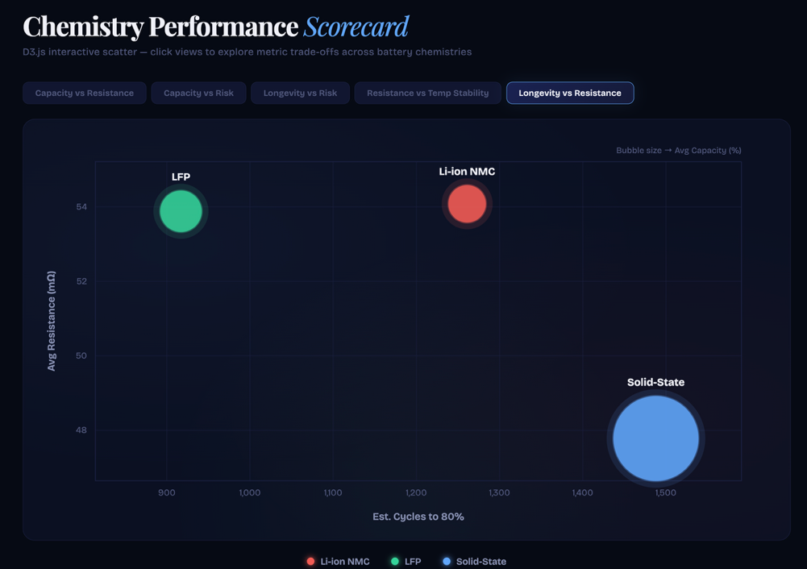
Figure 9: Chemistry Performance Scorecard Browser Display

6. Conclusion
Across all research questions examined, Solid-State consistently demonstrates the most favorable characteristics in this dataset. It is the only chemistry that never crosses the 80% EOL threshold across the full 500-cycle window. Its capacity fade rate stays flat near zero throughout, its resistance growth is nearly stable, and its thermal runaway risk distribution is concentrated nearest to zero. Its projected cycle life at approximately 1,450 cycles to 80% capacity retention is the highest of the three chemistries under either estimation method.
LFP and Li-ion NMC are more similar to each other than either is to Solid-State. Both dip below the 80% EOL threshold in the mid-cycle range before partially recovering. The stress index and temperature volatility analyses confirm that the simulation applied approximately equivalent operational conditions to all three chemistries, meaning the performance differences are attributable to the chemistry rather than to differential treatment. NMC carries a modestly higher thermal risk profile and wider resistance growth variance than LFP across the mid-cycle stress window.
The thermal risk category analysis confirms that runaway conditions are a small-tail phenomenon under the simulated operating conditions, with over 85% of all observations in the Low risk category. Within the limitations of a simulated dataset, these findings consistently support Solid-State as the most durable and lowest-risk chemistry across all metrics examined. LFP represents a viable lower-risk alternative to NMC where operating temperature can be controlled below 35 degrees C and mid-cycle EOL dip behavior can be managed through appropriate battery management systems.
This report describes patterns observed in a simulated dataset. No statistical testing was performed. Findings should not be generalized to physical battery systems without empirical validation.

References
Bates, A. M., Preger, Y., Torres-Castro, L., Harrison, K. L., Harris, S. J., & Hewson, J. (2022). Are solid-state batteries safer than lithium-ion batteries? Joule, 6(4), 742-755. https://doi.org/10.1016/j.joule.2022.02.007
Feng, X., Ouyang, M., Liu, X., Lu, L., Xia, Y., & He, X. (2018). Thermal runaway mechanism of lithium ion battery for electric vehicles: A review. Energy Storage Materials, 10, 246-267. https://doi.org/10.1016/j.ensm.2017.05.013
Preger, Y., Barkholtz, H. M., Fresquez, A., Campbell, D. L., Juba, B. W., Roman-Kustas, J., Ferreira, S. R., & Chalamala, B. (2020). Degradation of commercial lithium-ion cells as a function of chemistry and cycling conditions. Journal of the Electrochemical Society, 167(12), 120532. https://doi.org/10.1149/1945-7111/abae37
Sulzer, V., Mohtat, P., Aitio, A., Lee, S., Yeh, Y. T., Steinbacher, F., Khan, M. U., Lee, J. W., Siegel, J. B., Stefanopoulou, A. G., & Howey, D. A. (2021). The challenge and opportunity of battery lifetime prediction from field data. Joule, 5(8), 1934-1955. https://doi.org/10.1016/j.joule.2021.06.005

