**Total budget and donors of Agricultural Statistical Capacity Building projects (active 2015)**

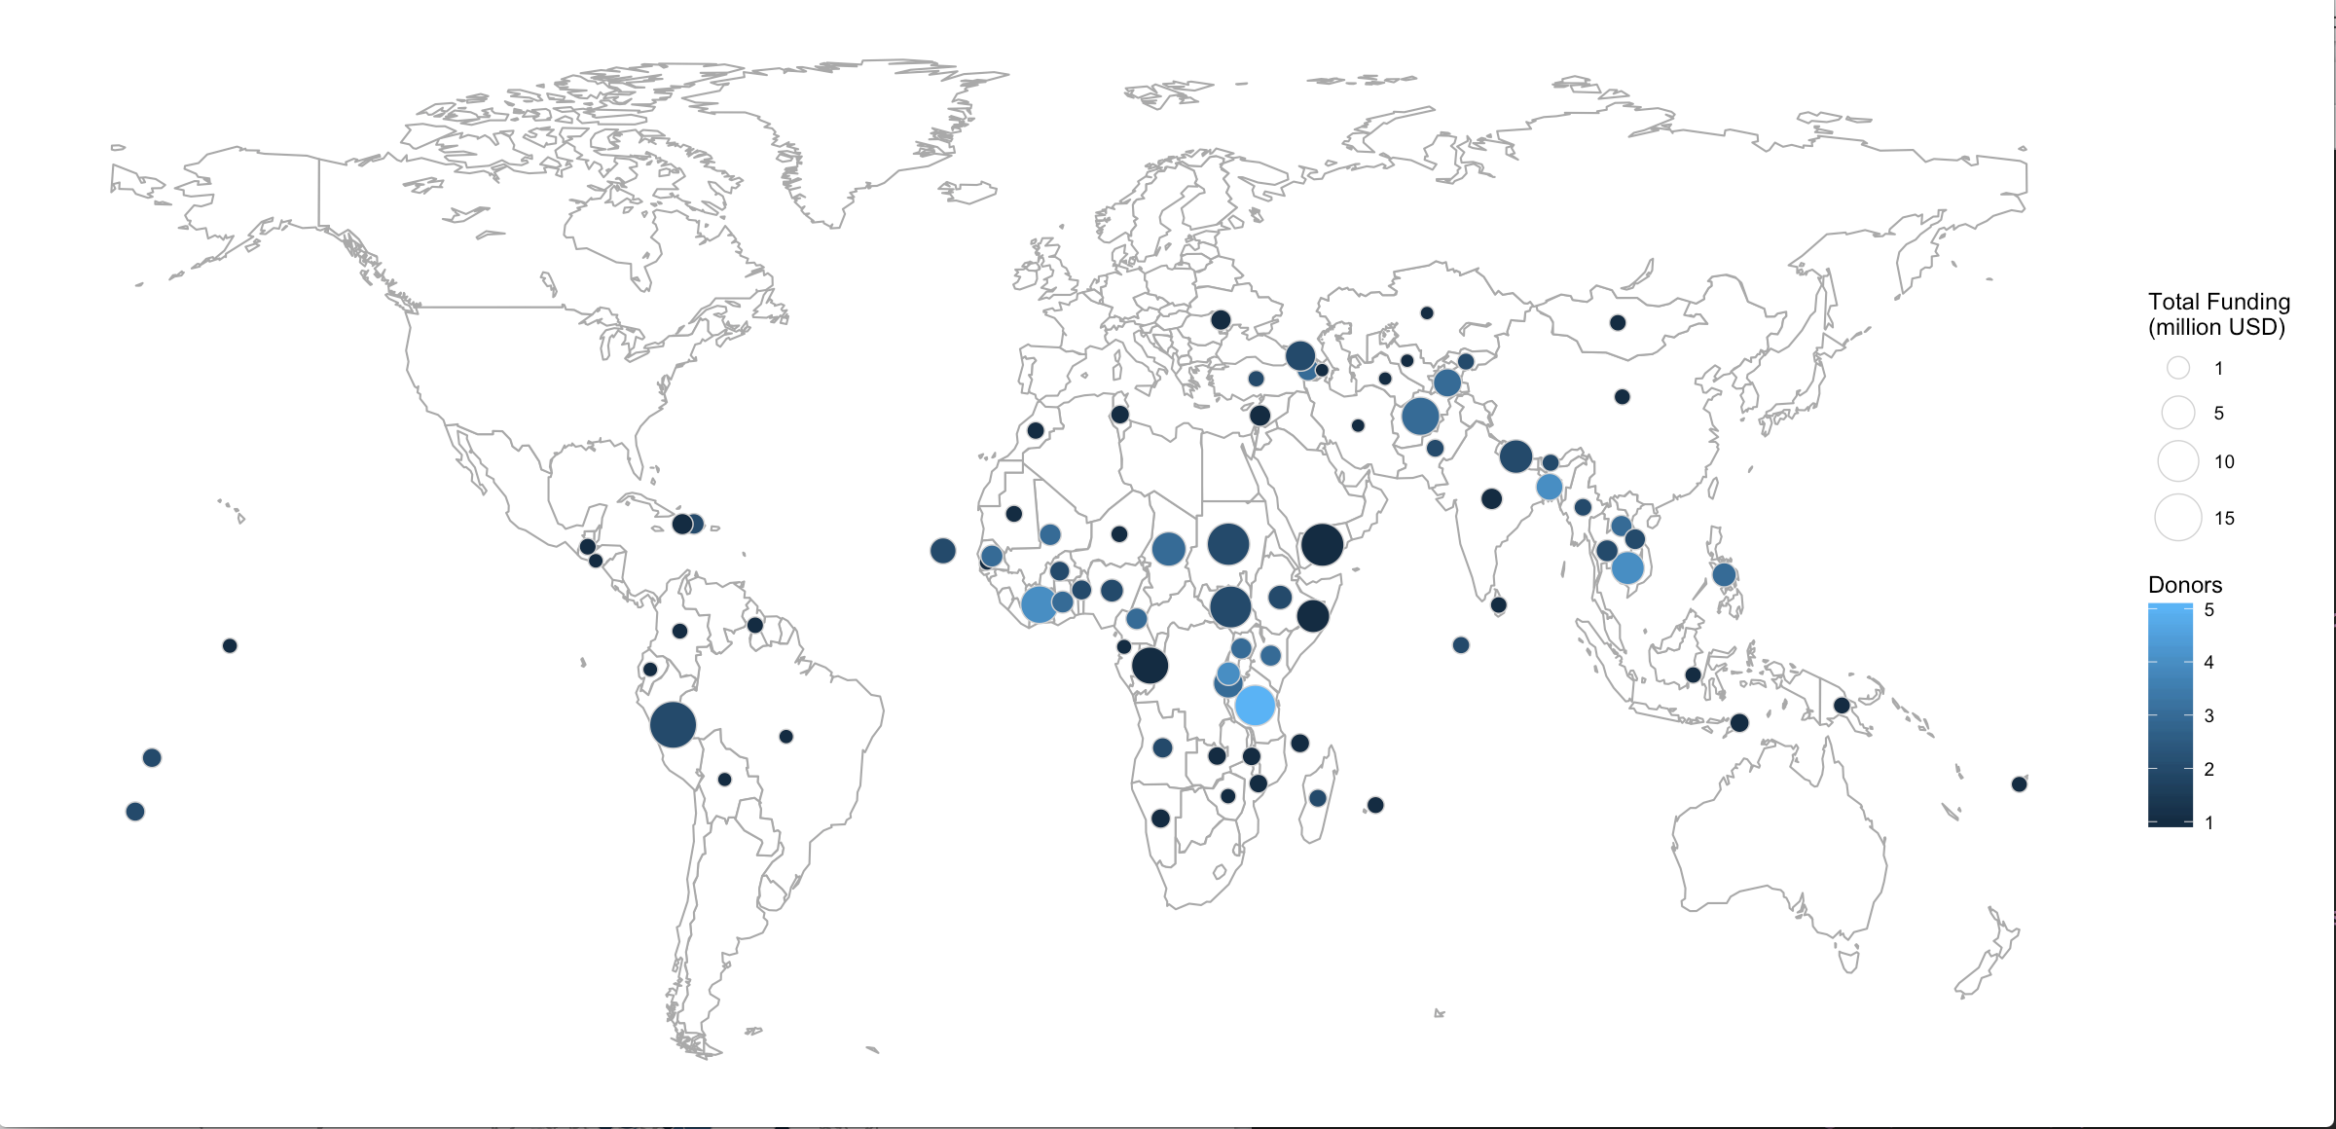

**Total budget and donors of Agricultural Statistical Capacity Building projects (active 2015)**

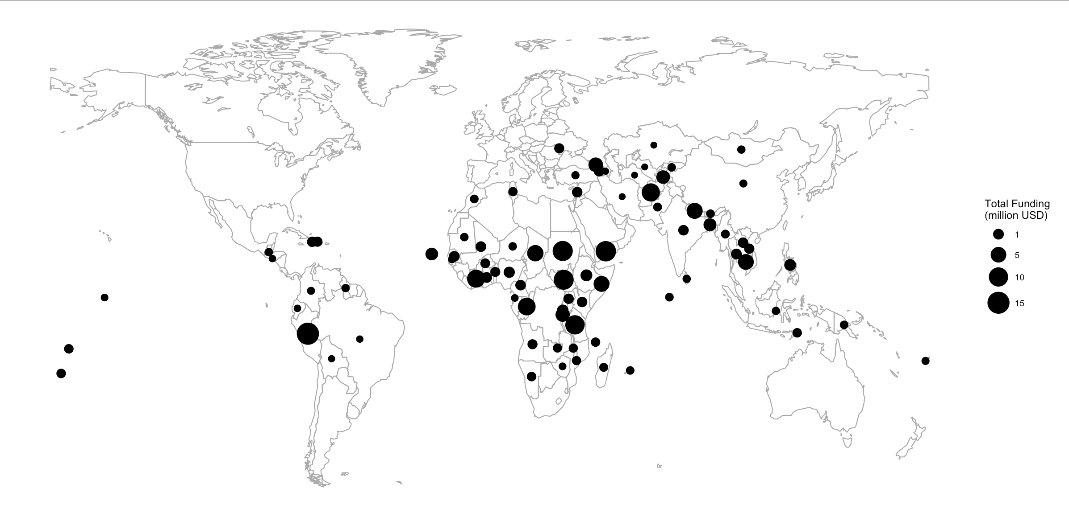

**Agricultural Statistical Capacity Building projects implemented by FAO (active 2015)**

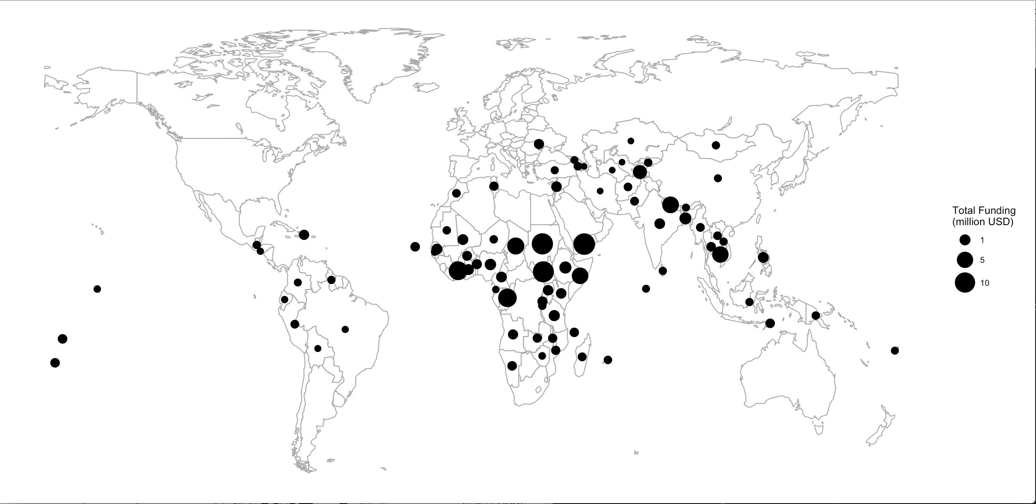

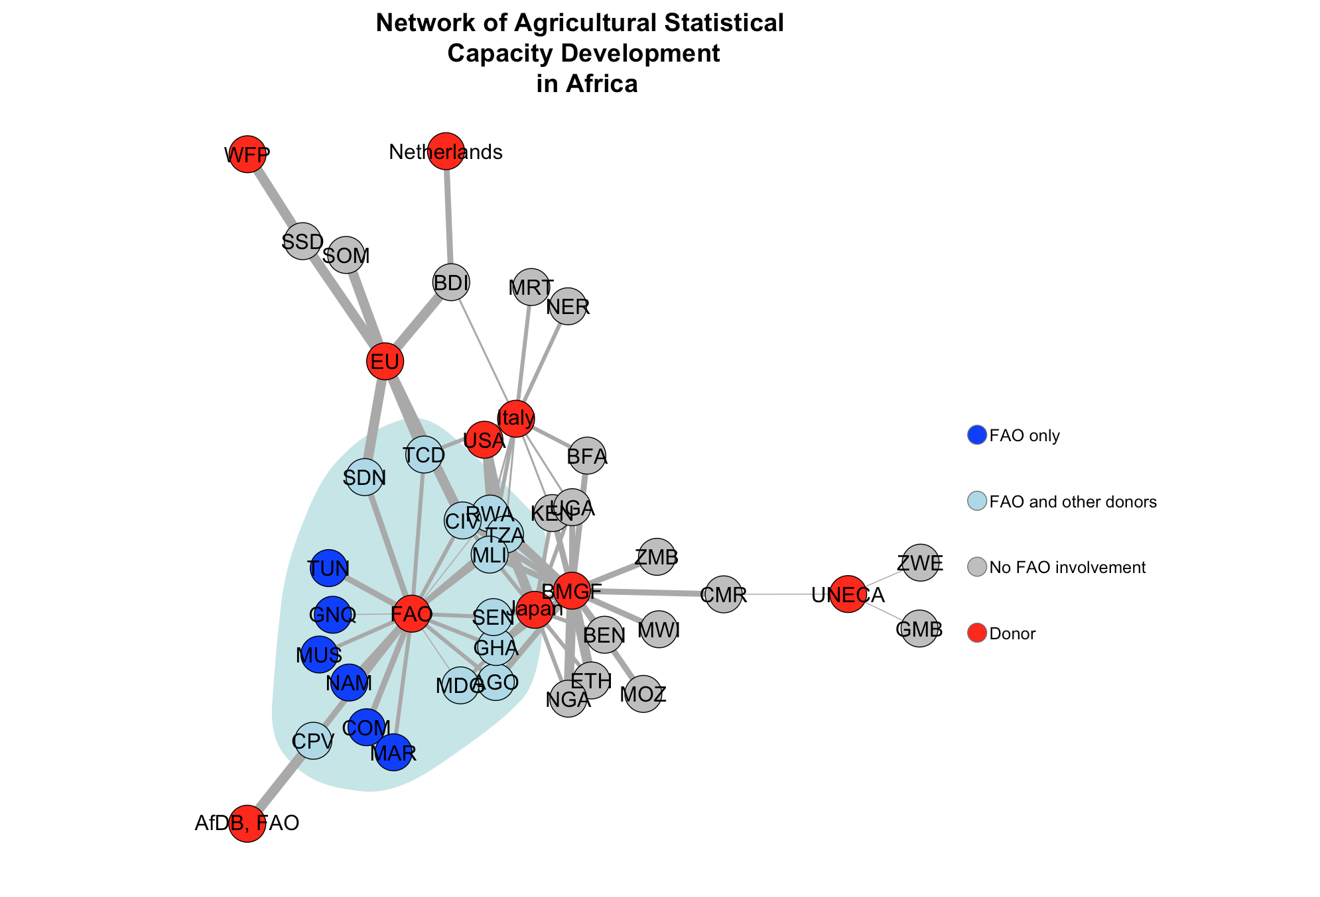

**Agricultural Statistical Capacity Assistance and Country Assessment Score**

