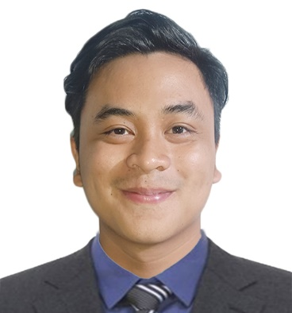

* **College**

**Bachelor of Engineering Technology: Computer Engineering Technology (BET-COET)**

Technological University of the Philippines-Cavite Campus

2018-2023

* **Senior High School**

**Information And Communications Technology (ICT)**

Asian Institute of Computer Studies-Bacoor Branch

2015-2018

* **To impart my knowledge and skills and to enhance my capabilities for personal growth and development**

**CAREER OBJECTIVE**

**Michael Angelo S. Rilan**

**Phone**: 0912-028-2536**Email:** micorilan1999@gmail.com

**Website:** <https://michaelrilan-portfolio.netlify.app/>

**Address:** Orchids St. Greenvalley, Molino II, Bacoor Cavite



**EDUCATION**

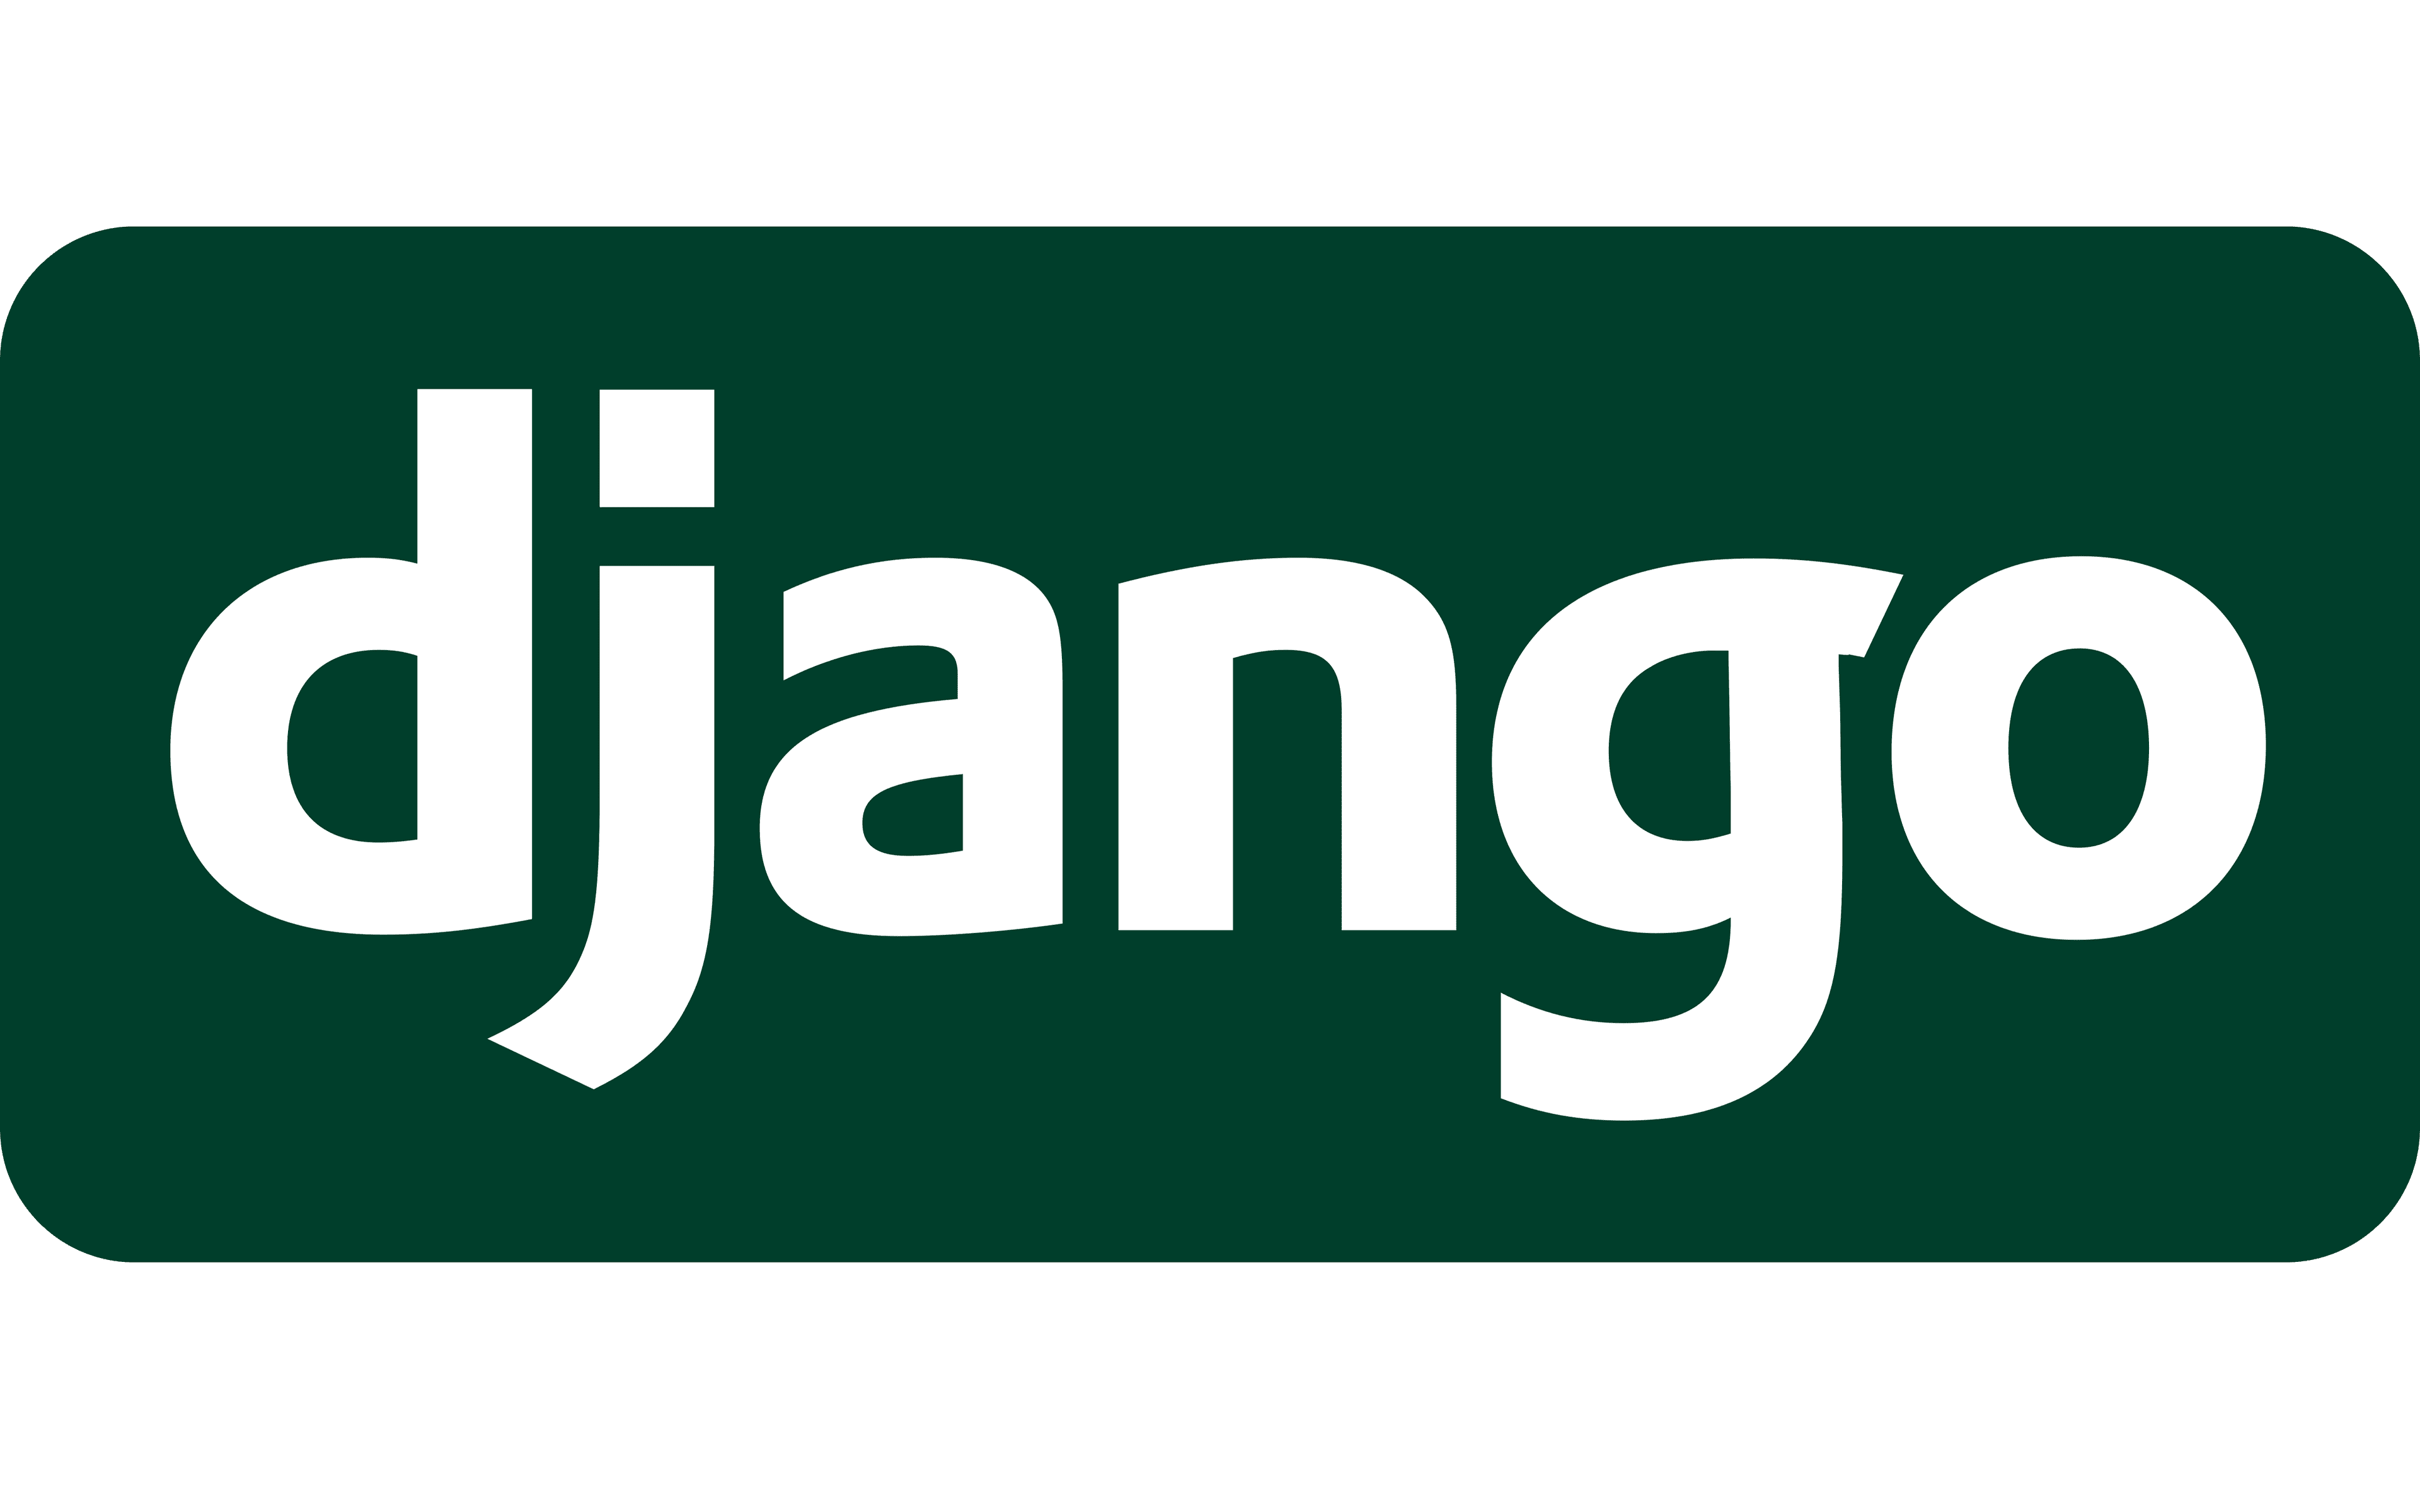

**SKILLS**

* **Web Developer/ Graphics Designer (On the Job Trainee)**

**JAE Hub Web Services**

**(March 06, 2023 - June 09, 2023)**

* Provide logo and video advertisement using different kinds of designing tools such as Canva, and Photoshop and providing UI for the user’s website using Figma.
* Provide a responsive web design depending on the company’s client desire using HTML, CSS and JavaScript.
* **Freelancing (Web, Desktop & Embedded Application Systems)**

**(2021- March 2023)**

* Possessing proficiency in Python as well as other programming languages and frameworks, including PHP, JavaScript, Django, and Arduino.
* Provides a user-friendly application depending on the description given by the client.



**WORK**

**EXPERIENCE**



* **Customer Service Representative**

**Teleperformance EDSA**

**(July 2021 – October 2021)**

* Solving different kinds of health insurance related issues with an empathetic approach.
* Provide a fast and accurate health insurance related information for the customer.
* **Service Crew**

**Jollibee North Molino**

**(April 2019 – July 2019)**

* All around dining crew that serves, clean and assist customers.

**WORK**

**EXPERIENCE**



* **Computer Literacy Program**

**DATACOM Institute of Computer Technology**

**(February 2015)**

* **Business Model Canvas Webinar**

**Technological University of the Philippines - Cavite Campus**

**(October 2020)**

**Seminars Attended**