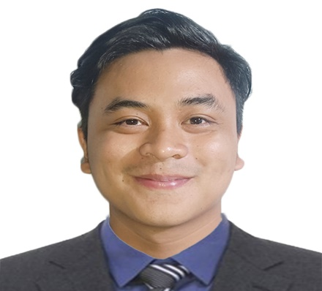

Rilan,Michael Angelo S.

Address: Orchids St, Greenvalley Molino II, Bacoor City Cavite

Contact Number : 0912-028-2536

E-mail : micorilan1999@gmail.com

|  |  |
| --- | --- |
| ObjectivesSkills | * To impart my knowledge and skills and to enhance my capabilities for personal growth and development. |
| Personal Information | **Date of Birth:** October 02, 1999 **Age:** 23  **Place of Birth:** Lemery, Batangas  **Gender:** Male  **Civil Status:** Single  **Religion:** Catholic  **Mother:** Catalina S. Rilan **Occupation:** House Wife  **Father:** Roberto A. Rilan **Occupation:** Factory Worker |
| Educational Attainment | **Tertiary**  **TECHNOLOGICAL UNIVERSITY OF THE PHILIPPINES-CAVITE CAMPUS**  **BACHELOR OF ENGINEERING TECHNOLOGY-COMPUTER ENGINEERING TECHNOLOGY** 2018-Present    **Secondary**  **ASIAN INSTITUTE OF COMPUTER STUDIES-BACOOR BRANCH**  **INFORMATION COMMUNICATION AND TECHNOLOGY(ICT)** 2016-2018  SENIOR HIGH SCHOOL  **Bacoor National High School - Molino Main** 2012 – 2016  Junior High School  **ELEMENTARY**  **San Nicolas Central School (San Nicolas Batangas)** 2010-2012  **Our Lady of Guadalupe Montessori School** 2004-2009 |
| WorkExperience | * **PhlPost- Imus November 2017 – February 2018**   **Data Encoder (OJT)**  **Imus Cavite**   * **Mang Inasal- SM Molino April 2018 – July 2018**   **Service Crew**  **SM Molino**   * **Jollibee North Molino April 2019 – July 2019**   **Service Crew**  **Beside Bacoor Government Center (BGC),**  **Molino blvd, Bacoor Cavite** |
| SeminarsAttended | * **Computer Literacy Program** February 2015   **DATACOM INSTITUTE OF COMPUTER TECHNOLOGY**  (COMPUTER HARDWARE SOFTWARE AND GRAPHICS DESIGN)   * **BUSINESS MODEL CANVAS WEBINAR** October 3 2020   **TECHNOLOGICAL UNIVERSITY OF THE PHILIPPINES-CAVITE CAMPUS** |
| Character References | * **John Christopher Ala**   **Customer Service Representative**  **Teleperformance EDSA**  **0967-817-0412**   * **Norelyn Sto. Domingo**   **Food Steward**  **Sodexo On-site Philippines Inc.**  **0966-988-0898** |

This is to certify that the above-mentioned information is true and correct.

**Signature over Printed Name**