Module 3 Project

Michael Rothbauer

Rasmussen College

Author Note

This paper is being submitted on April 21st, 2018, for Michael Rothbauer’s Mobile Web Application Development course.

Module 3 Activity

The database created for website.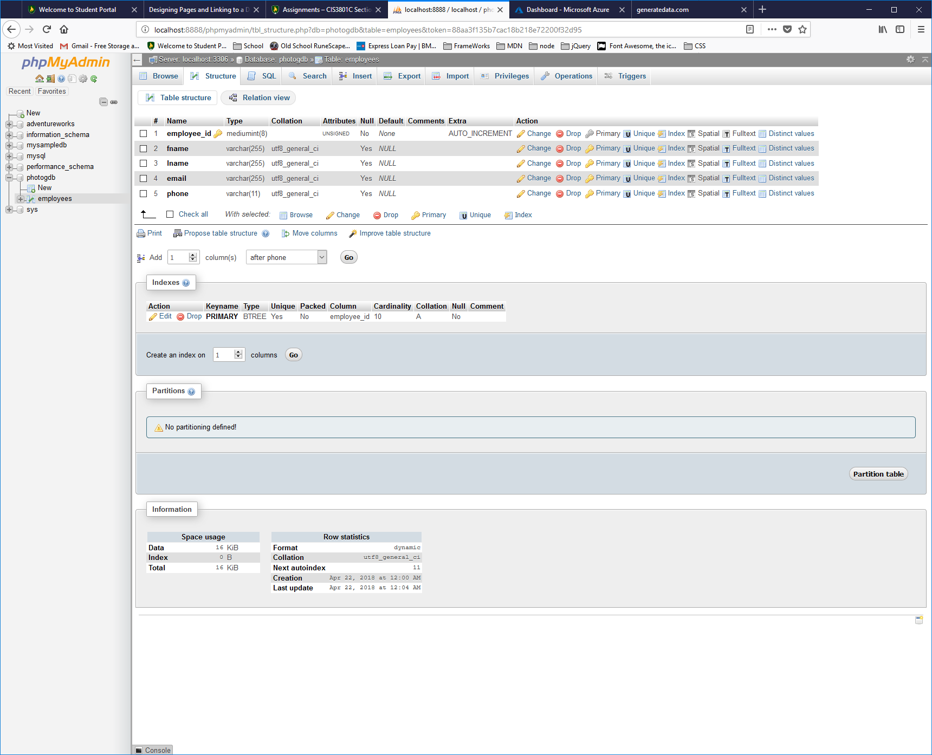

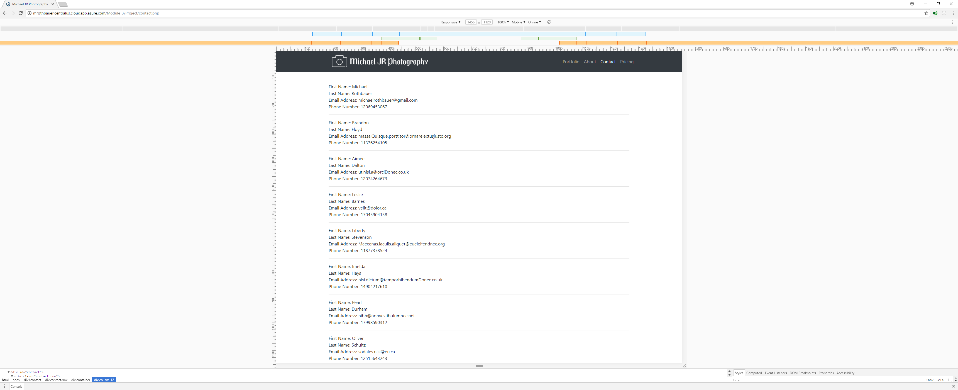Desktop view

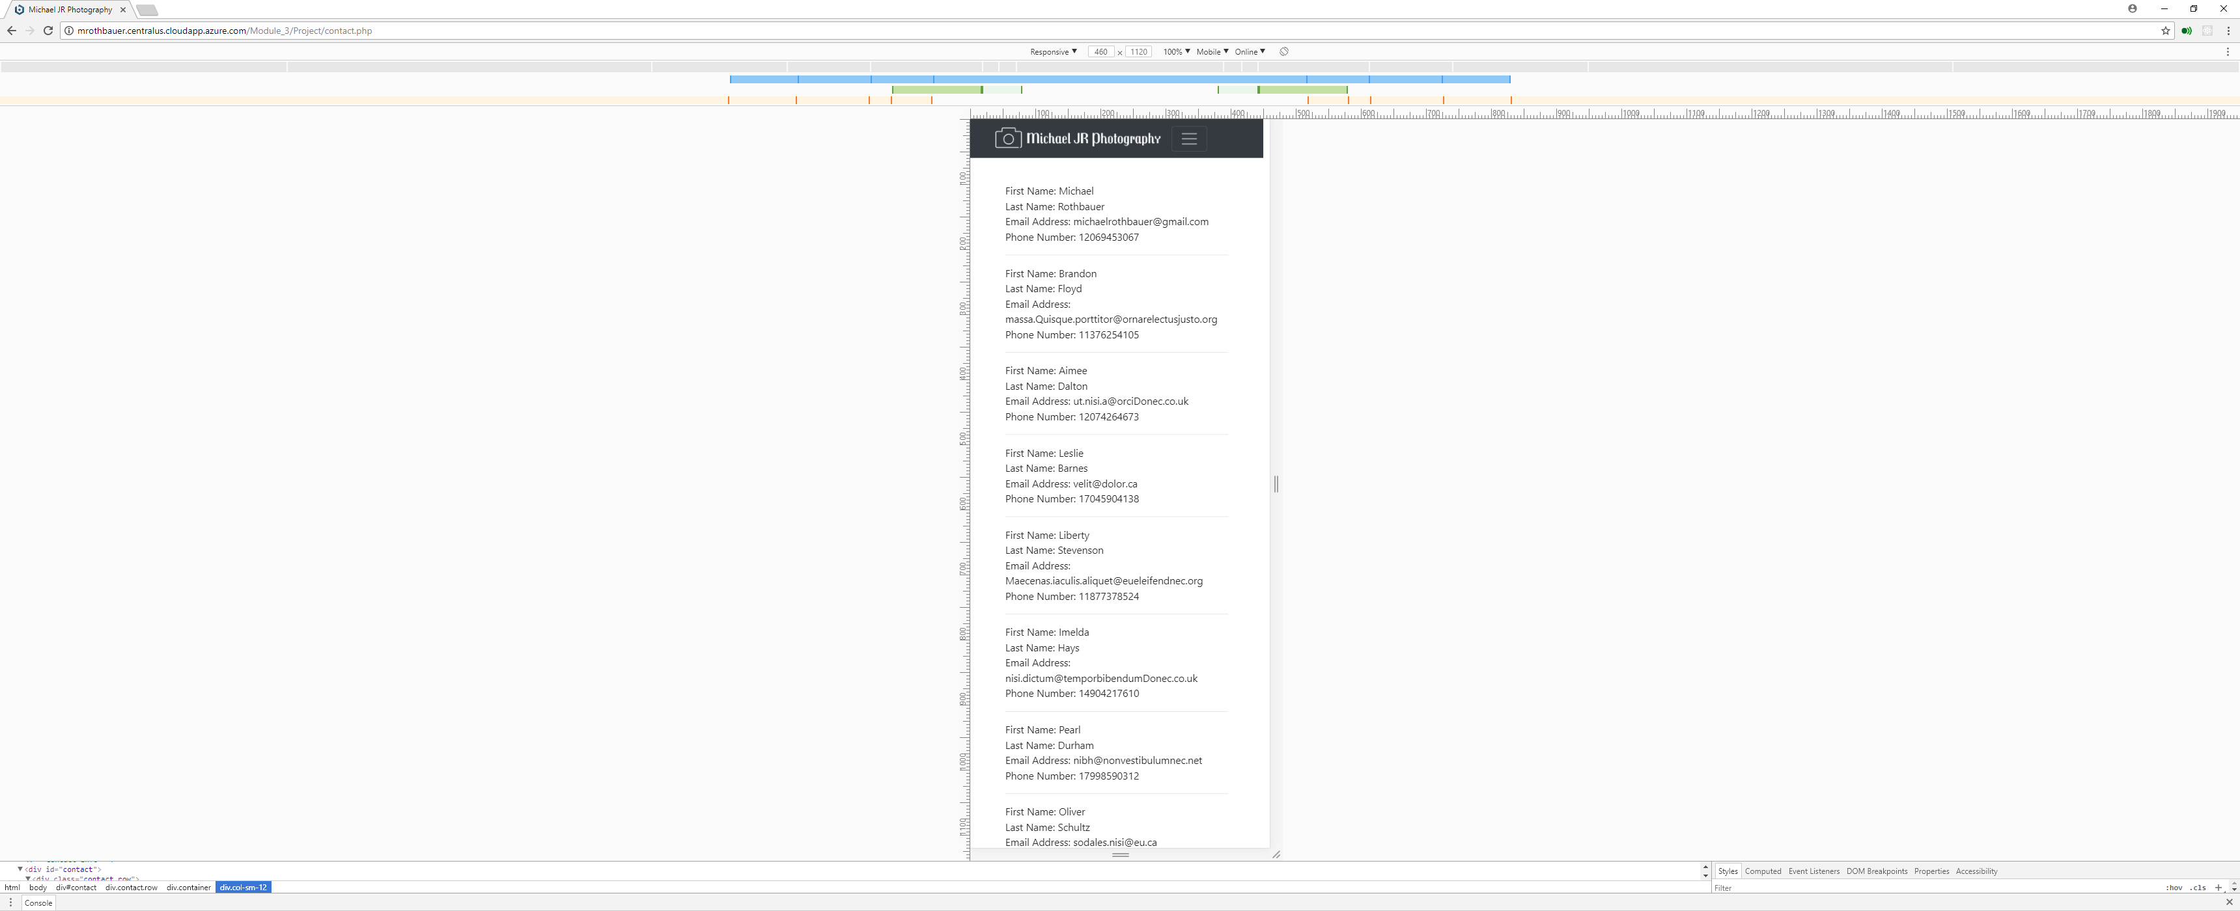Mobile View