Module 2 Project

Michael Rothbauer

Rasmussen College

Author Note

This paper is being submitted on April 12th, 2018, for Michael Rothbauer’s Mobile Web Application course.

Module 2 Project

FQDN: http://mrothbauer.centralus.cloudapp.azure.com//Module_2/Project/index.html

Github: <https://github.com/michaelrothbauer/COP1801_Javascript/tree/master/Module_2/Project>

Mobile Size:

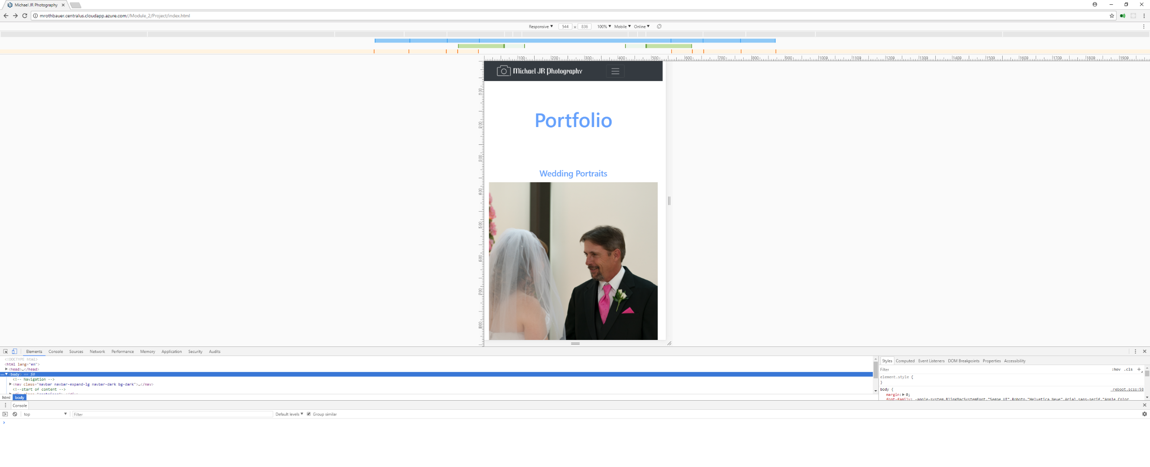

Desktop Size:

