Module 3 Project

Michael Rothbauer

Rasmussen College

Author Note

This paper is being submitted on April 21st, 2018, for Michael Rothbauer’s Mobile Web Application Development course.

Module 3 Activity

Github: https://github.com/michaelrothbauer/COP1801_Javascript/tree/master/Module_3/Project

FQDN: http://mrothbauer.centralus.cloudapp.azure.com/Module_3/Project/contact.php

The database created for website.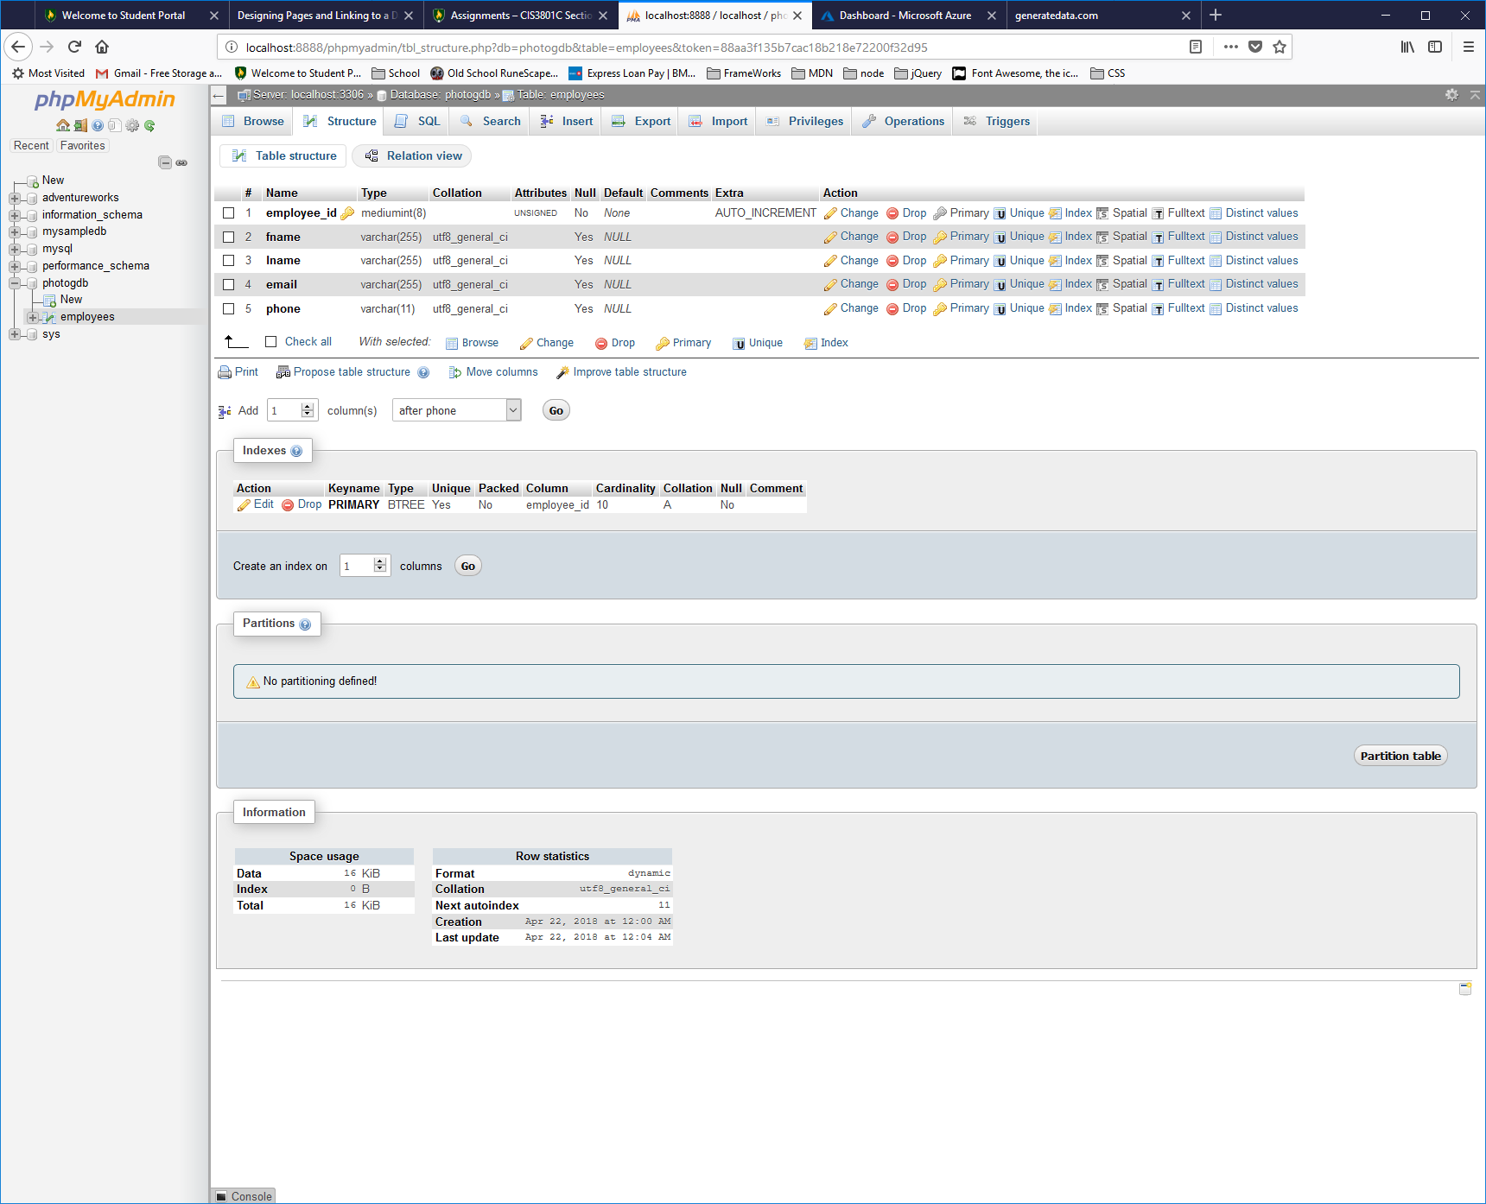

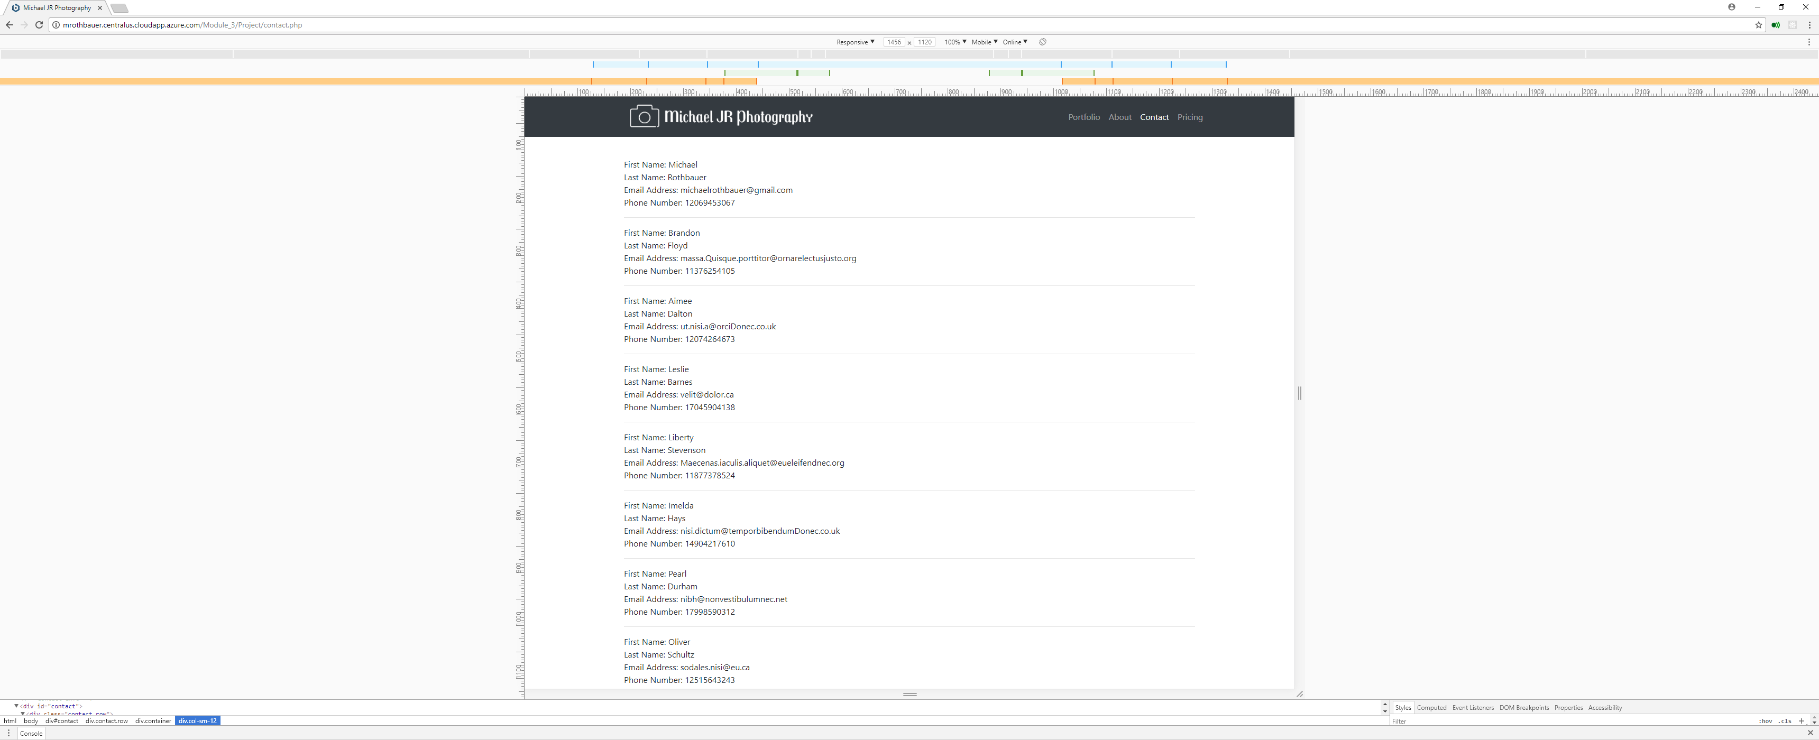Desktop view

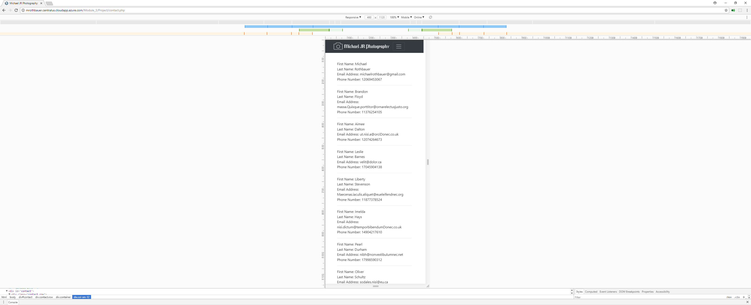Mobile View