Module 4 Activity

Michael Rothbauer

Rasmussen College

Author Note

This paper is being submitted on April 28th, 2018, for Michael Rothbauer’s Mobile Web Application Development course.

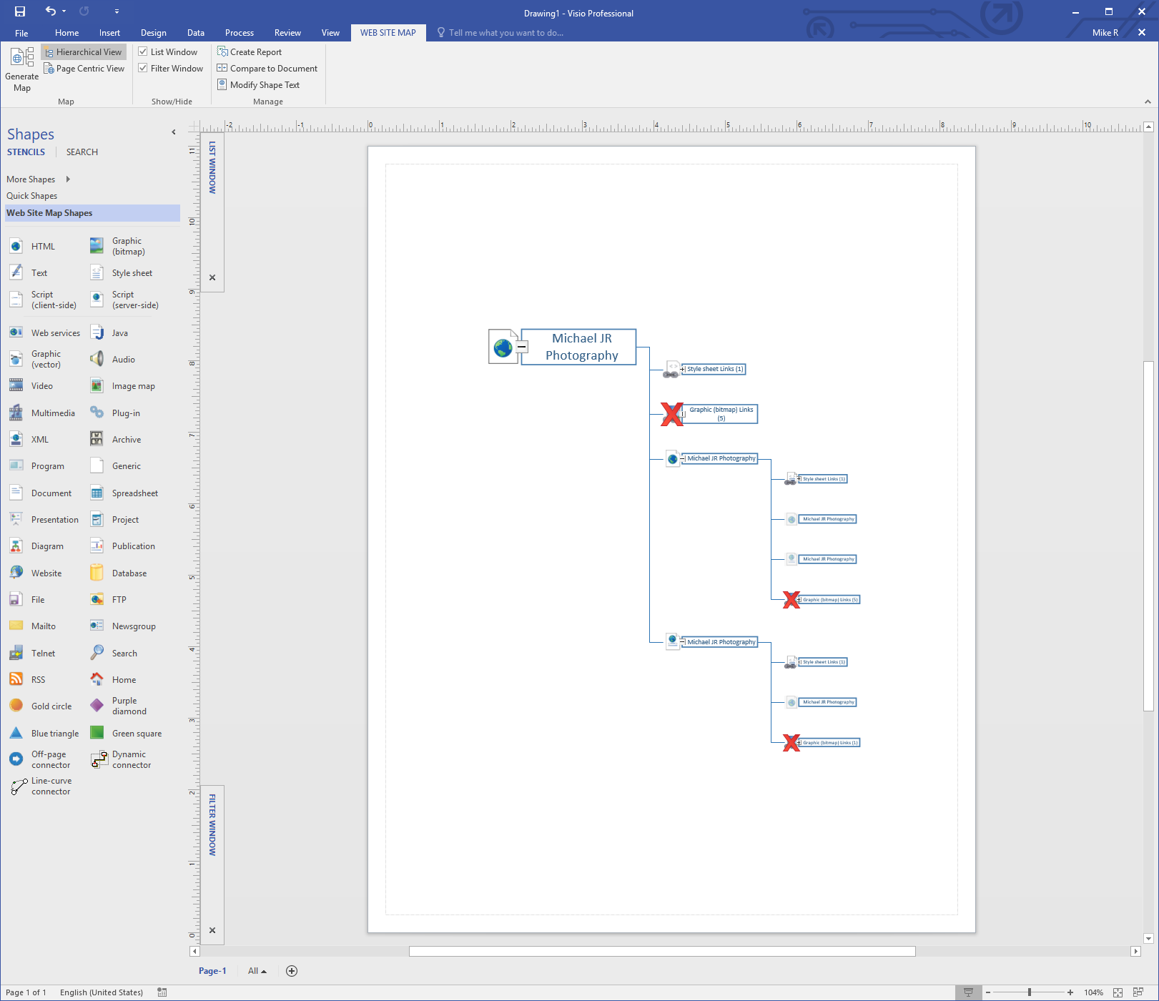Module 4 Activity