Module 4 Project

Michael Rothbauer

Rasmussen College

Author Note

This paper is being submitted on April 28th, 2018, for Michael Rothbauer’s Mobile Web Application Development course.

Module 4 Activity

Github: <https://github.com/michaelrothbauer/COP1801_Javascript/tree/master/Module_4>

FQDN: <http://mrothbauer.centralus.cloudapp.azure.com/Module_4/Project/index.html>

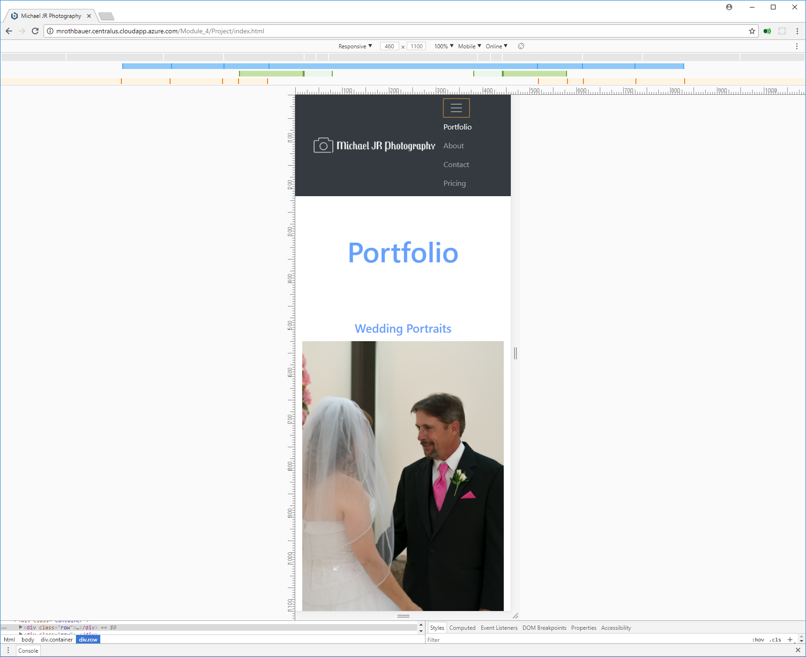Mobile:

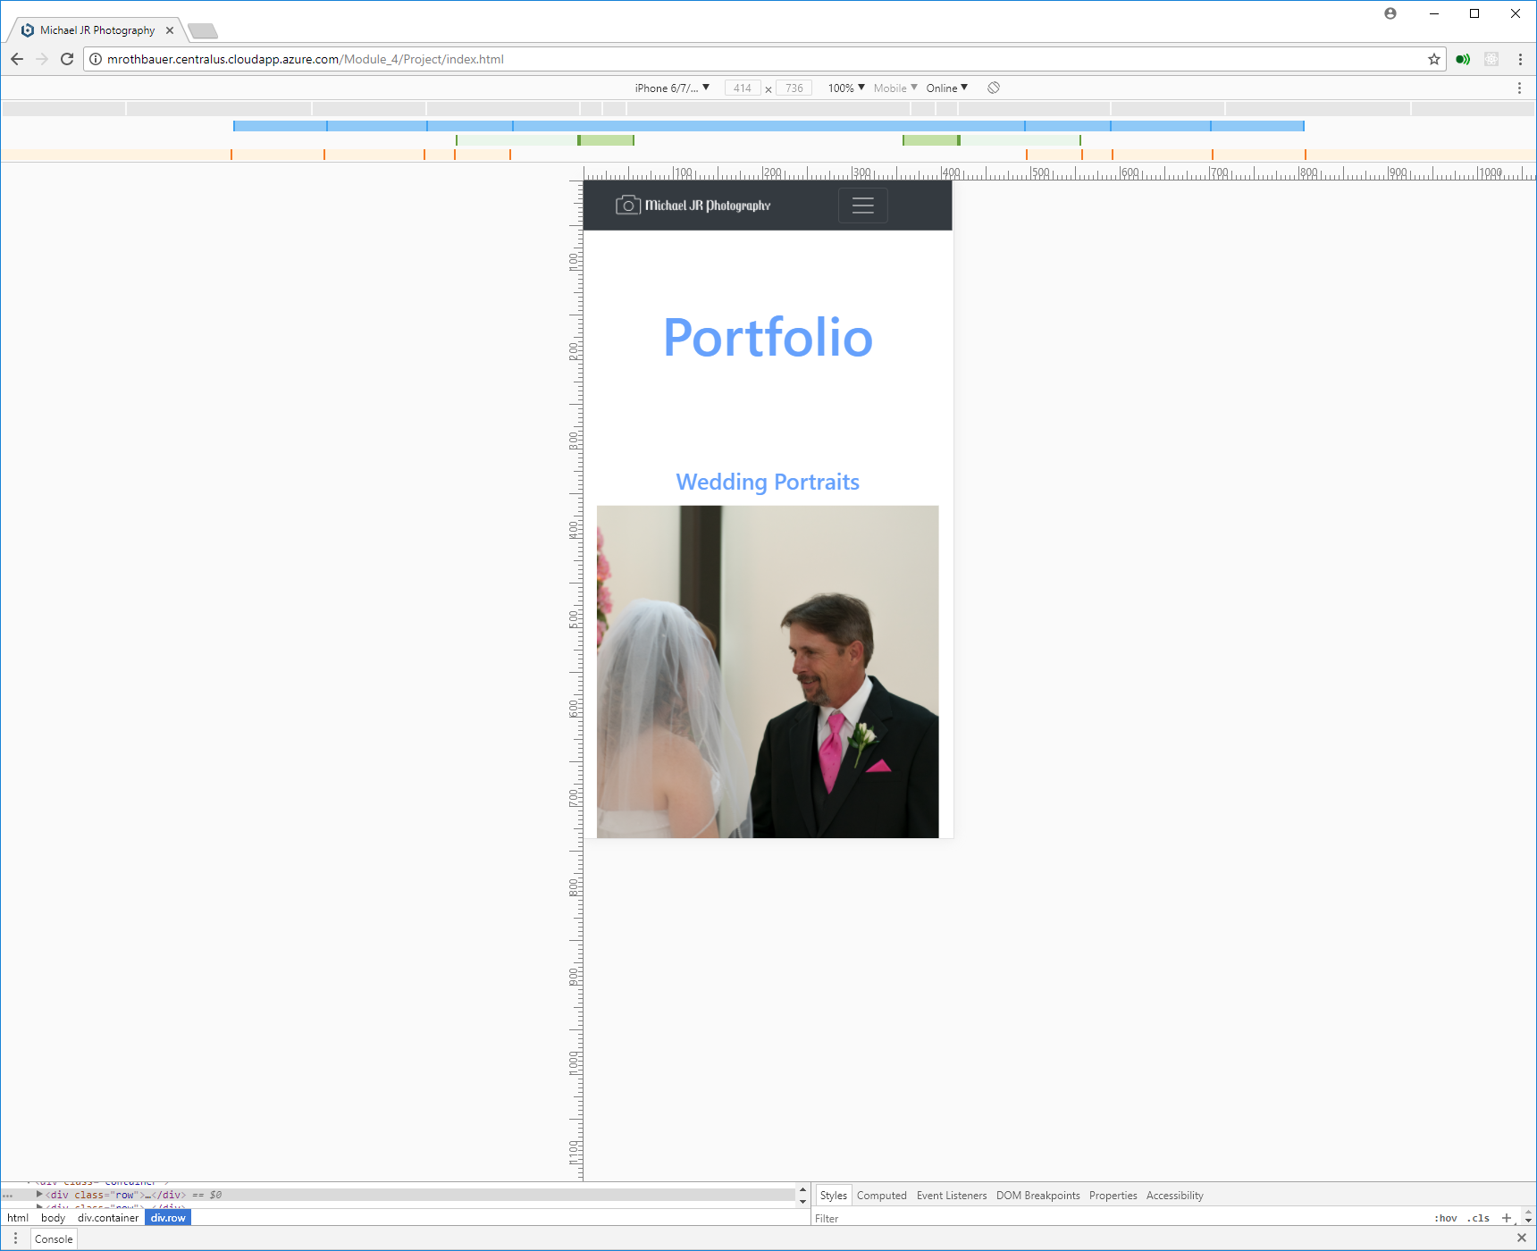iPhone Landscape and Portrait:

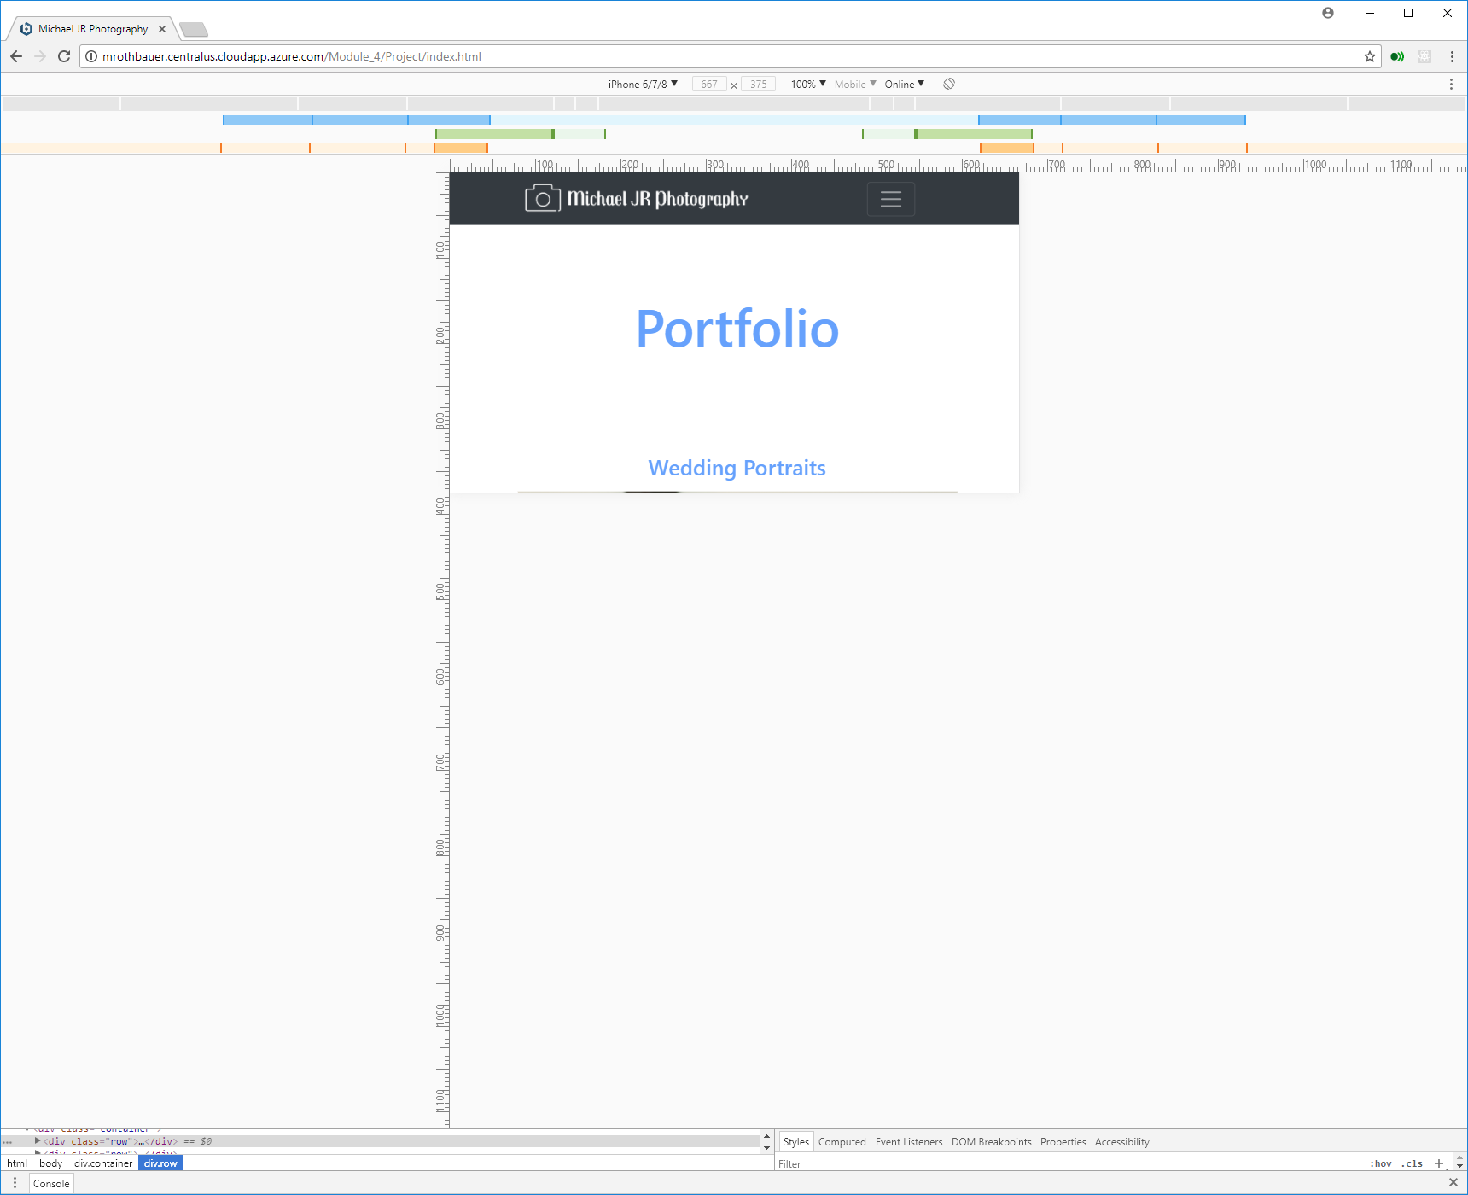

iPad Pro Landscape:

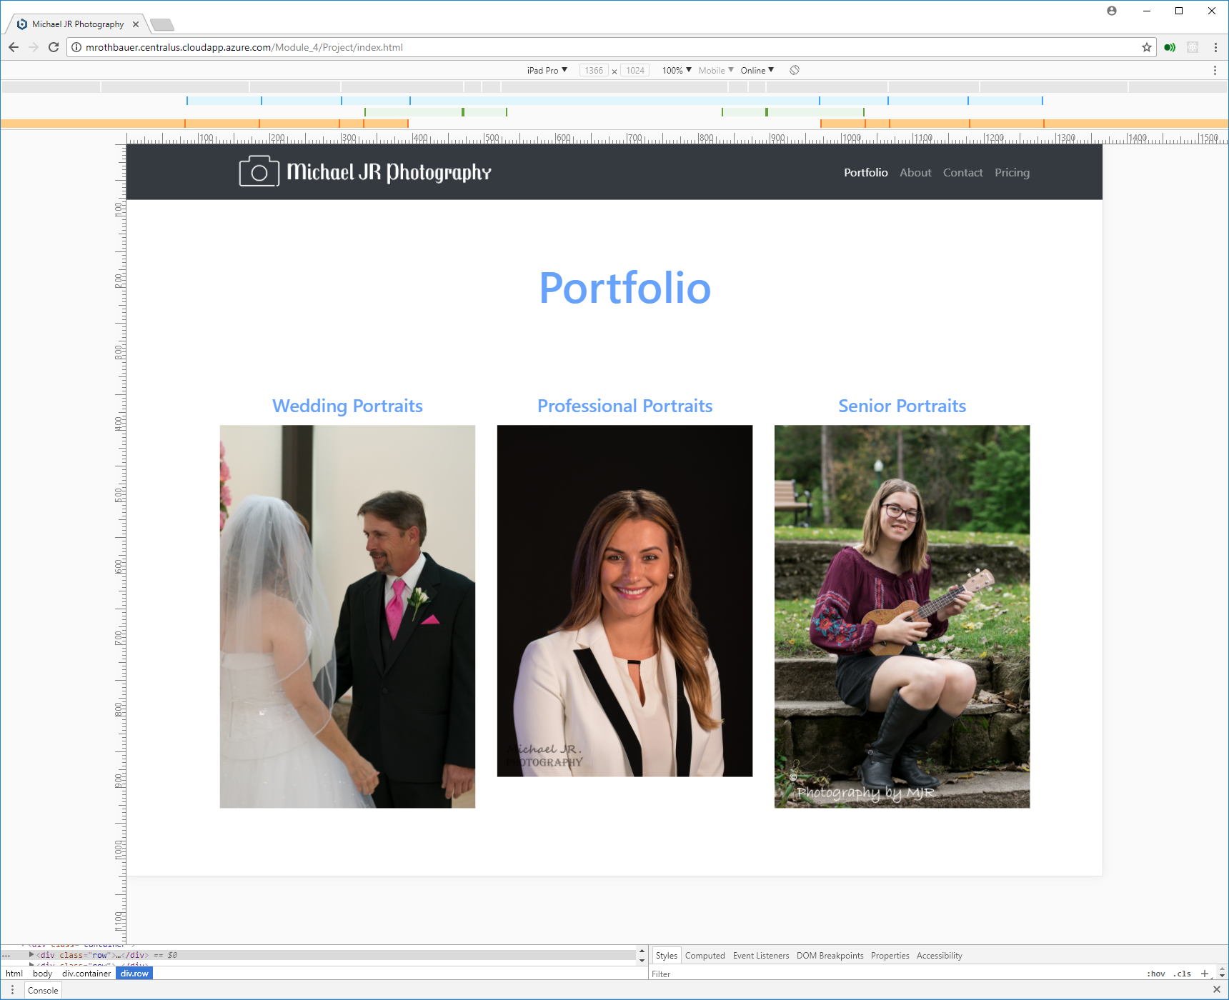

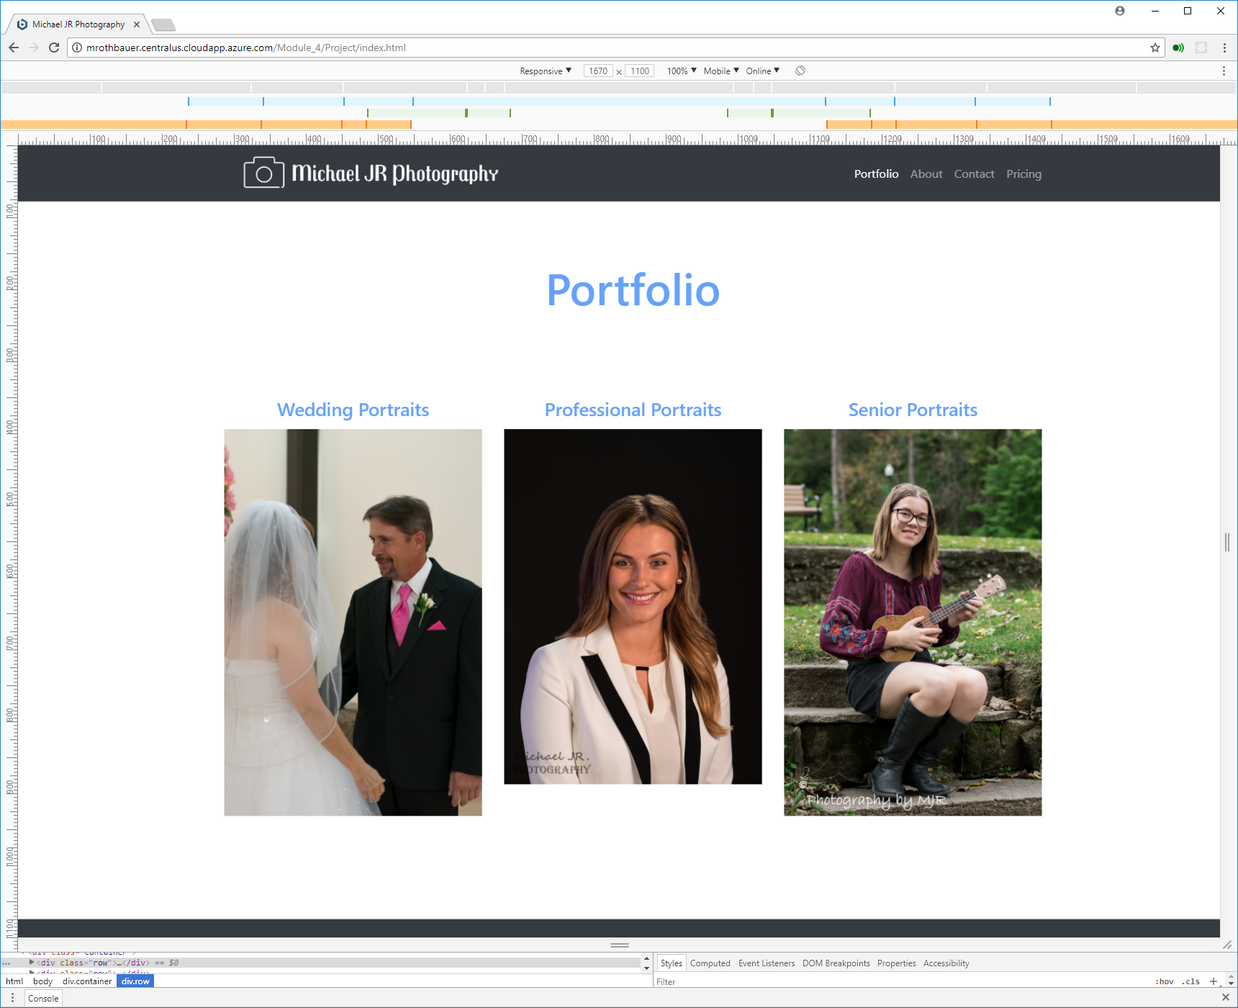Desktop:

Desktop Portrait



Galaxy S5:

