Songyue Huang
Kiet Le
Erik Burns
Mike Ryan
Jake Laverty

Project 4: The Extra Credit Project

After much hand wringing we decided to get the Pioneer 3DX to do a parallel parking job, much like the Mercedes and Lexus upper end cars can do now, using only the sonar array and a simple state “Mealy” machine.

The car will always park to the right, as it is on a two lane road (assumed, though this could be changed to park on either side of the road, but for the sake of following the traditional American rules of the road for a two lane road, we'll always parallel park to the right.

The Pioneer's sonar array is arranged as shown. The array has 16 sonar sensors numbered 0 to 15.

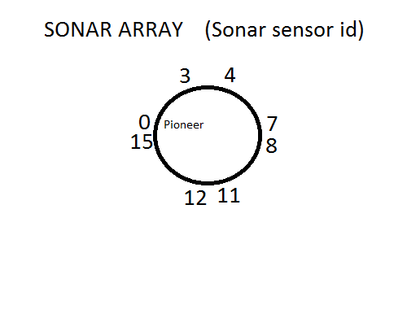

A top down view. Sensors 3 and 4 are at the front of the Pioneer, 12 and 11 are facing the rear, 0 and 15 are parallel and facing the left side of the pioneer, and 7 and 8 are parallel and facing the right side. Not all sensors are shown in this picture.

Our plan was to get the Pioneer to drive past the first car it is set next to until sensors 7 & 8 detect nothing within a meter then it knows it has passed the first car. This is when it entered state 2.

In state 2 the pioneer continues to move forward until sensor 7 detects something (car 2 or the front car) and sensor 8 doesn't detect something (showing the car is forward enough so that the front half is detecting something within 1 meter but there is a place to park between the cars. At this point, the Pioneer stops (sets speed = 0.0) and proceeds to step 3.

In state 3, the pioneer begins to reverse and turn so that it is going backward diagonally into the parking space. Once sensor 0 is at less than half a meter, and sensor 7 is at less than half a meter, the pioneer proceeds to state 4.

In state 4, the pioneer backs until it is between the two cars and begins to turn back (so the pioneer is again facing the same direction as the cars) until sensors 3 and 12 are within half a meter of something (the cars we're guessing). Once sensors 0 and 7 are cleared of anything within half a meter and sensors 3 and 12 pick up the cars in front and back, state 4 transitions to state 5.

In state 5, the pioneer sets both angular velocity and speed to 0.

The state machine is built entirely within the sonarCallback function.

Notes

We had issues for a while getting the Pioneer to turn and learned it cannot really turn in place. Thus, we always try to have it moving either forward or backward while also turning. We also had issues with getting errors when trying to change the forward or backward velocity and the angular velocity too much at the same time, so we dealt with that by always slowing or speeding up the forward or backward velocity first and having that run for some small time before changing the angular velocity.

Several of the members of the group went through the trouble of installing Ubuntu 12.04 LTS as well as setting up ROS and catkin on their laptops, but since ARIA is a rather large download with a lot of dependencies that needed to be resolved, we chose to stick to programming purely on the Macbooks (1 and 2) that had the environment already set up.

The tutorials were followed and much was learned. Only 1 Pioneer was hurt in the making of this extra credit project.

FIN

