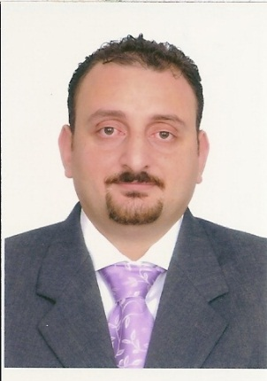

Nader Galal El Din Ahmed

Tourism Supervisor
Cairo - Egypt
+2 0128 67 27 887
naderhussein77@gmail.com

Objective | Pursuing a challenging career in a reputable organization where my experience, qualifications, skills and education can be best utilized and well enhanced.
Professional Experience  Certificates  Education | * March 2019 – Now  Tourism Supervisor  Excel Travel  Duties include:  - Managing sales process including marketing plans and groups sales  - Promoting the agency products to the customers.  - Participating in setting the sales plan  - Supervising the on-field operation.  - Handling clients’ issues and complains.  - Carrying out contracting and yielding with both tour operators & suppliers.  - Preparing tailor made requests (itineraries, pricing, reservations…etc) for both individual and groups.  - Preparing invoice for both suppliers and tour operators.  - Supervising and appraising junior staff.  - Planning and arranging the training for Junior staff  - Achieving the company’s targets  - Monitoring the cost/income of each file.  - Create and update the records of clients.  - Managing relationships with key accounts  - Having very good experience in dealing with different reservation and accounting software.  - Maintaining relationships with key persons.  - Facilitating the smooth running of the office  * June 2018 – February 2019  Operation Manager (Corporate Outgoing)  Panda Travel  Duties include:  - Contracting and yield done with travel agents, hotels, cruises and suppliers  - Organizing & prepare programs for outgoing clients in different destinations (Lebanon, Turkey, Kenya, Singapore….etc)  - Managing & supervising the operations carried out by the junior staff  - Achieving company goals  - Keeping financial statements and documents.  * January 2003 – May 2018  Assistant Director of Operation (incoming)  Master Travel Service  Duties include:  - Individually organizing and monitoring the tours of travel agencies of different nationalities: British, German, Swiss … etc.  - Preparing quotations and itineraries for both charter and FIT clients.  - Handling tailor made programs.  - Handling problems and complaints and determining eligibility for money returns.  * October 1999 – December 2002  Senior Tour Operator  South Sinai Travel  Duties Include  - Identifying the clients’ requirements and suggesting suitable travel packages or services.  - Highly experienced in dealing with hotels and cruises sales and reservations  - A highly organized administrator with proven office management skills and lots of initiatives.  * April – September 1999  Tour Operator & Tour leader  Amarco Tours  - Handling all the reservation work of the clients in the office and assisting them at the airport & during their tours.  ------------------------------------------------------------------------  - Sales for non-sales (March 2019)  FBIA (Accredited Academy)  - Hotel Sales Specialist (April 2020)  Marriott International  -------------------------------------------------------------------------  - B.A of faculty of Al-Alsun (Languages) –  Ain Shams University (Semester of June 1998)  Department of Spanish Language  Second Language: German  - Diploma in Spanish Language  Spanish Cultural Center /Superior, Cairo  - Diploma in Spanish Language  La Escuela De Verano Española, Madrid, Spain  -------------------------------------------------------------
Computer Skills | - Excellent knowledge in MS Word  - Good knowledge in MS Excel  - Familiar dealing with internet applications  - Some basic knowledge in dealing with computer problems and troubleshooting
Language Skills:
Mother tongue : Arabic
First Language : English V. Good
Second Language : Spanish V. Good
Third Language : German Fair

Personal Information

Marital Status : Married
Nationality : Egyptian
Birth Date : 06/03/1977

Reference will be provided upon request

-----------------------------------------------------------------------------------------------

