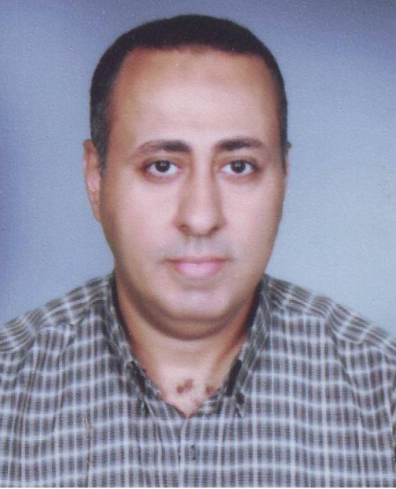

CV

- Name. Mohamed Hazem Nashat El Sherbeny.

- Nationality. Egyptian.

- Religion. Muslim.

- Address. Maadi-Cairo.

- Phone. 0100- 4973364

- Qualification. B. sc Ecomonics.

- Date of Graduation Mav 1991

- Experience 30 Years.

* Title & Companies:-

- Tour Operator Spring Tours - Cairo Office 92-94.

- Senior Tour Operator Travco - Cairo Office 94-96.

- Tourism Head Section
Spring Tours - Cairo Office 96-99.

- Tourism & Contracting Manager
Mostravel Tui Group - Sharm Office 99-03.

- Tourism & Operation Manager
Mostravel Tui Group - Hurghada Office 03-05.

- Operation Manager – National Travel Service Cairo 06-11.

- Office Manager – Hanove Travel Cairo 11-21.

* Languages. English.

* Other skills :-

- Computer Literacy.

- Hard Worker & Self Motivated.

- Good Effective Communications.

- Experience working with Multinational Companies.

- Advanced courses in Marketing & Tourism.

- Good Experience with online systems.

- Have my good business and deals with agents and individuals.

Thank you & Best Regards

Mohamed Hazem

