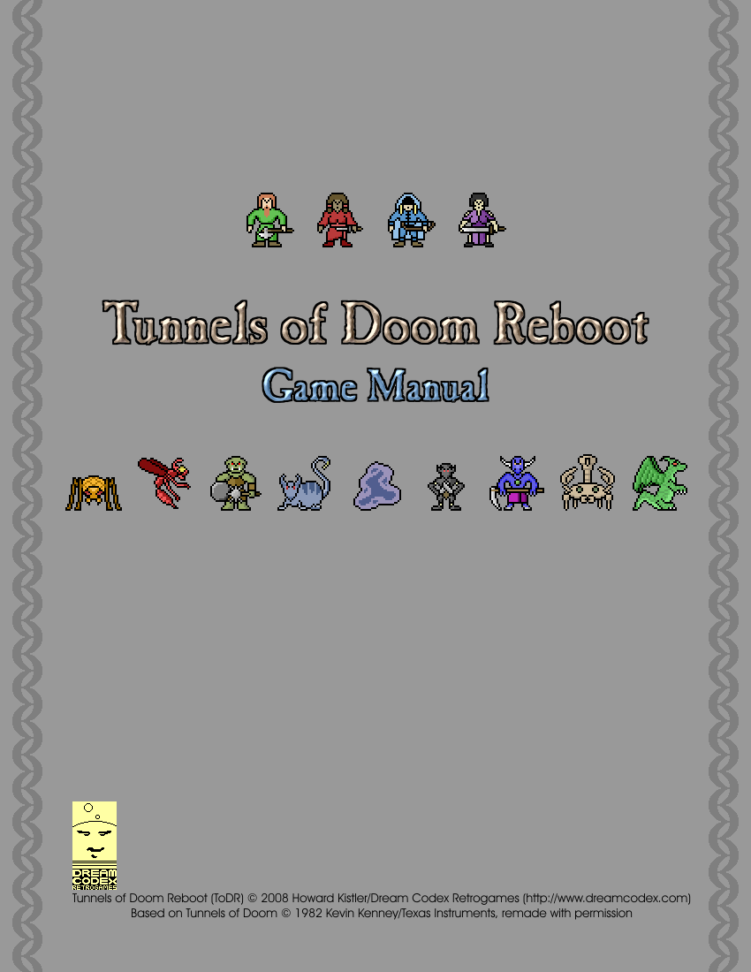

Tunnels of Doom Reboot

Game Manual

Tunnels of Doom Reboot (ToDR) © 2008 Howard Kistler/Dream Codex Retrogames (http://www.dreamcodex.com)
Based on Tunnels of Doom © 1982 Kevin Kenney/Texas Instruments, remade with permission
Contents

I. Introduction 4
Welcome to the Tunnels of Doom, Rebooted 4
About The Original 4
What Has Changed 4
Acknowledgements & Thanks 4
II. Installation 5
Requirements 5
Installing The Game 5
Startup Files 5
III. Basics Of Playing 6
The Main Menu 6
Game Options 6
Starting A New Game 7
Character Creation 7
Dungeon Creation 9
Loading A Game 10
Restocking The Dungeon 10
Saving A Game 11
IV. Players 12
Player Attributes 12
Player Inventory 13
Party Overview 13
V. Exploring 14
The Main Game Screen 14
Hallways 15
Rooms 15
Party Order 16
The Map 16
Stairs & Maps 17
Chests 18
Fountains 18
Living Statues 18
Vaults 19
Context Help 20
VI. Items 21
Item Basics 21
Equipment 21
Using Items 22
Managing The Inventory 22
Shopping 24
Trading Items 25
VII. Combat 27
Encountering Enemies 27
Combat Information 27
Moving In Combat 28
Using Weapons 28
Using Items In Combat 29
Passing A Turn 29
The Enemy Turn 29
On Death And (Not) Dying 29
Negotiation 30
Escape 30
VIII. Quests 31
Quest Overview 31
Timed vs Timeless 31
Measuring Success 31
Command Key Reference 32

I. Introduction

Welcome to the Tunnels of Doom, Rebooted

Thanks for downloading Tunnels of Doom Reboot! Chances are that you are either a fan of the original Tunnels of Doom, or someone who enjoys computer role-playing games (CRPGs). Or maybe you downloaded it because it looked interesting? Whatever the case, let me briefly explain what Tunnels of Doom Reboot (ToDR) is about.

ToDR is a game about exploring a dungeon with a party of characters, fighting monsters and collecting treasure while striving to finish your quests. The dungeon is a large complex up to ten levels deep, made up of rooms and hallways. Within its depths you will find many enemies, powerful weapons & armor, magic items, hoards of gold, enchanted fountains, living statues, deadly traps, and the always-useful shops. Your characters will battle to survive and grow stronger, while racing the clock to complete the crucial quests you have been set upon.

About The Original

The original Tunnels of Doom (ToD) game was released on the TI-99/4A computer from Texas Instruments. It was one of the first RPGs for any computer platform and is regularly cited as one of the top TI titles of all time. It's combination of first-person hallways with overhead rooms put it technologically ahead of other RPGs, and it featured much more depth of play than similar titles of the time.

What Has Changed

While this remake strives to retain as much of the original gameplay of ToD as possible, there have been some changes which hopefully make playing easier and more enjoyable. Of particular note is that characters will now automatically swap weapons if carrying both a melee (hand-to-hand, like a sword) and ranged (projectile, like a bow) weapon when carrying out different styles of attacks. Also, monsters also now have a chance of dropping additional gold after battle. They are also willing to negotiate even after combat has been initiated, so it's now possible to "beat them into submission" rather than resorting to all-out battle every time. There are other changes to discover as well, but the overall experience should be familiar to ToDR veterans, and should give new players a flavor of the original.

Acknowledgments & Thanks

Thanks first have to go out to Kevin Kenney, author of the original Tunnels of Doom, both for creating that game and for giving me permission to create this remake. Thanks as well to Ed Burns of the Tunnels of Doom Tribute Page for obtaining the consent.

Many thanks to Frank "Skyrunner" Scheffel of Brain Control (www.braincontrol.org), whose magnificent soundtrack made ToDR a far more atmospheric and overall better game.

Special thanks to my partner Rynne, not only for her continued support, but for starring in the title screen images as well.

A big thank you to the ToDR Army of beta testers and supporters who waited the four years it took to finish this and whose feedback made it a better product in the end. I appreciate everyone's efforts and contributions, and would like to further thank the following people for assistance above and beyond the call: Dan Howard, Luis Matthews, "darkstar" Mike, Seth Scott, Timothy Shaner, Aaron Smith, Jeff Stimson, Pam & Ed VanMuijen, and the supremely thorough Mike Woodsum.

And finally, thanks to you for playing! I hope you enjoy Tunnels of Doom Reboot.

II. Installation

Requirements

ToDR is written in Java, which means that you will need a compatible version of Java installed on your system. Most operating systems come with Java already installed. You can verify that Java is installed by running the following command from a command window (Command Prompt on Windows, Shell on Mac or Linux):

java –version

You need Java version 1.5 or higher to run ToDR. Nothing else is required, and ToDR has very low system requirements overall compared with most modern games.

If you don't have Java on your computer, you can usually obtain the latest version from here:

http://java.sun.com/javase/downloads

You only need the Java Runtime Environment installed in order to play.

Installing The Game

If you are reading this document, then you've probably already unpacked the todr.zip file. If not, go ahead and do that now. You should have a folder named "todr" where you unpacked the zip. Move this to wherever on your hard drive you like. For example, on Windows you might put it under "C:\Program Files\Games". You only need to know the location of this folder for when you later install extra adventure modules.

Once you've put the game folder where you want it, you'll need to create shortcuts to the startup files. This will make launching the game much easier. Let's go over that now.

Startup Files

ToDR comes with two simple scripts for launching the game. One is ToDR.bat, which is the startup file for Windows. The other is ToDR.sh, which you would use to start ToDR on a Mac or Linux system.

Once you've determined which startup file you'll use, you can create a shortcut to it and add that to your Start Menu or Dock or whatever else your OS uses. Rename the shortcut as well if you like. Now all you need to do to start a game of ToDR is click your shortcut.

III. Basics Of Playing

The Main Menu

When you first launch ToDR you will be greeted with the main menu.

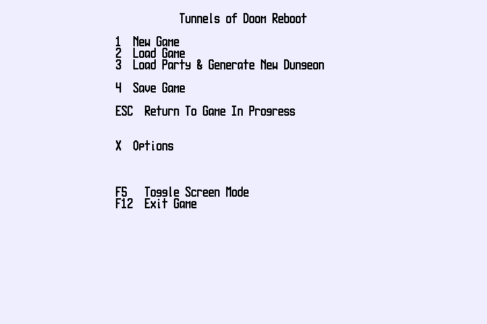
Main Menu
We will cover most of these choices in greater detail below. Just be aware of a few things:

- You can reach this menu at most points in the game by pressing the ESC key.
- You exit ToDR by pressing the F12 key.
- You can toggle the screen at any time between Fullscreen and Floating mode with the F5 key.

Game Options

You can access basic game options by pressing the X key from the main menu. This will take you to the options screen.

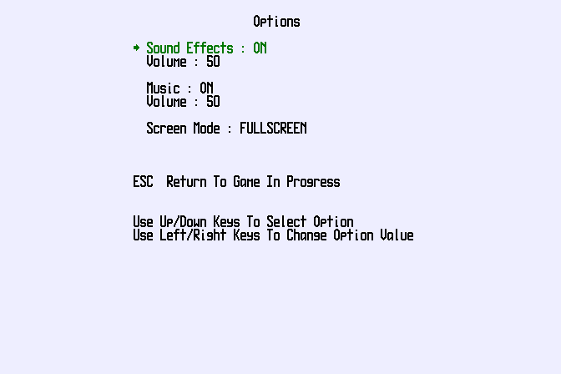
Options Screen
Use the Up/Down cursor arrow keys to change the current selected option (indicated by an arrow and highlighted coloring). Pressing the Left/Right arrow keys changes the selected value.

From here you can turn Sound Effects and Music on and off, as well as adjust the volume. You can also switching between Fullscreen and Floating display mode. (This can also be done at any point with the F5 key.)

Starting A New Game

Pressing 1 on the main menu will start a new game. The first thing you will need to do is select which game module you want to play. Modules are different adventures, each of which has its own character types, enemies, items, and quests. This is the Select Game Module screen:

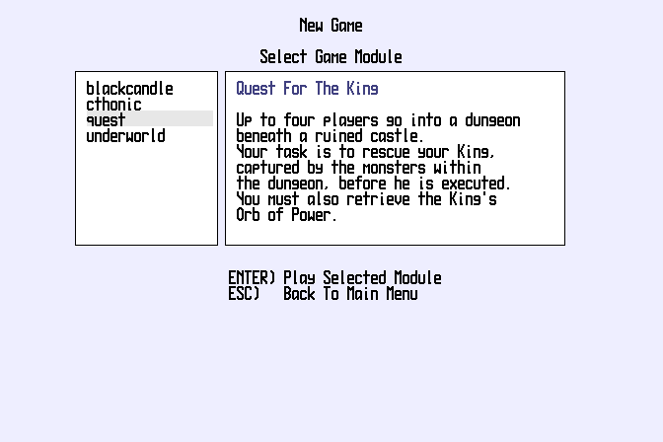
Select Game Module
The module names are shown in the list on the left, and a description of the module appears in the larger box on the right. Use the Up/Down arrows to select your module and then hit ENTER to proceed to Character & Dungeon Creation.

Character Creation

Before we start with Character Creation, did you notice what happened after you selected a module? You probably saw the graphics change. That's because each module has its own "look and feel", and it can change the overall interface, as well as fonts, colors, and other visual settings. So what things look like from here on in will depend somewhat on the module you've chosen. Throughout this manual we'll be using the included Quest For The King module in our pictures.

Now then, it's time to start building your party. This is the first screen you'll see in the Character Creation portion:

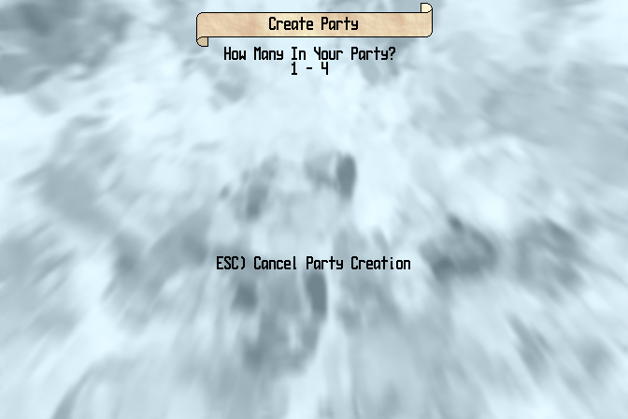
Character Creation - Party Size
First off you have to decide how big your party is. Parties can be from 1 to 4 players in size. More players in the party means a better chance of surviving (in general), and the ability to carry more stuff. But it also means that there will be bigger groups of enemies, and more people to share items and rations with. Also, individual characters will level up more slowly since they'll be making fewer killing blows in a big group.

Another consideration is that some character types are only available in parties with a single player. This is known as "solo mode", and it can be very challenging as you don't have any party members to fall back on. Often this is made up for by solo mode characters being more powerful than group characters. For example, Quest For The King includes the Hero solo mode character, who has abilities of all the group mode characters. See the module documentation for more information on player classes.

Now that you've determined how big you party of adventures is, it's time to create the individual players. Here's the Create Player screen, showing the Player Class choices:

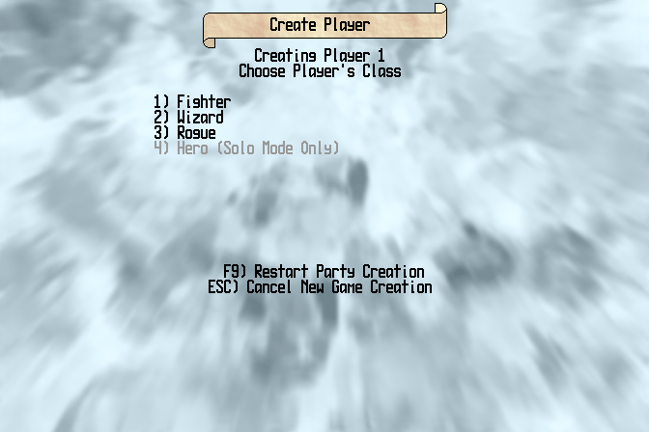
Create Player - Choose Class
Player Classes are types of players. RPGs, including ToDR, use player classes as a way of distinguishing individual abilities and skills. The player classes in Quest For The King are Fighter (can use all weapons and armor), Wizard (can use magic scrolls and gets bonuses with magic items), Rogue (decent combat abilities plus expert against traps), and Hero (a solo character with abilities of the other three classes).

If you decide at this point you want a different sized party, press F9 to go back to the Party Creation screen. Or you can cancel new game creation entirely at any point with the ESC key.

Once you've chosen the class for the first player, it's now time to chose their "distinguisher". The distinguisher is a way to tell members of the party apart. After all, it wouldn't be much fun to have a group of four fighters who look all the same, and it would get confusing after a while. Distinguishers also help give your characters their own feel. In Quest For The King, you distinguish characters first by class (which we've just done), and then by culture, as shown here:

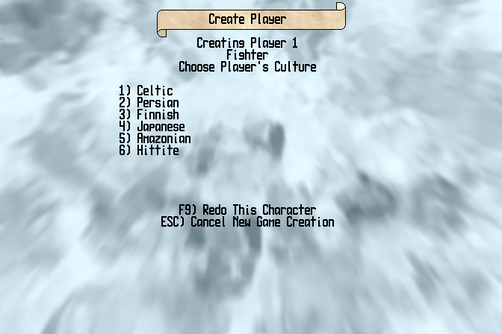
Create Player - Choose Distinguisher
In this case, you can pick from one of six ancient empires. You can even pick a different one for each character. The only thing you can't do is choose the same distinguisher for two characters of the same class. So you can't have two Amazonian Wizards, but it's fine to have a Persian Wizard and a Persian Rogue, or even a Finnish Fighter and a Hittite Wizard.

Lastly, you'll need to name your character. Here's the screen for that, where we've already started naming our Japanese Wizard:

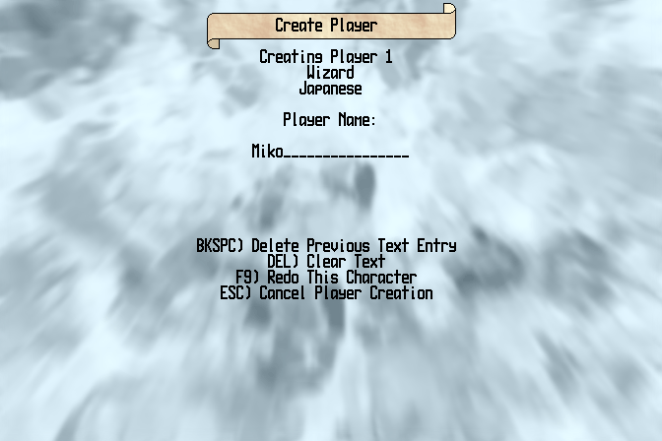
Character Creation - Name Player
You can use the BACKSPACE key to erase a character from the name, or DEL to clear the whole name and start over. When you're happy with the name, hit ENTER. If you have another player in your party, character creation will start for that one.

After you've created the whole party, you'll move on to Dungeon Creation.

Dungeon Creation

Now you're ready to specify what kind of dungeon you want to explore. First you'll need to set the difficulty level, as shown here:

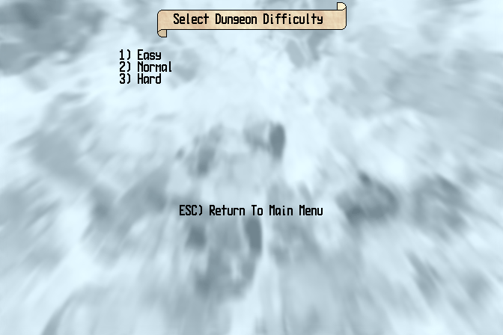
Dungeon Creation – Select Difficulty
The Normal setting creates a standard dungeon, with things fairly balanced against you. The Easy setting will populate the dungeon with smaller groups of weaker monsters and generally go a bit easier on the players. Conversely, the Hard setting will start off with tougher monsters in bigger groups, and is really for the seasoned ToDR player looking for an extra challenge.

After setting the difficulty level you will now set the number of levels in the dungeon, as this screen shows:

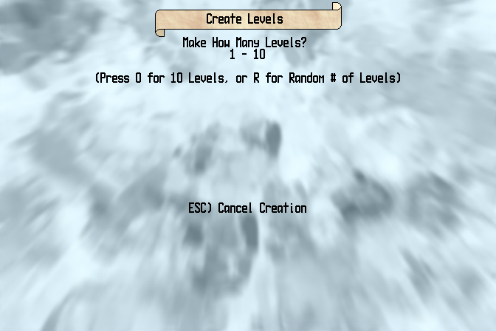
Dungeon Creation - Number Of Levels
Choose from 1 to 10 levels, or press R to have a random number of levels created.

Once you're finished creating the dungeon, you'll be taken to the Save Game screen to save everything. See Saving A Game below for more details on what to do there.

Loading A Game

Pressing 2 on the main menu, or F1 within the game, will take you to the Load Game screen:

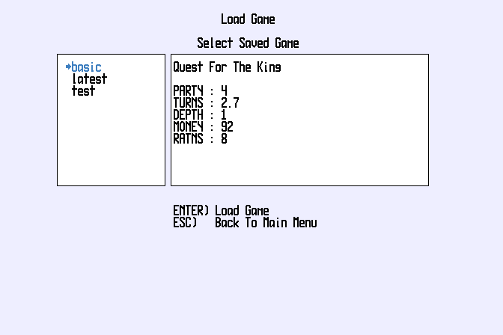
Load Game
Use the Up/Down cursor keys to select the save game and press ENTER to load. The large box displays information about the save game, such as what game module it is a save for, stats on the party, and how many game turns have elapsed. This is useful for telling otherwise similar save games apart.

Restocking The Dungeon

Pressing 3 on the main menu will allow you to load an existing party from a save game and drop them into a new dungeon. You will keep all experience and items from the previous game.

You will first be taken to the load screen, as above, where you will select the save game that has the party you want. After they are loaded in, you will go to the Dungeon Creation screen. Follow the same instructions as in Dungeon Creation above, and your party is off on a new adventure.
Please note that restocking is only available for parties that have completed a dungeon.

Saving A Game

An important part of any adventure is being able to save your progress, so that you can resume your questing later. Pressing 4 on the main menu, or F2 within the game, will take you to the Save Game screen:

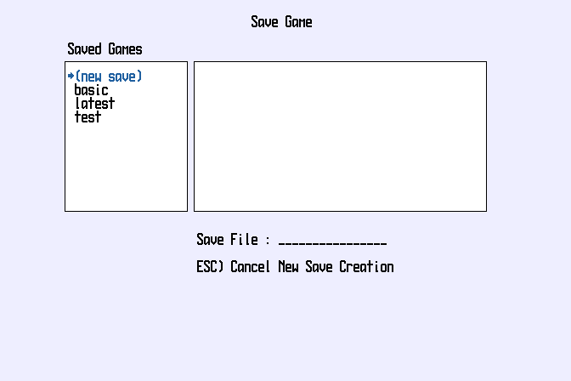
Save Game
Use the Up/Down cursor keys to select a save file and press ENTER when you've highlighted the selection. To create a new save game file, highlight (new save) like we've done in the picture and press ENTER. Then type a name for the save file and press ENTER again. A new save will be created for your game.

IV. Players

Player Attributes

Your party is made up of one or more players. Each player has a character class and distinguisher, as we covered in the Character Creation section. They also have their own attributes, abilities, bonuses, and inventories. Pressing the 1 key brings up the player information screen, and the Left/Right arrows switch the current player you're viewing. Let's take a look at the character information screen for one of our characters and see what's what:

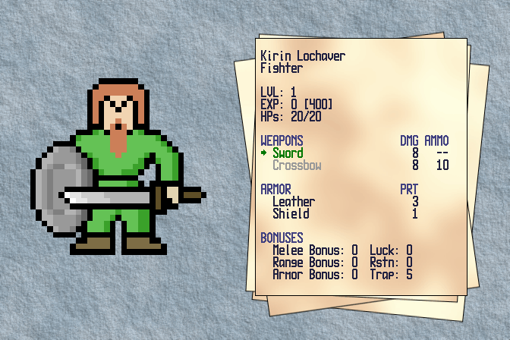
Player Information
On the left we see a large drawing of our player. Equipped items like his weapon and his shield are shown as well, making it easier to tell what each player is currently using.

In the information display on the right, we first see the player's name and his character class (in this case, he's a Fighter).

The next block shows his current Level (which is how experienced and powerful he is). Below that is his accumulated Experience (earned from striking the finishing blow on enemies), with the amount of experience needed to reach the next Level shown in brackets. Below that is the player's current hitpoints (after deducting wounds) and his total hitpoints.

The Weapons section list the player's equipped and alternate weapons. Also shown is the maximum damage the weapon will inflict with a successful hit, and how much ammo the weapon has (if any is needed). Weapons with unlimited ammo show a pair of plus signs in the ammo column, and thrown weapons (which are used once and then must be retrieved to use again) display a pair of arrows.

The Armor section show what body armor and special armor (like shields) are equipped. The protection value of these items is listed as well. (Protection from armor makes it harder for an enemy to land a damaging blow on the player.)

The last section is a list of Bonuses the player has earned. Some of these come from leveling up (and those level-up bonuses differ by character class). Other increases and decreases in bonuses come from magic items, fountains, and special attacks by enemies. Shown in this list are the Melee Bonus (affects chance of hitting with a hand weapon), Range Bonus (affects chance of hitting with a ranged/thrown weapon), Armor Bonus (affects player's general toughness and ability to withstand attacks), Luck (affects many things in little ways), Resistance (affects chance of avoiding bad magic effects), and Trap Resistance (affects ability to avoid traps).

Exit the Player Information screen by pressing 1 again, or by pressing ESC.

Player Inventory

Pressing the I (Inventory) key from either the main game screen or from the character view screen displays the current player's inventory. Use the Left/Right keys to switch to other players in the party. Here's the inventory of one of our characters:

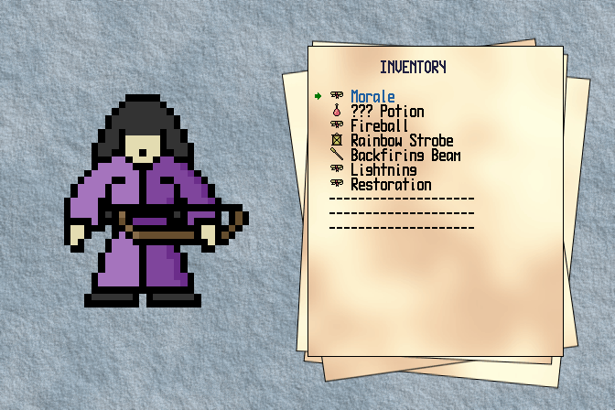
Player Inventory
Listed are all the items the player is carrying (up to a maximum of 10 items). There is an icon next to each item which shows what type it is (scroll, potion, lantern, etc.). Some items are already identified (like the Fireball scroll) and some are still unknown (like the ??? Potion). This screen is useful for reviewing who has what.

Pressing I again toggles the view between Player Information and Inventory. Exit these screens by pressing 1 or ESC.

Party Overview

Press the 2 key to bring up the Party Overview screen:

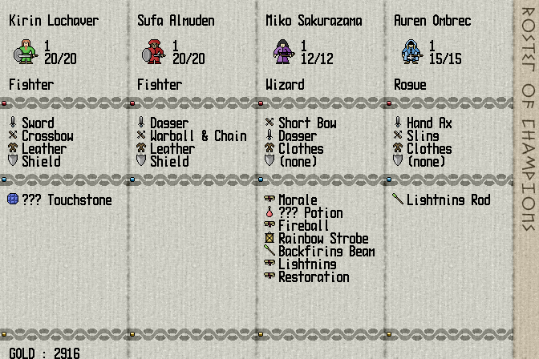
Party Overview
This screen show the whole party at a glance, with information on each player's level, hitpoints, weapons, armor, and inventory. Good for checking everybody before heading into battle or going on a shopping spree.

Exit the Party Information screen by pressing 2 again, or by pressing ESC.

V. Exploring

The Main Game Screen

When starting a new adventure, your party will begin in the Shop above the dungeon. This is a good chance to look around the screen and get familiar with the various features and indicators.

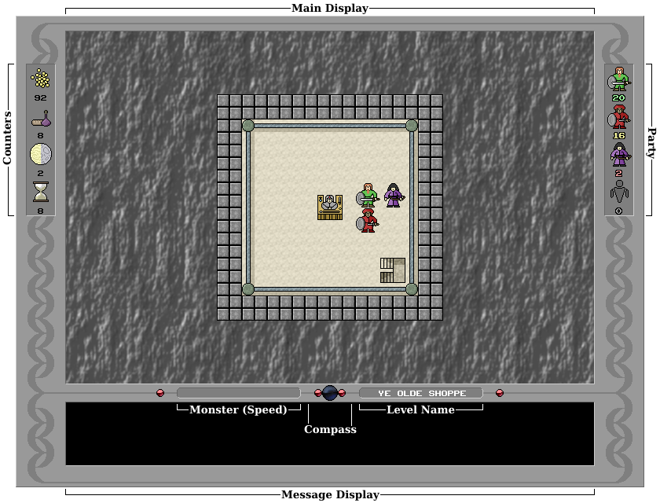

- Main Display - This is the game area where the action happens. It displays the current room your party is in (as shown here), or the hallway view if you are in a hallway, or otherwise it shows menus and important system messages.
- Counters - These display your current amounts of Gold (or whatever the module uses for currency), Rations (likewise), elapsed Turns, and elapsed Rounds. Gold is used to buy items, pay living statues, and bribe enemies. Rations are consumed at regular intervals (1 ration for each party member) and allow your party to heal while exploring. Turns are the major unit of time in the dungeon, and they act as a timer for your Quests. Rounds are the minor unit of time, passing with each step or with certain actions taken. 10 Rounds make up 1 Turn.
- Party - This displays all party members, along with their current hitpoints. When you start the game all your players should be perfectly healthy, but here we're showing the four levels of "woundedness". The first character is completely healthy, as shown by his green hitpoint indicator. The second character has suffered some damage, shown by a yellow hitpoint indicator. The third character is critically injured, as her red hitpoint indicator shows. And the fourth character is "ghosted", as shown by the grey indicator and ghost icon. Ghosted characters are not displayed in the main game area. However, they can be healed, and can even perform some actions (such as drinking from fountains). For more information see the On Death And (Not) Dying section.
- Message Display - Here various messages and short menus are displayed, telling you what is happening or what decisions you need to make.
- Compass - When wandering the halls, this will display the current cardinal direction your party is facing - N(orth), S(outh), E(ast), and W(est).
- Monster (Speed) - When in a room with monsters, their name is displayed here, along with their speed inside parentheses.
- Level Name - The name of the current dungeon level, as you may have guessed.

Hallways

The tunnels of doom are a sprawling dungeon comprised of rooms connected by hallways, like these:

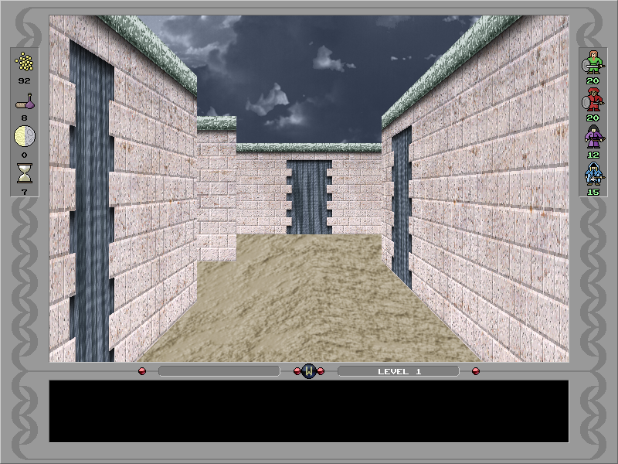
Hallway View
You navigate through the hallways with the cursor keys - Up moves you forward, Left and Right turn the party by 90°, and Down turns the party around. Each forward step passes one Round of time.

You will explore the halls, mapping as you go, seeking rooms containing treasure and foes. Sometimes the doors to rooms will be hidden. By pressing the S (Search) key you will reveal any hidden doors within your view, permanently exposing them. However, each search also passes a Round, so use it wisely when dealing with time-demanding quests.

While wandering the halls you may encounter roving groups of monsters. If you do, combat will ensue! See the Combat section for more information on encounters with enemies.

Rooms

The rooms of the dungeon are where things really happen. They can contain enemies, items, special features, and the goals of your quests. Here our party has entered a room containing a chest, a fountain, and a pair of Kobolds:

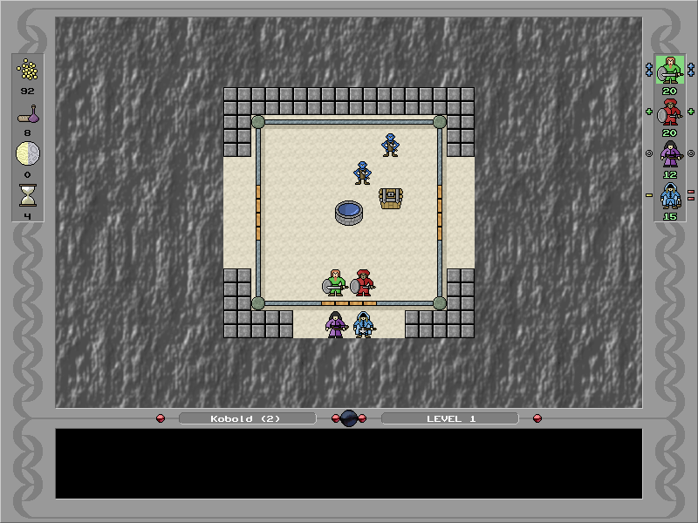
Room View
There are two ways to enter a room. The normal way is to press the Up (forward) key. This will put the lead members of the party inside the room, with the hind members waiting just outside the door. Should you wish to move the whole group inside immediately, use the B (Break) key instead of Up. The party will burst into the room, ready for action.

Before you enter a room you can choose to listen at the door. Press the L (Listen) key when facing a door. If there are monsters in the room (and you have Sound Effects enabled), you will hear the monster's sound. There are several distinct monster sounds associated with different monster types, and once you're familiar with them you'll be able to gauge who's behind that door more readily.

If the room you've entered contains monsters, you'll need to deal with them before you can doing anything else there. Or you can escape by taking all of your party members outside the doors. Party members who are outside the doors cannot attack monsters or use items with combat effects. However, they cannot be attacked either in that position.

Once combat is resolved (see Combat section for details), you are free to open chests, collect items, and use room features. To exit the room, press the cursor key that corresponds to the exit you want to use (Up for the top exit, Down for the bottom, etc.). The top of the room view is always North.

As with hallways, you can use Search from within rooms to find hidden exits as well. Sometimes these hidden doors will be the only way to proceed further into the dungeon.

Party Order

Since the arrangement of the party determines, among other things, who is first into the rooms and into combat, you can rearrange your party as you desire. Press the O (Order) key to access the Party Formation screen:

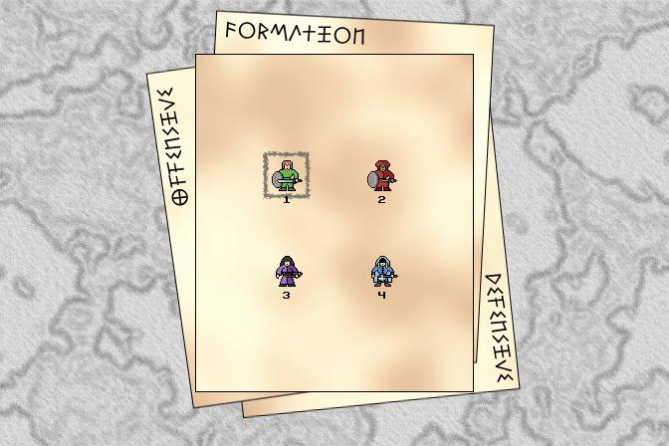
Party Formation
Press the number of the first player you want to change the position of. This will put a select cursor around the player (the box shown around player 1 here). Then press the number of the player you wish the change positions with. When you are done press the ESC key to return to the game.

The Map

As you explore you will build up a map of all the halls and rooms you have seen and visited. You can view your map for the current level by pressing the M (Map) key. The map will look something like this:
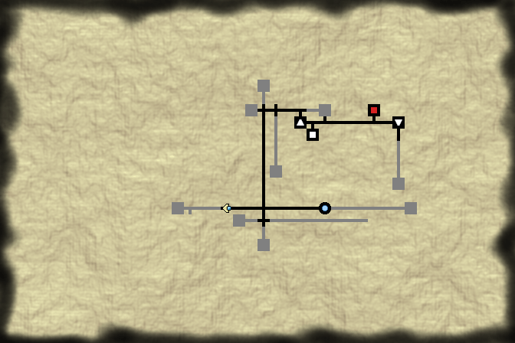
Map
Hallways and rooms in black are ones that you have visited. Items in grey you have merely seen. The rest is unrevealed until you explore it or find the level's Map item.

Put away the map by pressing M again, or pressing ESC.

Rooms and fountains are indicated on the map with special symbols. These are the ones for Quest For The King, check your module's documentation for the symbols used in other adventures.

 | Unexplored Room |  | Room with Vault
 | Room |  | Room with Living Statue
 | Room with Monsters |  | Shop
 | Up Staircase |  | Room with Fountain
 | Down Staircase |  | Fountain in Hallway
 | Party Location (points in direction party is facing)

Stairs & Maps

Your party moves between the levels of the dungeon via the stairs. Press the . (Stairs) key to use them. There are always one or more staircases on each level. Stairs are found only in rooms, either going up or down:

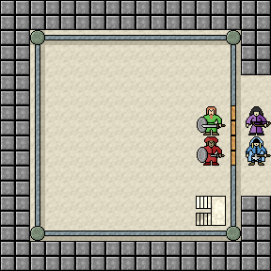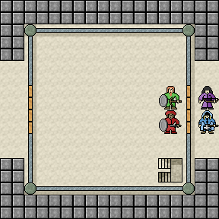
Stairs Up Stairs Down
You are always free to return up to previous levels, but you cannot go deeper into the dungeon until you locate the current level's Map item:

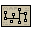
Map
Once you have that the whole floor's layout will be reveal (though rooms you haven't visited will not have their full contents shown). There are one or more Maps on each level, though sometimes they are hidden in chests.

Chests

Often you'll find a room contains a chest, like this one:

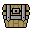
Chest
Open a chest by pressing the C (Chest) key, and then select who in the party will open the chest. Chests contains stashes of items, gold, and other goodies. However, they can also be trapped with devices that can injure the person who opens them, and sometimes the whole party! That's when it's handy to have a rogue-type character who is adept at avoiding traps.

Once a chest is opened it is replaced by a pile of all the loot that it contained.

Fountains

Fountains are wellsprings of magical waters bubbling up from deep in the earth. The are found both in rooms and in hallways:


Fountain
To drink from a fountain in the current room or one which in the same hall space as the players, press the F (Fountain) key. If there is more than one player in the party you will then be asked who wishes to drink. Players who drink from the fountain will receive the benefits (or afflictions) of the water's magics. Sometimes blessed effects may result, such as healing or increases in attributes, and sometimes dire ones, like wounding and misfortune. As you go deeper into the dungeon the powers of the waters increase, for both good and for ill.

Living Statues

Living Statues are mystical beings that can be found in places throughout the dungeon:

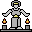
Living Statue
They possess the ability to identify unidentified items. Most magic items will have unknown properties when you first pick them up. You can determine what an item does by using it, but that can have dangerous consequences. As an alternative, you can present the item to a Living Statue, along with an offering of gold.

Press the A (Ask) key to ask a living statue about an item. You will first select who will talk to the statue. This will take you into this screen:

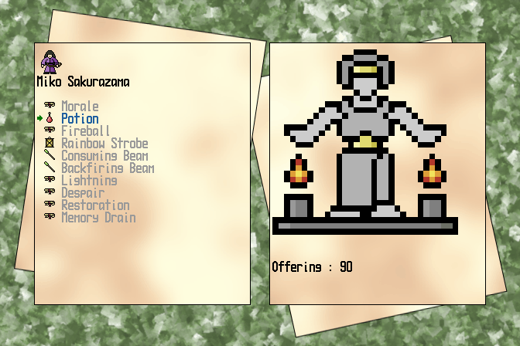
Living Statue Screen
On the left you will be shown a list of all the items that person is carrying. Identified items will be greyed, so selected an unidentified item with the Up/Down cursor keys. Once you're on the item you want to identify, press ENTER (or the A key again). Your current gold offering will be shown below the statue. Use the Up/Down keys to change amount. When you're settled on the offering amount, press ENTER to make the offer.

If the statue determines your offering is sufficient, it will identify the item for you. Play it cheap and offer too little though, and the statue will not only take your gold but also consume your item! So it pays to give a little extra when requesting the services of one of these beings.

Vaults

Vaults are hoards of treasure, locked away behind a secret code and a magical field:


Vault
When you encounter a vault, press the V (Vault) key to choose to open it. If you do, then you will next have to choose who will tackle the vault. (This is another time when a rogue-like character can be useful.) Once you've made your choice, you'll be taken to the Vault Code screen:

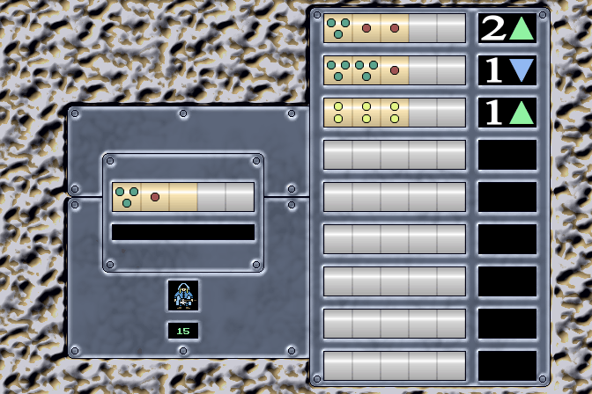
Vault Code Screen
Here we've already begun to make some guesses. The vault has a code to unlock it, as shown by the lock tumblers on the left. The gold tumblers indicate how many numbers are in the code (in this case, three), up to a maximum of five. The message window will tell us what the highest digit in the code is (this particular vault has a code with digits ranging from 1 to 3). You enter a guess by pressing the number key for each part of the code. If you accidentally enter a digit you don't want, press the Backspace key to remove it.

When you've entered all the numbers press ENTER and the vault shows your result on the right. This panel displays your 9 most recent guesses. The large number next to each guess tells you how many parts of the code you got right, and the triangle pointing up or down tells you whether the code is higher or lower than this guess. So we can tell from our guesses here that the code is higher than 222 (and it has at least one 2 in it, because 222 has 1 right code piece), lower than 331 (one part of which is right), and higher than 311 (two parts of which are right). It must be either 312 or 321, so we're about to try 312.

Below the code guessing area is a box showing the current player opening the vault and that player's hitpoints. There's a good reason to show the hitpoints - guessing the code wrong will
occasionally result in a shock to the player from the magic field around the vault. Too many wrong guesses can be deadly, so it pays to keep an eye on the guesser's hitpoints as well.

When you enter the correct code the vault will open up, revealing the treasures it contains. Vaults generally have more treasure than chests, so it pays to give it a try when you find one.

Context Help

At any time in the game you can get help on your available actions by pressing the / (Help) key. (The slash character shares a key with the ? on most keyboards, so you can think of Help as the question key as well.) This will display a list of common options for your current situation, with the relevant action keys highlighted. Here's an example, with the context help showing in the message area at the bottom of the screen:

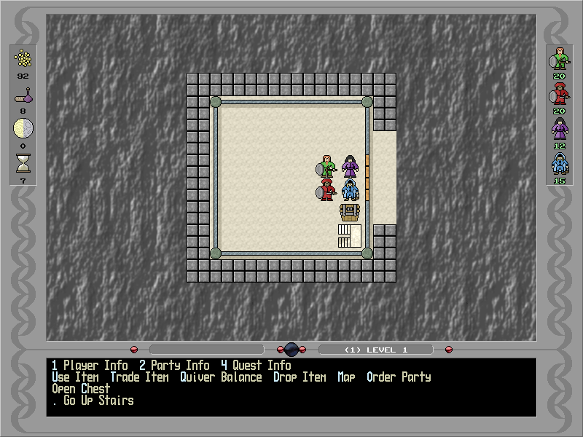
Context Help
Handy for when you forget a command or need options to consider.

VI. Items

Item Basics

There are many different items to find and buy in the dungeons. All items fall into one of four basic classes - Weapons, Armor, Magic Items, and Special Items. Each of these are major classes are further divided into more specific item types. Let's take a look at them, along with the treasure images that represent them in Quest For The King.

Weapons come in three kinds - Melee weapons, which are used in hand-to-hand combat, Ranged weapons which fire a projectile over a distance, and Thrown weapons which are thrown at the enemy and then must be retrieved before they can be used again. Players can carry two weapons, one equipped and the other as an alternate weapon they can switch to. Ammo for ranged weapons is often found among treasure piles as well.

Armor comes in two types - Body armor, which is worn over the whole body, and Special armor, which an accessory like a Shield or Cloak. Players can wear one armor of each type.

Magic Items are enchanted artifacts with a variety of powers and uses. The different types of Magic Items are - Potions, strange elixirs with unknown properties; Scrolls, which are read to invoke a magic spell; Wands, which fire spells over great distances; Lanterns, whose enchanted light can affect the whole environment; and Touchstones, magic gems that often confer powers simply by being picked up,

Special Items are those items who have a unique purpose in the game. As mentioned before, the Map item reveals the current level's layout and lets you proceed deeper with confidence, while Gold goes into your party's coinpurse for later spending, and Rations provide much-needed sustenance when a Shop is far away.

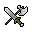 | 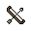 | 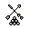 | 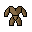 |  | 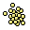 | 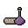
Melee Weapon | Ranged or Thrown Weapon | Ammo | Body Armor | Special Armor | Gold | Rations

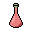 |  | 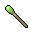 | 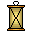 | 
Potion | Scroll | Wand | Lantern | Touchstone | Map

One other thing to know about items in general is that some items can only be used by certain character classes. For example, in Quest For The King many large weapons can only be used by the Fighter class, and only Wizards can use scrolls. This rules vary from module to module, so consult the information that comes with the adventure you're playing. Players who cannot use an item will be unable to purchase them in the shop (see the Shopping section for more information). They also will not be able to pick up or trade these items.

Equipment

We'll now go into some more depth about the items your players can equip. These are the weapons and armor items. As you would expect, weapons are primarily for dealing damage in combat, and armor is to avoid taking damage yourself.

Weapons have two basic characteristics - Damage, which is the most points of damage they can inflict on a hit, and Ammo, which is the type of ammunition a ranged weapon uses. Some weapons can be made to do more damage through enchantment, and they can also be weakened by some enemy special attacks. Any weapon weakened to 0 damage is destroyed. As a general rule weapons cannot be weakened or enchanted more than 5 points away from their base damage. So a dagger that does 4 points could be enchanted up to 9 damage, or weakened to 0 (and therefore destroyed), while a sword with a base damage of 8 could be enchanted up to 13 damage or weakened down to 3.

Armor has only one characteristic - Protection, the amount by which it lessens the chance of sustaining an injury. Armor is cumulative, so wearing leather armor with a protection of 3 and carrying a shield with a protection of 1 gives you an overall protection boost of 4. Armor can also be enchanted and weakened just like weapons.

Players can carry two weapons and switch between them, but can only carry one armor of each type. Players start the game with default weapons (such as Fists) and default armor (like Clothes). These default items are never lost and cannot be enchanted or weakened. If you lose a weapon or armor you will revert to using these default items.

Using Items

To use an item, press the U (Use) key. The current character's inventory is displayed. You can switch to another character using the Left/Right keys (except in combat). Use the Up/Down keys to select the item to use. Press ENTER (or the U key again) to use the item. If the item has to be used on a specific person or enemy (many potions and wands are like this), then you will need to select who to use it on. Choosing a party member is done through a simple menu in the message area, where numbered keys correspond to each player, while choosing an enemy is done with a targeting reticule just as when using a ranged weapon (see Combat for more information on using the targeting reticule).

All Magic Items have a charge, which is the number of times the item can be used. Some can only be used once, others may have many charges. This value is unknown, so be wise in your item use. Items which exhaust their charges disappear from the player's inventory.

Managing The Inventory

Each player can carry up to 10 Magic Items in their inventory. Unlike with weapons and armor, they can carry items that they themselves are not permitted to use. (For example, a Rogue carrying some extra scrolls for the party's Wizard.)

To get an item from a treasure pile press the G (Get) key. If the topmost item in the pile is a Special Item (Map, Gold, Ration), it will be collected and added to the party's goods. Otherwise you will be taken to the Item Gather screen:

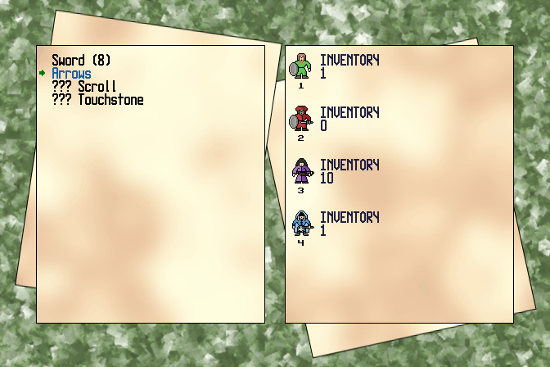
Item Gather
On the left is a list of all the treasure items to pick up. On the right is a list of the players. You can select which item to pick up with the Up/Down, and then give that item to a player by pressing the number key that corresponds to the number under the player picture.

You'll notice when you scroll through the items that if the current selected item is a Magic Item or Ammo, like in the picture above, then it shows each player's current inventory next to them. (Ammo does not take up any inventory slots, but is kept instead in a special quiver.) If the current item is a Weapon then it shows each player's two weapons next to them. Likewise, if the current item is armor then the player's two armor items are shown. This is to help you decide who can best use the item.

If a player cannot equip an item then their picture will be covered with the "Not Allowed" icon and they will not be able to pick up the item.

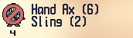
Item Not Allowed
If the player cannot use the item but can carry it, their picture will be covered with the "Not Usable" icon. They can still pick it up but will be unable to use it themselves.


Item Not Usable
Lastly, if the player simply has no more room in their inventory for the item, they will have the "Bag Full" icon drawn on them. They'll have to get rid of something if they want to pick it up, or otherwise have a friend carry it.


Inventory Full
Speaking of a full inventory, sometimes it's useful to be able to drop items. To drop an item, press the D (Drop) key. This will take you to the Drop Item screen:

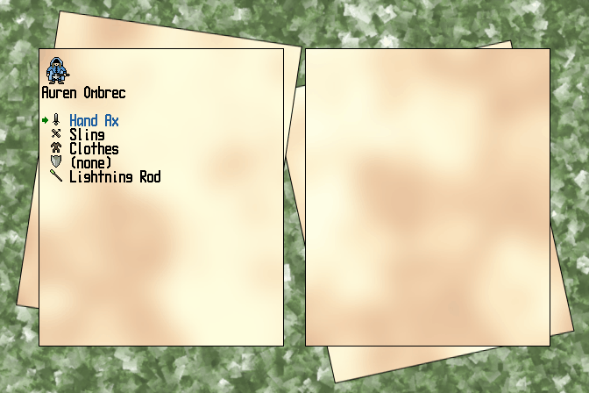
Drop Item
Here you'll see a list of the current player's items, both equipped and in the inventory. Change the active player with the Left/Right keys. Use the Up/Down key to select the item, and then press ENTER (or the D key again) to drop it. Note that you can only drop items in rooms. Should an item end up dropped in a hall during combat (for example, a thrown weapon or a treasure item dropped by defeated monsters), it must be picked up at the end of combat or it will be lost.

An alternative to dropping items is destroying them outright. Press the X (eXpunge) key to begin the process of destroying an item. The same screen as Drop Item is used, and it functions in the same way. The only difference is that when you press ENTER (or the X key again) to destroy the selected item, you will be asked to confirm the destruction by pressing Y(es) or N(o). Destruction is useful for disposing of weapons and armor that have been hopelessly corroded by enemy magics, or magic items that exert harmful effects.

The last thing to mention in item management is the Quiver Balance function, which distributes Ammo based on each player's needs. Press the Q (Quiver) key to balance the players' quivers. Then ammo is distributed to each player based on what weapons they are carrying. For example, if only one player is wielding a Short Bow, then all the other players will give her their arrows. If two players have a Crossbow then they will share the total of quarrels that the party possesses. This is an easy way get the ammo that various players have picked up into the hands that need it.

Shopping

Shops are a blessing to adventurers with coin in their pockets. Here the players can stock up on weapons, armor, rations, and even get healed. Shops are easy to spot by the presence of the shopkeeper:

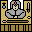
Shopkeeper
If you wish to engage the shopkeeper, press the P (Purchase) key. This will take you to the Shopping screen:

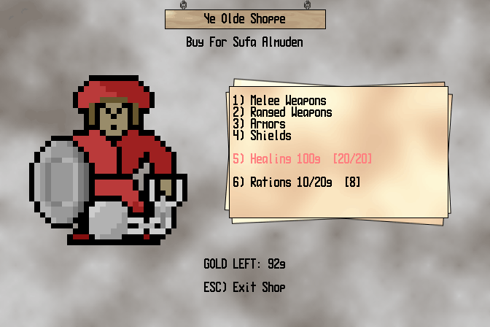
Shopping
From the main menu of the shop you can select Melee Weapons, Ranged Weapons (includes Thrown Weapons and Ammo for ranged weapons under the appropriate weapon), Armors, and Shields. Each of these choices will take you to another menu of the various items available. Items which you can't afford are shown in red, and items which the current player cannot use are shown in grey. As with most other screens, you can change the active player with the Left/Right keys. To buy an item you press the corresponding number in front of it. The party gold is shown at the bottom of the screen and updates with each purchase.

Healing buys a random amount of recovery for the active player. If you can't afford it, or the current player doesn't need it, it will be highlighted in red. The active player's current hitpoints and normal hitpoints are shown next to the healing in brackets. Shop healing is an expensive but risk-free way to recover from wounds.

Rations are sold in a pack. The picture above shows that this shop is selling a pack of 10 rations for 20 gold. The number in brackets at the end is the party's current amount of rations. Stocking up is a good idea, as the party only heals during exploring when they have rations to eat.

When you're done shopping, exit the shop with the ESC key. This key will also take you out of any submenu and back to the main shop menu.

Trading Items

You can trade items between your party members with the Trade screen. When you have two or more people in your party and you want to pass items between them, press the T key. This will open the trade select screen:

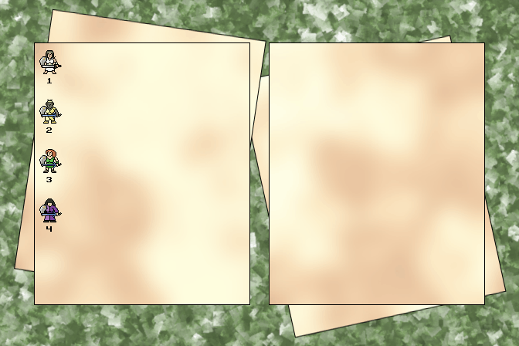
Trade Select
Your party members will be displayed with a number below each of them. Press the appropriate numbers to select the traders. If we press 1, it will select the first player and show us their inventory, like so:

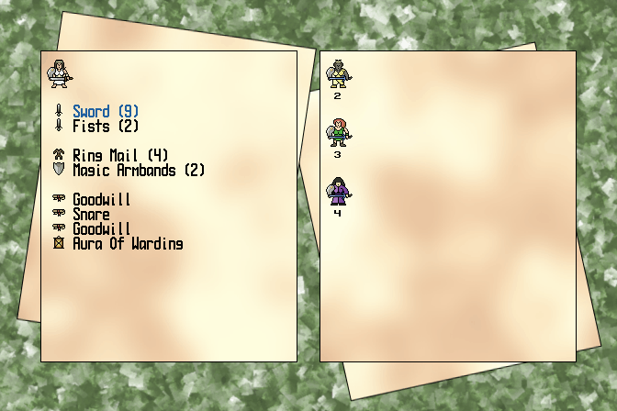
First Trader Selected
Now press the key for the other trader. Here we'll press 2, which gives us this:

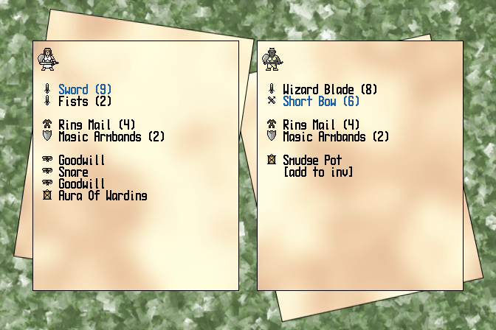
Second Trader Selected
Now by pressing the UP and DOWN arrows we can select what the first trader will give to the second trader. The selected item is show highlighted in blue text. Notice that the second trader has a blue highlight as well - this it the item that will be traded in place of the one they receive. The second trader will always trade an item of the same type whenever possible. If they are receiving a weapon, they will trade back their secondary weapon (if any). If they have space in their inventory for an item, then the [add to inv] option will be selected. Otherwise they won't have room for the item.

The "Item Not Allowed", "Item Not Usable", and "Inventory Full" markers will appear here as well as the situation warrants. If you're having trouble getting the right item to the right player, have the receiver trade with another character first, or perhaps change their current equipt weapon.

VII. Combat

Encountering Enemies

Entering the dungeon means entering enemy territory. Hostile monsters and their dark masters inhabit the depths, and battles are frequent. Any time you enter a room with enemies in it, you have only three choices - run, negotiate, or fight. Running won't get you very far and bribery will quickly exhaust your gold, so sooner or later you'll have to fight. And let's face it, exciting battles are what it's about.

There are two different opportunities for the chance for battle to arise. First are the room in which monsters are stationed. You are guaranteed to run into many rooms inhabited by foes. These rooms will remain held by the monsters until you defeat them (or bribe them to leave). You can avoid these rooms if you wish, but sometimes you will have to fight to get where you need to be.

Combat Information

Before entering into combat it's useful to have some information about your enemy, as well as your own odds against them. One of the ways to obtain information is to consult the Bestiary. When in a room with monsters, press the 3 key to bring up the Monster Info screen:

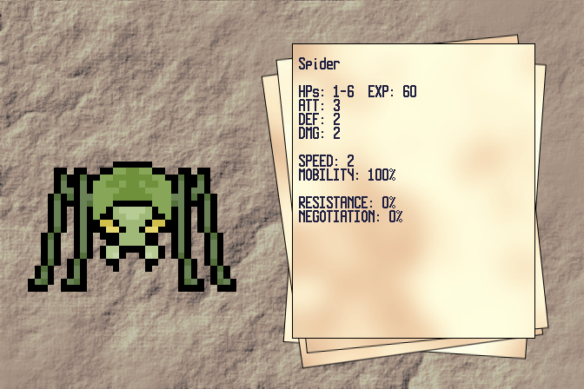
Monster Info
You'll see a large drawing of the monster in question and a sheet of important statistics.

At the top is the name of this type of monster. Below that is the range of hitpoints an specific monster of this type can have. Beside that is the amount of experience a player will gain from putting the finishing blow on this monster. Beneath that is the Attack rank of the monster (comparable to player Level), the monster's Defense rating (like Armor), and Damage (the maximum damage it can inflict, just like a Weapon's damage rating).

Next up is Speed. Most monsters have the same speed as players, 2, but some are faster. A few dangerous creatures have been spotted with speeds of up to 5, meaning they can attack many times in one round. We'll cover speed more in a moment.

Below speed is Mobility. This is how likely the creature is to move on any given turn. Some creatures are slow-moving, others are relentless in their pursuit of your players.

At the bottom you will find Resistance and Negotiation. Resistance is how likely the creature is to resist hostile magic. Some creatures are completely vulnerable to magic, others have innate magic or learned skills that let them avoid magical strikes. Negotiation will be discussed shortly, but essentially this number is the chance that the creature is willing to entertain a bribe of gold.

Exit the Monster Information screen by pressing 3 again, or by pressing ESC.
The other bit of combat information you can easily access are the battlegems that appear next to each player when in the presence of enemies. These are visible in the party area on the side of screen, like so:

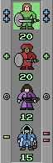
Battlegems
The gems on the left of the character show how good (or bad) the odds of landing a hit on the monster is. The gems on the right show the odds of the player avoiding a hit themselves. The best odds show as two blue gems shaped like plus signs, good odds as one green plus sign, basically even odds as a grey zero, bad odds as one yellow minus sign, and the worst odds as two red minus signs. Use this information to help decide when to press the attack, when to shield a fellow player, and when to run for it.

Finally, if you notice the green square behind the top player in the image above, this is the Action Indicator. It shows who is the current active player. When it is green the player can move or perform an action (like an attack or using an item). When it is red (usually after the player has moved), they can only perform an action. When the last player in the party has acted, it is then the monsters' turn.

Moving In Combat

Players and monsters alike have a speed attribute. Most players have a speed of 2, unless altered by magic (or modified by the module you're playing). Some monsters have a greater speed, which lets them do more per turn than is typical.

Movement in combat uses up 1 speed point per turn. However, the last speed point cannot be used for movement, only for actions, so effectively most players can only move one space per turn. Movement is controlled with the cursor keys. Players cannot move onto or through other players, monsters, or room features.

Attacking or using an item ends the player's turn, regardless of whether they would have another speed point left after the action or not.

Monsters move with the same movement costs, but they can also move diagonally. They can attack diagonally as well, so plan your position strategy with this information in mind.

Using Weapons

Melee weapons are the easiest to use. You simply move into a monster to attack. If your attack is successful you will see a damage number appear on the monster, showing how much damage your hit did:

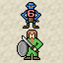

Do enough damage and you'll defeat the monster, earning an experience reward in the process:



Ranged & Thrown weapons are a bit more involved to use. First you press the F (Fire) key to begin the targeting procedure. A targeting reticule will appear, and you can switch it among the various monsters by pressing the F key repeatedly:

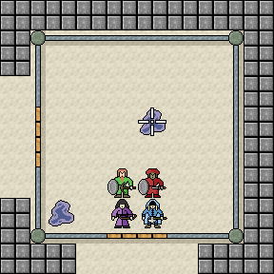
Targeting An Enemy
Once the reticule is on the enemy you want, press the SPACE bar to fire. This same procedure is used for magic items (like Wands) that have targeted effects. As with melee weapons, you will see a damage number (or magical effect) after a successful hit.

Using Items In Combat

Items can be used in combat just as you would when exploring. Indeed, many items are useful only in combat. The restriction in combat is that only the current player can use an item. Once their turn has passed they can't use an item until their turn comes around again. Item use also uses up all current player speed points for that turn.

Passing A Turn

If you don't want a specific player to do anything that turn, or if they have action points left you don't want to use, you can end their turn with the Z (snooZe) key.

The Enemy Turn

When all the players have used up their speed points for the turn, then the monsters will act. They may move, attack, and utilize their special powers up to the limits of their own speed. When all their actions are done the players get another turn with all their speed points restored. That is, assuming they survived the previous round.

On Death And (Not) Dying

Players whose wounds equal or exceed their hitpoints go into "ghosted" mode. They cannot fight or defend themselves, and are restricted in the acts they can perform. They are not drawn in the room view, and are shown in the party display with the ghost icon:


Ghosted Player
Ghosted players can be healed and otherwise restored, as long as there are active party members left. Should the entire party become ghosted then the game is over.

Negotiation

An alternative to combat is negotiation. To begin negotiations, press the N (Negotiate) key. If the monsters are agreeable to being bribed, you will enter the Negotiations screen:

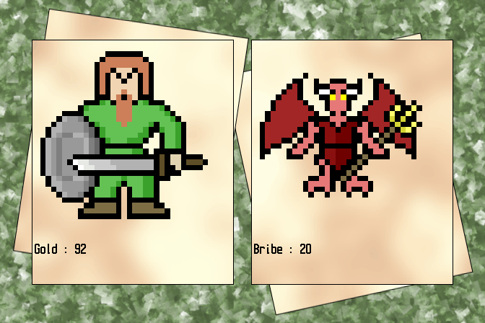
Negotiating
The party's gold is shown on the left, and the current bribe on the right below the monster picture. Change the bribe amount with the Up/Down keys, and press ENTER when you reach the amount you wish to offer. If you are successful then the monsters will depart. Offer too little and they will attack. Failed attempts at negotiation also give the monsters control of the turn, so check the monster info first to see how likely they are to negotiate. Monsters with a 0% negotiation will never negotiate, even when plied with magic.

You can negotiate at any point in combat Some monsters are smart enough to realise when you're desperate (or when they're losing) and will listen to your offer even after a few rounds of hacking and slashing.

Escape

The final stratagem for dealing with a room full of enemies is to flee. In order to do so, you must move all active members of your party outside of the room's door. Furthermore, they must all be outside the same door. It doesn't do you any good to have half you party in the southern hall and the other half in the eastern. Once everyone is out then the party has escaped, and they can withdraw to plot out other strategies.

VIII. Quests

Quest Overview

Quests are the overall goals your party has in their exploration of the depths. In the Quest For The King, you are looking to rescue your King from his monstrous captors, and also recover his arcane Rainbow Orb. Other modules will have other quests. When all quests have been finished (or time has run out on them), you must then head back up to the dungeon entrance (the first Shop). Once your party is there, the game ends and your success is evaluated.

You can view your quests by pressing the 4 key, which brings up the Quests screen:

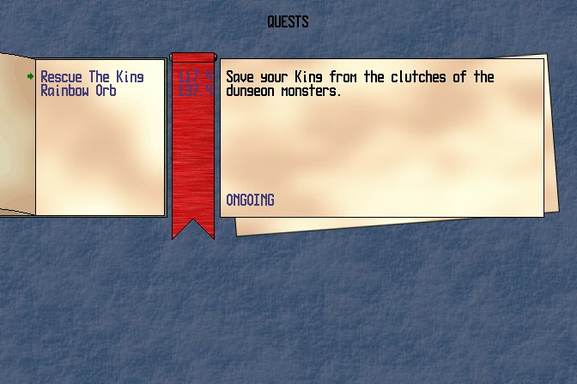
Quest Information
The Book of Quests on the left lists all your quests, while the Ribbon of Time shows how many Turns and Rounds you have left to complete them. The pages on the right show information about the current quest and its status (shown here as ONGOING). Move the select cursor with the Up/Down keys to view the information on other quests. Press 4 or ESC to exit the Quests screen.

Timed vs Timeless

Quests can be timed or timeless. Timed quests must be completed within a certain number of turns. Some timed quests are "partial" quests, in that you can still complete them when time has run out, but your success is less notable. Timeless quests never expire and remain until they are completed.

Measuring Success

When you have completed the final quest, you will be presented with a screen that shows you how well you did overall. This will differ from module to module, but you should get a good idea if you failed miserably, squeaked by, or triumphed completely.

Command Key Reference
Function Keys
F1 | Load Game
F2 | Save Game
F5 | Switch between Fullscreen and Floating window mode
F12 | Quit ToDR
Menu Keys
ESC | Exit Menu
1 | New Game
2 | Load Game
3 | Load Party & Generate New Dungeon
4 | Save Game
X | Game Options
ENTER | Confirm Menu Selection (where needed)
BKSPC | Erase One Text Letter (when naming character or game file)
DEL | Erase All Text (when naming character or game file)
Common In-Game Keys
/ | Help
1 | Player Info  - Use ⬅➔ to change displayed player
2 | Party Info
3 | Monster Info (in combat only)
4 | Quest Info
O | Change Party Order
M | Map
U | Use Item  - Select item to use with ⬆⬇  - Press ENTER or U key to use item  - Cancel with ESC key
I | View Inventory  - Use ⬅➔ to change displayed player
W | Swap Equipped Weapon (when viewing Player Info)
X | Destroy Item/Equipment  - Use ⬅➔ to select player who will destroy item  - Use ⬆⬇ to select item to destroy  - Press ENTER or X key to destroy item  - Press Y key to confirm destruction, or N to cancel  - Press ESC to exit destroy screen at any point
ESC | Cancel Current Action/Show Main Menu

Dungeon View Keys
⬆ | Move party forward
⬇ | Turn party around
⬅ | Turn party left
➔ | Turn party right
B | Break Through Door (moves whole party into room)
L | Listen At Door
S | Search Hallway For Hidden Doors
Room View Keys
⬆ | Move party out North exit
⬇ | Move party out South exit
⬅ | Move party out West exit
➔ | Move party out East exit
. | Use Stairs
P | Purchase Items From Shop
D | Drop Item/Equipment  - Use LEFT/RIGHT arrows to select player who will drop item  - Use ⬆⬇ to select item to drop  - Press ENTER or D key to drop selected item  - Press ESC to exit drop screen
G | Get Items On Floor  - Party items like Gold and Rations are automatically added when "got"  - Individual items must be given to specific players  - Select the item to get with ⬆⬇  - Give item to a player by pressing the number key that corresponds to the number below them  - Players cannot be given items they cannot equip, or which would exceed the limit of their inventory size
T | Trade Between Players
Q | Balance Quivers (distributes ammo between players with appropriate weapons)
C | Open Chest
V | Open Vault  - Select player who will open vault from list (except in solo mode)  - Input your guess using number keys (use BACKSPACE to correct errors)  - Press ENTER to submit guess  - Give up on vault with ESC key
F | Drink From Fountain
A | Ask Living Statue About An Item
S | Search Room For Hidden Doors

Combat Keys
⬆⬇⬅➔ | Move active player into empty space, or attack adjacent enemy with melee weapon
U | Use Item  - Select and use item as per general Use command  - If item affects one player, select which player from list that is shown (solo mode games automatically pick only player)  - If item effects one enemy, game switches to Fire mode
F | Fire Weapon or Item  - Use F to move targeting reticule onto desired enemy  - Use SPACE bar to fire when ready
N | Negotiate
Z | End Current Player Turn (in combat)
ESC | Cancel Current Action
Shop Keys
⬅➔ | Change Current Buying Player
1 | Shop For Weapons
2 | Shop For Ranged Weapons
3 | Shop For Body Armor
4 | Shop For Special Armor
5 | Shop For Healing
6 | Shop For Rations
ESC | Exit Current Menu/Exit Shop (when at top menu)

