Adding an appointment to the Appointment Calendar after clicking the “Add” button.

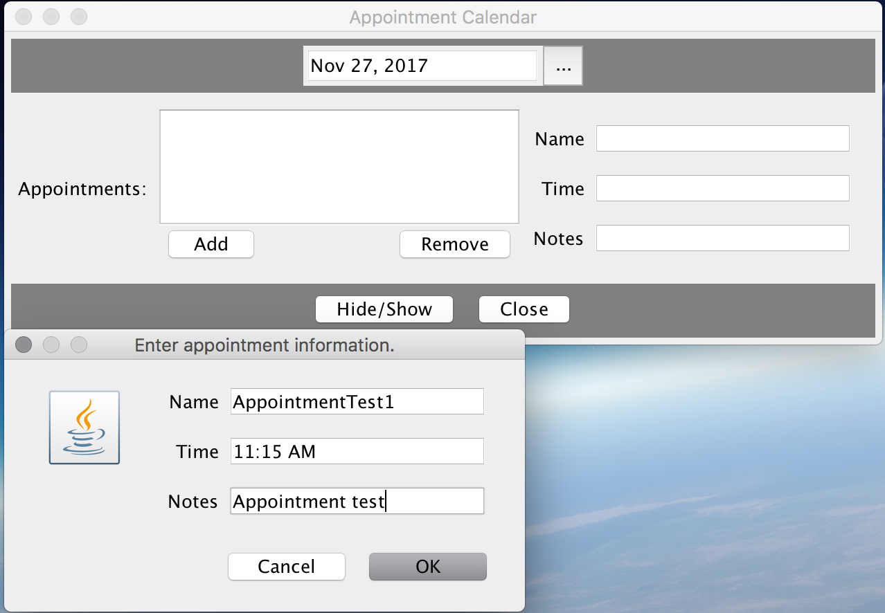

Appointment is added to the ListView, and displays all the appointment information while selected in the ListView.

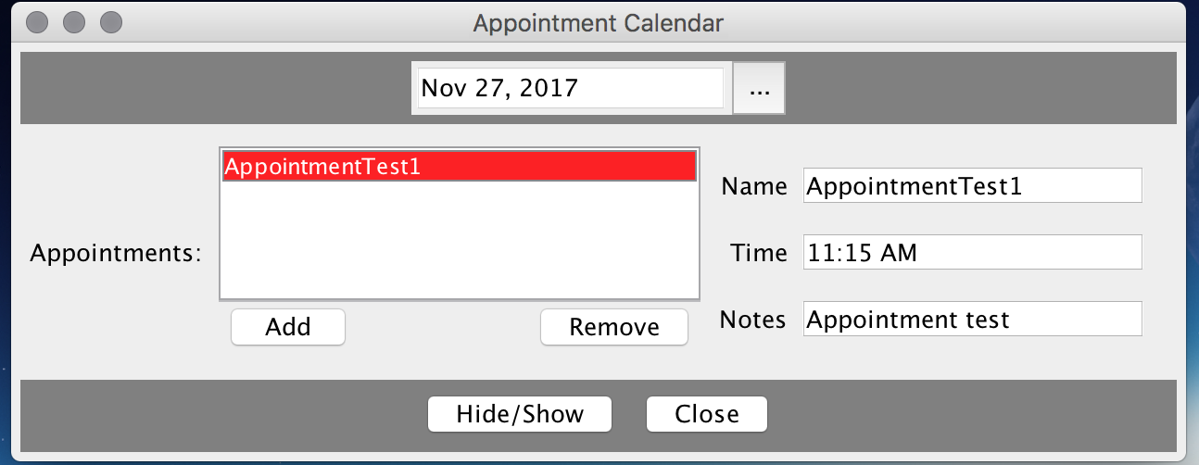

The appointment has been removed by clicking the “Remove” button, and the form displays nothing since there are no selected appointments.

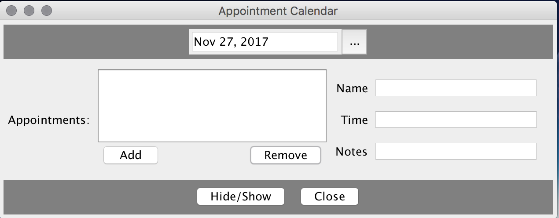

Added two appointments and displaying the information from the first appointment.

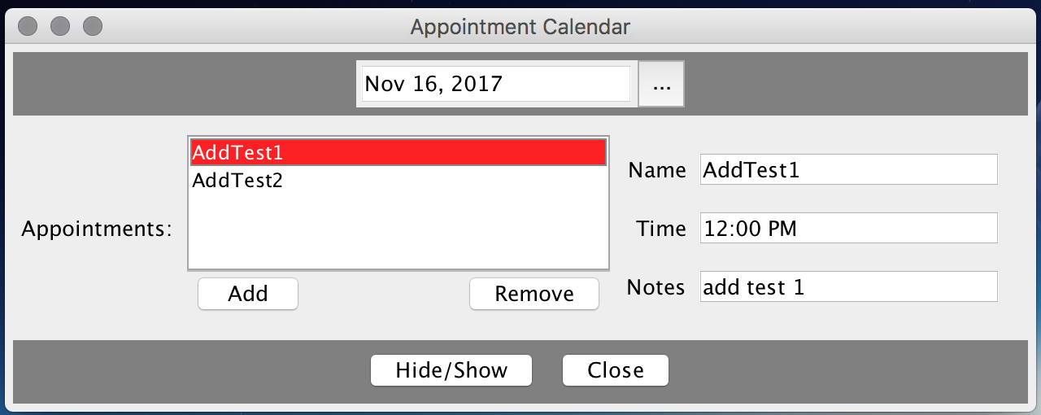

Display the information for the second appointment.

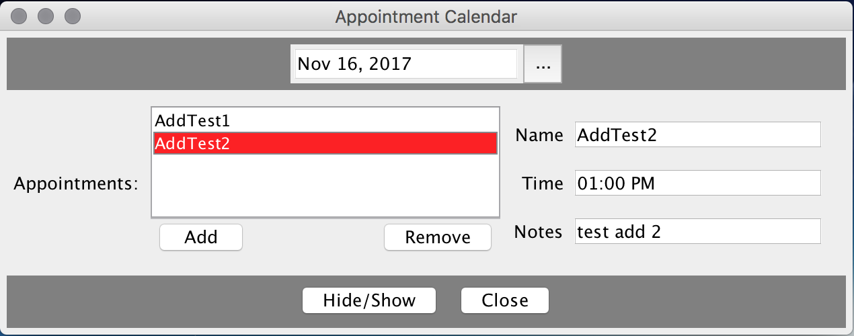

Remove a single item AddTest2 which removes the appointment information from the form. One appointment still remains for Nov 16, 2017.

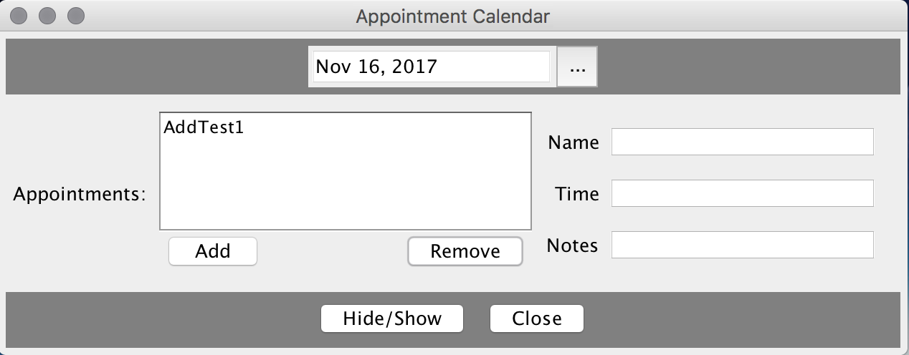

Remove AddTest1 from the ListView, and now there are no appointments for the date of Nov 16, 2017.

