**Why I chose Tocumwal**

I chose Tocumwal because I have used the information on the Tocumwal Archives in my pervious two assignments as they images are a lot more intriguing. The information provided was laid out nicely and for someone like me who is a beginner to programming, it would be the best way forward.

The websites I essentially use on a day to day basis usually revolve around sports, there is a wide variety of colours on display and it is very enticing, hence why I used a couple of images on my index page.

The index page is very simple, I aimed to make it simple and easy to use for people as they know where they will exactly head to. Basic navigation is the only thing I personally know, as the websites I usually visit seem to be very basic. I have a navigation bar at the top with 5 headings, these headings include: Home, Tocumwal background, Heritage Listing, Origins and From Tocumwal to Canberra.

It may be a simple navigation, but it is effective I believe. It remains on the top of the page towards the left throughout all the pages, so it is easily accessible. The design of the website stayed consistent through all the pages and it acted as a simple way for people to gather their information.

Attached is a photo of the navigation:

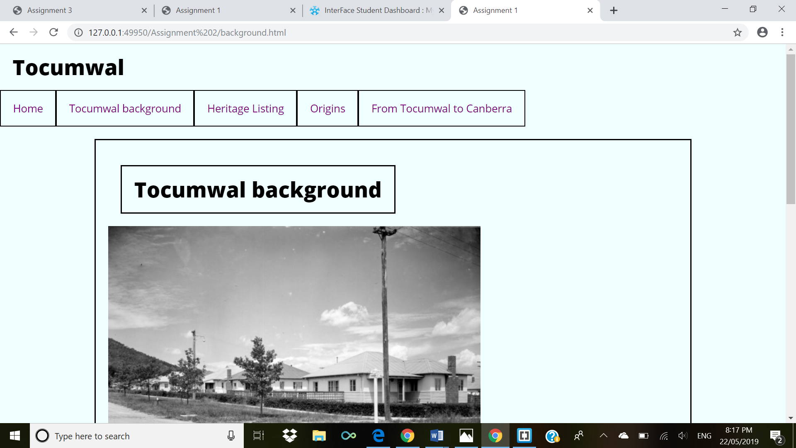

Simple, yet effective… the whole element of my design factor was to keep it simple; this was made clear right from the get-go and it is evident through the ease where one can navigate.

**Design Choices**

I went with the Azure colour as the background colour through my website, this was because I believe it is a nice and crisp colour, it was also a bit more exciting than white and it kept my text very easy to read.

The whole reasons for my design was just to keep it simple. I kept the font and font size at the standard and also just used black as the colour for my text because of the ease it is to read on the Azure background.

The navigation was at the top left of the page, this is because people generally read from left-to-right and it was just natural for the viewer to start at the top left and gradually descend down the page.

I put in a couple of black and white photographs, these worked really well with the colour scheme of the website.

**Designs that inspired me**

I have to be honest, no design really inspired me for my website, I had not much idea of how I wanted my website to look, but I just was focused on creating a cool and easy to use website. I am a Sports Media student and I spend my time on the web browsing through sporting content, I spend a lot of time on the Canberra Raiders website.

It is a simple site and it follows the same structure as NRL.com and all the other NRL clubs, however it is very easy to use and the colours and use of media intices me, I cannot say I inspired to create my site like the Raiders site, however it is the quintessential design and layout for an avid NRL fan.

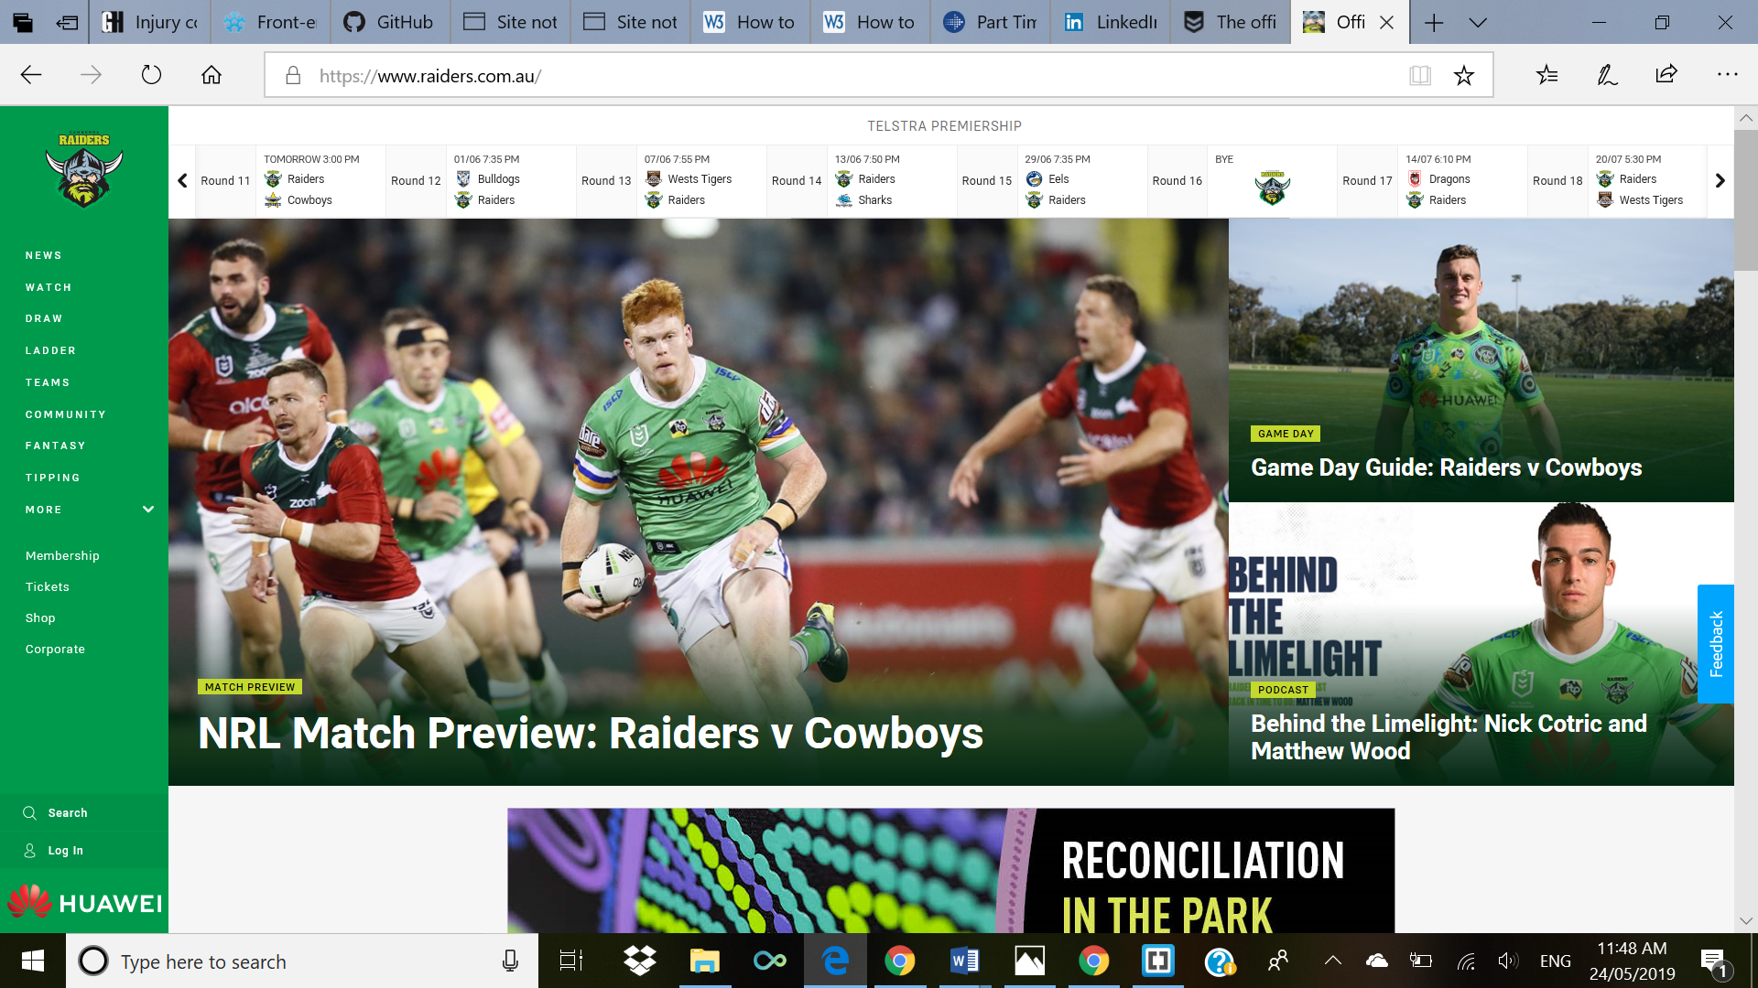

**Overall approach that guided the design decision**

I am new to coding and programming; this was all a new process for me… I had very little idea on how I would design my site, so I decided that I would keep it relatively simple.

The websites that inspired, as mentioned above, did not really play a big part in my approach to designing my site, however I liked how easy they were to use and that the draw was at the top so fans could see when their team plays and what time.

My second assignment inspired me to follow a similar template as it was the first time I have worked with Cascading Style Sheets (CSS) and I wanted to try and develop my skills from the knowledge I already had, it was as simple as just building on what I had and the weekly tutorials definitely helped in my design approach.

**Reasons for design decisions**

The NRL and Canberra Raiders site lacked a title home page, a title home page would have given the users a simple bit of information of what the website stands for.

Another website I visit frequently is the Sunderland AFC website, they have title homepage with a lot of information available.

Again a simple design, but effective, it was a design I wanted to follow because of the simplicity over the design and the ease of use.

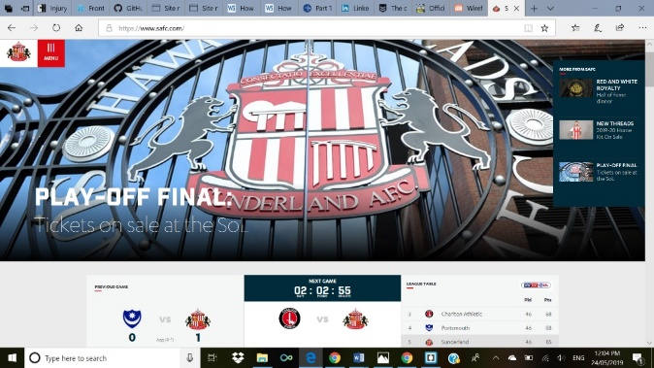

**Description of challenges you encountered and how you solved them**

Being a Sports Media student and never doing anything like this previously, I encountered a plethora of problems, a lot of them were an easy fix but it was the first time I had ever done any programming or coding.

Class time with Riley was vital in solving my problems, I had a lot of solvalbe problems as simple as not closing my tags and Riley was more than happy to assist me on a number of occasions, I required extra help and Riley saw that and assited me.

I found it very hard to keep up with the rest of the class, the other students seemed to be a lot further advanced than I was and it was something I struggled with. I would often look around and saw many doing something that I hadnt even started yet, to overcome this I relied on Riley and his knowledge, he was very helpful and I believe if it was not for him, I would have never even gotten this far in the unit.

A thing I often found myself doing was not closing my tags, it was just something I often forgot to do. I believe it was because I had never done this before and it was just rookie erros, running my code through the WC3 validator helped, it showed what I was doing wrong and helped me eradicate my errors.

CSS was also a big challenge for me, HTML in the first part of the semester was painful, however I got more comfortable with it towards the end, CSS was a completely new langauge for myself and so much to take in, I watched multiple tutorials on how to master CSS, which did help, but it is still something I am not particulary comfortable with.

Riley was the main reason for my problems being fixed, he explained things in a way I could understand and made it easier for me to do. I reached out to him via email to complete this final task and he was very helpful, I am very proud of myself with how hard I pushed myself to complete this unit.

**Idea sketches for different devices:**

Mobile:

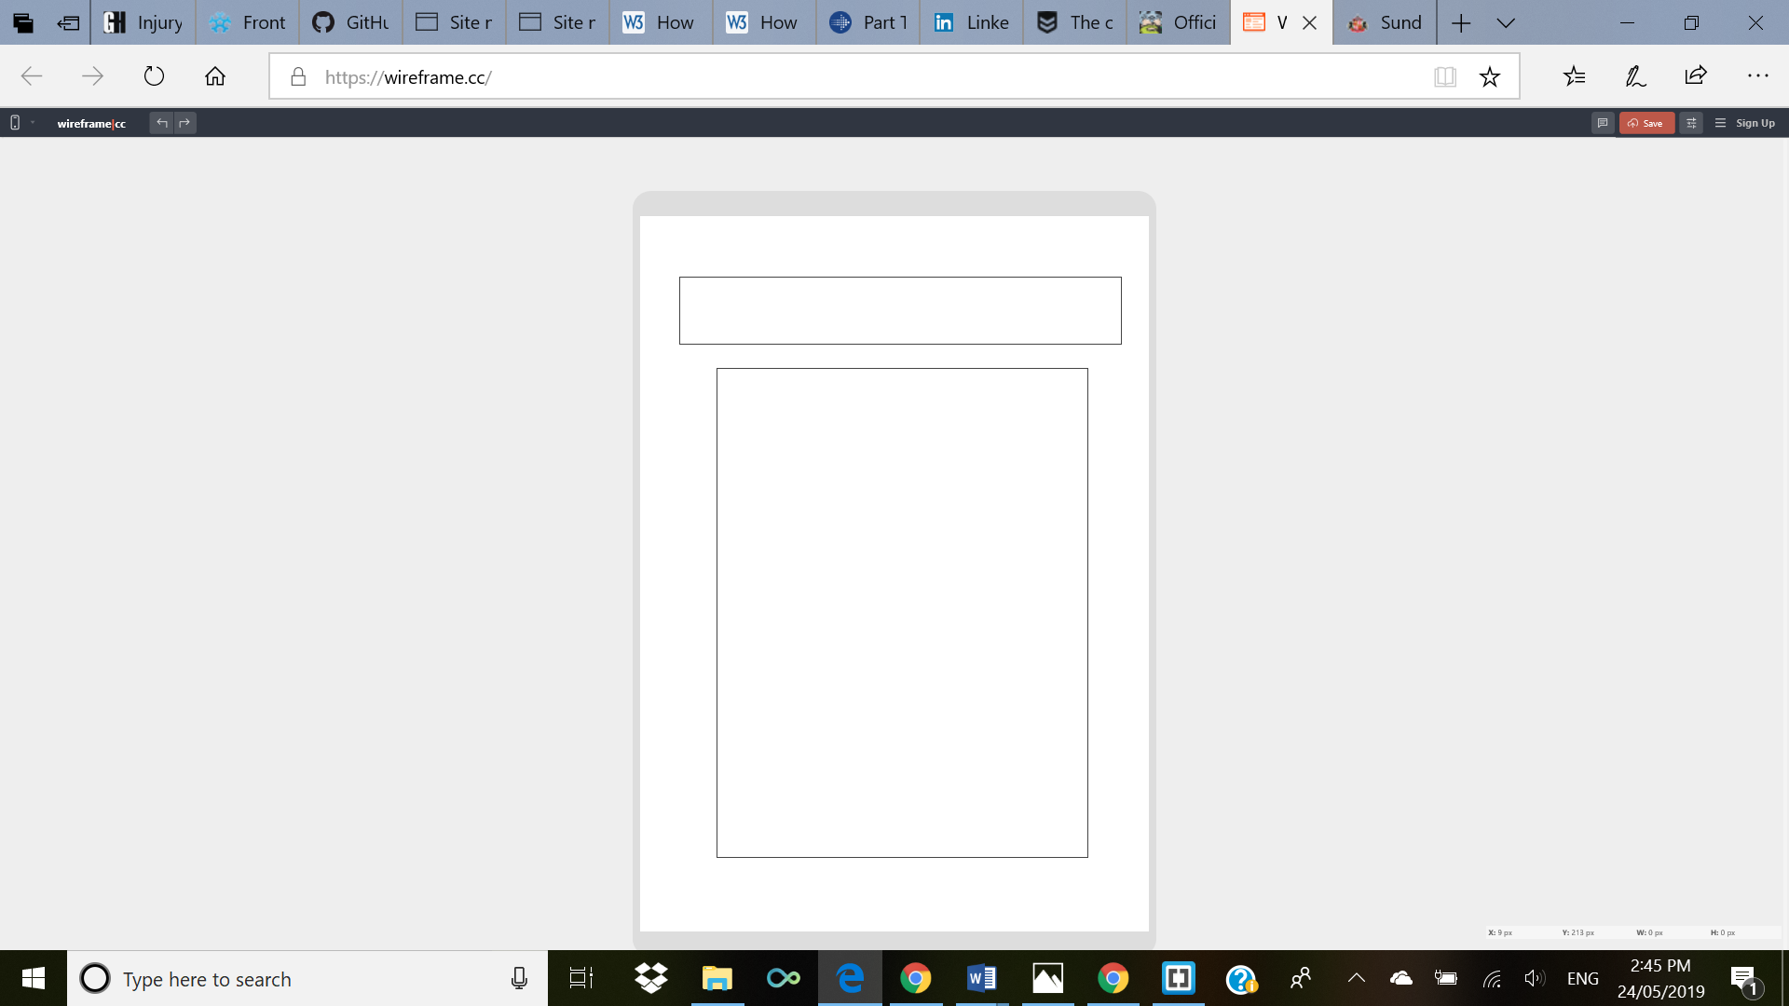

Desktop:

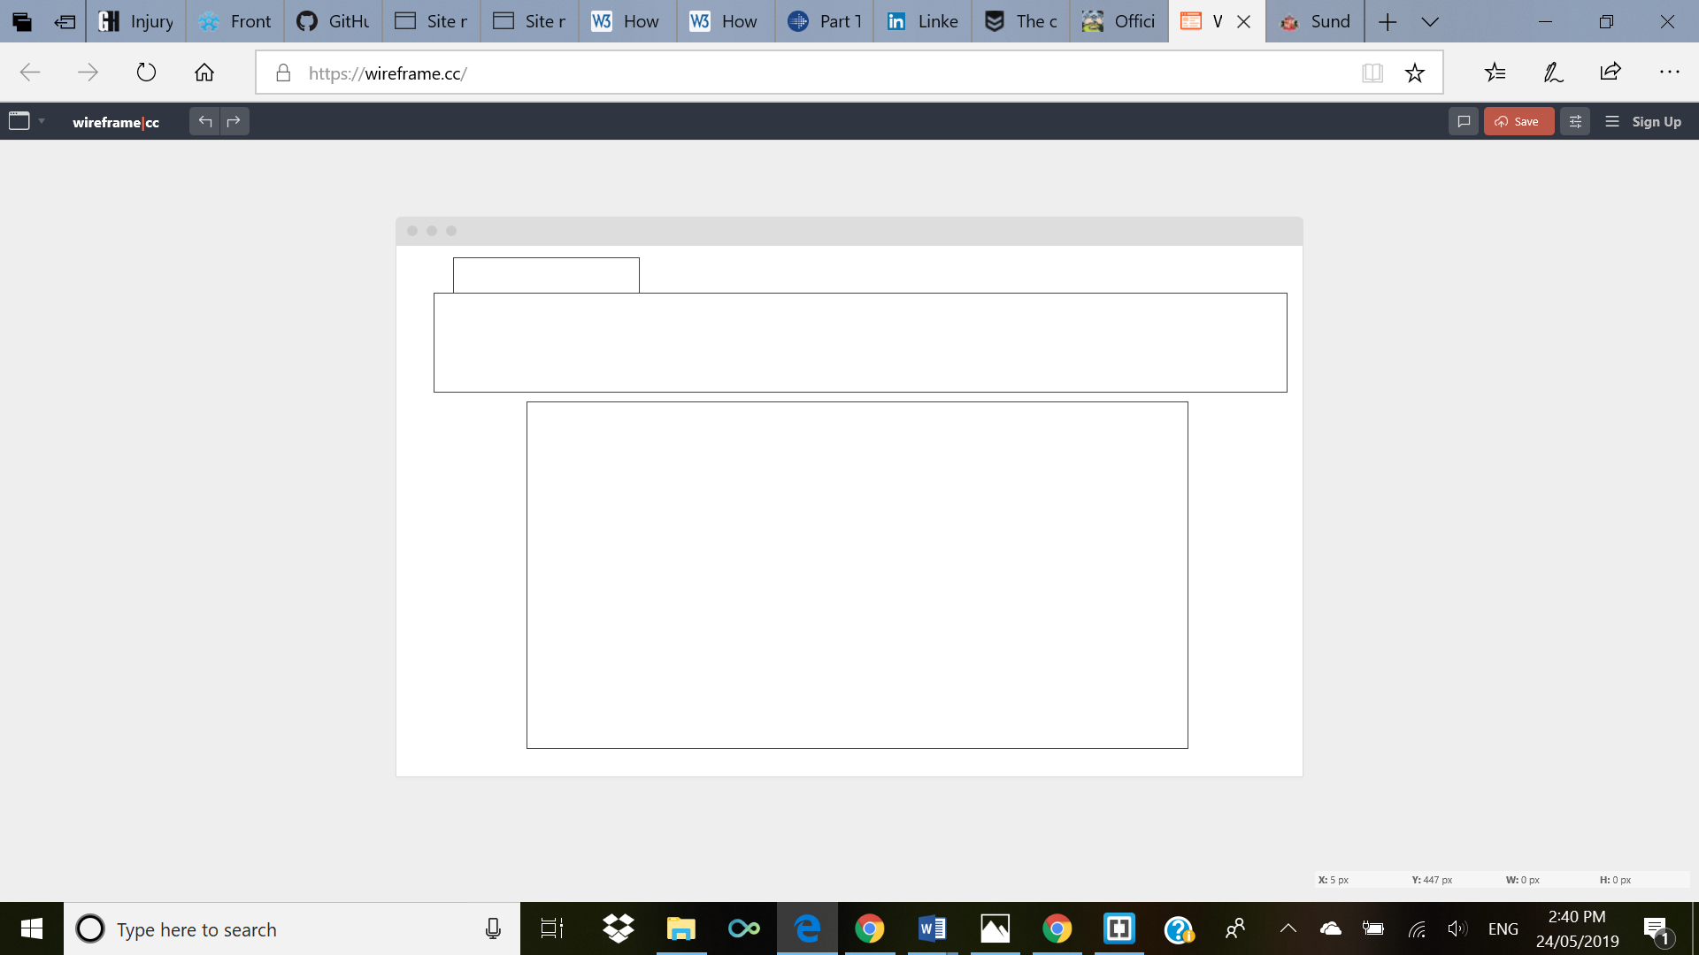

Tablet:

