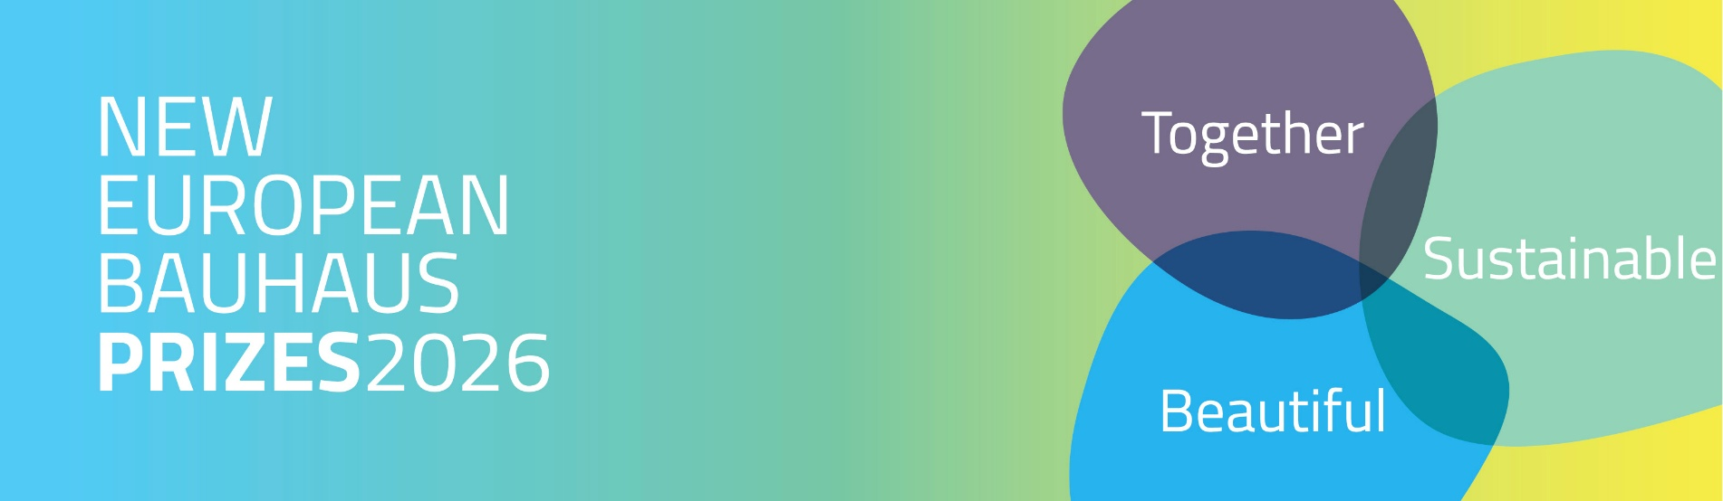

Application Bootcamp
Date 11th March 2026 – STRAND B – Rising Stars

Transcript
11 March 2026, 12:01pm
Sara Nardi
(SLIDE 1) Good afternoon, everyone. My name is Sara Nardi, and I am pleased to host this application boot camp for potential applicants to Strand B (Rising Stars). I am joined today by Alessandra from DG REGIO, representing the European Commission.

Before outlining the format, I will invite Alessandra to deliver her introductory remarks.

Alessandra Biscaro (DG REGIO)
On behalf of DG REGIO of the European Commission, I would like to welcome all participants. This boot camp session is designed to support potential applicants to the Rising Stars strand of the New European Bauhaus Prizes 2026.

Sara will share practical guidance, examples from past prize-winning projects, and recommendations on how to present your concept effectively.

(SLIDE 2) This year, a total of 13 prizes will be awarded. For the Rising Stars category, each winner will receive €15,000, in addition to a communication package and tailored coaching support. Several runners-up will receive €5,000 each. Winners will be announced during the annual award ceremony organised by the European Commission.

The 2026 edition introduces several important developments:
- Four new prize categories,
- A thematic prize focused on water resilience, and
- Further international expansion.
In addition to the Western Balkans and Ukraine, Moldova is now eligible to participate. Applications are also open for the first time to candidates from Brazil and Japan through a dedicated international prize.

For further information on eligibility criteria, categories, and the special prize, please consult the Guide for Applicants available on the Prizes platform. You may also review the recordings and materials from last week’s information sessions. Should you have additional questions, please use the contact form on the platform.

We recognise that many applicants are still working on draft submissions, which is already a positive step. We encourage you to use today’s guidance to refine and submit your applications before the deadline of 17 March at 19:00 (CET).

I now return the floor to Sara.

Sara Nardi
The application boot camp is a new initiative designed to support applicants in navigating the application process. While many of you are already experienced in developing and implementing projects, articulating these ideas in a structured application can be challenging. Our aim is therefore to provide strategic guidance that will facilitate this process.

The session will focus on:
- Understanding the application structure,
- Developing a strategic approach to drafting responses, and
- Drawing inspiration from previous prize-winning projects.

If possible, participants are encouraged to have their draft application open or to take notes during the session.

This format is intended to provide practical advice on writing a compelling application. A compelling application is both persuasive and engaging. While there is no single approach to effective writing, certain key elements consistently strengthen applications, and these will be highlighted throughout the session.

Please note that this session will not address project-specific questions. For such queries, participants are advised to consult the resources available on the website or submit questions through the designated channels.

(SLIDE 3) Applicants for the Rising Stars strand must be under the age of 30. Projects may already be implemented or still at the conceptual stage. Eligible projects may include:
- Place-based initiatives implemented in a specific location, or
- Innovative tools, materials, methodologies, or conceptual approaches with broader applicability.
In either case, applicants should demonstrate both contextual relevance and potential for replication or scaling.

Examples include projects addressing water resilience or circularity, which may be either location-specific or methodological in nature.

(SLIDE 4) Regarding water resilience, projects may similarly be either location-specific (e.g. flood interventions in Faenza) or methodological innovations such as the Warka Tower.

(SLIDE 5) To illustrate, previous winning projects include:
- “Republica” in Amsterdam Noord (a place-specific project), and
- “Living Places” in Copenhagen (a methodological approach to affordable housing).

Let us now proceed with an overview of the application form.

(SLIDE 7) Application form overview
Participants are encouraged to familiarise themselves with the structure of the application form. Each section is designed to complement the others and should not repeat the same content.

Key sections include:
- Project overview – title and short description (used for communication purposes).
- Detailed description – concept, results, and project narrative.
- Adherence to New European Bauhaus values and principles.
- EU competitiveness – including business model and scalability.

From Section 2 onward, responses will be evaluated in detail. Applicants should therefore adopt a strategic approach to structuring content.

(SLIDE 8) Tips to always keep in mind
When drafting responses, applicants should:
- Familiarise yourself with the application structure and determine how best to communicate key information.
- Write a story having the receiver in mind
- Provide concrete examples.
- Emphasise measurable results and long-term impact.
- Use data and user testimonials to support claims and illustrate impact.
- Position your project as both an embodiment of New European Bauhaus principles and a contribution to the green transition.

(SLIDE 9) This year, each question is accompanied by sub-questions to guide applicants. These are available in Annex 1 of the Guide for Applicants.

(SLIDE 10) Applicants for the Water Resilience Prize should also consult Annex 2.

(SLIDE 11-12) Project Overview
Now we are ready to dive deeper into each section, one by one. We start with the Project Overview. As mentioned before, this part is not the foundation for evaluation, but it’s still important to write a catchy description of your project.

(SLIDE 13-14) Detailed Description
This is where evaluators focus on the content of your application and decide whether your project is unique, exemplary, and strong. We will walk through selected questions, showing how they are asked, offering tips, providing examples from previous winners, and highlighting the strengths of those applications.

Tips for writing:
- Start with a very short description so the reader immediately understands your project.
- Then, provide a longer description of achieved results: testing, user response, and projected impact. Consider not just immediate outcomes but long-term impact – on your community, society, and in general.

(SLIDE 15) Example of application response
- Connects aesthetics, inclusion, participation, and beauty.
- Intentionally engages people who would otherwise be excluded (e.g., non-native speakers in Estonia).
- Tackles complex issues like accessibility and gentrification.
- Uses reused materials (circularity) and emphasizes longevity.
- Expands from a single project to a city-wide strategy.

(SLIDE 16-17) Adherence to New European Bauhaus Values
We focus here on aesthetics. Measuring aesthetics can be tricky, but you can make it more concrete:
- Describe how your project addresses aesthetics, considering materials, sensory experience, and involvement of artists, designers, or craftsmen.
- Use examples

(SLIDE 18) Example of application response
- Preserves local cultural identity while integrating innovation.
- Creates a unique atmosphere for visitors.
- Involves local artists, supporting creative economy goals.
- Demonstrates exemplarity in rethinking urban spaces.

(SLIDE 19) Adherence to New European Bauhaus working principles
Participation should be substantial and meaningful, not just a checkbox exercise. Describe:
- How participants were involved.
- How participation impacted them
- Innovative methods for engaging vulnerable or underrepresented groups.

(SLIDE 20) Example of application response
- Participation reconnects people with nature and the environment.
- Participation supports learning processes and strengthens solutions.
- The project anticipates challenges and addresses downsides proactively.
- Use keywords like exemplify, demonstrate, show, inspire, highlighting replicability and impact.

(SLIDE 21-22) EU Competitiveness
Your business model should show financial soundness and adaptability:
- Explain past and current funding sources.
- Outline future revenue generation plans and a durable, adaptable strategy.
- Highlight innovation compared to similar projects.

(SLIDE 23) Example of application response
- Clear cost structure and revenue streams.
- Time horizon showing sustainability and adaptability.
- Combines value creation for nature with financial sustainability.

(SLIDE 24) Closing of Bootcamp
Time is up. I hope this overview is useful. Remember, submit your application by Tuesday, March 17, at 7 p.m. Good luck with your writing process and the evaluation!

stopped transcription

