Study Guide for Operating System (midterm)

What is operating system?

- A program that manages the computer hardware
- An intermediary between the computer user and the computer hardware
- Manages hardware and software resources of a computer
- Manages computer resources efficiently.

What are the goals of Operating system?

- Executes user programs and make solving user problems easier
- Makes the computer system convenient to use
- hides the messy details which must be performed
- presents user with a virtual machine easier to use
- Manages the resources
- Uses the computer hardware in an efficient manner
- time sharing: each program gets some time to use a resource
- resource sharing: each program gets a portion of a resource

What is a Process?
Any program that is in execution is a process. In a computer many processes run in parallel. Or at least system creates an illusion of things happening in parallel. A high priority process can interrupt a low priority process and block its execution. In that case, high priority process runs first then low priority process continue.
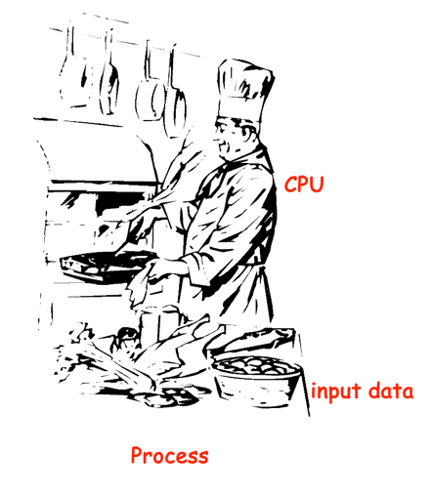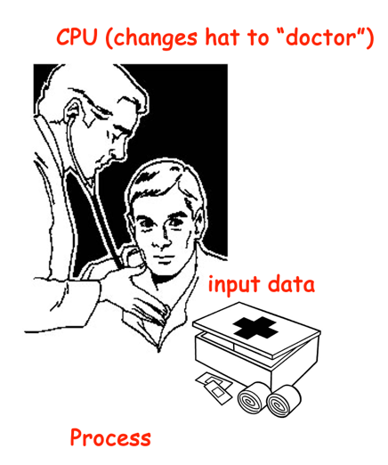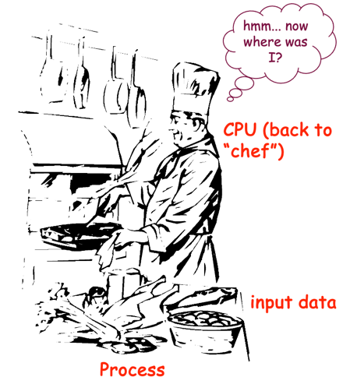

What is a thread?
A thread is the execution part of the program. It is possible to parallelize the execution part. Like assume that you are running a chrome browser. Then the whole browser is a process. The browser can have multiple tabs open with different websites. These tabs are running in parallel too. We can call these tabs threads.

In the previous example, the chef in his kitchen making pasta is a process. When chef decides to make two types of pasta concurrently, then there are two threads in the kitchen!

How multitasking works in a computer?

Multitasking gives the illusion of parallel processing (independent virtual program counters) on one CPU.

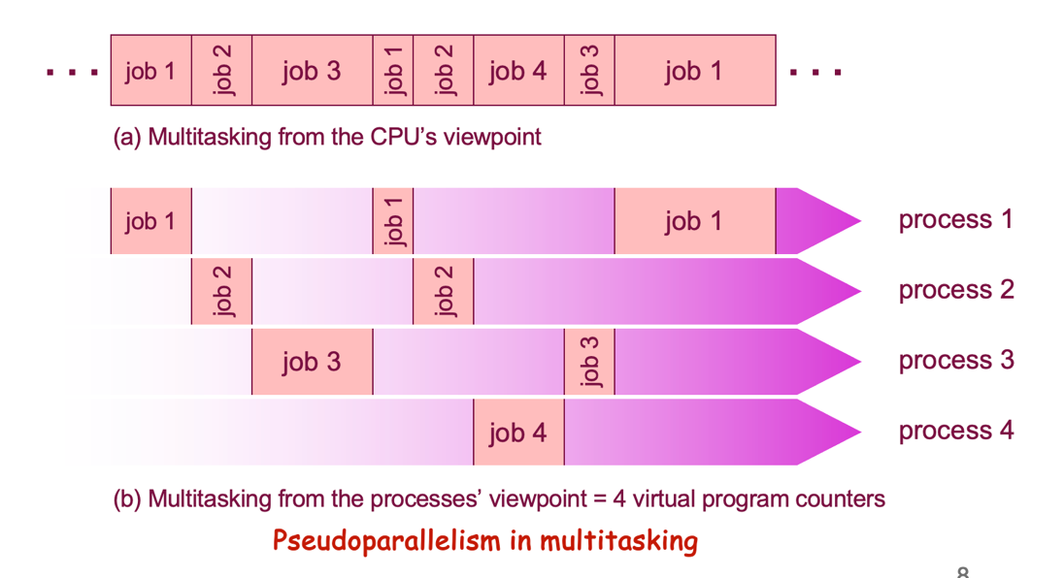

When there is only one CPU running multiple jobs (processes), it basically time share the CPU. Than means, it runs Job1 for a while, then switch to Job2 , then after a while switch to job3, then switch back to Job1. If computer can do this kinds of switching very fast, it can create a illusion that everything is running in parallel. Actually, that is not possible with one CPU.

What are the states that a process can have?
A process can be in different states. –
- new: The process is being created
- ready: The process is waiting to be assigned to a processor
- running: Instructions are being executed
- waiting: The process is waiting for some event to occur
- terminated: The process has finished execution

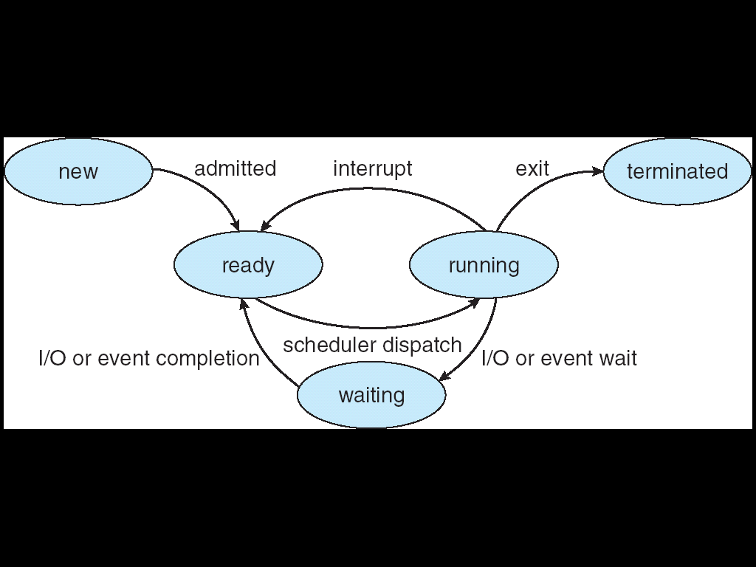

How to decide which process to execute and when?
It absolutely depends on CPU scheduler. Later we will describe many algorithms to decide on CPU scheduling.

What is the fastest storage in the system?
Registers!
Speed wise: registers > Level 1 Cache (L1 cache) > Level 2 cache (L2 cache) > Level 3 cache (L3 cache/Last level cache) > main memory (RAM) > Hard disk drive(HDD).
Size wise : registers < Level 1 Cache (L1 cache) < Level 2 cache (L2 cache) < Level 3 cache (L3 cache/Last level cache) < main memory (RAM) < Hard disk drive(HDD).

Processes

What is a process control block?

- is included in the context, along with the stack
- is a “snapshot” that contains all necessary and sufficient data to restart a process where it left off (ID, state, CPU registers, etc.)
- is one entry in the operating system’s process table (array or linked list)

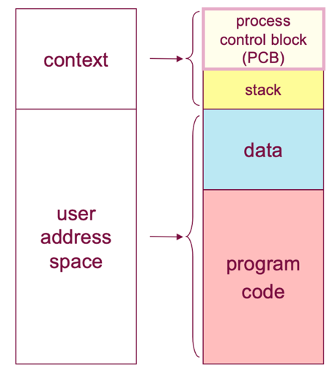
How processes are stored in the memory?

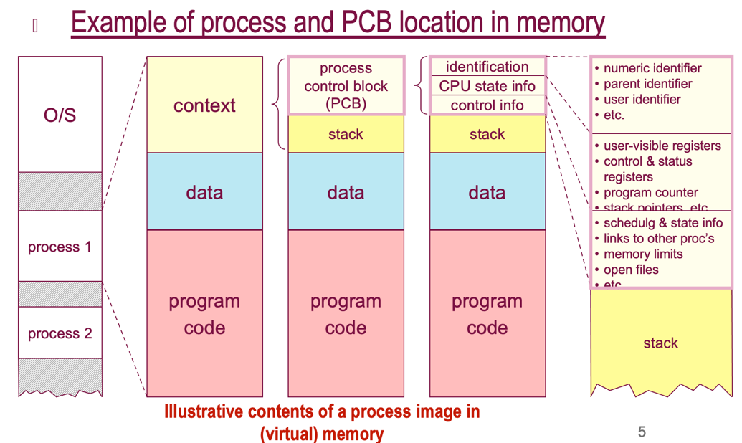

What are the events that leads to process creation?

- the system boots
  - when a system is initialized, several background processes or “daemons” are started (email, logon, etc.)
- a user requests to run an application
  - by typing a command in the CLI shell or double-clicking in the GUI shell, the user can launch a new process
- an existing process spawns a child process
  - for example, a server process (i.e. web server, file server) may create a new process for each request it handles
  - the init daemon waits for user login and spawns a shell
- a batch system takes on the next job in line

How to create a process?

You can use fork() to create an identical version of the current program. It creates a child process that is exactly the same as parent process.

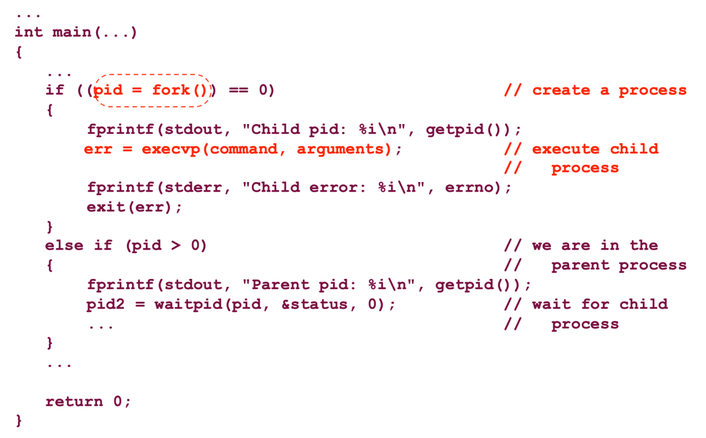

Watch the video on fork(). [Go to iLearns Content->Lecture recording->Lecture 4 recording, watch from 34.35 minutes to end] also watch Lecture 5 recordings.
Also practice the following exercise!

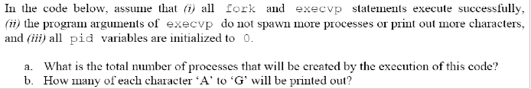
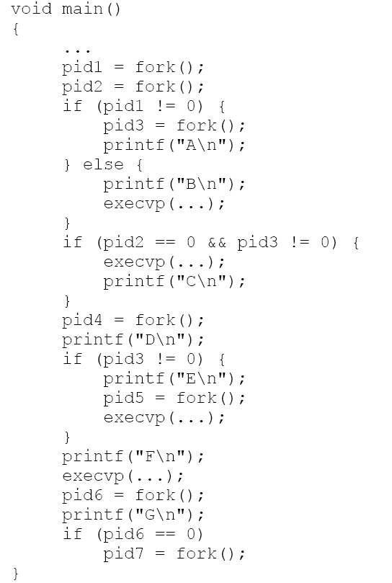
Watch Lecture recordings. Lecture 5 recording from 59:21th minutes to the end.

What is context switching? Why it is necessary? and what is the overhead?

- When CPU switches to another process, the system must save the state of the old process and load the saved state for the new process
- Context-switch time is overhead; the system does no useful work while switching
- Switching time is dependent on hardware support
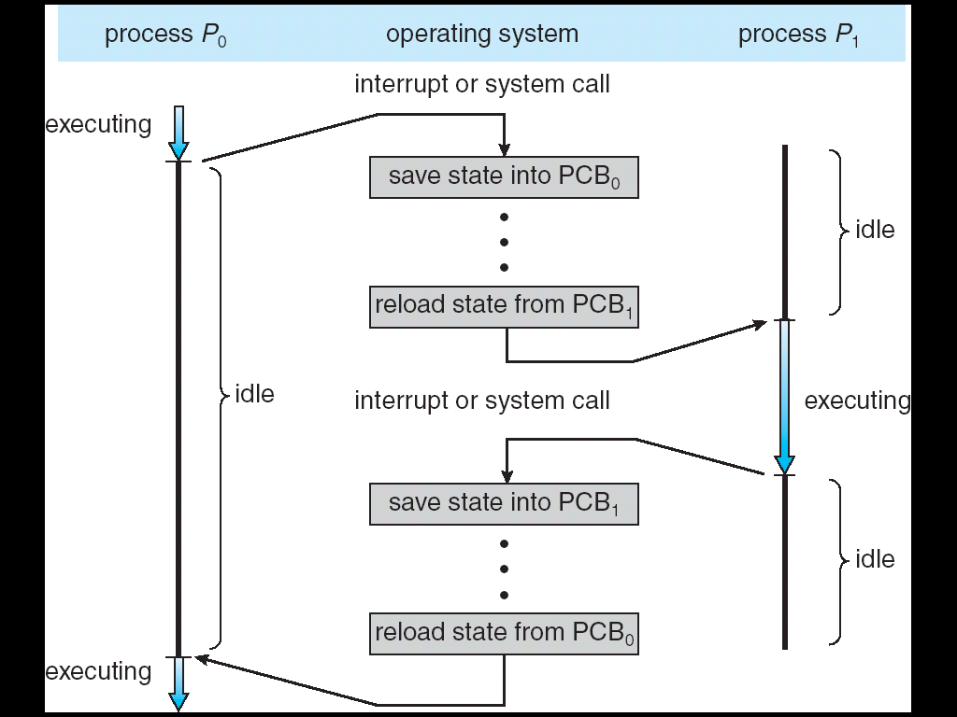
How does a full process switch happen, step by step?
- save CPU context, including PC and registers (the only step needed in a simple mode switch)
- update process state (to “Ready”, “Blocked”, etc.) and other related fields of the PCB
- move the PCB to the appropriate queue
- select another process for execution: this decision is made by the CPU scheduling algorithm of the O/S
- update the PCB of the selected process (state = “Running”)
- update memory management structures
- restore CPU context to the values contained in the new PCB
What events trigger the O/S to switch processes?
- interrupts — external, asynchronous events, independent of the currently executed process instructions
- clock interrupt: O/S checks time and may block process
- I/O interrupt: data has come, O/S may unblock process
- memory fault: O/S may block process that must wait for a missing page in memory to be swapped in
- exceptions — internal, synchronous (but involuntary) events caused by instructions O/S may terminate or recover process
- system calls — voluntary synchronous events calling a specific O/S service ® after service completed, O/S may either resume or block the calling process, depending on I/O, priorities, etc.

Three levels of scheduling

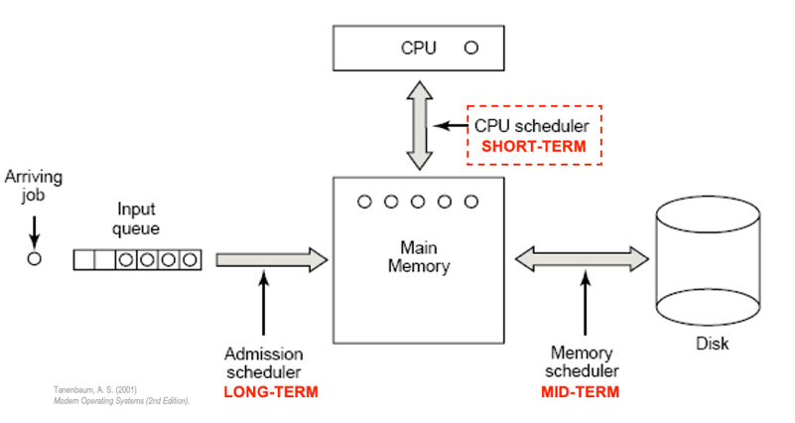
- Long-term scheduling
  - the decision to add a program to the pool of processes to be executed (job scheduling)
- Medium-term scheduling
  - The decision to add to the number of processes that are partially or fully in main memory (“swapping”)
- Short-term scheduling = CPU scheduling
  - the decision as to which available processes in memory are to be executed by the processor (“dispatching”)
- I/O scheduling
  - the decision to handle a process’s pending I/O request
Frequency of scheduling
- Short-term scheduler is invoked very frequently (milliseconds) Þ (must be fast)
- Long-term scheduler is invoked very infrequently (seconds, minutes) Þ (may be slow)
- The long-term scheduler controls the degree of multiprogramming
- Processes can be described as either:
  - I/O-bound process – spends more time doing I/O than computations, many short CPU bursts
  - CPU-bound process – spends more time doing computations; few very long CPU bursts
èlong-term schedulers need to make careful decision
Inter-process Communication (IPC):

- Shared Memory: by using the same address space and shared variables
- Message Passing: processes communicate with each other without resorting to shared variables

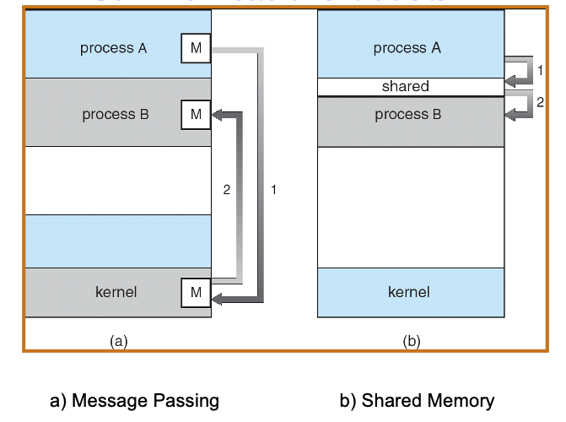
Message Passing:
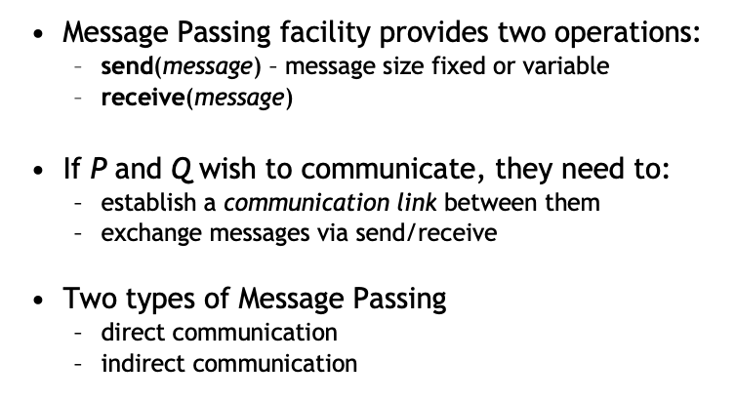

Direct Communication:
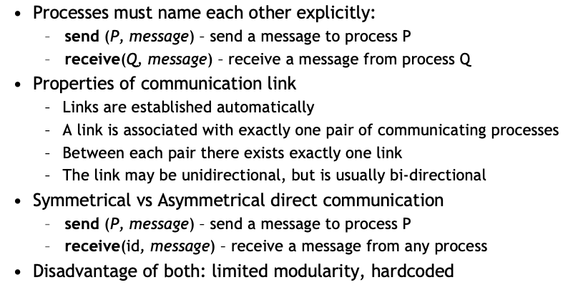

Indirect communication:
