**CHAPTER 1**

**1.0 INTRODUCTION: A Web-based Electronic Voting Application**

A **web application** or **web-based application** is a computer program that uses the  web browsers and web technology to perform tasks over the Internet.

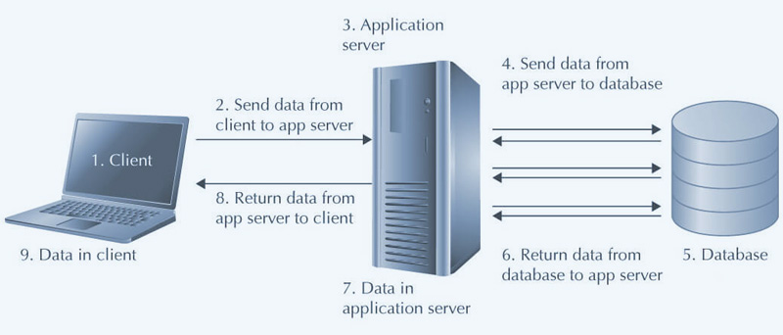

Web Applications are perfect tools in order to upgrade your daily cumbersome and manual office/business tasks to a convenient, automated, and paperless process. Almost every business can hugely benefit from an in-house software.  
In general, web applications are applications that operate within a web browser. The user of a web application is often required to type “username” and “password” in order to be able to have access to and work with the application. Using a database, the data can be created, updated, deleted, and seen or printed. Millions of businesses use the Internet as a cost-effective communications channel. It lets them exchange information with their target market and make fast, secure transactions. However, effective engagement is only possible when the business is able to capture and store all the necessary data, and have a means of processing this information and presenting the results to the user.  
  
Most Web applications use a combination of server-side scripts (PHP and ASP) and sometimes python(DJANGO) to handle the storage and retrieval of the information, and client-side scripts (JavaScript and HTML) to present information to users. This allows users to interact with the company using online forms, content management systems, shopping carts and more. In addition, the applications allow employees to create documents, share information, collaborate on projects, and work on common documents regardless of location or device

An **Electronic voting** (also known as **e-voting**) is voting that uses electronic means to either aid or take care of casting and counting votes.

Its features are as follows:

* Personal login is required
* Only Admin can see the Election Result
* Content is unique to user based on linked account information
* Secure access point for personalized information
* Dynamic content changes more frequently than typical websites
* Interactive functionalities for portal site members

and many more. . .

**1.1 Background of the study**

An **Election voting system** is voting that uses electronic means to either aid or take care of casting and counting votes.

In recent years, information technology has greatly affected all aspects of our national life, and to a large extent, this includes politics. One basic feature of democracy that cuts across all divides of people is the act of election. Traditional manual methods of conducting elections are no longer preferred because of the long period of preparation, violence, rigging, dis-enfranchization of eligible voters, over-voting, mistakes made in counting the votes, long period of counting and high cost of voting process etc. The most recent method being advocated for is electronic voting (e-voting). E-voting is an election system that allows a voter to record his or her secure and secret ballot electronically.

This work showed how e-voting through the use of mobile devices like tablets, Ipads and PCs would totally eradicate all these problems as people would no longer go to election venues to cast their votes, rather they would be at the comfort of their homes and offices to exercise their franchise using any of these electronic devices effortlessly.

Now ,Conducting a credible election in Crawford University increasingly becoming a very difficult task, and this has adversely affected the socio-political of the school and its students. Encyclopedia Britannica defined an election as a formal decision-making process by which a population chooses an individual to hold public office. Elections have been the usual mechanism by which modern representative democracy has operated since the 17th century. Elections may fill offices in the legislature, sometimes in the executive and judiciary, and for regional and local government. This process is also used in many other private and business organizations, from clubs to voluntary associations and corporations.

Election is said to be credible when the outcome of such election is acceptable to generality of the people especially if the loser demonstrates the spirit of sportsmanship occasioned by the electoral process transparency. Free, fair and credible elections are central to electoral democracy and provide vital means of empowering citizens to hold their leaders accountable. In a multi-party democracy, it behooves both the elected and appointed government officials at all levels of the political system to render periodic account of their stewardship to the populace.

Registered students are provided with a unique login details to log into the private area of the website. Here, personalized content is provided, based on a database or similar tool that holds the student data. For example, students can log on to the website for their school and see the contestants or candidates and other relevant information. The depth and breadth of information provided varies widely and is often tied to the system architecture of the school.

Creating and maintaining an information e-votingl is a new technological development and has resulted in the creation of new jobs and career paths. There are two areas of skill that are required to form an educational portal: **computer systems** and **content management**. This type of website requires a dedicated web server, that can support both public and private sections. There needs to be a mechanism or program to manage requests for user identifications and passwords, as well as the ability to make their vote count.

In addition to basic user management, the private section of the website usually has connection to either the student system or data from that system. This information requires additional security to protect student privacy and prevent unauthorized access. Specially trained security and infrastructure staff are required to set up and maintain these tools.

Content management refers to all the text, pictures, files, and data provided to users through the education portal. In many organizations, a site administrator logs into the website with his unique account information and has the ability to maintain or add voters and candidates also to check election result. This role is critical to keeping the website functional and meeting user’s needs.

Crawford University does not host its own e-voting system and needs to implement to the advantage of the institution and benefit of the pupils. Due to the challenges of the present traditional voting system this e-voting system project promises to provide a perfect solution to all the stated problems.

**1.2 Statement of the problem**

The purpose of this study is to develop a web-based Electronic voting Application as a solution to the problems of traditional way of voting.

Elections in Crawford are usually plagued with a myriad of challenges that do not make the elections turn out hitch-free. Specifically in the last general elections in CONAS, some challenges were experienced with the introduction of a traditional electoral process

This study therefore aims at designing a web-based electoral system, with an online voting solution that would by-pass the use of traditional electoral process.

**1.3 Aim and objectives of the study**

The **aim** of this study is to proffer solution to the above stated problems being faced and to develop a web-based electronic voting system for Crawford University using PHP to develop each web page and MYSQL as the database for storage of information on the website. The objectives are as below:

The main objective of this study is to design a web-based electoral system with an online voting solution. The specific objectives are to:

* by-pass the use of traditional pattern of voting with its attendant issues in Crawford University elections;
* eliminate electoral violence and other challenges associated with manual voting methods and
* evaluate the performance of the designed system.

**1.4 Significance of the study**

The study will be beneficial to the following:

1. **To the Students**

Through this system, the students will be able to use the e-voting system effectively for their upcoming election.

1. **To the Academic officers**

Through this system, academic officers in charge will be able to manage electoral processes for the upcoming elections.

1. **To the Future Researchers**

The future researchers could gain knowledge from the study on the benefits, advantages and disadvantages, impact of developing web portals which they may apply to their research in the future. By improving on the e-voting system.

1. **Project Supervisors**

This will serve as a tool for the easy management of student accounts and review of project work.

**1.5 Scope of the study**

The application of this software may not be limited to Crawford University alone but can be used equally by other universities, even secondary schools and colleges. This paper only covers all that is required to design and implement the e-voting program and nothing more.

**1.6 Limitation of the study**

Usually, every work has some limitations and this study is not exempted. These are the following things that limit the e-voting application development:

**TIME LIMITATION:** A researcher cannot boast a present accuracy of the research work due to difficulties ranging from other academic work, health condition and other distraction during the period of the research work, because in the work there is limited amount of time even from the research to be carried out.

**FINANCIAL LIMITATION:** limits the researcher’s frequency of investigation on the web toward gathering the necessary information relevant for the study.

**1.8 METHODOLOGY**

**Language:** PHP (recursive acronym for PHP: Hypertext Preprocessor) is a widely-used open source general-purpose scripting language that is especially suited for web development and can be embedded into HTML.).

**Architectural pattern:** Model View Controller(MVC is an architectural pattern that separates an application into three main logical components: the **model**, the **view**, and the **controller**. Each of these components are built to handle specific development aspects of an application. MVC is one of the most frequently used industry-standard web development framework to create scalable and extensible projects.)

**Database:** MySql (MySQL is an Oracle-backed open source relational database management system (RDBMS) based on Structured Query Language (SQL). MySQL runs on virtually all platforms, including Linux, UNIX and Windows. Although it can be used in a wide range of applications, MySQL is most often associated with web applications and online publishing.)

* Understand system to be designed
* Install PHP, mysql unto your local computer.
* Start development.

**1.9 CONCLUSION**

The aim of this project is to provide a web-based e-voting application to be used in the Crawford university to improve efficiency. Though in the long run, more features may still be added which will entail expanding the program to be more complex than this. This is a very challenging project and I love it because it makes me learn a new things, it introduces me to the practice of use of MVC in the world of development.