

**A project proposal**

On

**A Web Base Electronic Voting System For Crawford University With Data Mining Approach**

by

**Sholadiran Michael Oasunkanmi**

**170502143**

**Computer Science**

Submitted in partial fulfillment of the requirement for the award of Bachelor of Science degree in Computer Science

To

The department of Computer and Mathematical Sciences, Crawford University, Igbesa, Ogun State.

**Under The Supervision of:**

**Mr. David Ikudaisi**

**INTRODUCTION**

Elections allow the people to choose those that will represent them and allowed people to express their preferences for how they will be governed. Normally, the integrity of the election process is fundamental to the integrity of democracy itself. The election system must be strong enough to withstand a variety of fraudulent actions and must be transparent and comprehensible that voters and candidates can accept the results of an election. Unsurprisingly, research shows a lot of examples of elections being manipulated in order to inﬂuence their outcome. Notwithstanding, Electronic voting, just as the introduction of any new technology, which must be adopted with a lot of caution, because it could be disastrous if there is no regards for all the risks associated to the system before been apply on the electorates. In the developed countries, E-voting system adoption was preceded by pilot schemes. In Europe; France, UK, Spain, Denmark and Ireland had trials preparatory to its worldwide adoption (Lemos, 2003). Research shows that a comprehensive E-voting system would increase the standard of elections in the country because it would alleviate the problem of paper-based method. It is also believed that electronic voting system would save the country from previous horrible experience as it promises free, fair, transparent, confidential and convenient elections as well as the speedy processing of results (Abdulhamid, Adebayo, Ugiomoh, & AbdulMalik, 2013).

The design of a “good” voting system, whether electronic or using traditional paper ballots or mechanical devices, must satisfy a number of sometimes competing criteria. The anonymity of a voter’s ballot must be preserved, both to guarantee the voter’s safety when voting against a malevolent candidate, and to guarantee that voters have no evidence that proves which candidates received their votes. The existence of such evidence would allow votes to be purchased by a candidate. The voting system must also be tamper-resistant to thwart a wide range of attacks, including ballot stufﬁng by voters and incorrect tallying by insiders. Another factor, as shown by the so-called “butterﬂy ballots” in the Florida 2000 presidential election, is the importance of human factors(Alvarez, Hall, & Trechsel, 2009). A voting system must be comprehensible to and usable by the entire voting population, regardless of age, inﬁrmity, or disability. Providing accessibility to such a diverse population is an important engineering problem and one where, if other security is done well, electronic voting could be a great improvement over current paper systems. Flaws in any of these aspects of a voting system, however, can lead to indecisive or incorrect election results(Fuglerud & Røssvoll, 2012).

Many parts of Nigeria have experienced setbacks, which have led to the destruction of both lives and property, simply because the rule of the game was not adhered to, and so political violence, unhealthy politicking have been the order of the day. People usually wanting to impose themselves on the voters, so they use all sorts of means to get into office. And this has continued to cause a lot of harm and has made the citizens poorer in spite of the abundance of natural and human resources in the country, In the developing countries particularly the Sub-Sahara Africa and Africa in general, elections had been marred by gross irregulmities leading to wanton destruction of lives and properties (Helen 2005, lyayi, 2004, Okoye. 2004 ). E-voting is seen as a saviour.

May 29, 2009 Nigeria celebrated ten of democracy. A lot of Nigerians said it was not worth celebrating, because our electoral system is a flawed exercise. Our political and electioneering process is branded with a lot of irregularities, ranging from ballot box snatching, stuffing of ballot boxes, political killings, the use of political thugs to harass opposing candidates and finally weak Electoral Act. This mainly, is due to the fact that electoral processes in Nigeria are been done manually and the result of such manual electoral process inevitably produces questionable electoral results. Elections in most developed nations of the world with enviable democratic platforms has over the years been conducted electronically and in these countries little or no setbacks follow the results of such elections as they are seen to be free, fair and credible. The Nigeria’s Independent National Electoral Commission (INEC) has since indicated its interest in using the electronic voting system for future elections. This decision has been as a result of series of accusations levelled on the electoral body by some political parties, for aiding a particular set of political party especially in the 2007 and 2011 general elections to rig those elections. If the Nations Electoral Commission is determined to conduct a credible poll in the future elections, then electronic voting should be seen as a veritable option to achieve its aim. Electronic voting (also Known as biometric voting) has been effectively implemented in same election

**LITERATURE REVIEW**

The term "electronic voting" has been used for a large variety of systems, ranging from hand-held infrared devices, kiosk systems with touch screens machines used in polling stations to remote voting via the Internet. e-Voting is the preferred platform for future elections in the developed and developing nations of the world. It is a system that has modernized the electoral processes and electorates are able to cast their votes through an electronic device as against the traditional manual system(Abdulhamid et al., 2013).

The three types of e-Voting include: (a) Polling station e-Voting: where voters cast their votes electronically on an electronic machine within the polling booth; (b) Kiosk e-Voting: where voters cast their votes at pre-selected stations through ATM-Iike terminals; and (c) Remote e-Voting: where voters cast their votes anywhere, and anytime, there is Internet access; as well as voting through mobile device

Election is central to the existence, stability and development of democracy in any country. Therefore, the electoral system of a government determines the political growth and democratic stability of that society. In Nigeria, the agency charged with the conduct and supervision of elections is the Independent National Electoral Commission (INEC) which was empowered by the 1999 constitution to conduct a free and fair election. Four methods of voting have been used so far in Nigeria. These are Open Ballot System (OBS), Modified Open Ballot System (MOBS), Re-modified Open-secret Ballot System (REMOBS) and Continuous Accreditation and Voting System(CAVS)(Ayo, Adebiyi, & Sofoluwe, 2012).

Open Ballot System (OBS), also known as Option A4, is a voting method in which voters vote openly by queuing or otherwise, indicating the candidate of their choice. This is opposed to a secret ballot, where a voter's choices are confidential. The system minimizes incidences of election rigging that come with the secret ballot system as well as other fraudulent-related electoral practices. This method was used for the 1979, 1983 and the June 12, 1993 election, which is regarded as the fairest and freest election in the history of Nigeria(Esan & Ayeni, 2017).

The Modified Open Ballot System (MOBS) is a modified version of the popular open ballot system. The difference between the two is that while the open ballot exposes to everyone at the polling booth the choice of a voter, the MOBS, though open, allows voters make their choice secretly. This method was adopted in 1999, 2003 and 2007 general election respectively. Furthermore, Re-modified Open-secret Ballot System (REMOBS) is an advanced form of MOBS in which accreditation and release of ballot papers to a voter are done openly, while the voter would thereafter retire alone to a private place to exercise his franchise. Under this method, accreditation of voters commences at the same time throughout the country while voting takes place

immediately after accreditation simultaneously across the federation. Whoever is not accredited is disallowed from voting. After accreditation, voters are asked to queue up while they are being counted loudly by the presiding officer. After counting, nobody is allowed to join the queue. The total number of votes cast should not exceed the number of people on the queue. Voters are enjoined to stay and ensure that their votes count. REMOBS was adopted for 2011 and 2015 general elections(Kohno, Stubblefield, Rubin, & Wallach, 2004).

Continuous Accreditation and Voting System (CAVS) was introduced immediately after the 2015 general election by INEC Chairman, Professor Mahmood Yakubu. Has said it adopted the method from the recommendations made by the commonwealth Observer Mission which observed the 2015 general election in Nigeria. This method allows for accreditation and voting being done concurrently. The accreditation process comprise of verification by the SCR, checking of the register of voters and inking of the cuticle of the specific finger. After accreditation, the voter is issued ballot papers to make his choice secretly inside the cubicle while he deposits ballot papers inside the box in the presence of everyone in the polling station. This method was adopted in all the elections conducted after 2015 general election. It was eventually used for the 2019 general election.

INEC modernization plan as regards the electoral process of the country led to the discovery of electronic voter register (EVR) which was adopted in 2007 for the registration of prospective voters. It involved the use of direct data capture machines (DDCMs) to capture the records of voters electronically with a view to eliminating most of the problems associated with previous elections and ensure free and fair elections in Nigeria. Although the implementation of EVR eliminated duplication of names on the register, which subsequently minimized discrepancies in the electoral process in Nigeria. However, research shows that it was not very successful because it was marred by poor logistics [6] and all manner of irregularities. Hence, INEC reached further to modernize the process during the 2011 and 2015 elections by the introduction of smart card readers and linking its various polling locations around the country to EVR. Sadly, research reveals that the desired result was not achieved as the irregularities persisted. Therefore, this paper discusses the required e-voting system in Nigeria and barriers to its full implementation. Of logs in order to make sure that it is beyond manipulation(Bagui, Mink, & Cash, 2007).

**STATEMENT OF PROBLEM**

This research will state problem associating with data mining and electronic Evoting system in Nigeria, In this era of information and communication technology, electronic democracy is a necessity because it allows the use of computers and computerized voting equipment in an election. Therefore, INEC introduced the EVR and SCR so as to improve the credibility of elections in Nigeria. Although, the system mitigated some problems associated with election malpractice and was able to provide some level of democratic dividend to about thirty to forty percent, research reveals that it is yet to meet up with international standard for the provision of viable, successful and generally accepted electoral system for democracy. Also, it is observed that an average Nigerian is yet to fully trust the body in the conduct of free and fair elections.

In view of this INEC is expected to combine EVR and SCR with the deployment of electronic voting machines and election result transmitting devices that will be acceptable by all stakeholders such that these devices would be self-auditing and fully equipped with real time facilities, that is, intermittently displaying progress reports and transmitting these reports in real time and a transparent manner. Also, the operations of these devices should be simple, understandable by an average electorate and transparent enough to alleviate fear of manipulations. In addition, the required e-voting system in Nigeria should be the one that is secure and reliable enough to be a suitable alternative to the paper based system. It should also guarantee the desired transparency, credibility and acceptability by the electorates and give all stakeholders (every participating political party, relevant agencies of government, internal security services, the media and interested electorates) the access to independently keep trackof logs in order to make sure that it is beyond manipulation

Voting system requirements

Each country defines a set of specific laws to guide its voting system, to establish its organization, and to ensure its impartiality, integrity, and democratic principles. Elections based in an e-voting system must comply with the laws and rules for voting systems, and also fulfill the following requirements

**Aim and objectives of the study**

The aim of this study is to proffer solution to the above stated problems being faced and to develop a web-based electronic voting system for Crawford University using with the approach of data mining to develop each web page and MYSQL as the database for storage of each user data on the database. The objectives are as below:

The main objective of this study is to design a web-based electoral system with an online voting solution. The specific objectives are to:

* By-pass the use of traditional pattern of voting in Crawford University elections
* Eliminate electoral violence and other challenges associated with manual voting methods
* Enable quick analysis of voters and candidates Performance.
* Enable quick analysis of election result.

**METHODOLOGY**

The design and implementation phase of this e-voting application development is concerned with the design of proposed system using unified modeling language (UML) and the translation of the design into the desired design specifications into source code. The primary goal of the implementation is to write the source code and also that conforms to the specifications. Basically in this research, PHP, MySQL, JavaScript, CSS and HTML were used to design a user friendly interface (UFI) because they are the more appropriate and most preferable programming language used for designing web applications. The two major users in this project are the voters and administrator. The designs UMLs are listed in Figures 1 below. The main modules in this real-time e-voting system are:

Registration process (voters card and print)

* Registration Module
* Ballot design module
* Registration Module
* Database Administrator module
* Voting module
* Real-Time Live Results module
* Registration Module

This module is for the voter, where he/she must first register his/her details first into the registration form, fulfilling all the required specifications. The required fields are; First name (CHAR), Middle name (CHAR), Surname (CHAR), Sex (BOOLIAN), Date of birth (DATE) ,User name (CHAR), Email (VARCHAR) and Picture upload (jpg, gif, bitmap and maximum size of 5MB). If the validations are valid then only the information get registered. Once the voter gets registered he/she is provided voters identity number (VIN) on the voters’ card which would be printed out and be used in case of password loss.

* Ballot Design Module

This feature is provided for the administrator, where ballot can be setup i.e. inserting candidate names into the ballot for respective categories (electoral position). The administrator can also update any candidates’ profile or information by either editing or deleting information for respective categories of the election. After editing the setup the administrator can post the ballot for voting.

* Database Administrator Module

Administrator has the privilege of viewing registered voters and editing their information, searching for a person (registered voter) by entering his name or VIN, can view the details of all voters who have registered. The administrator is also provided with the feature of viewing the information of voting i.e. numbers of voters, the all error log, view live results, though voters also have the privilege to view live results as the voting is taking place, which reduce the tendencies for rigging.

* Voting Module

This module is for the voters, where votes are casted. After a voter has registered, a password is sent to the mail of each registered voter. During the voting, on the voting interface, voters are required to fill in their username and password correctly, which automatically takes them to the voting proper. And once a voter has cast his or her vote for all categories i.e. for Governor and Local council elections, a voter cannot go back on this page to cast a vote again.

* Live Result Module

This module is developed for the voter, where he/she can view the results of the respective categories live immediately a vote is cast and this vote counts appears

on top of the homepage .

**PROPOSED MODEL**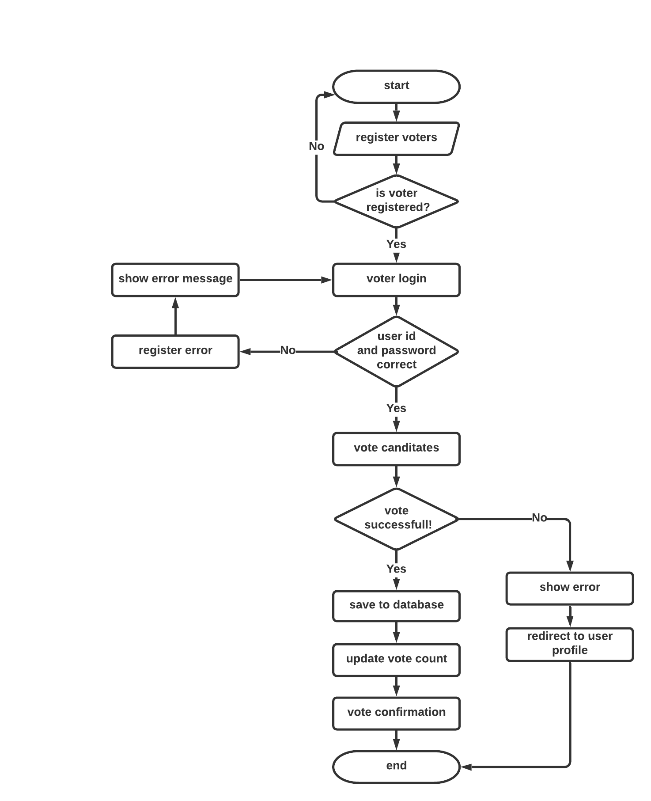

**CONTRIBUTION TO KNOWLEDGE**

Based on my research and literature review I was able to come to a conclusion that most profound e voting system where implemented with weak data extraction and insertion technique hence in this project a better data extraction and insertion technique will be used with a lot of concentration in security and to minimize the rate of manipulation of data by doing this we tend to borrow an approach in data mining called data clutering.by using cluttering we are able to classify each data gotten based on its category.

**CONCLUSION**

The increase in the number of registered voters exercise may be an indication that the Nation is not ripe for technology-based innovations without providing the basic infrastructure, and proper sensitization. Furthermore, it is high time government started looking inward for the production of such technologies locally, where possible, rather than being completely sourced abroad.

The proposed system is simple, indigenous. and secure. It attempts to proffer reasonable solutions. to existing problems in the various countries of use, with a view to guaranteeing a successful e-Voting implementation in Nigeria without necessarily repeating their mistakes .It eliminates the moribund activities associated with the manual system and reduces drastically the duration of elections as the whole exercise can be concluded in a day, thus, resulting in huge financial savings.

The success factors include: making adequate preparations and get the electorates familiarized with whatever electronic devices to be adopted before being put to use: employing the use of biometric-based voters' card to solve the problem of over-voting: provision of multilingual ballot to cater for the teaming illiterate population. Similarly. the number of political parties is reduced to a manageable size for simplicity. efficiency. effectiveness and for voters· satisfaction in line with the concept of usability.

There is provision for disability as well as the outright elimination of invalid votes arising from multiple voting.

Finally, the integrated system would avail the electorates the opportunity of casting their votes using the most convenient medium among the EVM, i-voting and m-voting. The adoption of the integrated system is likely to increase the level of participation in the polity because of the ease of voting and its tendency to eliminate electoral fraud.

**REFERENCES**

Abdulhamid, S. í. M., Adebayo, O. S., Ugiomoh, D. O., & AbdulMalik, M. D. (2013). The Design and Development of Real-Time E-Voting System in Nigeria with Emphasis on Security and Result Veracity. *International Journal of Computer Network & Information Security, 5*(5).

Alvarez, R. M., Hall, T. E., & Trechsel, A. H. (2009). Internet voting in comparative perspective: the case of Estonia. *PS: Political Science & Politics, 42*(3), 497-505.

Ayo, C., Adebiyi, A., & Sofoluwe, A. (2012). E-voting implementation in Nigeria: the success factors.

Bagui, S., Mink, D., & Cash, P. (2007). Data mining techniques to study voting patterns in the US. *Data Science Journal, 6*, 46-63.

Esan, A. O., & Ayeni, T. (2017). E-voting in Nigeria: Barriers to full implementation. *Ahmadu Bello University*.

Fuglerud, K. S., & Røssvoll, T. H. (2012). An evaluation of web-based voting usability and accessibility. *Universal Access in the Information Society, 11*(4), 359-373.

Kohno, T., Stubblefield, A., Rubin, A. D., & Wallach, D. S. (2004). *Analysis of an electronic voting system.* Paper presented at the IEEE Symposium on Security and Privacy, 2004. Proceedings. 2004.