**Michael Sikora**

**2018.06.14**

**Simulation Setup 1**

Two 3-mic clusters were used, set a half meter apart in the y-direction.

One source was set at 3.5 meters in the x-direction from the midpoint between the clusters. The source used was a banded white noise source filtered to be between 200 and 3800 Hertz.

The SRP image was gathered for 4 orientations. The source was windowed iteratively in time with a 0.5 second increment between windows. The orientations were generated using the pitch and yaw angles. Angles were randomly selected for the pitch in the range of 0 to 90 degrees. Angles were randomly selected for the yaw in the range of -90 to 90 degrees. These ranges match the physical Pan-Tilt mounts.

The average, minimum and maximum images were calculated, plotted and saved as .png's. The main lobe outline was calculated by amplitude thresholding the image by the max value of the image over the squareroot of two. The outline of the thresholded region was calculated and plotted in black.

**Results**

The following plots are shown below: The 4 SRP images of each cluster orientation, the average image, the minimum image, and the maximum image.

The images are plotted using the same z-scale.

**Figures**

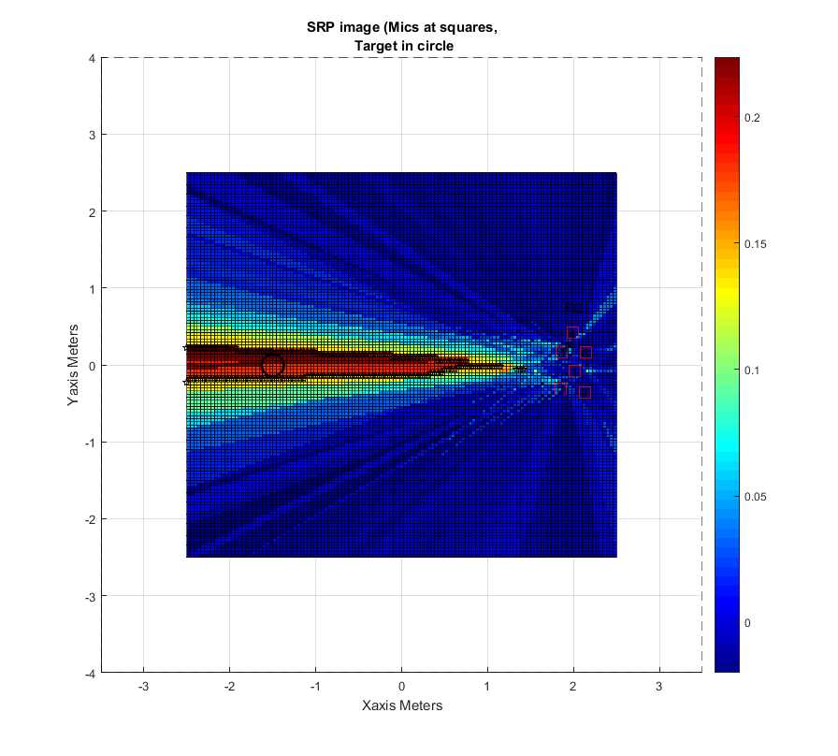SRP1

SRP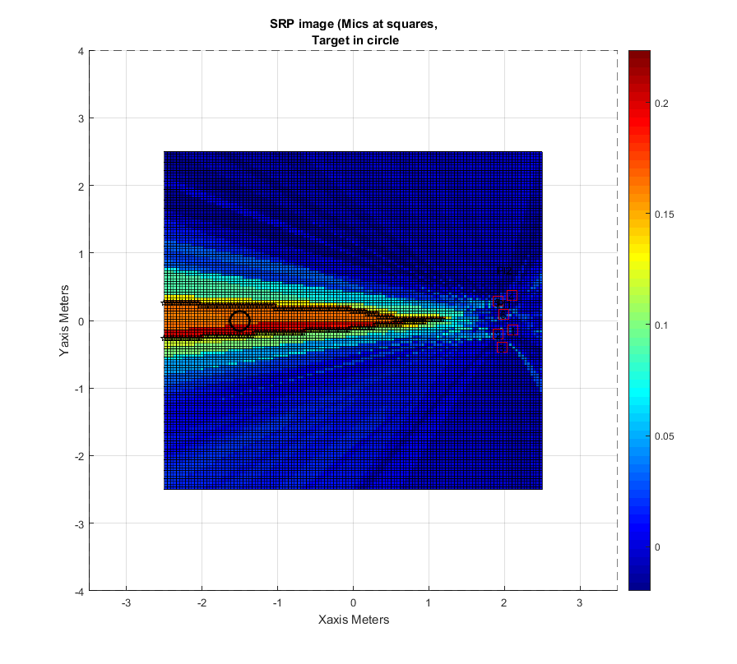2

SRP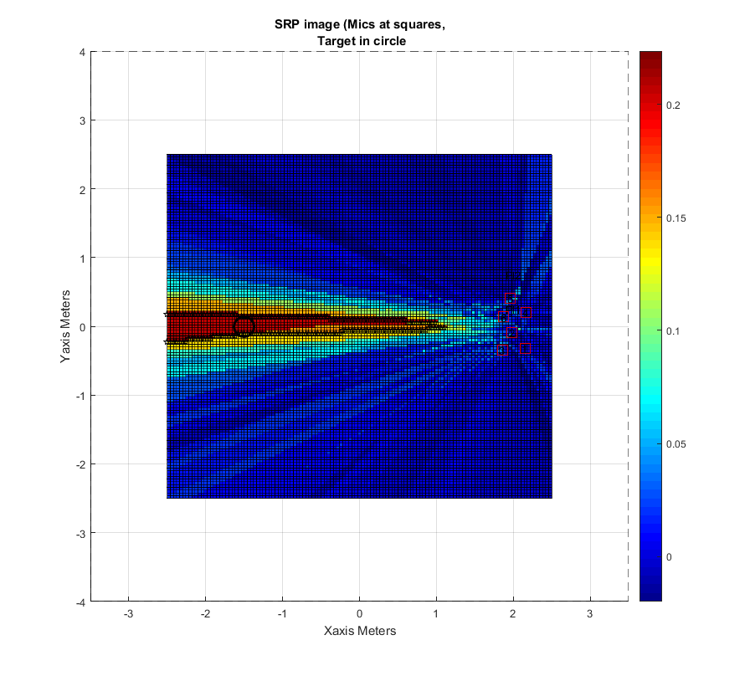3

SRP4

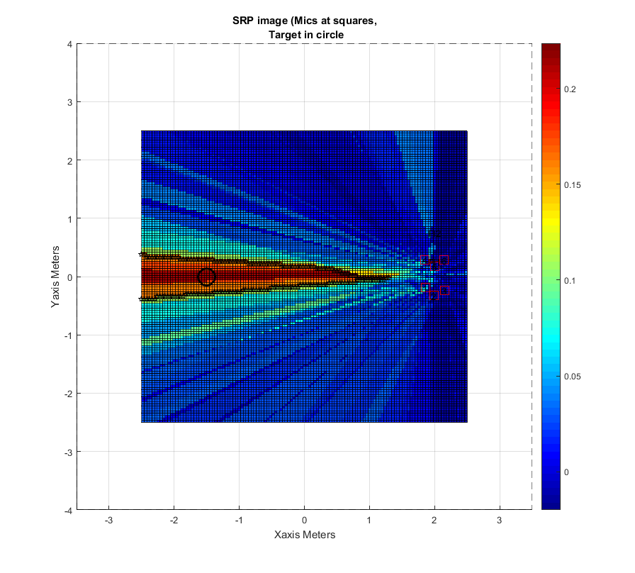

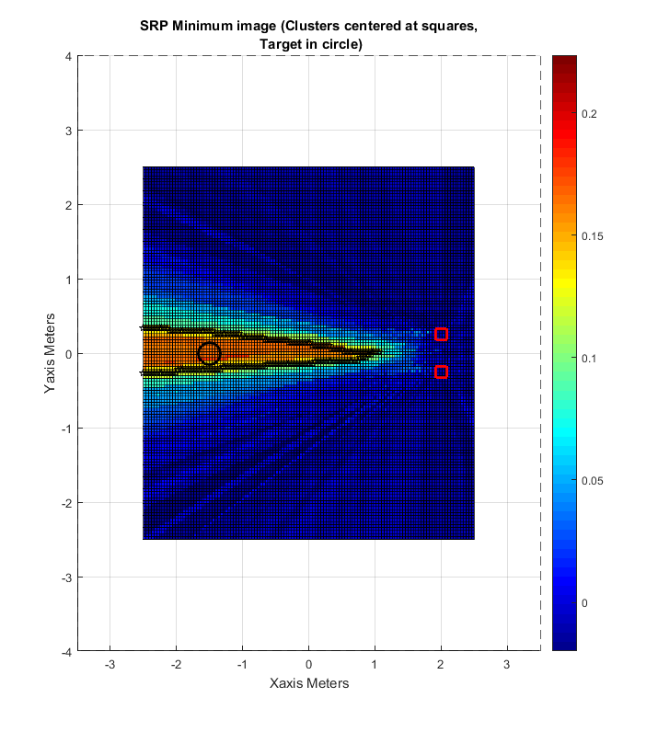Minimum

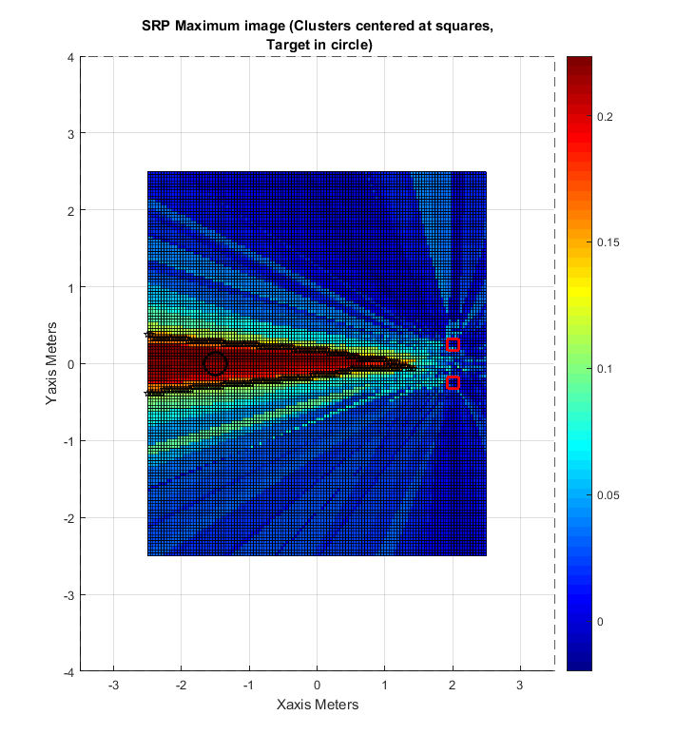

Maximum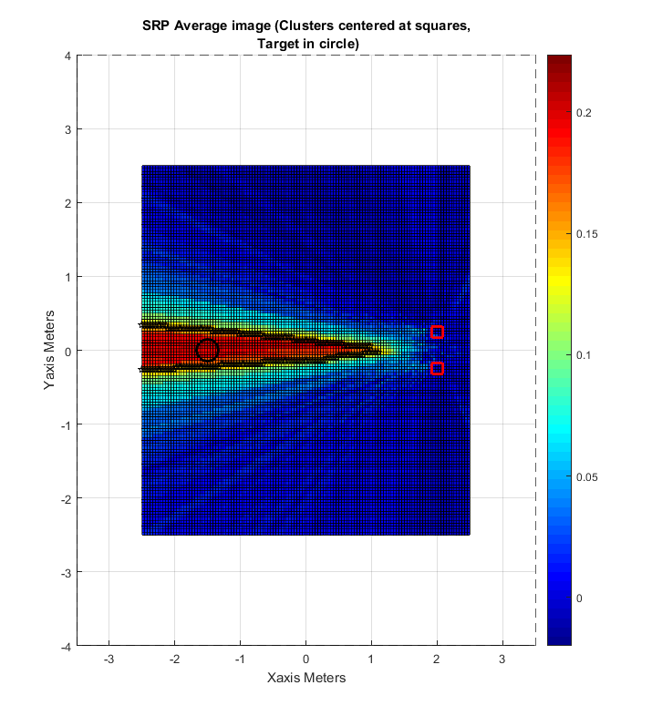Average

**2018.06.15**

**Simulation Setup 2**

The same positions were used as in the first setup for the clusters’ center coordinates and the signal position center. The same source signal was used.

The SRP image was now gathered for 16 orientations. The orientations were randomly selected in the same ranges as before. However, for this simulation, the two clusters were set to different orientations.

**Results**

The main lobe position showed more variation between SRP images than in setup 1.

**Figures**

The following images show: The first four SRP images, the most accurate mainlobe SRP (14th orientation), and the minimum, maximum and average images.

**Conclusions**

Of the maximum, minimum and average images, the minimum appears to produce the most accurate main lobe and reduce the side lobe energy significantly. The average and maximum produce wider main lobes than the minimum. Compared to the previous setup, this setup appears to produce narrower main lobes.

