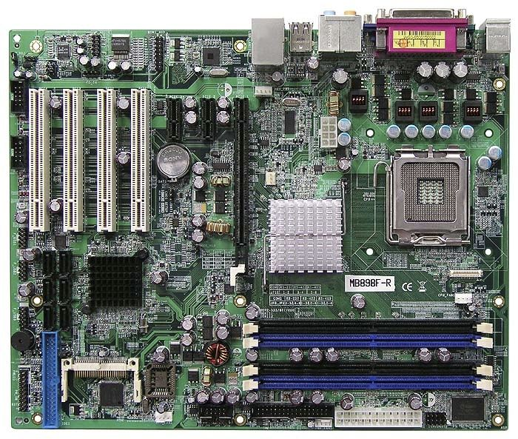

*A. PCI Slots*

*B. Northbridge*

*C. Southbridge*

*D. External Ports*

*E. Date & Time Battery*

*F. RAM Slots*

*G. EIDE Port*

*H. SATA Ports*

*I. CPU & Slot*

*J. P1 Connector*

*K. Front Panel Connectors*

*L. BIOS chip*