Software Requirements Specification with UML Diagrams

Use Case Diagram
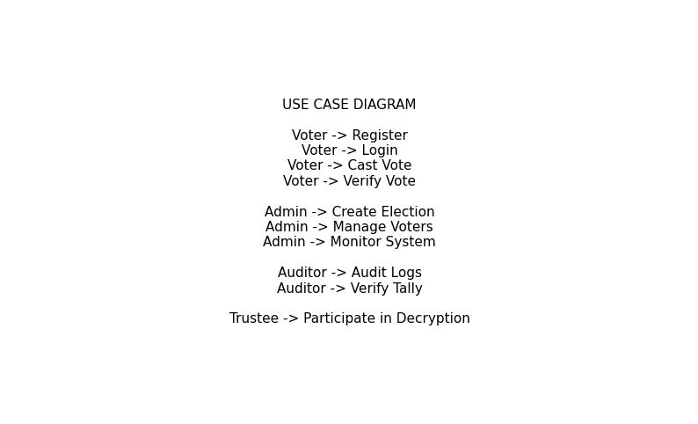

Sequence Diagram - Vote Casting
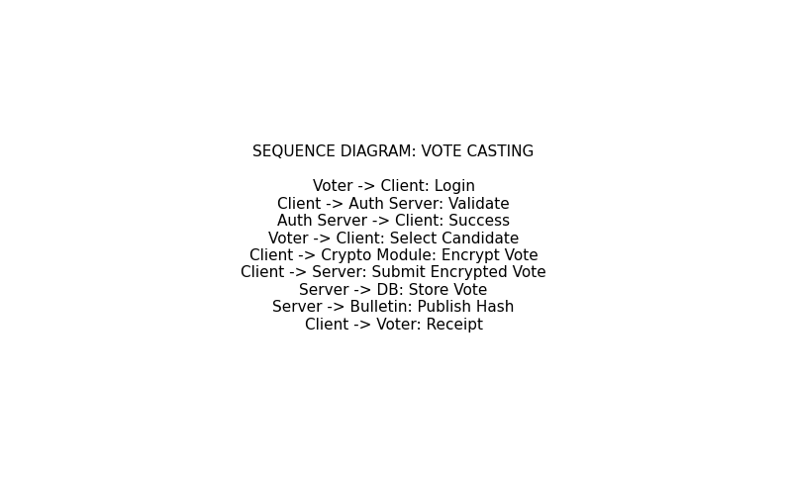

Sequence Diagram - Tallying
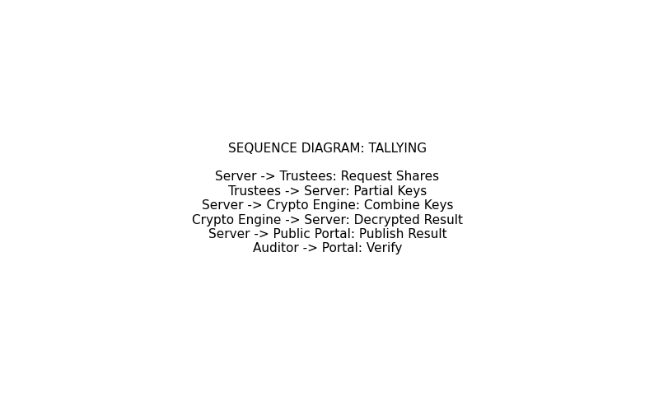

System Architecture Diagram
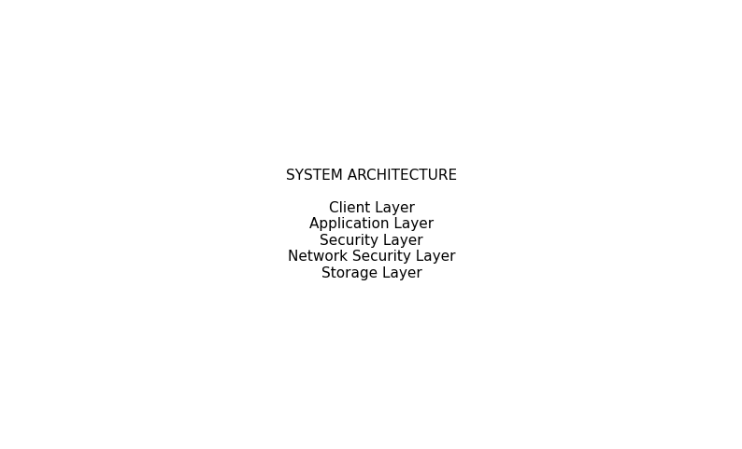

SOFTWARE REQUIREMENTS SPECIFICATION (SRS)

Secure End-to-End Verifiable Electronic Voting System Using Network Security and Cryptographic Data Protection

1. Introduction

1.1 Purpose of the Document
This Software Requirements Specification (SRS) defines the functional and non-functional requirements of a Secure End-to-End Verifiable Electronic Voting System (SEEVS). The system integrates network security mechanisms and cryptographic data protection techniques to ensure confidentiality, integrity, availability, verifiability, and resistance to insider and external attacks.
This document serves as a reference for developers, system architects, supervisors, and examiners involved in the design and implementation of the proposed system.

1.2 Scope of the System
The proposed system is a web-based electronic voting platform that allows eligible voters to cast ballots securely while ensuring:
- Vote secrecy
- Authentication and authorization
- End-to-end verifiability
- Secure transmission and storage of votes
- Public auditability without privacy compromise
Unlike conventional e-voting systems, the proposed solution prevents servers from accessing plaintext votes and introduces distributed trust through cryptographic verification.

1.3 Definitions and Acronyms
Term | Meaning
E2E | End-to-End
SEEVS | Secure Electronic Voting System
TLS | Transport Layer Security
IDS/IPS | Intrusion Detection/Prevention System
ZKP | Zero-Knowledge Proof
DMZ | Demilitarized Zone
EVS | Electronic Voting System

2. Overall Description

2.1 Product Perspective
The system is a standalone secure voting platform accessible through web browsers. It uses a layered architecture:
- Presentation Layer – voter interface
- Application Layer – voting logic and authentication
- Security Layer – cryptographic operations and verification
- Database Layer – encrypted storage

2.2 Product Functions
The system will:
- Register and authenticate voters
- Allow secure vote casting
- Encrypt votes on the client side
- Store encrypted ballots securely
- Provide public verification tools
- Perform secure tallying using homomorphic encryption
- Maintain audit logs
- Provide administrative monitoring

2.3 User Classes and Characteristics
User | Description
Voter | Casts and verifies votes
Election Administrator | Manages election setup
System Auditor | Verifies election integrity
Trustee Authority | Participates in distributed key decryption

2.4 Operating Environment
- Web browsers (Chrome, Firefox, Edge)
- Linux/Windows servers
- Django backend framework
- Encrypted database server
- Secure network infrastructure
- React.js frontend framework

2.5 Design Constraints
- Must preserve ballot secrecy
- Must operate over unreliable networks
- Must comply with cryptographic best practices
- Must remain usable by non-technical voters

2.6 Assumptions and Dependencies
- Voters possess valid credentials
- Secure TLS infrastructure exists
- Trustees are independent entities
- Election environment supports network monitoring

3. System Features (Functional Requirements)

3.1 Voter Registration
FR-1: The system shall allow eligible voters to register using unique credentials.
FR-2: The system shall validate voter identity before activation.

3.2 Authentication and Authorization
FR-3: The system shall authenticate voters using multi-factor authentication.
FR-4: The system shall prevent duplicate voting.

3.3 Secure Vote Casting
FR-5: The system shall encrypt votes on the client device before transmission.
FR-6: The system shall ensure the server cannot access plaintext ballots.

3.4 End-to-End Verifiability
FR-7: The system shall provide voters with verification receipts.
FR-8: The system shall allow public verification of tally correctness.

3.5 Secure Storage
FR-9: The system shall store ballots in encrypted form.
FR-10: The system shall protect stored data against unauthorized modification.

3.6 Secure Tallying
FR-11: The system shall compute results using homomorphic aggregation.
FR-12: The system shall require multiple trustees to decrypt final results.

3.7 Auditing and Logging
FR-13: The system shall maintain tamper-evident logs.
FR-14: The system shall allow auditors to verify election processes.

3.8 Administrative Control
FR-15: Administrators shall create and manage elections.
FR-16: Administrators shall monitor system health and security alerts.

4. Non-Functional Requirements

4.1 Security Requirements
- End-to-end encryption
- Distributed key management
- Insider attack resistance
- Zero-knowledge verification
- Secure network segmentation
- IDS/IPS monitoring

4.2 Performance Requirements
- Support large voter turnout
- Maintain low latency during vote casting
- Ensure availability during peak periods

4.3 Reliability Requirements
- Fault tolerance
- Automatic recovery mechanisms
- Backup and redundancy

4.4 Usability Requirements
- Intuitive interface
- Accessibility support
- Clear verification feedback

4.5 Maintainability Requirements
- Modular architecture
- Clear documentation
- Secure update mechanisms

4.6 Scalability Requirements
- Horizontal scaling of servers
- Load balancing
- Cloud deployment compatibility

5. External Interface Requirements

5.1 User Interface
- Web-based voting dashboard
- Verification receipt interface
- Admin control panel

5.2 Hardware Interface
- Standard server infrastructure
- Secure networking devices
- Monitoring systems

5.3 Software Interface
- Django framework
- Cryptographic libraries
- Database encryption toolsx
- React.js framework for front end

5.4 Communication Interface
- TLS encrypted communication
- Secure API endpoints
- Network segmentation

6. System Architecture Overview
The proposed system adopts a layered security architecture:
- Client Layer
  - Secure voting interface
  - Client-side encryption
- Application Layer
  - Authentication
  - Election logic
- Security Layer
  - Homomorphic encryption
  - Zero-knowledge proofs
  - Distributed key management
- Network Security Layer
  - TLS
  - IDS/IPS
  - Rate limiting
  - Segmented network zones
- Storage Layer
  - Encrypted database
  - Tamper-evident logs

7. Risk Analysis
Risk | Mitigation
Insider attack | Distributed keys
Network attack | Segmentation + IDS
Malware on client | Verification mechanisms
DoS attack | Rate limiting
Cryptographic misuse | Formal review

8. Gap Resolution Alignment
The proposed system addresses previously identified gaps:
Gap | Solution
Lack of E2E verifiability | Cryptographic receipts
Weak key management | Threshold cryptography
Insider threats | Distributed trust
Privacy vs audit conflict | Zero-knowledge proofs
Weak network protection | Segmented secure architecture

9. Conclusion
This SRS defines the requirements for a secure electronic voting platform that integrates network security and cryptographic protection. By addressing empirical weaknesses observed in prior voting systems, the proposed system enhances trust, security, verifiability, and resilience against real-world cyber threats.

