The Menacing New Yorker
Volume 3, Issue 1 The Official Newsletter of the Countdown NY Line March 16, 1999
Fourth Issue Days Until Line Up 33
Lucas Changes Release Date to May 19th!
What is he doing to us…
By: Robert Cartagena

Good 'ol George has done it again. With the release of the second trailer, Lucas has thrown us a curve ball by bumping-up the release date by two days. Citing that he wanted regular "Joes" to be able to see it without the Theatres being mobbed he has decided to release the film two days earlier than originally expected. Now the only thing I have to ask myself is, "What does this do to my New York Line, since we had planned on being on line until the 21st of May not until the 19th?” Well to be completely honest and frank about it: We don't know. We had a meeting this past Thursday and there were mixed feelings on this subject. Before we give our take on this subject we would like to hear from you, the fans. Please email us at NYLineup99@hotmail.com and tell us what you think. We all hope to hear from you soon.
Portrait of a Fanatic…
By Mike Gent

Is he a fan? Is he a fanatic? Is he disturbed? Every morning he is awakened by the incessant bleepings and chirpings of his R2D2 alarm clock. He steps into his “faux” Ewok-skin slippers and stumbles into the bathroom, guided by the phosphorescent glow of a light-saber night-light. He peers into the mirror, mashes down his hair and tells himself repeatedly, “The force is strong with this one…” Every morning during breakfast, he enjoys a bowl of “Droids” cereal as he flips through his outdated issues of the “Displaced Jedi” fanzine. On occasional mornings, after a much needed “bathing” in the company of his rubber Jawa “bath buddies”, he girds his loins with a pair of expertly modified “Dark Side” underoos. And finally, every morning as he makes his way out the door, he pauses reverentially in front of the wall-mounted display of limited edition “Imperial Montage: An X-Wing Pilot’s Photographic Odyssey” dinner plates (signed and numbered by the artist).

Is he a fan? Is he a fanatic? No, he’s most definitely disturbed.

Fortunately, he doesn’t really exist (???). And fortunately, the real Star Wars fans and fanatics are conscientious, intelligent, well-adjusted, sane individuals, who just happen to have a passionate interest in sharing and celebrating the Lucas legacy with other fans, with other fanatics, and most especially, with the uninitiated.

Last week I had the opportunity to finally meet the small army of “volunteer-fanatics” who are responsible for the organization and administration of the New York Line. Far from being a loosely-knit band of well-intentioned but overwhelmingly incompetent zealots, this is a crack team of professionals who really have their sh*t together.

I mean, imagine my surprise when I was handed various form prototypes, meeting minutes, schedules, calendars, media clippings…the organization behind this endeavor is astounding. I found myself more than a little miffed that I wasn’t as overtly committed to the cause, but I guess we all

do what we can—and they’ve pulled off nothing short of a miracle in a matter of weeks.

Corporate sponsorship, TV interviews, magazine articles, a veritable media circus…And it’s all in the name of a few dedicated fans who want to make darn sure that this most historic moment in entertainment, nay, spiritual history is never, ever forgotten.

So, when I left the NY Line meeting last week, I couldn’t help feeling extremely grateful that somebody was doing what those folks are doing. And I was glad to be a part of it, albeit a small part. At home, as I activated my light-saber night-light, and as I set my R2D2 alarm clock for the next morning, a prayer of thanks, a mantra of satisfaction pervaded my thoughts: “The force is strong with them…The force is strong with them…”

Mike Gent can be seen here regularly on
The Menacing New Yorker

Inside This Issue
1 | What is he doing to us…?
1 | Portrait of a Fanatic…
2 | PR Princess
2 | First Star on the Left…
3 | Help Wanted
3 | Logistically Speaking
4 | In the News
5 | Keep Pressing!
continued on page 4


The PR Princess
By Suzanne Sousa

In memory of the great Yankee Clipper, Joe DiMaggio, I took some creative liberties with the classic song, “New York, New York” made famous by Frank Sinatra:

Start spreading the news
We'll be standing for days
I am a part of something very huge
New York Line to Star Warssssssss (You have to hold this note for at least 7 seconds!)

These vagabond shoes
Are longing to stay
Right through the very heart of it
New York Line to Star Warssssssss (Again 7 seconds!)

I wanna wake up
in a theater… that will ..show the film
And I know that weekend
I will be King of the Hill
Top of the Heap! (Yell this really loud!)
A number one fan…

My Jersey town blues
Are melting away
Keeping my fingers crossed
For the New York Lineeeeeee (Hold for 5 seconds!)

If we can get a theater
We can make it work so well
It’s up to you dear George, dear George
Come On Georgeeee (Loud so he could hear you!)

TAKE IT AGAIN FROM THE TOP!

Take a bow, have a nice cold one and see the trilogy one more time…

Suzanne Sousa
PR Princess

PR PRINCESS…continued
First Star on the Left…
By Jason Narvaez

I'm currently sitting at my terminal waiting to see what goodie Countingdown.com is planning to give us this fine Tuesday afternoon (of course, I'm praying it's Trailer B)! As I sit, I'm looking around my desk and examining all of the Star Wars memorabilia I've been able to fit in this tiny, cramped area. I've got my Boba Fett mug, various images from the Internet adorning my cubicle wall, and a stormtrooper perched atop my monitor (among other things).

To my eternal enjoyment, these keepsakes can whisk me to galaxy far, far away whenever the monotonous daily grind begins to close in and erase my brain. For this, I am forever in George Lucas' debt. What would this world be like without Star Wars? Let's see...

- There would be no ILM, THX, or Lucasfilm, which in
turn would mean…
2) No ET, Raiders of the Lost Ark, Poltergeist, Willow (well, there would be no morphing), Abyss, T2, Jurassic Park, Babe, Jumanji, and the list goes on (add any movies you see fit). Maybe these films would have been made, but they wouldn't look the same and thus a few of them would've fallen short.
3) Harrison Ford wouldn't be a household name, the Animated Joker wouldn't sound quite the same, and just who would have played Meg Ryan's best friend in When Harry Met Sally?

All of these things were constructed from someone's imagination. Imagination is fed through knowledge, experience and emotion and one of my first memories of pure joy was when my parents sat me down in a movie theatre and I was immersed in a universe constructed by some geeky 27 year-old's imagination. This guy was able to share his private little world with millions of people and get paid for it. How do you like that?

All I can say now is thanks, George Lucas! Thanks for the inspiration and as Graphic Designer for the Star Wars Line- New York I'll try to…well…do a pretty good job on the next newsletter.

Jason Narvaez

HelpWanted Ads
There are several positions that need to be filled for our NY line crew to be complete. If you see a job you might be able to fill please contact us at: Nyline99@hotmail.com Subj: Help wanted

Volunteers Wanted:

TECHNICAL COORDINATOR
We are looking for a technically savvy individual who can work with out supervision to help us get our technical issues sorted out. This person should have PC as well as server experience; Web authoring a plus. This person would be responsible for working out the logistics of getting power and telephone connections for connectivity into the Internet as well as keeping the laptops and computers on the line functioning. You will be working with our main Technical Coordinator as well as with the National Technical Coordinator. Please contact us if you think you fit the bill.

Sponsors Wanted
We are currently looking for Corporate sponsors. If you know any organizations that may be interested in donating equipment, services or funds please have them contact Louis Chang.
Phone: (212) 407-5872
E-mail: nyline99@hotmail.com
Subj: Sponsors

Logistically Speaking
By Abbas Rezvi

Hi everyone.

The next couple of days will be crucial, as we will be posting our shift schedule soon. I know quite a few of you have been wondering how we are going to pull this whole "lining-up one month in advance business" off. Once you see the schedule it will be much clearer.

In the meantime let me respond to our many overseas fans that will be flying in specifically to see Episode 1. First of all, you have our deepest admiration for we don't know too many people willing to leave their country, fly over the Atlantic (or Pacific), cross several time zones, surmount language barriers, pass through US customs and finally, take a ride in a New York yellow cab (you pick which one is the hardest!) just to come and see a movie.

But of course, it is not just a movie, it is an event. It would not be an exaggeration to call it the most anticipated film of the century. And, since moviemaking only started a century ago (hey, there was no Counting Down to "The Kiss" by Lumiere, was there ?), it is definitely the most eagerly awaited movie of ALL time ! So of course it is not surprising to see so many of you flying thousands of miles to be among the first to see this film and to take part in the Countdown event. We will make sure that none of you are disappointed by this experience. Do not even consider that you will be left out because you live outside the States. For the past weeks I have tried to respond individually to all of your queries as I want to make sure you have all the information at hand. Our role here is to make your visit as enjoyable and fulfilling as possible. We will also be posting general information about how to get around in the city and try to respond to individual queries.

We are aware that many of you are concerned about not being able to line up as your flights may land either the night before or even on opening day. Do not worry. Whether you are coming from France, Belgium, Germany, Spain, Singapore, the UK or Tatooine, we will do our best to get you a seat for one of the opening day shows. Just let me know what is the
latest time your flight will make it into JFK. Also please return the Ticket Request Form before the deadline.

Just get here and take part in the fun. We want to show to the world (and believe me the world will be watching) that we are a diverse international community coming together like old friends sharing the same passion: we are the Star Wars Generation!

Until next time, see ya! And keep e-mailing me with your questions and suggestions.
Abbas Rezvi
Line Logistics Coordinator
New York Line

In the News!!!
www.film.com reports:
There will be a special screening of EPISODE I in six cities to benefit various children's charities on May 16 and a digital version will be released to four specially designed theaters on May 18.

E! Entertainment and The NY Line had a blast Last Friday Night (which is why this newsletter is a little late). They taped us on line for the trailer and we mugged and hollered for the camera, it was great. They also Interviewed Robert Cartagena and Suzanne Sousa for their show (we are still trying to figure out which one) and asked us all sorts of questions. So stay tuned for more. Thank you Suzanne for setting up that interesting experience.
Here is an article that on www.salonmagazine .com:
"South Park" spoof: Oh my God, they killed "Star Wars"!
The folks at LucasFilm certainly know how to build a buzz. Once again, the Internet is a flurry as "Star Wars" fans rush to download the second trailer for "Star Wars: The Phantom Menace." Just like the first trailer last November, the new two-minute "Star Wars" extravaganza was released to the Net on Thursday, a day before it is to be released in the theaters. Meanwhile, over at the exhaustive fan site Countdown to Star Wars, a group of fans has put together an utterly irreverent spoof of the original "Phantom Menace" trailer. Called "Park Wars: The Little Menace," it is an exact cartoon replica of the trailer, using its original voices and much of its soundtrack -- but subbing "South Park" characters for the denizens of the movie. (Think Ike playing the part of Anakin Skywalker.) "South Park" fans will recognize plenty of visual puns: There's a Cheesy Poof-eating Yoda, Mr Hankey as a sea monster, flying school buses and even a token "they killed Kenny!" joke. Although the animators had no assistance from "South Park's" creators (or, for that matter, permission from them), the parody looks impressively like an actual "South Park" episode. As the trailer jokes,
"Every generation has a legend ...
Every journey has a first step ...
Every galaxy has a dirty little bastard."
-- Janelle Brown

Fanatics…continued from page 1

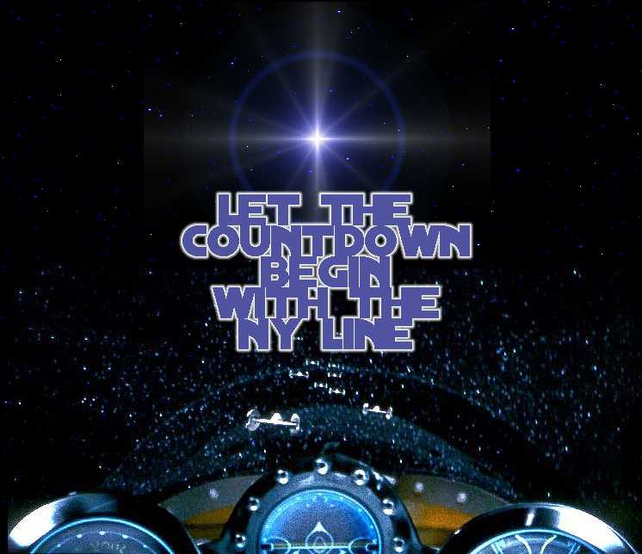

NY Line Volunteers:
NY Line Coordinator & Editor in Chief
Robert Cartagena
aka Red Leader
Ny Line Administrator
Michelle Hadlow
aka r2d2
Public Relations & Asst. Line Coordinator
Suzanne Sousa
aka Red 1 or Pr Princess
Technical Coordinator
Ayaz Asif
aka Red 2
Sponsor Relations
Louis Chang
aka Red 3
Editor
Vincent Terrasi
aka Red 4
Line Logistics
Abbas Rezvi
aka Red 5
City Liasons Coordinator
Giovanni Jarimillo
aka Red 6
Graphics and Video Producer
Jason Narvaez
aka Blue Leader
Graphics
John Green
aka Blue 1
Web Master
Jason McAlpin
aka Blue 2
Graphics
Pete Hernandez
aka Blue 3
Assistant Line Logistics Coordinator
Amit Sazena
aka Red 8
Fundraising Activities
Karen Grenke
aka Green Leader
Assistant Sponsor Relations
Noel Anthony de-Joya
aka Green 1
All Around Supporter and Great Guy
Michael L. Gent
aka Red 7

Keep Pressing!

In this section, you can read about what the media has said about us recently!

Countingdown.com will be featured in a story on ACCESS HOLLYWOOD on Wednesday March 17, 1999 so keep those VCR’s rolling. Also we were taped Friday Night at Sony Lincoln Square for a E! Entertainment Television special report, air date to be determined.

Keep that press coming Suzanne!

You can contact Suzanne Sousa @:
Nyline99@hotmail.com
Attn: PR Princess

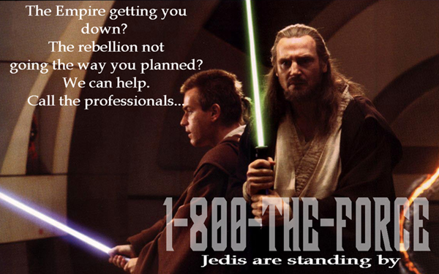

Well, we have reached the end of our Fourth issue of The Menacing New Yorker newsletter!

Hope to hear from you soon! See you in one week!
Contact Robert at: nyline99@hotmail.com
DISCLAIMER
Unless otherwise specified, proposed line-ups at theaters are considered UNAUTHORIZED and are not officially sanctioned by any movie studio, production company, theater chain or individual theater. If at any point the appropriate bodies agree to authorize and participate in a line, that line will be publicly declared an AUTHORIZED line.

Aside from specifically authorized lines, Countdown: The Ultimate Fan Site and Countdown to Star Wars only provide the forum for organizing lines, and do not accept responsibility for participants who meet and congregate on said sites. Those who choose to involve themselves in lines do so completely at their own risk.

