The Menacing New Yorker
Volume 4, Issue 1 The Official Newsletter of the Countdown NY Line April 5, 1999
Fifth Issue Days Until Line Up 19
43 Days Until The Big Show!
The pressure is on…
By: Robert Cartagena

There are many times in your life when you say to yourself, "I wish I had done this or that". And it usually pertains to an event or happening. Well these are words I will never utter regarding the NYLine. I have taken on a job of tremendous proportion (little did I no). Every little detail must pass through my desk from how many people are signed up with the Countdown Listbot to the kind of equipment we will be using on line. It has become an enormous responsibility. But one I would not trade for the world. The group of people, whom I am proud to call my staff, have done an amazing job of helping me gather all the wealth of information needed to pull such an event off. An event, I dare say, that will be the most unique vigil ever held for a movie such as this. And what a movie it will be. I am happy to report all is going smoothly, thanks to the volunteers, and with the exceptions of a few glitches here and there. Everything will come off wonderfully. So my hat goes off to the volunteers: Suzanne, Gio, Louis, Vinny, Mike, Abbas, Amit, Karen, Jason, Pete, John, Matthew, Noel, Steve, and of course Michele. You have all been an inspiration to me and keep me going even when I don't want to. Until Next Time…

Everyone's a Critic…
By Mike Gent

Everyone’s a Critic…

Last night as I was watching television I saw a preview for the movie “Life is Beautiful.” One of the critical blurbs announced: “It will restore your faith in movies.” It made me think. Have I lost my faith in movies? I realized that, as a matter of fact, I have. Or, to be more precise, I’ve become jaded, indifferent, and apathetic when it comes to the concept of the “modern” movie. Maybe it’s because today’s moviemakers try too hard to create something “fresh”. Maybe it’s because today’s moviemakers simply don’t try hard enough.

Whatever the case, I find it ironic that the most anticipated film release of the year, decade, or century is a movie that revisits the most classically simple and the most classically abused artistic theme: the struggle between good and evil.

Behind all the fandemonium, behind all the hype, behind each and every product offering, lies the heart and soul of everything that is meaningful and virtuous; and it is gracefully rearing its angelic head in a little film called “Star Wars Episode I: The Phantom Menace.” Although the title threatens otherwise, it’s more than evident from the press and previews that this movie will cover the same basic territory as its acclaimed predecessors. The good guys are as obviously good as good can be obvious. The bad guys…well, let’s just say that, from what’s been shown so far, these grim folk aren’t about to get any time off for good behavior.

And perhaps the best thing about this return to that long ago in a galaxy far away is that I feel at home there. I mean, even though this is an experience that promises to be filled with strange places and the strangest “people”, it all seems so blissfully comfortable and familiar. Certainly much more familiar than recently created movie worlds of wannabe gangsters and well-endowed high school heroines.

Which brings me back to my original point: movies today have grown alarmingly predictable and stagnant. Deep (or even shallow for that matter) spiritual and social issues have been more or less eclipsed by the unabashed grandstanding of the American Dream.

However, I and so many others have continued to patronize the film industry – perhaps vainly hoping and praying that someone else could pull off something utterly mind-blowing, just like a much younger George Lucas did over 20 years ago. But it seems like everyone who’s tried has fallen far short of the dream, and all we are left with is a handful of dusty mirages in an otherwise barren desert. We need a new hope. We need a true oasis. The Phantom Menace will be that new hope, that true oasis. We will drink from its fountains; we will rest in its shade. It will heal our wounds; it will ease our suffering…

It will restore our faith in movies.

Mike Gent can be seen here regularly on
The Menacing New Yorker

Inside This Issue
1 | The pressure is on…
1 | Everyone's a critic…
2 | PR Princess
2 | City guy
3 | Help Wanted
3 | Logistically Speaking…
5 | From the Administrators Desk…
5 | Live from New York…
6 | Volunteers List
continued on page 4

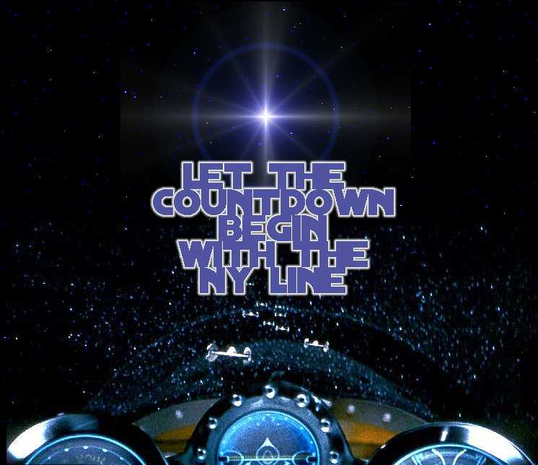
The PR Princess
By Suzanne Sousa

Ah! Spring is in the air! The stores are filled with Easter baskets and Passover treats and slowly and surely, the newsstands and airwaves are full of stories about the upcoming release of a certain film. Vogue
- In Style - Vanity Fair - The New York Times - Entertainment Weekly - 60 Minutes - Popular Mechanics - the list is getting more and more extensive... As PR Princess for the NYLine to Countdown to Star Wars, I
am excited to be one of the many people who will be actively participating in the celebration of Lucasfilm’s release of Star Wars: Episode I - The Phantom Menace. The month of April will be a busy month with regards to media outreach. Thus far, most of the media coverage of the NYLine has come about in three ways - the national contacts of Countdown’s co-founder, Phillip, of Los Angeles; reporters who heard of the Countdown site and are interested in the New York angle; and press contacts referred by several NYLine coordinators. After the Easter holiday, I plan on unleashing my 20-page media list into the NY arena by faxing two-page press releases and following up each one with phone calls and e-mails. The first wave will concentrate on the print media - all the local newspapers, plus feature story pitches to magazines. Radio stations will also be included in the first wave with special attention to Promotion Directors who could help provide prizes for line-up fans. The group photo, dubbed "The Line before the Line" that will be taken on April 9th is designed to add a certain NY character and increase our visibility on the official Countdown website. It also helps to have a stock photo available for event listings in
newspapers and for college and weekly newspapers who may not have the means to provide for a photographer. The second wave of NYLine media outreach will begin one week before the official start of the line-up on April 24th, and will focus on local TV stations and cable outlets. Subsequently, and throughout the entire month, I will be contacting the main media outlets on a regular basis and apprising them of our plans and any new developments or activities taking place on the Countdown line-up. Of course, I expect that on May 19th it will be an absolute media circus with reporters and television crews all over us like mynocks on the Millennium Falcon! Yet all the media mania will be inconsequential compared to me sitting in a dark theater, with a huge Pepsi, a bucket of popcorn and two boxes of gummy bears enthralled like a child, a witness to the first screening of an amazing film from a legendary saga.

PR Princess

PR PRINCESS…continued
The City Guy…
By Giovanni Jarimillo

Hello Star Wars fanatics, it's me, Gio, your City Ordinances Liaison for Countdown to Star Wars - NYC Line. Just wanted to update you on what's going on my end. It turns out that the NY Line does NOT need a street activities permit since we will NOT be blocking off the street and traffic, nor will we be digging up trenches for construction (unless the Empire discovers us, then we prepare for battle). The people that we will need permission from are the theater owners and the local merchants around the theater. We plan to notify (out of courtesy) the local NYPD precinct and let them know that the fun begins on April 24th.

Second, we have agreed to terms with France Telecom, a company that runs a website called Voila.com., on a sponsorship agreement. They will provide equipment that will enable us to record and display, via the Internet, the fans that are lined up throughout the month – 24 hours a day, 7 days a week. Now, you might think that this would require another type of permit...a film permit, but since this web camera is small and would be placed on private property, again, we (the NY Line) do NOT need such a permit, absent staging lights, blocked-off streets, etc, etc. It's all up to the theater and the merchants who own the property where we'll be lining up.

My other title which has been bestowed upon me by our fearless leader Robert, is that of Board Moderator
for the Message Board for our NY Line up. That has and still is a fun job, since I'm always on line and like to respond to questions immediately. The main concern for many fans is, will anyone be able to get tickets if we line up in the required number of shifts, even though Lucasfilm and 20th Century Fox Studios have prevented ANY advanced ticket sales for the first 2 weeks. What I can officially say is that we will guarantee you a ticket for opening day, either the very first show, a primetime show, or late show. Now does that mean that we will get them in advance? No. It means that theater will be able to set aside a block of tickets for us and will release them on the day of the show. So for international fans...DON'T WORRY, you'll be able to see the movie along with us American fans, because the New York City Line will truly be a melting pot (aka a Bacta tank) of all Star Wars fans of every race, and culture.

May the force be with you...always!
Gio
City Ordinances Liaison

HelpWanted Ads
There are several positions that need to be filled for our NY line crew to be complete. If you see a job you might be able to fill please contact us at: Nyline99@hotmail.com Subj: Help wanted

Volunteers Wanted:

TECHNICAL COORDINATOR
We are looking for a technically savvy individual who can work with out supervision to help us get our technical issues sorted out. This person should have PC as well as server experience; Web authoring a plus. This person would be responsible for working out the logistics of getting power and telephone connections for connectivity into the Internet as well as keeping the laptops and computers on the line functioning. You will be working with our main Technical Coordinator as well as with the National Technical Coordinator. Please contact us if you think you fit the bill.

Sponsors Wanted
We are currently looking for Corporate sponsors. If you know any organizations that may be interested in donating equipment, services or funds please have them contact Karen Grenke.
E-mail: nylinesponsor@hotmail.com

Logistically Speaking
By Abbas Rezvi

Hi Folks,

So now that you have seen the shift schedule, we hope your fears have been put to rest. As you can see, the minimum requirement can be met by anyone. Though the final shift will be interactive and there may be some slight modifications as to the value of a few shifts (depending on the timing of the first show) this should allow you to plan ahead and cancel all these oh-so important social engagements to bond with some seriously committed Star Wars fans !

I am still getting a number of queries regarding the ticket form. Don't worry you have not missed it. It has not been posted yet. It has been ready for a while, we are just waiting to sign on the dotted line with the theater management. Also, the no-presale rule will definitely prevent the likes of Moviefone to gatecrash our party: the only way to get tickets to the film in the first opening 2 weeks will be to...hey LINE UP !!!

A few of our overseas fans have expressed concern as a number of them will not be able to get to the US until a couple of days if not on the day of the first show. Once again, as I have stated it in the previous newsletter, we appreciate the effort that our overseas fans are making to see Episode I, and therefore we are committed to ensure that tickets will be made available to them. Please make sure that you e-mail me at nylineup99@hotmail.com to specify the number of people coming over and the date of arrival. Some of you have already done so.

Finally, as we are getting closer to the day of lining up, please please let all your relatives, friends, old friends, new friends, acquaintances, pets,...etc, know about our event. People will find out one way or another sooner or later, we want them to know about it NOW !

Until next time, keep on sending your queries to nylineup99@hotmail.com!

Abbas Rezvi
Line Logistics Coordinator
New York Line

Critic…continued from page 1



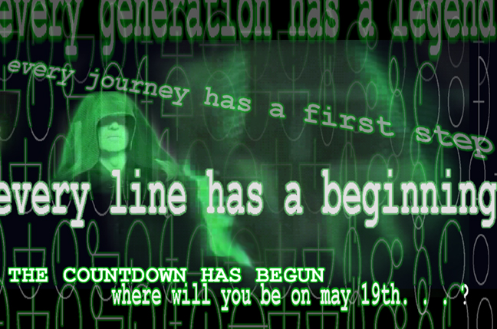

Live From New York… It's the Star Wars Line!
By: Steve Lorenzo

Don't live in New York City? Can’t get off work to wait four weeks in front of a movie theater? Have no fear – you will still be able to catch the “Star Wars” fever radiating from the Countdown New York line, and you need look no further than your own computer screen! Through the generous sponsorship of VOILA.COM and webcam technology, you can join the New York line though live 24-hour streaming video and two daily half-hour webcasts.

The 24-hour webcams will be a live, uncensored attempt to bring the spirit of “Star Wars” to a global audience. Anybody who needs the boost that can only be found through watching the zany antics of their fellow fans and fanatics will be able to view everything from the late-night “Star Wars” Trivial Pursuit games to the inevitable Queen Amidala look-alike fashion shows.

For those who can’t tune in day and night, events during the two weeks leading to May 19 will be summarized in daily webcasts. While the program schedule has yet to be announced, two elements of the webcasts are certain: 1) They will serve to pass along the latest news of all things “Star Wars” and the New York line; and 2) They will offer information and entertainment of interest to anybody who plans to join
the line, whether they’re coming from the Bronx or Berlin.

Menacing New Yorkers have already been discussing the form of these webcasts, and we’ve come up with a few ideas and surprises that are sure to keep you tuning in. The first few episodes will have information
geared towards “Star Wars” fans making their first trip into that wretched hive of scum and villainy known as New York City. We’ll show you how to navigate the NYC Subway and find the stores selling the
latest and greatest “Star Wars” memorabilia. As we move closer to May 19, the content will be determined more by the personalities joining the line and the people viewing from their homes and offices.

To that end, we invite you to submit any ideas that you would like to see turned into a 3 to 5-minute feature segment on these broadcasts. Just as the Countdown New York line will serve as a gathering place for all who hold “Star Wars” near and dear to their hearts, these broadcasts will be a reflection of the revelry leading to the long-awaited first screening of “The Phantom Menace.” Join the party – if not in line, then on-line!

Please submit any ideas for the “Star Wars” line broadcasts to nylineproduction@hotmail.com

From the Administrators Desk…
By: Michele Hadlow
Aka R2D2

You are about to be inundated with updates…

First- we have several new volunteers to welcome. As you may have noticed from this newsletter, several of our new volunteers are graphic designers- much needed Graphic designers!. These designers are not only hard at work sprucing up our newsletter, but are also busy designing buttons, t-shirts and other good stuff, so you have Jason, John and Pete to thank for thecool new look we will have.

If you are a student in New York or have been to any conventions or comic book stores lately you may have noticed our recruitment flyers. Abbas and his team- Amit and Matthew , have been busy getting the word out about our group. Because of this and the increasing media coverage Suzanne has been able to generate, our membership is expected to grow enormously in the next couple of weeks. As our first group of members, you have the opportunity to take a first look at the shift calendar that is now posted on our web site.
< http://www.countingdown.com/starwars/events/newyork/>
Our group has been hard at work ironing out all the details of this schedule. We are now working out the technicals with a Web master to get it posted so you can sign up for your shifts, so take a look and start thinking about what time slots you would like to fill.

We are very happy to be working with the Starlight foundation on this event. Not only is it a very worthy organization to be contributing to, it is also opening up all kinds of doors for our group. Suzanne is working out the details now, but be prepared to dig deep for this great organization.

You may have noticed that our group is generating a lot of interest in the media lately. This will only increase, so keep you eyes and ears open to hear what the world has to say about our group. Our Sponsor Relations coordinator Louis has switched into full gear so we soon hope that many other companies will be joining Voila.com in sponsoring us, keep an eye out for information on that as well.

Now the theater…..All I can say is stay tuned. All of our hard work has not gone unnoticed by Lucas and the theaters. I have total confidence that a home will be announced soon.

Michele

NYLine
Countdown Volunteers:

NY Line Coordinator & Editor in Chief
Robert Cartagena
aka Red Leader
Ny Line Administrator
Michelle Hadlow
aka r2d2
Public Relations & Asst. Line Coordinator
Suzanne Sousa
aka Red 1 or Pr Princess
Business Manager/Treasurer
Louis Chang
aka Red 3
Technical Coordinator
Matthew
aka Red 2
Sponsor Relations
Karen Grenke
aka Green Leader
Assistant Sponsor Relations
Noel Anthony de-Joya
aka Green 1
Editor
Vincent Terrasi
aka Red 4
Line Logistics
Abbas Rezvi
aka Red 5
City Liasons Coordinator
Giovanni Jaramillo
aka Red 6
Graphics and Video Producer
Jason Narvaez
aka Blue Leader
Graphics
John Green
aka Blue 1
Graphics
Pete Hernandez
aka Blue 3
Assistant Line Logistics Coordinator
Amit Sazena
aka Red 8
All Around Supporter and Great Guy
Michael L. Gent
aka Red 7

Keep Pressing!

In this section, you can read about what the media has said about us recently!

The Countdown line was featured in an article in WiredNews last week. Also a mention was given in USA Today on 3/29/99.

The NYLine will be doing a huge media blitz this coming next weeks so be on the look out.

Keep that press coming Suzanne!

You can contact Suzanne Sousa @:
Nyline99@hotmail.com
Attn: PR Princess



Well, we have reached the end of our Fifth issue of The Menacing New Yorker newsletter!

Hope to hear from you soon! See you in one week!
Contact Robert at: nyline99@hotmail.com
DISCLAIMER
Unless otherwise specified, proposed line-ups at theaters are considered UNAUTHORIZED and are not officially sanctioned by any movie studio, production company, theater chain or individual theater. If at any point the appropriate bodies agree to authorize and participate in a line, that line will be publicly declared an AUTHORIZED line.

Aside from specifically authorized lines, Countdown: The Ultimate Fan Site and Countdown to Star Wars only provide the forum for organizing lines, and do not accept responsibility for participants who meet and congregate on said sites. Those who choose to involve themselves in lines do so completely at their own risk.

