Senior Project Logistic Regression

Michael Streyle

November 5th, 2018

# Beginning

# Initial Model

Call:  
glm(formula = classification ~ pelvic_tilt + pelvic_incidence +   
 lumbar_lordosis_angle + sacral_slope + pelvic_radius + degree_spondylolisthesis,   
 family = binomial(link = "logit"), data = lr_train)  
  
Deviance Residuals:   
 Min 1Q Median 3Q Max   
-2.40458 -0.39229 -0.04114 0.40079 2.80457   
  
Coefficients:  
 Estimate Std. Error z value Pr(>|z|)   
(Intercept) -3.304e+00 5.267e-01 -6.274 3.52e-10 ***  
pelvic_tilt -5.314e+08 4.441e+08 -1.197 0.23146   
pelvic_incidence 9.151e+08 7.648e+08 1.197 0.23146   
lumbar_lordosis_angle 9.587e-02 4.788e-01 0.200 0.84132   
sacral_slope -7.127e+08 5.956e+08 -1.197 0.23146   
pelvic_radius 1.147e+00 3.156e-01 3.633 0.00028 ***  
degree_spondylolisthesis -6.375e+00 9.626e-01 -6.623 3.52e-11 ***  
---  
Signif. codes: 0 '***' 0.001 '**' 0.01 '*' 0.05 '.' 0.1 ' ' 1  
  
(Dispersion parameter for binomial family taken to be 1)  
  
 Null deviance: 308.84 on 247 degrees of freedom  
Residual deviance: 141.83 on 241 degrees of freedom  
AIC: 155.83  
  
Number of Fisher Scoring iterations: 7

Call:  
glm(formula = class ~ degree_spondylolisthesis + sacral_slope +   
 pelvic_radius + pelvic_tilt + Direct_tilt, family = binomial(link = "logit"),   
 data = lr_train)  
  
Deviance Residuals:   
 Min 1Q Median 3Q Max   
-2.07271 -0.37358 -0.04328 0.40737 2.63670   
  
Coefficients:  
 Estimate Std. Error z value Pr(>|z|)   
(Intercept) -3.3643 0.5325 -6.318 2.64e-10 ***  
degree_spondylolisthesis -6.3018 0.9480 -6.648 2.98e-11 ***  
sacral_slope 1.5558 0.3547 4.386 1.15e-05 ***  
pelvic_radius 1.1881 0.3089 3.846 0.00012 ***  
pelvic_tilt -0.7932 0.3237 -2.451 0.01426 *   
Direct_tilt -0.3782 0.2264 -1.671 0.09473 .   
---  
Signif. codes: 0 '***' 0.001 '**' 0.01 '*' 0.05 '.' 0.1 ' ' 1  
  
(Dispersion parameter for binomial family taken to be 1)  
  
 Null deviance: 308.84 on 247 degrees of freedom  
Residual deviance: 140.48 on 242 degrees of freedom  
AIC: 152.48  
  
Number of Fisher Scoring iterations: 7

[,1] [,2]  
[1,] 36 6  
[2,] 4 16

[,1] [,2]  
[1,] 36 7  
[2,] 4 15

[1] 0.8387097

[1] 0.8225806

[,1] [,2]  
[1,] 37 6  
[2,] 3 16

[1] 0.8548387

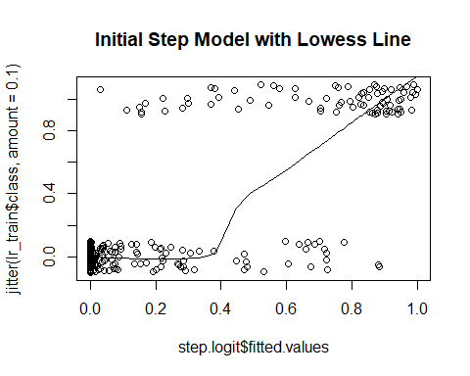

# Find Optimal Cutoff for Train/Test Initial Model with Forward Stepwise

[,1] [,2]  
[1,] 40 16  
[2,] 0 6

[1] 0.7419355

# Cross-Validation with Initial Model with Optimizing with Set Seed

[,1] [,2]  
[1,] 189 23  
[2,] 21 77

[1] 0.8580645

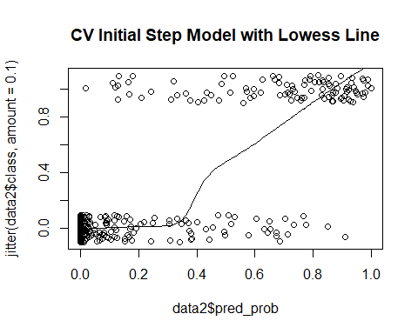

# Accuracy Distribution of Cross-Validation with Initial Model with Optimizing

# Add Provided Random Noise

[,1] [,2]  
[1,] 193 28  
[2,] 17 72

[1] 0.8548387

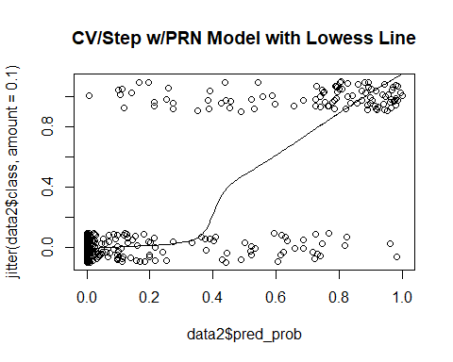

# Add 10 Random Variables

[,1] [,2]  
[1,] 187 26  
[2,] 23 74

[1] 0.8419355

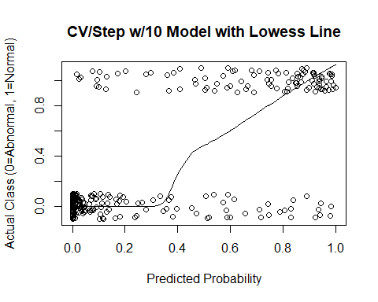

# Add 100 Random Variables with set seed

[,1] [,2]  
[1,] 175 34  
[2,] 35 66

[1] 0.7774194

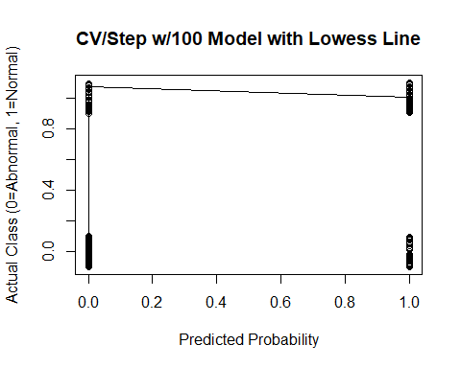

[1] "sdev" "rotation" "center" "scale" "x"

PC1 PC2 PC3 PC4  
pelvic_incidence -0.4585396 -0.03986544 0.02559957 -0.04130906  
pelvic_tilt -0.2988447 -0.09654887 0.10297940 0.09719343  
lumbar_lordosis_angle -0.3962508 -0.02873156 -0.03282033 0.01412432  
sacral_slope -0.3659877 0.02079636 -0.04390970 -0.12551259  
pelvic_radius 0.1216077 -0.04026772 -0.04059324 0.06597922

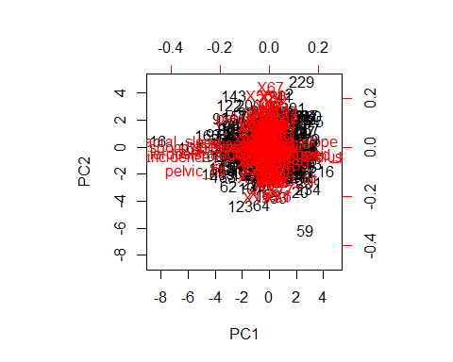

[1] 3.980433 2.465193 2.320331 2.234025 2.204784 2.197591 2.101477  
 [8] 2.045163 2.019319 1.999980

[1] 0.03522507 0.02181587 0.02053390 0.01977013 0.01951136 0.01944771  
 [7] 0.01859714 0.01809879 0.01787008 0.01769893 0.01732758 0.01708304  
[13] 0.01661430 0.01631056 0.01610876 0.01578239 0.01542219 0.01515624  
[19] 0.01498812 0.01468698

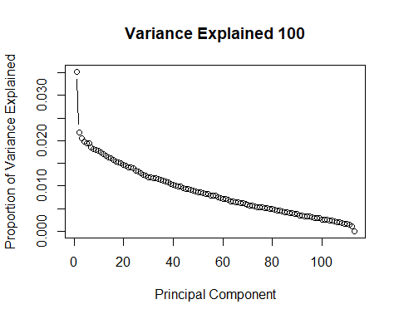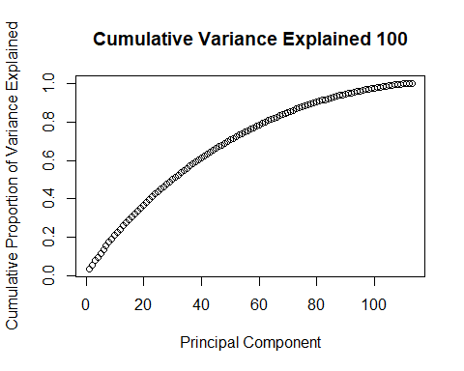

# Accuracy Distribution for 100 Random Variables

# Add 500 Random Variables

[,1] [,2]  
[1,] 175 27  
[2,] 35 73

[1] 0.8

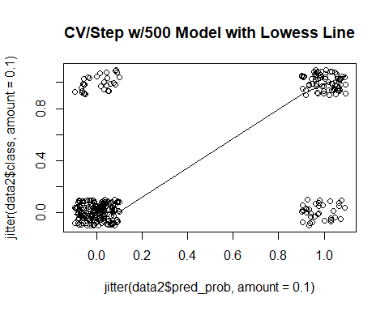

[1] "sdev" "rotation" "center" "scale" "x"

PC1 PC2 PC3 PC4  
pelvic_incidence 0.3427986 -0.008366553 0.025014206 0.030629291  
pelvic_tilt 0.2150461 -0.029647281 -0.026541067 0.017892787  
lumbar_lordosis_angle 0.2936539 -0.017941039 -0.003384455 0.030592587  
sacral_slope 0.2798461 0.011361719 0.051909732 0.025989929  
pelvic_radius -0.1085754 -0.028813317 0.027042366 -0.001630254

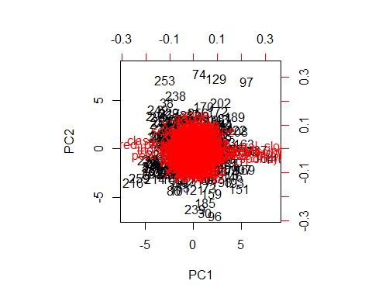

[1] 5.874800 5.064426 5.022195 4.982542 4.934381 4.843773 4.679750  
 [8] 4.662627 4.564496 4.523734

[1] 0.011429572 0.009852969 0.009770806 0.009693662 0.009599963  
 [6] 0.009423684 0.009104571 0.009071258 0.008880343 0.008801038  
[11] 0.008727385 0.008548648 0.008463923 0.008390731 0.008292869  
[16] 0.008238491 0.008174125 0.008094779 0.008002274 0.007914800

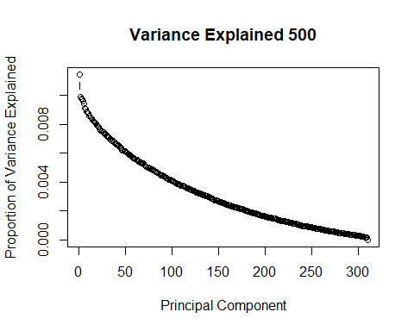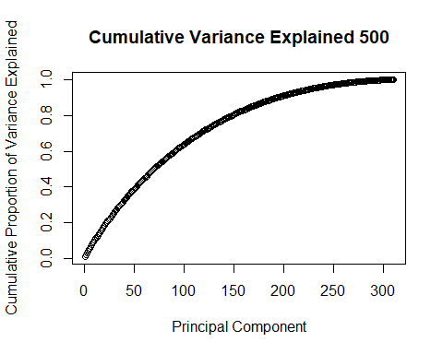

# Add 1000 Random Variables

NULL

[,1] [,2]  
[1,] 171 25  
[2,] 39 75

[1] 0.7935484

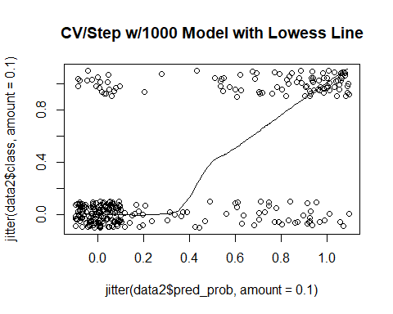

[1] "sdev" "rotation" "center" "scale" "x"

PC1 PC2 PC3 PC4  
pelvic_incidence 0.26039490 -0.008145069 0.018005619 0.04386852  
pelvic_tilt 0.15651824 -0.015057780 -0.042867289 0.01757024  
lumbar_lordosis_angle 0.22794649 -0.006828880 0.005227278 0.01130359  
sacral_slope 0.21767067 0.000768123 0.055082960 0.04323084  
pelvic_radius -0.09339356 -0.020479532 0.028754927 -0.01895133

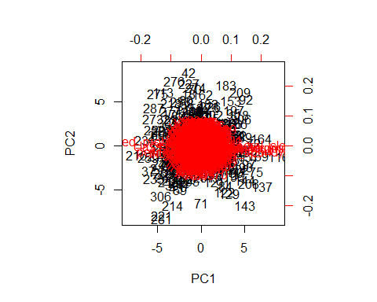

[1] 8.159674 7.822566 7.566269 7.419606 7.416358 7.311467 7.268683  
 [8] 7.240749 7.114971 7.056890

[1] 0.008047015 0.007714562 0.007461803 0.007317166 0.007313962  
 [6] 0.007210520 0.007168326 0.007140778 0.007016737 0.006959457  
[11] 0.006859799 0.006795145 0.006750020 0.006689229 0.006664719  
[16] 0.006590777 0.006537566 0.006509526 0.006471214 0.006419935

