Senior Project Random Forest

Michael Streyle

October 30th, 2018

# Introduction

# Initial Model

MeanDecreaseGini  
pelvic_tilt 13.15211  
pelvic_incidence 12.14187  
lumbar_lordosis_angle 12.68480  
sacral_slope 12.80926  
pelvic_radius 16.58574  
degree_spondylolisthesis 38.84536

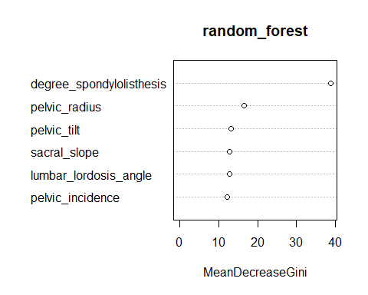

Confusion Matrix and Statistics  
  
 Reference  
Prediction Abnormal Normal  
 Abnormal 38 2  
 Normal 10 12  
   
 Accuracy : 0.8065   
 95% CI : (0.6863, 0.8958)  
 No Information Rate : 0.7742   
 P-Value [Acc > NIR] : 0.33265   
   
 Kappa : 0.5396   
 Mcnemar's Test P-Value : 0.04331   
   
 Sensitivity : 0.7917   
 Specificity : 0.8571   
 Pos Pred Value : 0.9500   
 Neg Pred Value : 0.5455   
 Prevalence : 0.7742   
 Detection Rate : 0.6129   
 Detection Prevalence : 0.6452   
 Balanced Accuracy : 0.8244   
   
 'Positive' Class : Abnormal

mtry = 2 OOB error = 16.13%   
Searching left ...  
mtry = 1 OOB error = 18.55%   
-0.15 0.05   
Searching right ...  
mtry = 4 OOB error = 19.76%   
-0.225 0.05

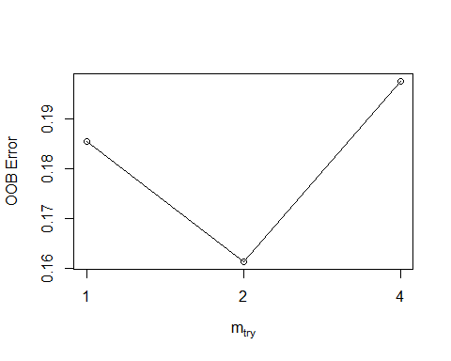

Call:  
 randomForest(x = x, y = y, mtry = res[which.min(res[, 2]), 1])   
 Type of random forest: classification  
 Number of trees: 500  
No. of variables tried at each split: 2  
  
 OOB estimate of error rate: 16.94%  
Confusion matrix:  
 Abnormal Normal class.error  
Abnormal 152 18 0.1058824  
Normal 24 54 0.3076923

MeanDecreaseGini  
pelvic_incidence 13.60084  
pelvic_tilt 11.98641  
lumbar_lordosis_angle 11.80908  
sacral_slope 13.10558  
pelvic_radius 16.39389  
degree_spondylolisthesis 39.96065

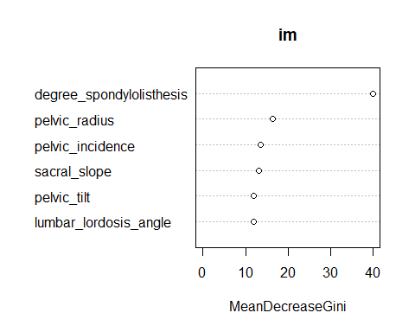

# Cross-Validation Model

mtry = 2 OOB error = 17.1%   
Searching left ...  
mtry = 1 OOB error = 16.77%   
0.01886792 0.05   
Searching right ...  
mtry = 4 OOB error = 16.45%   
0.03773585 0.05

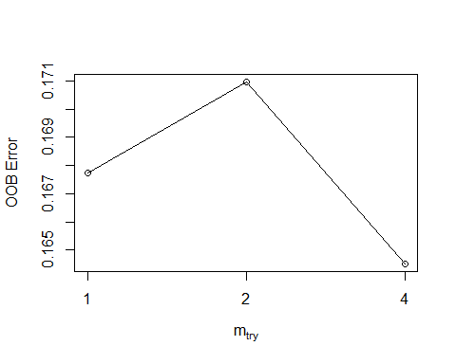

mtry OOBError  
1.OOB 1 0.1677419  
2.OOB 2 0.1709677  
4.OOB 4 0.1645161

MeanDecreaseGini  
pelvic_tilt 13.15211  
pelvic_incidence 12.14187  
lumbar_lordosis_angle 12.68480  
sacral_slope 12.80926  
pelvic_radius 16.58574  
degree_spondylolisthesis 38.84536



Confusion Matrix and Statistics  
  
 Reference  
Prediction Abnormal Normal  
 Abnormal 187 23  
 Normal 26 74  
   
 Accuracy : 0.8419   
 95% CI : (0.7965, 0.8807)  
 No Information Rate : 0.6871   
 P-Value [Acc > NIR] : 3.261e-10   
   
 Kappa : 0.6355   
 Mcnemar's Test P-Value : 0.7751   
   
 Sensitivity : 0.8779   
 Specificity : 0.7629   
 Pos Pred Value : 0.8905   
 Neg Pred Value : 0.7400   
 Prevalence : 0.6871   
 Detection Rate : 0.6032   
 Detection Prevalence : 0.6774   
 Balanced Accuracy : 0.8204   
   
 'Positive' Class : Abnormal

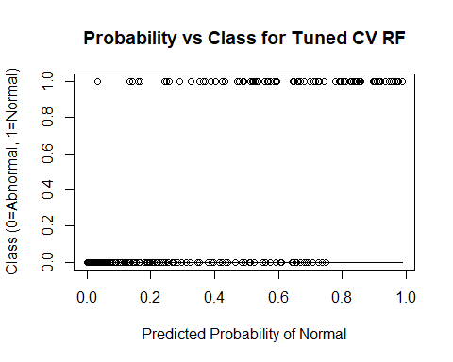

# Add Provided Random Noise

mtry = 3 OOB error = 19.03%   
Searching left ...  
mtry = 2 OOB error = 17.42%   
0.08474576 0.05   
mtry = 1 OOB error = 21.94%   
-0.2592593 0.05   
Searching right ...  
mtry = 6 OOB error = 19.68%   
-0.1296296 0.05

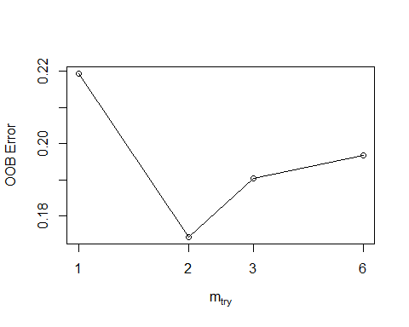

mtry OOBError  
1.OOB 1 0.2193548  
2.OOB 2 0.1741935  
3.OOB 3 0.1903226  
6.OOB 6 0.1967742

MeanDecreaseGini  
pelvic_incidence 8.859955  
pelvic_tilt 9.250360  
lumbar_lordosis_angle 8.412710  
sacral_slope 8.561810  
pelvic_radius 14.124541  
degree_spondylolisthesis 25.057467  
pelvic_slope 4.515013  
Direct_tilt 5.361990  
thoracic_slope 5.314960  
cervical_tilt 5.856255  
sacrum_angle 5.578070  
scoliosis_slope 6.937531

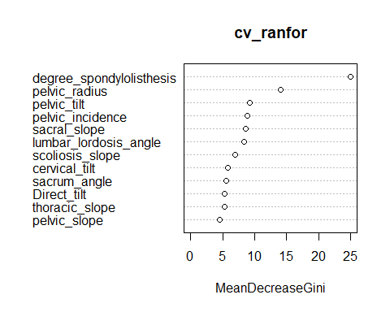

Confusion Matrix and Statistics  
  
 Reference  
Prediction Abnormal Normal  
 Abnormal 188 22  
 Normal 35 65  
   
 Accuracy : 0.8161   
 95% CI : (0.7684, 0.8577)  
 No Information Rate : 0.7194   
 P-Value [Acc > NIR] : 5.282e-05   
   
 Kappa : 0.5645   
 Mcnemar's Test P-Value : 0.112   
   
 Sensitivity : 0.8430   
 Specificity : 0.7471   
 Pos Pred Value : 0.8952   
 Neg Pred Value : 0.6500   
 Prevalence : 0.7194   
 Detection Rate : 0.6065   
 Detection Prevalence : 0.6774   
 Balanced Accuracy : 0.7951   
   
 'Positive' Class : Abnormal

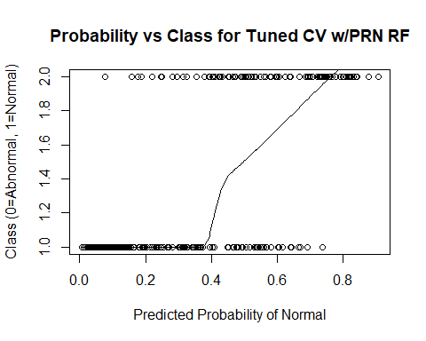

# Add 10 Random Variables

mtry = 4 OOB error = 19.03%   
Searching left ...  
mtry = 2 OOB error = 19.35%   
-0.01694915 0.05   
Searching right ...  
mtry = 8 OOB error = 19.03%   
0 0.05

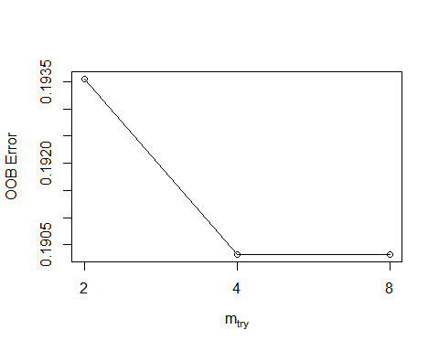

mtry OOBError  
2.OOB 2 0.1935484  
4.OOB 4 0.1903226  
8.OOB 8 0.1903226

MeanDecreaseGini  
pelvic_incidence 3.2022659  
pelvic_tilt 4.5670598  
lumbar_lordosis_angle 5.0248268  
sacral_slope 9.9702033  
pelvic_radius 9.1985254  
degree_spondylolisthesis 43.9117143  
pelvic_slope 0.9751303  
Direct_tilt 1.4061935  
thoracic_slope 2.0743864  
cervical_tilt 1.8274781  
sacrum_angle 1.9724421  
scoliosis_slope 1.8839118  
X1 1.9651829  
X2 1.9712072  
X3 1.8640025  
X4 3.1620878  
X5 2.3345345  
X6 3.1114970  
X7 3.3487048  
X8 1.8452842  
X9 2.6035675  
X10 1.8380684

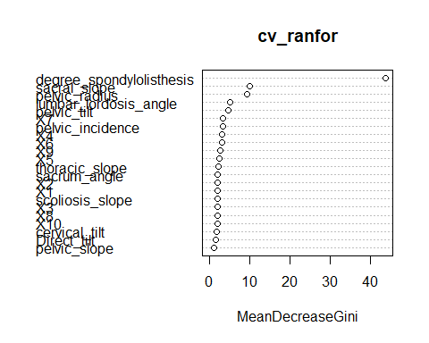

Confusion Matrix and Statistics  
  
 Reference  
Prediction Abnormal Normal  
 Abnormal 185 25  
 Normal 25 75  
   
 Accuracy : 0.8387   
 95% CI : (0.7929, 0.8779)  
 No Information Rate : 0.6774   
 P-Value [Acc > NIR] : 8.779e-11   
   
 Kappa : 0.631   
 Mcnemar's Test P-Value : 1   
   
 Sensitivity : 0.8810   
 Specificity : 0.7500   
 Pos Pred Value : 0.8810   
 Neg Pred Value : 0.7500   
 Prevalence : 0.6774   
 Detection Rate : 0.5968   
 Detection Prevalence : 0.6774   
 Balanced Accuracy : 0.8155   
   
 'Positive' Class : Abnormal

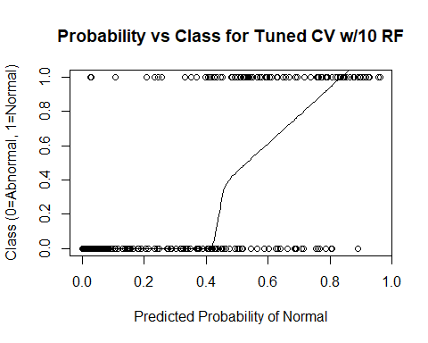 # Add 100 Random Variables

mtry = 10 OOB error = 22.26%   
Searching left ...  
mtry = 5 OOB error = 30.97%   
-0.3913043 0.05   
Searching right ...  
mtry = 20 OOB error = 24.52%   
-0.1014493 0.05

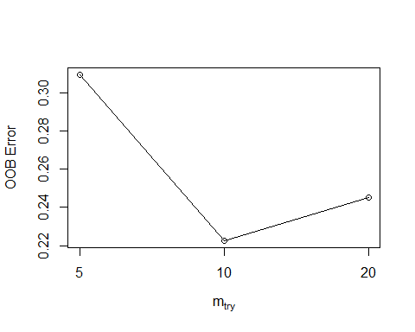

mtry OOBError  
5.OOB 5 0.3096774  
10.OOB 10 0.2225806  
20.OOB 20 0.2451613

MeanDecreaseGini  
pelvic_incidence 3.5641762  
pelvic_tilt 3.3364984  
lumbar_lordosis_angle 4.1795320  
sacral_slope 2.1758695  
pelvic_radius 4.6062258  
degree_spondylolisthesis 13.4208132  
pelvic_slope 0.5021879  
Direct_tilt 0.4562610  
thoracic_slope 0.6121050  
cervical_tilt 0.6490038  
sacrum_angle 0.8462769  
scoliosis_slope 0.8053812  
X1 0.6778439  
X2 0.7681018  
X3 0.5986865  
X4 0.6395936  
X5 1.1574296  
X6 0.9578584  
X7 0.8195534  
X8 0.5693077  
X9 0.8036344  
X10 0.5131597  
X11 0.6718749  
X12 0.8218499  
X13 0.6936367  
X14 0.8080790  
X15 0.7415135  
X16 0.9315695  
X17 0.8227422  
X18 0.7675297  
X19 0.6834504  
X20 0.5525062  
X21 0.8873626  
X22 1.3218316  
X23 0.4555300  
X24 0.7460673  
X25 0.8135725  
X26 0.8221727  
X27 0.8228608  
X28 0.6093707  
X29 0.8005218  
X30 0.4597668  
X31 0.4503310  
X32 0.5027736  
X33 0.4704129  
X34 0.8271870  
X35 0.6919351  
X36 0.4129119  
X37 0.4176781  
X38 0.4859588  
X39 0.6571532  
X40 0.5607707  
X41 0.8422408  
X42 0.6237343  
X43 0.5391351  
X44 0.6084440  
X45 0.5481742  
X46 0.6294841  
X47 0.5116424  
X48 1.0152811  
X49 0.4335624  
X50 0.4320520  
X51 0.6124192  
X52 0.6786963  
X53 0.8362618  
X54 0.7361601  
X55 0.7630174  
X56 0.5427745  
X57 1.0309441  
X58 0.6285753  
X59 0.4628716  
X60 0.5709009  
X61 0.8848405  
X62 0.6564414  
X63 0.8029348  
X64 0.9675891  
X65 0.4215953  
X66 0.5415668  
X67 0.8627367  
X68 0.6104719  
X69 0.8989694  
X70 0.5206083  
X71 0.4498217  
X72 0.8733714  
X73 0.7831430  
X74 0.5914240  
X75 1.5269245  
X76 1.0941257  
X77 1.4513585  
X78 0.6886498  
X79 0.7448360  
X80 0.5132508  
X81 0.9279296  
X82 0.7091917  
X83 0.5736508  
X84 0.6183928  
X85 0.5801355  
X86 1.1174080  
X87 0.6260272  
X88 1.0469253  
X89 0.6245683  
X90 0.7147637  
X91 0.5763333  
X92 1.0072758  
X93 0.5329751  
X94 0.7784585  
X95 0.7014517  
X96 0.8857833  
X97 0.6277713  
X98 0.6463808  
X99 0.7828845  
X100 0.6499342

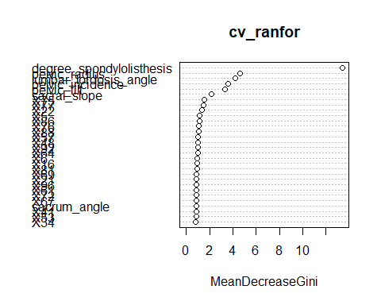

Confusion Matrix and Statistics  
  
 Reference  
Prediction Abnormal Normal  
 Abnormal 192 18  
 Normal 58 42  
   
 Accuracy : 0.7548   
 95% CI : (0.703, 0.8017)  
 No Information Rate : 0.8065   
 P-Value [Acc > NIR] : 0.9896   
   
 Kappa : 0.3734   
 Mcnemar's Test P-Value : 7.691e-06   
   
 Sensitivity : 0.7680   
 Specificity : 0.7000   
 Pos Pred Value : 0.9143   
 Neg Pred Value : 0.4200   
 Prevalence : 0.8065   
 Detection Rate : 0.6194   
 Detection Prevalence : 0.6774   
 Balanced Accuracy : 0.7340   
   
 'Positive' Class : Abnormal

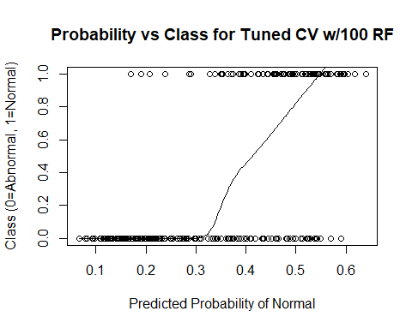

# Add 500 Random Variables

mtry = 22 OOB error = 32.26%   
Searching left ...  
mtry = 11 OOB error = 32.58%   
-0.01 0.05   
Searching right ...  
mtry = 44 OOB error = 27.74%   
0.14 0.05   
mtry = 88 OOB error = 24.84%   
0.1046512 0.05   
mtry = 176 OOB error = 19.03%   
0.2337662 0.05   
mtry = 352 OOB error = 22.9%   
-0.2033898 0.05

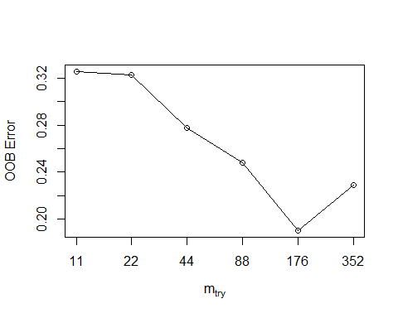

mtry OOBError  
11.OOB 11 0.3258065  
22.OOB 22 0.3225806  
44.OOB 44 0.2774194  
88.OOB 88 0.2483871  
176.OOB 176 0.1903226  
352.OOB 352 0.2290323

MeanDecreaseGini  
pelvic_incidence 6.01100462  
pelvic_tilt 3.38621535  
lumbar_lordosis_angle 3.38204323  
sacral_slope 1.84095368  
pelvic_radius 6.61375200  
degree_spondylolisthesis 29.69157311  
pelvic_slope 0.04516613  
Direct_tilt 0.05921861  
thoracic_slope 0.28618526  
cervical_tilt 0.10897747  
sacrum_angle 0.05223586  
scoliosis_slope 0.06663832  
X1 0.02960129  
X2 0.07636687  
X3 0.16661184  
X4 0.04863451  
X5 0.10742465  
X6 0.26578690  
X7 0.17616101  
X8 0.08328187  
X9 0.19831939  
X10 0.04033133  
X11 0.11273203  
X12 0.06154676  
X13 0.12715521  
X14 0.21590919  
X15 0.01675745  
X16 0.07298429  
X17 0.09978005  
X18 0.07644006  
X19 0.04767568  
X20 0.01928116  
X21 0.22156802  
X22 0.36132039  
X23 0.03678497  
X24 0.07818254  
X25 0.40941571  
X26 0.19638778  
X27 0.09877176  
X28 0.55740077  
X29 0.04900979  
X30 0.09326776  
X31 0.05102179  
X32 0.06179487  
X33 0.10394346  
X34 0.19932217  
X35 0.04293341  
X36 0.05409918  
X37 0.08539927  
X38 0.11589262  
X39 0.03693409  
X40 0.07416488  
X41 0.17868996  
X42 0.05328176  
X43 0.04976898  
X44 0.05743946  
X45 0.04320375  
X46 0.06791816  
X47 0.04224700  
X48 0.22214187  
X49 0.10783932  
X50 0.06129321  
X51 0.11258447  
X52 0.07751939  
X53 0.07971532  
X54 0.09749348  
X55 0.05284229  
X56 0.06923572  
X57 0.13788549  
X58 0.07596851  
X59 0.15465781  
X60 0.07671116  
X61 0.12330184  
X62 0.01923306  
X63 0.15183106  
X64 0.07857717  
X65 0.02756508  
X66 0.03266193  
X67 0.03617204  
X68 0.05365864  
X69 0.09030315  
X70 0.07436254  
X71 0.08809051  
X72 0.05169864  
X73 0.37302217  
X74 0.03099392  
X75 0.19216087  
X76 0.26427187  
X77 0.37414607  
X78 0.33110780  
X79 0.11133380  
X80 0.05611238  
X81 0.11583623  
X82 0.05931341  
X83 0.06050782  
X84 0.20131448  
X85 0.02110258  
X86 0.29794029  
X87 0.04191640  
X88 0.08738797  
X89 0.06984945  
X90 0.07378192  
X91 0.12342942  
X92 0.09392362  
X93 0.09396828  
X94 0.13264929  
X95 0.04590794  
X96 0.08765083  
X97 0.16594496  
X98 0.12797302  
X99 0.05731357  
X100 0.06706657  
X101 0.06487321  
X102 0.14071207  
X103 0.28628130  
X104 0.15972425  
X105 0.13511206  
X106 0.11035306  
X107 0.06045395  
X108 0.05526211  
X109 0.06618923  
X110 0.03146295  
X111 0.07414700  
X112 0.04467685  
X113 0.18689112  
X114 0.06654089  
X115 0.11832695  
X116 0.08729151  
X117 0.10837718  
X118 0.05961255  
X119 0.14412188  
X120 0.12519334  
X121 0.05411145  
X122 0.05773627  
X123 0.09112382  
X124 0.13259947  
X125 0.08274779  
X126 0.10798220  
X127 0.08246826  
X128 0.17160849  
X129 0.15822923  
X130 0.03380575  
X131 0.14833513  
X132 0.23223608  
X133 0.12910473  
X134 0.20058092  
X135 0.09472974  
X136 0.04045340  
X137 0.03387976  
X138 0.09871264  
X139 0.04250720  
X140 0.24841844  
X141 0.17066478  
X142 0.16477167  
X143 0.11492612  
X144 0.12261287  
X145 0.04582035  
X146 0.05321394  
X147 0.25491069  
X148 0.17117766  
X149 0.06540284  
X150 0.13580258  
X151 0.06538597  
X152 0.04333726  
X153 0.15595083  
X154 0.07085186  
X155 0.12545881  
X156 0.02565294  
X157 0.21200909  
X158 0.04324198  
X159 0.02431852  
X160 0.18846197  
X161 0.27907309  
X162 0.12915179  
X163 0.12056938  
X164 0.10879677  
X165 0.06715881  
X166 0.35606259  
X167 0.02377555  
X168 0.14604953  
X169 0.05987168  
X170 0.17339194  
X171 0.08943269  
X172 0.05921203  
X173 0.18621241  
X174 0.04205375  
X175 0.09606354  
X176 0.13001952  
X177 0.03165576  
X178 0.05092353  
X179 0.06941343  
X180 0.07277669  
X181 0.11646062  
X182 0.10026587  
X183 0.04626869  
X184 0.22276236  
X185 0.11399451  
X186 0.15885405  
X187 0.08940498  
X188 0.06152393  
X189 0.07765397  
X190 0.05527593  
X191 0.16615003  
X192 0.08298090  
X193 0.09599317  
X194 0.06504682  
X195 0.02164871  
X196 0.09316481  
X197 0.06078110  
X198 0.08758853  
X199 0.11519842  
X200 0.09797695  
X201 0.14539931  
X202 0.05804286  
X203 0.12115162  
X204 0.26841086  
X205 0.06941323  
X206 0.01097693  
X207 0.05700664  
X208 0.04869068  
X209 0.12228680  
X210 0.11556243  
X211 0.12659351  
X212 0.04111852  
X213 0.05109449  
X214 0.03895095  
X215 0.05380040  
X216 0.04959300  
X217 0.13305732  
X218 0.04277244  
X219 0.09767859  
X220 0.05890807  
X221 0.16070062  
X222 0.06015762  
X223 0.13874404  
X224 0.03599820  
X225 0.06227555  
X226 0.07657752  
X227 0.07320796  
X228 0.07859173  
X229 0.05728403  
X230 0.10044975  
X231 0.30628811  
X232 0.10141014  
X233 0.13152829  
X234 0.14235180  
X235 0.06338949  
X236 0.04480747  
X237 0.02842601  
X238 0.04638949  
X239 0.07303603  
X240 0.03977027  
X241 0.06827309  
X242 0.06199111  
X243 0.14882137  
X244 0.08988683  
X245 0.11943579  
X246 0.10733939  
X247 0.06241004  
X248 0.00000000  
X249 0.36070313  
X250 0.03751100  
X251 0.01888413  
X252 0.05526302  
X253 0.05404373  
X254 0.10552227  
X255 0.04423335  
X256 0.08950585  
X257 0.26087441  
X258 0.06005404  
X259 0.19365427  
X260 0.22809735  
X261 0.20349920  
X262 0.11191022  
X263 0.22534566  
X264 0.12601928  
X265 0.02811094  
X266 0.15717099  
X267 0.07076741  
X268 0.23495913  
X269 0.04399480  
X270 0.39937443  
X271 0.02964628  
X272 0.07454013  
X273 0.13198675  
X274 0.13501219  
X275 0.07628363  
X276 0.04841984  
X277 0.01732045  
X278 0.29615806  
X279 0.05197209  
X280 0.07151182  
X281 0.10396071  
X282 0.05801499  
X283 0.03886648  
X284 0.07898286  
X285 0.01391795  
X286 0.79921123  
X287 0.11907175  
X288 0.04493681  
X289 0.17990764  
X290 0.01125458  
X291 0.06743635  
X292 0.11579969  
X293 0.22508816  
X294 0.14922695  
X295 0.03624125  
X296 0.44774558  
X297 0.06589552  
X298 0.24415356  
X299 0.08219398  
X300 0.03403485  
X301 0.06215493  
X302 0.04741238  
X303 0.09781729  
X304 0.13942279  
X305 0.30591724  
X306 0.05318756  
X307 0.03465408  
X308 0.14502515  
X309 0.07988285  
X310 1.14306916  
X311 0.08534156  
X312 0.16394420  
X313 0.22316972  
X314 0.13496098  
X315 0.11909359  
X316 0.13778142  
X317 0.15620302  
X318 0.06294721  
X319 0.15806082  
X320 0.04932005  
X321 0.11991534  
X322 0.28939938  
X323 0.07476737  
X324 0.05052789  
X325 0.09434827  
X326 0.11386498  
X327 0.03471169  
X328 0.17875278  
X329 0.11263300  
X330 0.29379503  
X331 0.09552123  
X332 0.06059783  
X333 0.13296937  
X334 0.06902640  
X335 0.06273031  
X336 0.06880401  
X337 0.05895698  
X338 0.06881401  
X339 0.09196805  
X340 0.09539718  
X341 0.32371356  
X342 0.14986698  
X343 0.12754155  
X344 0.36177542  
X345 0.05051254  
X346 0.05558095  
X347 0.02729924  
X348 0.15466339  
X349 0.14514688  
X350 0.13959844  
X351 0.04118863  
X352 0.03360604  
X353 0.17257610  
X354 0.05362445  
X355 0.07015613  
X356 0.22133034  
X357 0.07993607  
X358 0.08949952  
X359 0.33462442  
X360 0.09033103  
X361 0.24431169  
X362 0.02690504  
X363 0.07325393  
X364 0.04164257  
X365 0.13339052  
X366 0.02915569  
X367 0.21439277  
X368 0.08654824  
X369 0.02993166  
X370 0.12603162  
X371 0.04707672  
X372 0.06409290  
X373 0.21662978  
X374 0.07294744  
X375 0.07351679  
X376 0.11641184  
X377 0.14788362  
X378 0.04034184  
X379 0.06439364  
X380 0.11137306  
X381 0.06105248  
X382 0.04622828  
X383 0.16312343  
X384 0.10294410  
X385 0.07724731  
X386 0.08114749  
X387 0.12303958  
X388 0.11624757  
X389 0.34750491  
X390 0.12382322  
X391 0.08558764  
X392 0.14595424  
X393 0.24123071  
X394 0.12414085  
X395 0.24781413  
X396 0.25807712  
X397 0.11524256  
X398 0.09279484  
X399 0.12426039  
X400 0.07954898  
X401 0.03610606  
X402 0.04258988  
X403 0.04002011  
X404 0.11741639  
X405 0.12657313  
X406 0.11174856  
X407 0.09145022  
X408 0.15830641  
X409 0.11708910  
X410 0.15065552  
X411 0.45926802  
X412 0.13702555  
X413 0.06280918  
X414 0.07704318  
X415 0.10359136  
X416 0.62844909  
X417 0.07188091  
X418 0.11396474  
X419 0.08491941  
X420 0.05719615  
X421 0.07256876  
X422 0.06423859  
X423 0.10376987  
X424 0.05350430  
X425 0.09884132  
X426 0.06017410  
X427 0.21054910  
X428 0.05326538  
X429 0.10520856  
X430 0.04721791  
X431 0.02969168  
X432 0.06418809  
X433 0.03986593  
X434 0.07326510  
X435 0.12039957  
X436 0.14543992  
X437 0.02699954  
X438 0.05012261  
X439 0.10916970  
X440 0.10028287  
X441 0.05556797  
X442 0.08459049  
X443 0.14028038  
X444 0.07330491  
X445 0.15595518  
X446 0.17867765  
X447 0.06966831  
X448 0.21655547  
X449 0.19106301  
X450 0.09481681  
X451 0.27322529  
X452 0.05371390  
X453 0.03244262  
X454 0.03147247  
X455 0.17653336  
X456 0.05615220  
X457 0.05942578  
X458 0.04826606  
X459 0.06282020  
X460 0.04164307  
X461 0.04938120  
X462 0.12921818  
X463 0.15622494  
X464 0.02595093  
X465 0.07772079  
X466 0.09464694  
X467 0.11204336  
X468 0.04209215  
X469 0.62489809  
X470 0.11803744  
X471 0.04730336  
X472 0.13240865  
X473 0.03121062  
X474 0.14362277  
X475 0.02750417  
X476 0.07308047  
X477 0.08235458  
X478 0.13111682  
X479 0.10029707  
X480 0.11398555  
X481 0.28432850  
X482 0.08430164  
X483 0.03307739  
X484 0.02532989  
X485 0.18335172  
X486 0.17966671  
X487 0.17140127  
X488 0.05135618  
X489 0.05273243  
X490 0.25182593  
X491 0.23237098  
X492 0.12348176  
X493 0.15542872  
X494 0.13002097  
X495 0.05241345  
X496 0.16280785  
X497 0.16094081  
X498 0.12550336  
X499 0.08603477  
X500 0.23455052

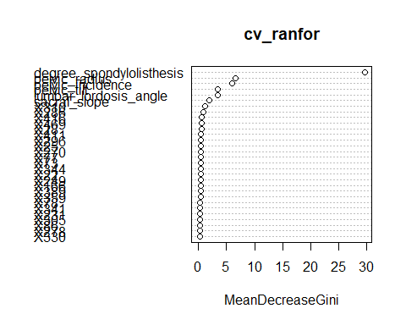

Confusion Matrix and Statistics  
  
 Reference  
Prediction Abnormal Normal  
 Abnormal 182 28  
 Normal 37 63  
   
 Accuracy : 0.7903   
 95% CI : (0.7407, 0.8343)  
 No Information Rate : 0.7065   
 P-Value [Acc > NIR] : 0.0005294   
   
 Kappa : 0.5087   
 Mcnemar's Test P-Value : 0.3210620   
   
 Sensitivity : 0.8311   
 Specificity : 0.6923   
 Pos Pred Value : 0.8667   
 Neg Pred Value : 0.6300   
 Prevalence : 0.7065   
 Detection Rate : 0.5871   
 Detection Prevalence : 0.6774   
 Balanced Accuracy : 0.7617   
   
 'Positive' Class : Abnormal

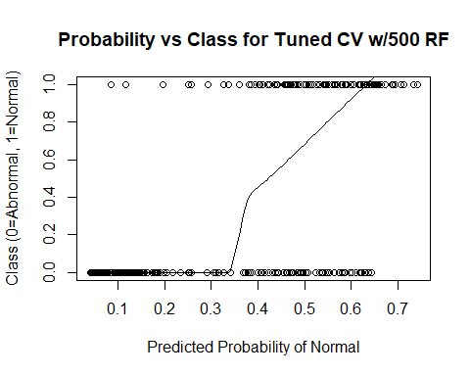

# Add 1000 Random Variables

mtry = 31 OOB error = 30.32%   
Searching left ...  
mtry = 16 OOB error = 32.9%   
-0.08510638 0.05   
Searching right ...  
mtry = 62 OOB error = 30.65%   
-0.0106383 0.05

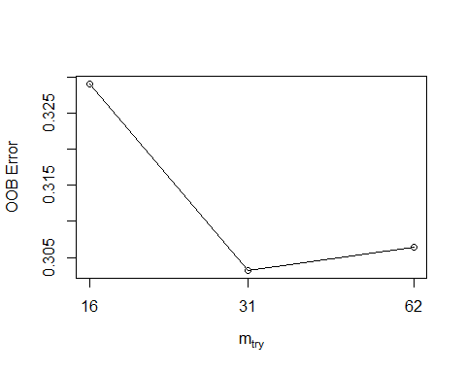

mtry OOBError  
16.OOB 16 0.3290323  
31.OOB 31 0.3032258  
62.OOB 62 0.3064516

MeanDecreaseGini  
pelvic_incidence 1.115865888  
pelvic_tilt 0.981450644  
lumbar_lordosis_angle 0.975049651  
sacral_slope 0.395121701  
pelvic_radius 1.849761856  
degree_spondylolisthesis 3.565151873  
pelvic_slope 0.043054130  
Direct_tilt 0.112771258  
thoracic_slope 0.036546526  
cervical_tilt 0.048519792  
sacrum_angle 0.084515479  
scoliosis_slope 0.098642966  
X1 0.110725066  
X2 0.095204713  
X3 0.084426512  
X4 0.133966330  
X5 0.196215418  
X6 0.066426525  
X7 0.101167765  
X8 0.102328764  
X9 0.086409782  
X10 0.060620587  
X11 0.119566181  
X12 0.138858466  
X13 0.045334508  
X14 0.071295411  
X15 0.259547404  
X16 0.065672330  
X17 0.069879710  
X18 0.112287686  
X19 0.088829552  
X20 0.066341833  
X21 0.081837614  
X22 0.473760239  
X23 0.070109449  
X24 0.050637532  
X25 0.086569566  
X26 0.117118955  
X27 0.106494432  
X28 0.140308903  
X29 0.062346060  
X30 0.080721929  
X31 0.062293997  
X32 0.102054121  
X33 0.043153305  
X34 0.130603745  
X35 0.095472731  
X36 0.118973340  
X37 0.093745077  
X38 0.075535333  
X39 0.037310434  
X40 0.078961066  
X41 0.072955051  
X42 0.139290860  
X43 0.024685360  
X44 0.112154248  
X45 0.110484666  
X46 0.087231615  
X47 0.027096028  
X48 0.161762101  
X49 0.051950633  
X50 0.092888960  
X51 0.068466958  
X52 0.103834530  
X53 0.083579779  
X54 0.113287144  
X55 0.073942322  
X56 0.063352996  
X57 0.230502271  
X58 0.103424052  
X59 0.031666818  
X60 0.083753015  
X61 0.086607812  
X62 0.049546794  
X63 0.032232303  
X64 0.137917260  
X65 0.048311288  
X66 0.223666363  
X67 0.114273681  
X68 0.003000000  
X69 0.106001491  
X70 0.069452269  
X71 0.056771217  
X72 0.053156287  
X73 0.060635206  
X74 0.066387505  
X75 0.194152036  
X76 0.138847306  
X77 0.170590950  
X78 0.150557871  
X79 0.066035443  
X80 0.164027190  
X81 0.356918568  
X82 0.029403648  
X83 0.119951364  
X84 0.035985461  
X85 0.076337628  
X86 0.083262416  
X87 0.171388596  
X88 0.185044491  
X89 0.087787823  
X90 0.057788747  
X91 0.101863020  
X92 0.208353874  
X93 0.063387167  
X94 0.030050521  
X95 0.038819307  
X96 0.108423715  
X97 0.141063205  
X98 0.088237299  
X99 0.084174437  
X100 0.089119048  
X101 0.072258579  
X102 0.147813835  
X103 0.046933782  
X104 0.187757995  
X105 0.068665949  
X106 0.095041002  
X107 0.110426863  
X108 0.037815012  
X109 0.078960366  
X110 0.026133733  
X111 0.102420125  
X112 0.067271026  
X113 0.304004398  
X114 0.093116722  
X115 0.081294731  
X116 0.055718008  
X117 0.065292613  
X118 0.078195443  
X119 0.200623427  
X120 0.049250887  
X121 0.053363970  
X122 0.062650891  
X123 0.049216111  
X124 0.149692591  
X125 0.195318792  
X126 0.185565116  
X127 0.036327426  
X128 0.156228659  
X129 0.056974021  
X130 0.064484472  
X131 0.081058720  
X132 0.071333601  
X133 0.106819054  
X134 0.022694125  
X135 0.041136001  
X136 0.012533333  
X137 0.048161034  
X138 0.082276802  
X139 0.095844805  
X140 0.133947921  
X141 0.294975558  
X142 0.053949112  
X143 0.043692867  
X144 0.091017622  
X145 0.088008208  
X146 0.086277022  
X147 0.118107273  
X148 0.110309550  
X149 0.046371949  
X150 0.220694828  
X151 0.055801041  
X152 0.028436495  
X153 0.065181290  
X154 0.104623459  
X155 0.084123336  
X156 0.090908487  
X157 0.144262657  
X158 0.069707031  
X159 0.051183819  
X160 0.313881181  
X161 0.077421901  
X162 0.255670527  
X163 0.094669272  
X164 0.138084101  
X165 0.061683260  
X166 0.075805278  
X167 0.072647142  
X168 0.083703296  
X169 0.054956011  
X170 0.137924241  
X171 0.131789623  
X172 0.045163616  
X173 0.054039139  
X174 0.073312263  
X175 0.113372628  
X176 0.154126651  
X177 0.081812885  
X178 0.069401439  
X179 0.077105341  
X180 0.063367828  
X181 0.076126379  
X182 0.082366250  
X183 0.085158990  
X184 0.109096731  
X185 0.082536297  
X186 0.061361710  
X187 0.099795972  
X188 0.118058885  
X189 0.099715629  
X190 0.281757234  
X191 0.068695952  
X192 0.113294855  
X193 0.139203964  
X194 0.083731398  
X195 0.081221464  
X196 0.114847774  
X197 0.096201436  
X198 0.071126804  
X199 0.063246089  
X200 0.134008238  
X201 0.050355863  
X202 0.064032448  
X203 0.122575373  
X204 0.084713402  
X205 0.035541172  
X206 0.112908469  
X207 0.033876013  
X208 0.051870825  
X209 0.043289449  
X210 0.145527797  
X211 0.112334801  
X212 0.163512824  
X213 0.121462133  
X214 0.031432612  
X215 0.087038052  
X216 0.030368560  
X217 0.097495344  
X218 0.089520675  
X219 0.140504376  
X220 0.192931019  
X221 0.078876705  
X222 0.070933526  
X223 0.240083625  
X224 0.058578935  
X225 0.186479843  
X226 0.105952775  
X227 0.044995217  
X228 0.048294271  
X229 0.032588934  
X230 0.086197541  
X231 0.088998487  
X232 0.050742157  
X233 0.110852186  
X234 0.236603553  
X235 0.059932738  
X236 0.079039535  
X237 0.062096595  
X238 0.150375437  
X239 0.077965128  
X240 0.095528590  
X241 0.068449242  
X242 0.137378413  
X243 0.193073287  
X244 0.047244450  
X245 0.114328746  
X246 0.101873274  
X247 0.073340994  
X248 0.071750888  
X249 0.253699511  
X250 0.070065611  
X251 0.098047925  
X252 0.034858776  
X253 0.057916057  
X254 0.048127498  
X255 0.090314160  
X256 0.086746356  
X257 0.097927441  
X258 0.139353745  
X259 0.168190812  
X260 0.097409184  
X261 0.060110428  
X262 0.051817967  
X263 0.091151825  
X264 0.186960718  
X265 0.103057289  
X266 0.067144315  
X267 0.124637261  
X268 0.145811397  
X269 0.018882542  
X270 0.174180222  
X271 0.058656461  
X272 0.121706148  
X273 0.073916236  
X274 0.057988495  
X275 0.061575554  
X276 0.051062851  
X277 0.118815375  
X278 0.072346924  
X279 0.090628282  
X280 0.115311150  
X281 0.233043504  
X282 0.051597957  
X283 0.056319645  
X284 0.092150887  
X285 0.006831791  
X286 0.096049282  
X287 0.091149537  
X288 0.081455927  
X289 0.100851406  
X290 0.054534099  
X291 0.108128957  
X292 0.115071098  
X293 0.061315472  
X294 0.082203891  
X295 0.071806699  
X296 0.227984929  
X297 0.071102411  
X298 0.093434563  
X299 0.119200986  
X300 0.102471785  
X301 0.051867033  
X302 0.093157402  
X303 0.074230501  
X304 0.090070638  
X305 0.078286198  
X306 0.041499637  
X307 0.120448126  
X308 0.053218981  
X309 0.139566045  
X310 0.097178252  
X311 0.096520037  
X312 0.040363634  
X313 0.103447440  
X314 0.120965436  
X315 0.067717220  
X316 0.032797479  
X317 0.052299714  
X318 0.032204848  
X319 0.055002871  
X320 0.070613705  
X321 0.099935491  
X322 0.057172959  
X323 0.112619173  
X324 0.108299904  
X325 0.134766391  
X326 0.089750633  
X327 0.061808699  
X328 0.120269367  
X329 0.041995703  
X330 0.063554256  
X331 0.089595710  
X332 0.084893505  
X333 0.219097954  
X334 0.051121196  
X335 0.030816654  
X336 0.049800816  
X337 0.103583059  
X338 0.309361448  
X339 0.047917997  
X340 0.050803996  
X341 0.084654208  
X342 0.055990494  
X343 0.076566819  
X344 0.151129369  
X345 0.062143692  
X346 0.082739857  
X347 0.017828188  
X348 0.098682042  
X349 0.092193041  
X350 0.039913497  
X351 0.113799339  
X352 0.077481870  
X353 0.197784010  
X354 0.141586680  
X355 0.150916678  
X356 0.019430676  
X357 0.049364648  
X358 0.058667776  
X359 0.125476257  
X360 0.112961341  
X361 0.089710633  
X362 0.053162826  
X363 0.105406936  
X364 0.057036188  
X365 0.124207781  
X366 0.028584933  
X367 0.090666732  
X368 0.069666890  
X369 0.094027821  
X370 0.094486781  
X371 0.153290489  
X372 0.027098667  
X373 0.546036936  
X374 0.074986736  
X375 0.113980204  
X376 0.066735289  
X377 0.104397453  
X378 0.037206183  
X379 0.074602554  
X380 0.129895547  
X381 0.062166502  
X382 0.063064759  
X383 0.065759751  
X384 0.062936512  
X385 0.123938979  
X386 0.067404648  
X387 0.071472100  
X388 0.217975359  
X389 0.098150054  
X390 0.080610639  
X391 0.091653671  
X392 0.131137681  
X393 0.066072500  
X394 0.052014861  
X395 0.108763911  
X396 0.091533309  
X397 0.043604920  
X398 0.073267984  
X399 0.133863784  
X400 0.180964773  
X401 0.160664545  
X402 0.067006809  
X403 0.114291235  
X404 0.042555918  
X405 0.090395672  
X406 0.065070279  
X407 0.074798561  
X408 0.096327971  
X409 0.110393691  
X410 0.087828861  
X411 0.071935474  
X412 0.049840430  
X413 0.089406422  
X414 0.069125893  
X415 0.076986412  
X416 0.129300936  
X417 0.075235954  
X418 0.090511565  
X419 0.066618059  
X420 0.148534908  
X421 0.058556010  
X422 0.091473241  
X423 0.121712794  
X424 0.101372033  
X425 0.087764838  
X426 0.133234928  
X427 0.094084947  
X428 0.045714666  
X429 0.222876193  
X430 0.065966905  
X431 0.091612580  
X432 0.030691956  
X433 0.089790547  
X434 0.137473220  
X435 0.096064507  
X436 0.081042222  
X437 0.089942635  
X438 0.074153061  
X439 0.081070291  
X440 0.092695862  
X441 0.167195352  
X442 0.197740985  
X443 0.025784040  
X444 0.100152773  
X445 0.091570627  
X446 0.105470589  
X447 0.155659303  
X448 0.070489324  
X449 0.054486476  
X450 0.053567858  
X451 0.065227854  
X452 0.118938106  
X453 0.052707711  
X454 0.066030562  
X455 0.171658498  
X456 0.208766434  
X457 0.028759460  
X458 0.100270644  
X459 0.056830644  
X460 0.066618868  
X461 0.201829435  
X462 0.070479062  
X463 0.061581422  
X464 0.045503228  
X465 0.096499830  
X466 0.069753220  
X467 0.090358862  
X468 0.073587374  
X469 0.193669801  
X470 0.120476842  
X471 0.135115938  
X472 0.113764825  
X473 0.073848870  
X474 0.234704108  
X475 0.048185848  
X476 0.081241639  
X477 0.123468990  
X478 0.197121427  
X479 0.046717165  
X480 0.053324932  
X481 0.055663754  
X482 0.177648697  
X483 0.056650957  
X484 0.155876592  
X485 0.071874345  
X486 0.064000486  
X487 0.152047485  
X488 0.107687778  
X489 0.060216356  
X490 0.082809353  
X491 0.091912485  
X492 0.116205330  
X493 0.069788514  
X494 0.071537915  
X495 0.061054994  
X496 0.086729254  
X497 0.069365593  
X498 0.091905220  
X499 0.054755995  
X500 0.169573991  
X501 0.064035909  
X502 0.057950296  
X503 0.154036842  
X504 0.061096409  
X505 0.079899828  
X506 0.150297904  
X507 0.110614571  
X508 0.121749199  
X509 0.074410704  
X510 0.040945679  
X511 0.062826700  
X512 0.066073528  
X513 0.090339270  
X514 0.058510401  
X515 0.140380971  
X516 0.390050814  
X517 0.040705571  
X518 0.140239699  
X519 0.085902392  
X520 0.074123411  
X521 0.130477476  
X522 0.066237461  
X523 0.176372925  
X524 0.072689411  
X525 0.104972950  
X526 0.131391796  
X527 0.090128532  
X528 0.083902689  
X529 0.162631125  
X530 0.235549264  
X531 0.160590347  
X532 0.098446303  
X533 0.066783398  
X534 0.081970940  
X535 0.147846077  
X536 0.057327698  
X537 0.052130678  
X538 0.081998200  
X539 0.055421363  
X540 0.112959817  
X541 0.116038585  
X542 0.115797173  
X543 0.059237416  
X544 0.117149547  
X545 0.077532558  
X546 0.030113036  
X547 0.116959199  
X548 0.093919182  
X549 0.112002272  
X550 0.074958009  
X551 0.077332432  
X552 0.060270573  
X553 0.032508300  
X554 0.105325712  
X555 0.045330984  
X556 0.113447413  
X557 0.030951954  
X558 0.051652505  
X559 0.080304864  
X560 0.137890834  
X561 0.127819737  
X562 0.034064002  
X563 0.074636133  
X564 0.105301732  
X565 0.067025759  
X566 0.102911541  
X567 0.025786157  
X568 0.124103785  
X569 0.060658631  
X570 0.146778332  
X571 0.142094287  
X572 0.142007690  
X573 0.016485921  
X574 0.062918149  
X575 0.112998943  
X576 0.141122121  
X577 0.106459600  
X578 0.037442894  
X579 0.151640196  
X580 0.107688169  
X581 0.041872694  
X582 0.024087990  
X583 0.063617312  
X584 0.019672485  
X585 0.072555166  
X586 0.071243092  
X587 0.058371564  
X588 0.223048146  
X589 0.099772580  
X590 0.051212244  
X591 0.168117543  
X592 0.034497388  
X593 0.081355262  
X594 0.101505061  
X595 0.220027672  
X596 0.058972767  
X597 0.040705801  
X598 0.169614108  
X599 0.127162200  
X600 0.066443907  
X601 0.121680969  
X602 0.107706327  
X603 0.097232263  
X604 0.085217043  
X605 0.074725470  
X606 0.032721914  
X607 0.087020628  
X608 0.106064842  
X609 0.144325515  
X610 0.105125462  
X611 0.101870013  
X612 0.137439306  
X613 0.020823963  
X614 0.201671241  
X615 0.043889087  
X616 0.078797214  
X617 0.062780491  
X618 0.066820152  
X619 0.116199670  
X620 0.099722207  
X621 0.143517179  
X622 0.115372892  
X623 0.019810423  
X624 0.087832680  
X625 0.096642539  
X626 0.081618452  
X627 0.190656564  
X628 0.157283526  
X629 0.019854342  
X630 0.115064159  
X631 0.057758245  
X632 0.078209918  
X633 0.026278788  
X634 0.095237163  
X635 0.030831736  
X636 0.225191924  
X637 0.114943057  
X638 0.152734851  
X639 0.140311600  
X640 0.044839313  
X641 0.097643233  
X642 0.066767593  
X643 0.098410382  
X644 0.074911800  
X645 0.080700600  
X646 0.042896762  
X647 0.064060705  
X648 0.073538818  
X649 0.077094537  
X650 0.057343895  
X651 0.298655521  
X652 0.134257023  
X653 0.156732038  
X654 0.066635831  
X655 0.087018718  
X656 0.108078524  
X657 0.110372236  
X658 0.027240704  
X659 0.106410542  
X660 0.148586985  
X661 0.036786240  
X662 0.123129889  
X663 0.140982069  
X664 0.066004215  
X665 0.059563310  
X666 0.049804335  
X667 0.169661246  
X668 0.052411567  
X669 0.028787365  
X670 0.233693537  
X671 0.085832139  
X672 0.044882497  
X673 0.043154309  
X674 0.224100498  
X675 0.194687228  
X676 0.140029314  
X677 0.058946097  
X678 0.064174454  
X679 0.057398973  
X680 0.116835584  
X681 0.043951409  
X682 0.042625355  
X683 0.235012590  
X684 0.063117688  
X685 0.058551879  
X686 0.041958137  
X687 0.178676472  
X688 0.071363477  
X689 0.084884915  
X690 0.082778337  
X691 0.094609092  
X692 0.067925946  
X693 0.181992189  
X694 0.082194697  
X695 0.101521819  
X696 0.075869061  
X697 0.075644372  
X698 0.092079154  
X699 0.091861418  
X700 0.090505534  
X701 0.067995118  
X702 0.070535173  
X703 0.125361944  
X704 0.197139327  
X705 0.096651297  
X706 0.074736801  
X707 0.141232977  
X708 0.147829817  
X709 0.105286000  
X710 0.110485503  
X711 0.046500071  
X712 0.133694050  
X713 0.058291139  
X714 0.135822958  
X715 0.132228593  
X716 0.149245198  
X717 0.052957259  
X718 0.209916354  
X719 0.045276573  
X720 0.248294671  
X721 0.080151932  
X722 0.102518082  
X723 0.095952886  
X724 0.107417137  
X725 0.086753610  
X726 0.130451628  
X727 0.119404967  
X728 0.068087482  
X729 0.074667990  
X730 0.165799158  
X731 0.069093046  
X732 0.032894103  
X733 0.138217604  
X734 0.075245489  
X735 0.302844235  
X736 0.032426462  
X737 0.090516045  
X738 0.128630918  
X739 0.036972115  
X740 0.147298348  
X741 0.113588903  
X742 0.206654861  
X743 0.040976428  
X744 0.080237957  
X745 0.125751830  
X746 0.086292795  
X747 0.073952009  
X748 0.040718121  
X749 0.081032080  
X750 0.089462930  
X751 0.046937437  
X752 0.060109701  
X753 0.053138613  
X754 0.056277264  
X755 0.111558154  
X756 0.088940041  
X757 0.180283039  
X758 0.094267492  
X759 0.081119676  
X760 0.015769022  
X761 0.054036628  
X762 0.135736979  
X763 0.063169586  
X764 0.040513152  
X765 0.115572080  
X766 0.083388586  
X767 0.031983514  
X768 0.087810370  
X769 0.146116025  
X770 0.153357400  
X771 0.185095492  
X772 0.061376711  
X773 0.129229297  
X774 0.078219473  
X775 0.111448304  
X776 0.193335482  
X777 0.091484392  
X778 0.112841441  
X779 0.095203792  
X780 0.094421749  
X781 0.125909161  
X782 0.249428190  
X783 0.127690978  
X784 0.092938301  
X785 0.124193410  
X786 0.106341631  
X787 0.077209064  
X788 0.064410946  
X789 0.080284384  
X790 0.090446515  
X791 0.077089083  
X792 0.129394033  
X793 0.066981558  
X794 0.070191117  
X795 0.116902593  
X796 0.090065961  
X797 0.120391060  
X798 0.084584847  
X799 0.040292669  
X800 0.064783521  
X801 0.068052607  
X802 0.062497255  
X803 0.085701815  
X804 0.085245574  
X805 0.058374541  
X806 0.045799762  
X807 0.085639233  
X808 0.079062399  
X809 0.249574490  
X810 0.121916078  
X811 0.064032507  
X812 0.043507854  
X813 0.054519714  
X814 0.125892822  
X815 0.065548713  
X816 0.137788828  
X817 0.095066998  
X818 0.069755094  
X819 0.562160374  
X820 0.153922200  
X821 0.042488616  
X822 0.090342781  
X823 0.068572883  
X824 0.070421096  
X825 0.035594765  
X826 0.087514081  
X827 0.097887059  
X828 0.076027933  
X829 0.091337055  
X830 0.072098152  
X831 0.096683774  
X832 0.163852794  
X833 0.076628505  
X834 0.290977278  
X835 0.080799456  
X836 0.082006109  
X837 0.075766402  
X838 0.120032708  
X839 0.159637640  
X840 0.097335602  
X841 0.111688977  
X842 0.104684683  
X843 0.067194902  
X844 0.167237028  
X845 0.086825091  
X846 0.044900329  
X847 0.084875823  
X848 0.158200589  
X849 0.047904889  
X850 0.049361081  
X851 0.101495234  
X852 0.234941034  
X853 0.162823315  
X854 0.054022493  
X855 0.034518659  
X856 0.065422566  
X857 0.036916545  
X858 0.050922452  
X859 0.126597462  
X860 0.106484054  
X861 0.107444072  
X862 0.063442621  
X863 0.025886916  
X864 0.091081006  
X865 0.087076543  
X866 0.084970250  
X867 0.071660316  
X868 0.072744415  
X869 0.155566547  
X870 0.078419700  
X871 0.062029561  
X872 0.071756161  
X873 0.067722040  
X874 0.158565984  
X875 0.122567728  
X876 0.079553388  
X877 0.083711815  
X878 0.143569050  
X879 0.090686659  
X880 0.109534012  
X881 0.112150403  
X882 0.096098037  
X883 0.127270929  
X884 0.155350673  
X885 0.162277283  
X886 0.083159274  
X887 0.073082361  
X888 0.143972595  
X889 0.089247339  
X890 0.081819242  
X891 0.067089373  
X892 0.072896219  
X893 0.053409284  
X894 0.117841604  
X895 0.143763610  
X896 0.112336377  
X897 0.129464577  
X898 0.107447797  
X899 0.064023632  
X900 0.057759905  
X901 0.212822623  
X902 0.111754519  
X903 0.066502279  
X904 0.059395581  
X905 0.025364939  
X906 0.141577083  
X907 0.079188565  
X908 0.088142428  
X909 0.085336747  
X910 0.050320802  
X911 0.104361880  
X912 0.085550831  
X913 0.139630227  
X914 0.089966576  
X915 0.185560688  
X916 0.126423184  
X917 0.081709423  
X918 0.012552672  
X919 0.110514794  
X920 0.075689819  
X921 0.164436597  
X922 0.076825409  
X923 0.086798981  
X924 0.118358517  
X925 0.101178832  
X926 0.065431364  
X927 0.065883472  
X928 0.057874743  
X929 0.173900981  
X930 0.064587063  
X931 0.211019946  
X932 0.049605560  
X933 0.438061705  
X934 0.085949049  
X935 0.087489813  
X936 0.049099762  
X937 0.131483279  
X938 0.094262464  
X939 0.085063480  
X940 0.071137366  
X941 0.054102411  
X942 0.121911757  
X943 0.058348025  
X944 0.066657042  
X945 0.035884057  
X946 0.071539835  
X947 0.106462370  
X948 0.056710451  
X949 0.069084218  
X950 0.085754660  
X951 0.202174591  
X952 0.068557694  
X953 0.118903919  
X954 0.075585835  
X955 0.040994285  
X956 0.078984747  
X957 0.045963239  
X958 0.021093794  
X959 0.031373161  
X960 0.084947142  
X961 0.127300462  
X962 0.059472081  
X963 0.067075795  
X964 0.043598912  
X965 0.087877384  
X966 0.055093846  
X967 0.068258512  
X968 0.127214536  
X969 0.066662379  
X970 0.058375361  
X971 0.113681937  
X972 0.097503146  
X973 0.100220176  
X974 0.089318364  
X975 0.049414313  
X976 0.217110661  
X977 0.049045164  
X978 0.039499567  
X979 0.093364765  
X980 0.107530043  
X981 0.095772171  
X982 0.073876774  
X983 0.065665798  
X984 0.086810663  
X985 0.168357964  
X986 0.127513928  
X987 0.110614738  
X988 0.075784586  
X989 0.124916600  
X990 0.060131300  
X991 0.599396521  
X992 0.086185784  
X993 0.087073751  
X994 0.051589080  
X995 0.085972522  
X996 0.099551165  
X997 0.175446219  
X998 0.095957299  
X999 0.047548470  
X1000 0.072433237

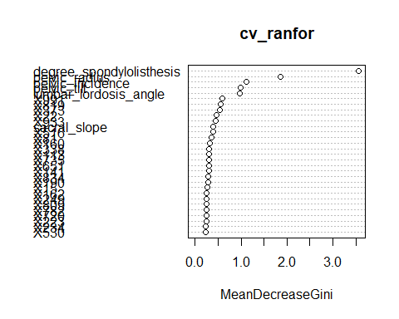

Confusion Matrix and Statistics  
  
 Reference  
Prediction Abnormal Normal  
 Abnormal 210 0  
 Normal 100 0  
   
 Accuracy : 0.6774   
 95% CI : (0.6223, 0.7292)  
 No Information Rate : 1   
 P-Value [Acc > NIR] : 1   
   
 Kappa : 0   
 Mcnemar's Test P-Value : <2e-16   
   
 Sensitivity : 0.6774   
 Specificity : NA   
 Pos Pred Value : NA   
 Neg Pred Value : NA   
 Prevalence : 1.0000   
 Detection Rate : 0.6774   
 Detection Prevalence : 0.6774   
 Balanced Accuracy : NA   
   
 'Positive' Class : Abnormal

