Senior Project Random Forest

# Initial Model

MeanDecreaseGini  
pelvic_tilt 13.15211  
pelvic_incidence 12.14187  
lumbar_lordosis_angle 12.68480  
sacral_slope 12.80926  
pelvic_radius 16.58574  
degree_spondylolisthesis 38.84536

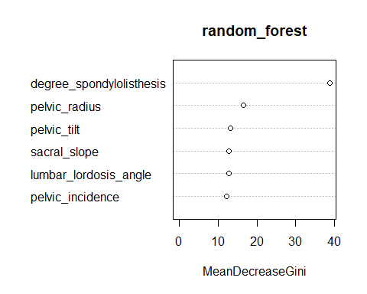

Confusion Matrix and Statistics  
  
 Reference  
Prediction Abnormal Normal  
 Abnormal 38 2  
 Normal 10 12  
   
 Accuracy : 0.8065   
 95% CI : (0.6863, 0.8958)  
 No Information Rate : 0.7742   
 P-Value [Acc > NIR] : 0.33265   
   
 Kappa : 0.5396   
 Mcnemar's Test P-Value : 0.04331   
   
 Sensitivity : 0.7917   
 Specificity : 0.8571   
 Pos Pred Value : 0.9500   
 Neg Pred Value : 0.5455   
 Prevalence : 0.7742   
 Detection Rate : 0.6129   
 Detection Prevalence : 0.6452   
 Balanced Accuracy : 0.8244   
   
 'Positive' Class : Abnormal

mtry = 2 OOB error = 16.13%   
Searching left ...  
mtry = 1 OOB error = 18.55%   
-0.15 0.05   
Searching right ...  
mtry = 4 OOB error = 19.76%   
-0.225 0.05

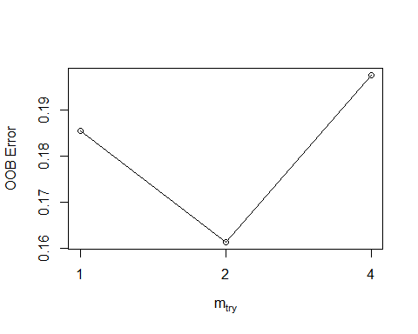

Call:  
 randomForest(x = x, y = y, mtry = res[which.min(res[, 2]), 1])   
 Type of random forest: classification  
 Number of trees: 500  
No. of variables tried at each split: 2  
  
 OOB estimate of error rate: 16.94%  
Confusion matrix:  
 Abnormal Normal class.error  
Abnormal 152 18 0.1058824  
Normal 24 54 0.3076923

MeanDecreaseGini  
pelvic_incidence 13.60084  
pelvic_tilt 11.98641  
lumbar_lordosis_angle 11.80908  
sacral_slope 13.10558  
pelvic_radius 16.39389  
degree_spondylolisthesis 39.96065

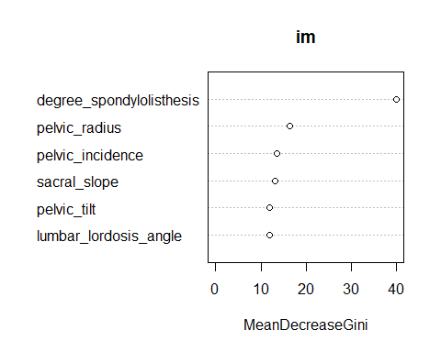

# Cross-Validation Model

mtry = 2 OOB error = 17.1%   
Searching left ...  
mtry = 1 OOB error = 16.77%   
0.01886792 0.05   
Searching right ...  
mtry = 4 OOB error = 16.45%   
0.03773585 0.05

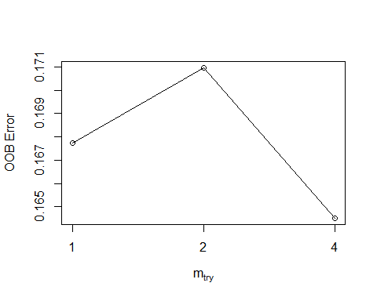

mtry OOBError  
1.OOB 1 0.1677419  
2.OOB 2 0.1709677  
4.OOB 4 0.1645161

MeanDecreaseGini  
pelvic_tilt 13.15211  
pelvic_incidence 12.14187  
lumbar_lordosis_angle 12.68480  
sacral_slope 12.80926  
pelvic_radius 16.58574  
degree_spondylolisthesis 38.84536



Confusion Matrix and Statistics  
  
 Reference  
Prediction Abnormal Normal  
 Abnormal 187 23  
 Normal 26 74  
   
 Accuracy : 0.8419   
 95% CI : (0.7965, 0.8807)  
 No Information Rate : 0.6871   
 P-Value [Acc > NIR] : 3.261e-10   
   
 Kappa : 0.6355   
 Mcnemar's Test P-Value : 0.7751   
   
 Sensitivity : 0.8779   
 Specificity : 0.7629   
 Pos Pred Value : 0.8905   
 Neg Pred Value : 0.7400   
 Prevalence : 0.6871   
 Detection Rate : 0.6032   
 Detection Prevalence : 0.6774   
 Balanced Accuracy : 0.8204   
   
 'Positive' Class : Abnormal

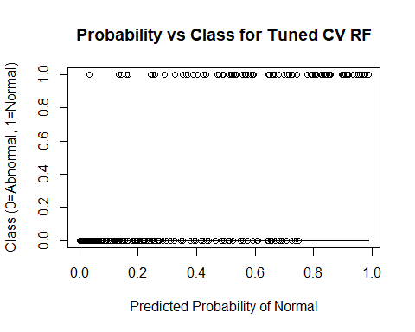

# Add Provided Random Noise

mtry = 3 OOB error = 19.03%   
Searching left ...  
mtry = 2 OOB error = 17.42%   
0.08474576 0.05   
mtry = 1 OOB error = 21.94%   
-0.2592593 0.05   
Searching right ...  
mtry = 6 OOB error = 19.68%   
-0.1296296 0.05

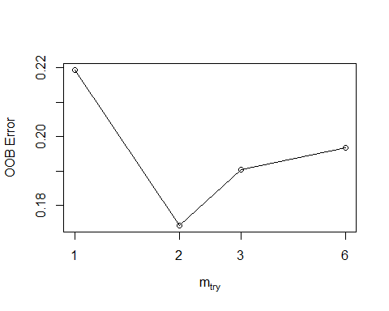

mtry OOBError  
1.OOB 1 0.2193548  
2.OOB 2 0.1741935  
3.OOB 3 0.1903226  
6.OOB 6 0.1967742

MeanDecreaseGini  
pelvic_incidence 8.859955  
pelvic_tilt 9.250360  
lumbar_lordosis_angle 8.412710  
sacral_slope 8.561810  
pelvic_radius 14.124541  
degree_spondylolisthesis 25.057467  
pelvic_slope 4.515013  
Direct_tilt 5.361990  
thoracic_slope 5.314960  
cervical_tilt 5.856255  
sacrum_angle 5.578070  
scoliosis_slope 6.937531

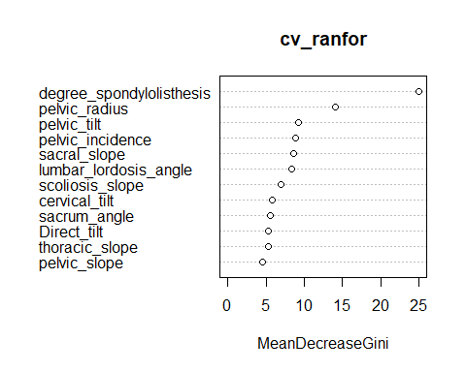

Confusion Matrix and Statistics  
  
 Reference  
Prediction Abnormal Normal  
 Abnormal 188 22  
 Normal 35 65  
   
 Accuracy : 0.8161   
 95% CI : (0.7684, 0.8577)  
 No Information Rate : 0.7194   
 P-Value [Acc > NIR] : 5.282e-05   
   
 Kappa : 0.5645   
 Mcnemar's Test P-Value : 0.112   
   
 Sensitivity : 0.8430   
 Specificity : 0.7471   
 Pos Pred Value : 0.8952   
 Neg Pred Value : 0.6500   
 Prevalence : 0.7194   
 Detection Rate : 0.6065   
 Detection Prevalence : 0.6774   
 Balanced Accuracy : 0.7951   
   
 'Positive' Class : Abnormal

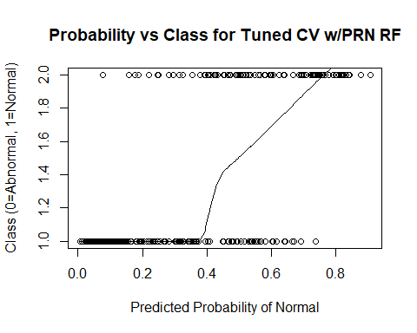

# Add 10 Random Variables

mtry = 4 OOB error = 19.03%   
Searching left ...  
mtry = 2 OOB error = 19.35%   
-0.01694915 0.05   
Searching right ...  
mtry = 8 OOB error = 19.03%   
0 0.05

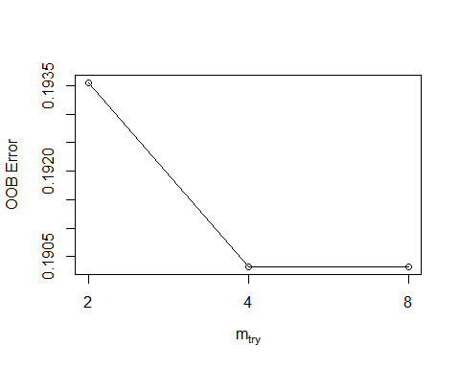

mtry OOBError  
2.OOB 2 0.1935484  
4.OOB 4 0.1903226  
8.OOB 8 0.1903226

MeanDecreaseGini  
pelvic_incidence 3.2022659  
pelvic_tilt 4.5670598  
lumbar_lordosis_angle 5.0248268  
sacral_slope 9.9702033  
pelvic_radius 9.1985254  
degree_spondylolisthesis 43.9117143  
pelvic_slope 0.9751303  
Direct_tilt 1.4061935  
thoracic_slope 2.0743864  
cervical_tilt 1.8274781  
sacrum_angle 1.9724421  
scoliosis_slope 1.8839118  
X1 1.9651829  
X2 1.9712072  
X3 1.8640025  
X4 3.1620878  
X5 2.3345345  
X6 3.1114970  
X7 3.3487048  
X8 1.8452842  
X9 2.6035675  
X10 1.8380684

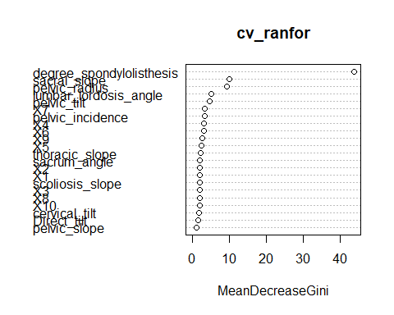

Confusion Matrix and Statistics  
  
 Reference  
Prediction Abnormal Normal  
 Abnormal 185 25  
 Normal 25 75  
   
 Accuracy : 0.8387   
 95% CI : (0.7929, 0.8779)  
 No Information Rate : 0.6774   
 P-Value [Acc > NIR] : 8.779e-11   
   
 Kappa : 0.631   
 Mcnemar's Test P-Value : 1   
   
 Sensitivity : 0.8810   
 Specificity : 0.7500   
 Pos Pred Value : 0.8810   
 Neg Pred Value : 0.7500   
 Prevalence : 0.6774   
 Detection Rate : 0.5968   
 Detection Prevalence : 0.6774   
 Balanced Accuracy : 0.8155   
   
 'Positive' Class : Abnormal

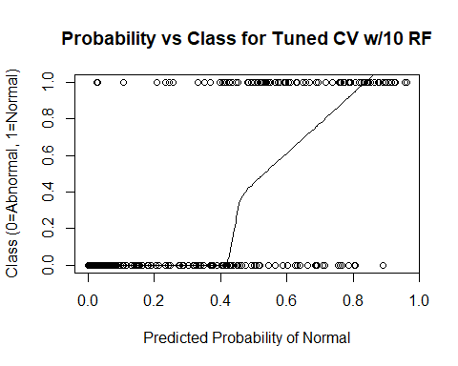 # Add 100 Random Variables

mtry = 10 OOB error = 22.26%   
Searching left ...  
mtry = 5 OOB error = 30.97%   
-0.3913043 0.05   
Searching right ...  
mtry = 20 OOB error = 24.52%   
-0.1014493 0.05

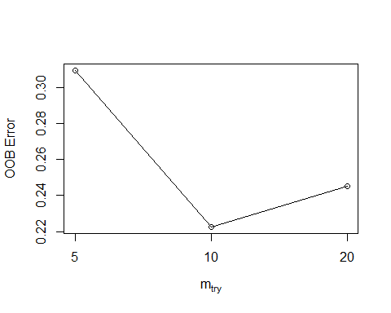

mtry OOBError  
5.OOB 5 0.3096774  
10.OOB 10 0.2225806  
20.OOB 20 0.2451613

MeanDecreaseGini  
pelvic_incidence 3.5641762  
pelvic_tilt 3.3364984  
lumbar_lordosis_angle 4.1795320  
sacral_slope 2.1758695  
pelvic_radius 4.6062258  
degree_spondylolisthesis 13.4208132  
pelvic_slope 0.5021879  
Direct_tilt 0.4562610  
thoracic_slope 0.6121050  
cervical_tilt 0.6490038  
sacrum_angle 0.8462769  
scoliosis_slope 0.8053812  
X1 0.6778439  
X2 0.7681018  
X3 0.5986865  
X4 0.6395936  
X5 1.1574296  
X6 0.9578584  
X7 0.8195534  
X8 0.5693077  
X9 0.8036344  
X10 0.5131597  
X11 0.6718749  
X12 0.8218499  
X13 0.6936367  
X14 0.8080790  
X15 0.7415135  
X16 0.9315695  
X17 0.8227422  
X18 0.7675297  
X19 0.6834504  
X20 0.5525062  
X21 0.8873626  
X22 1.3218316  
X23 0.4555300  
X24 0.7460673  
X25 0.8135725  
X26 0.8221727  
X27 0.8228608  
X28 0.6093707  
X29 0.8005218  
X30 0.4597668  
X31 0.4503310  
X32 0.5027736  
X33 0.4704129  
X34 0.8271870  
X35 0.6919351  
X36 0.4129119  
X37 0.4176781  
X38 0.4859588  
X39 0.6571532  
X40 0.5607707  
X41 0.8422408  
X42 0.6237343  
X43 0.5391351  
X44 0.6084440  
X45 0.5481742  
X46 0.6294841  
X47 0.5116424  
X48 1.0152811  
X49 0.4335624  
X50 0.4320520  
X51 0.6124192  
X52 0.6786963  
X53 0.8362618  
X54 0.7361601  
X55 0.7630174  
X56 0.5427745  
X57 1.0309441  
X58 0.6285753  
X59 0.4628716

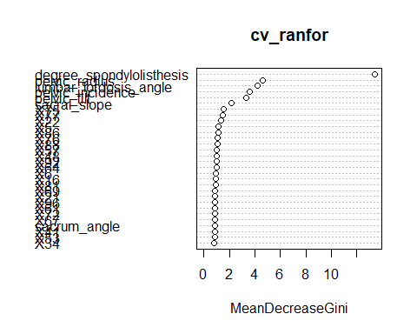

Confusion Matrix and Statistics  
  
 Reference  
Prediction Abnormal Normal  
 Abnormal 192 18  
 Normal 58 42  
   
 Accuracy : 0.7548   
 95% CI : (0.703, 0.8017)  
 No Information Rate : 0.8065   
 P-Value [Acc > NIR] : 0.9896   
   
 Kappa : 0.3734   
 Mcnemar's Test P-Value : 7.691e-06   
   
 Sensitivity : 0.7680   
 Specificity : 0.7000   
 Pos Pred Value : 0.9143   
 Neg Pred Value : 0.4200   
 Prevalence : 0.8065   
 Detection Rate : 0.6194   
 Detection Prevalence : 0.6774   
 Balanced Accuracy : 0.7340   
   
 'Positive' Class : Abnormal

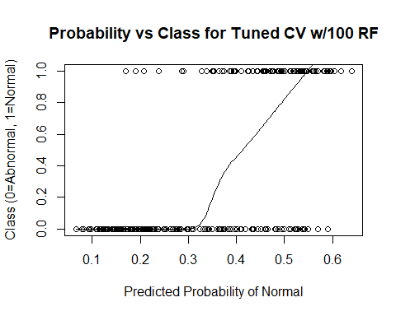

# Add 500 Random Variables

mtry = 22 OOB error = 32.26%   
Searching left ...  
mtry = 11 OOB error = 32.58%   
-0.01 0.05   
Searching right ...  
mtry = 44 OOB error = 27.74%   
0.14 0.05   
mtry = 88 OOB error = 24.84%   
0.1046512 0.05   
mtry = 176 OOB error = 19.03%   
0.2337662 0.05   
mtry = 352 OOB error = 22.9%   
-0.2033898 0.05

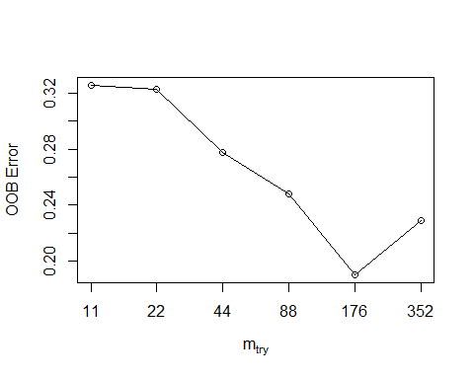

mtry OOBError  
11.OOB 11 0.3258065  
22.OOB 22 0.3225806  
44.OOB 44 0.2774194  
88.OOB 88 0.2483871  
176.OOB 176 0.1903226  
352.OOB 352 0.2290323

MeanDecreaseGini  
pelvic_incidence 6.01100462  
pelvic_tilt 3.38621535  
lumbar_lordosis_angle 3.38204323  
sacral_slope 1.84095368  
pelvic_radius 6.61375200  
degree_spondylolisthesis 29.69157311  
pelvic_slope 0.04516613  
Direct_tilt 0.05921861  
thoracic_slope 0.28618526  
cervical_tilt 0.10897747  
sacrum_angle 0.05223586  
scoliosis_slope 0.06663832  
X1 0.02960129  
X2 0.07636687  
X3 0.16661184  
X4 0.04863451  
X5 0.10742465  
X6 0.26578690  
X7 0.17616101  
X8 0.08328187  
X9 0.19831939  
X10 0.04033133  
X11 0.11273203  
X12 0.06154676  
X13 0.12715521  
X14 0.21590919  
X15 0.01675745  
X16 0.07298429  
X17 0.09978005  
X18 0.07644006  
X19 0.04767568  
X20 0.01928116  
X21 0.22156802  
X22 0.36132039  
X23 0.03678497  
X24 0.07818254  
X25 0.40941571  
X26 0.19638778  
X27 0.09877176  
X28 0.55740077  
X29 0.04900979  
X30 0.09326776  
X31 0.05102179  
X32 0.06179487  
X33 0.10394346  
X34 0.19932217  
X35 0.04293341  
X36 0.05409918  
X37 0.08539927  
X38 0.11589262  
X39 0.03693409  
X40 0.07416488  
X41 0.17868996  
X42 0.05328176  
X43 0.04976898  
X44 0.05743946  
X45 0.04320375  
X46 0.06791816  
X47 0.04224700  
X48 0.22214187  
X49 0.10783932  
X50 0.06129321  
X51 0.11258447  
X52 0.07751939  
X53 0.07971532  
X54 0.09749348  
X55 0.05284229  
X56 0.06923572

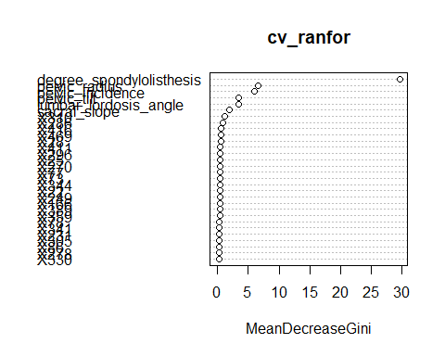

Confusion Matrix and Statistics  
  
 Reference  
Prediction Abnormal Normal  
 Abnormal 182 28  
 Normal 37 63  
   
 Accuracy : 0.7903   
 95% CI : (0.7407, 0.8343)  
 No Information Rate : 0.7065   
 P-Value [Acc > NIR] : 0.0005294   
   
 Kappa : 0.5087   
 Mcnemar's Test P-Value : 0.3210620   
   
 Sensitivity : 0.8311   
 Specificity : 0.6923   
 Pos Pred Value : 0.8667   
 Neg Pred Value : 0.6300   
 Prevalence : 0.7065   
 Detection Rate : 0.5871   
 Detection Prevalence : 0.6774   
 Balanced Accuracy : 0.7617   
   
 'Positive' Class : Abnormal

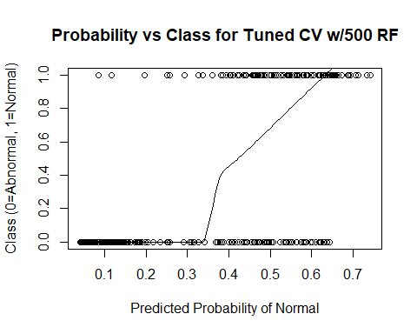

# Add 1000 Random Variables

mtry = 31 OOB error = 30.32%   
Searching left ...  
mtry = 16 OOB error = 32.9%   
-0.08510638 0.05   
Searching right ...  
mtry = 62 OOB error = 30.65%   
-0.0106383 0.05

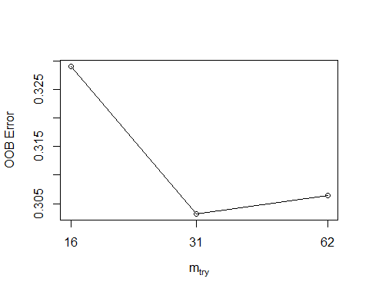

mtry OOBError  
16.OOB 16 0.3290323  
31.OOB 31 0.3032258  
62.OOB 62 0.3064516

MeanDecreaseGini  
pelvic_incidence 1.115865888  
pelvic_tilt 0.981450644  
lumbar_lordosis_angle 0.975049651  
sacral_slope 0.395121701  
pelvic_radius 1.849761856  
degree_spondylolisthesis 3.565151873  
pelvic_slope 0.043054130  
Direct_tilt 0.112771258  
thoracic_slope 0.036546526  
cervical_tilt 0.048519792  
sacrum_angle 0.084515479  
scoliosis_slope 0.098642966  
X1 0.110725066  
X2 0.095204713  
X3 0.084426512  
X4 0.133966330  
X5 0.196215418  
X6 0.066426525  
X7 0.101167765  
X8 0.102328764  
X9 0.086409782  
X10 0.060620587  
X11 0.119566181  
X12 0.138858466  
X13 0.045334508  
X14 0.071295411  
X15 0.259547404  
X16 0.065672330  
X17 0.069879710  
X18 0.112287686  
X19 0.088829552  
X20 0.066341833  
X21 0.081837614  
X22 0.473760239  
X23 0.070109449  
X24 0.050637532  
X25 0.086569566  
X26 0.117118955  
X27 0.106494432  
X28 0.140308903  
X29 0.062346060  
X30 0.080721929  
X31 0.062293997  
X32 0.102054121  
X33 0.043153305  
X34 0.130603745  
X35 0.095472731  
X36 0.118973340  
X37 0.093745077  
X38 0.075535333  
X39 0.037310434  
X40 0.078961066  
X41 0.072955051  
X42 0.139290860  
X43 0.024685360  
X44 0.112154248  
X45 0.110484666  
X46 0.087231615  
X47 0.027096028  
X48 0.161762101  
X49 0.051950633  
X50 0.092888960  
X51 0.068466958  
X52 0.103834530  
X53 0.083579779  
X54 0.113287144  
X55 0.073942322  
X56 0.063352996  
X57 0.230502271  
X58 0.103424052  
X59 0.031666818

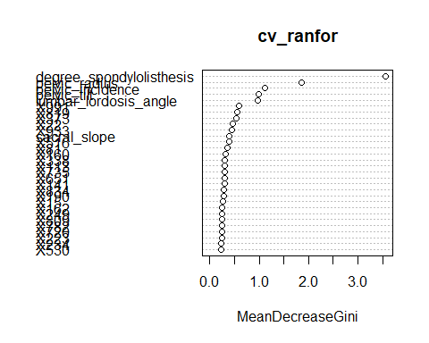

Confusion Matrix and Statistics  
  
 Reference  
Prediction Abnormal Normal  
 Abnormal 210 0  
 Normal 100 0  
   
 Accuracy : 0.6774   
 95% CI : (0.6223, 0.7292)  
 No Information Rate : 1   
 P-Value [Acc > NIR] : 1   
   
 Kappa : 0   
 Mcnemar's Test P-Value : <2e-16   
   
 Sensitivity : 0.6774   
 Specificity : NA   
 Pos Pred Value : NA   
 Neg Pred Value : NA   
 Prevalence : 1.0000   
 Detection Rate : 0.6774   
 Detection Prevalence : 0.6774   
 Balanced Accuracy : NA   
   
 'Positive' Class : Abnormal

