Senior Project Support Vector Machine

Michael Streyle

October 13th, 2018

## randomForest 4.6-14

## Type rfNews() to see new features/changes/bug fixes.

## Loading required package: lattice

## Loading required package: ggplot2

##   
## Attaching package: 'ggplot2'

## The following object is masked from 'package:randomForest':  
##   
## margin

# Initial Model

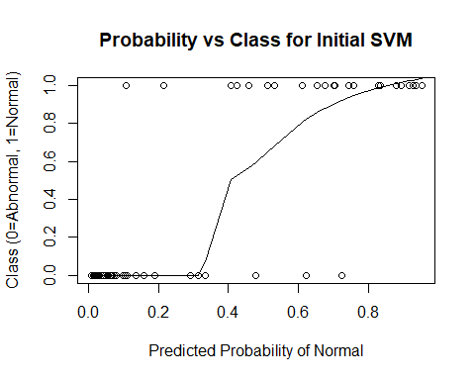

## Confusion Matrix and Statistics  
##   
## Reference  
## Prediction Abnormal Normal  
## Abnormal 38 5  
## Normal 2 17  
##   
## Accuracy : 0.8871   
## 95% CI : (0.7811, 0.9534)  
## No Information Rate : 0.6452   
## P-Value [Acc > NIR] : 1.515e-05   
##   
## Kappa : 0.7456   
## Mcnemar's Test P-Value : 0.4497   
##   
## Sensitivity : 0.9500   
## Specificity : 0.7727   
## Pos Pred Value : 0.8837   
## Neg Pred Value : 0.8947   
## Prevalence : 0.6452   
## Detection Rate : 0.6129   
## Detection Prevalence : 0.6935   
## Balanced Accuracy : 0.8614   
##   
## 'Positive' Class : Abnormal   
##

##   
## Parameter tuning of 'svm':  
##   
## - sampling method: 10-fold cross validation   
##   
## - best parameters:  
## gamma cost  
## 0.1 1  
##   
## - best performance: 0.1323333   
##   
## - Detailed performance results:  
## gamma cost error dispersion  
## 1 1e-05 1e-03 0.3148333 0.06779804  
## 2 1e-04 1e-03 0.3148333 0.06779804  
## 3 1e-03 1e-03 0.3148333 0.06779804  
## 4 1e-02 1e-03 0.3148333 0.06779804  
## 5 1e-01 1e-03 0.3148333 0.06779804  
## 6 1e-05 1e-02 0.3148333 0.06779804  
## 7 1e-04 1e-02 0.3148333 0.06779804  
## 8 1e-03 1e-02 0.3148333 0.06779804  
## 9 1e-02 1e-02 0.3148333 0.06779804  
## 10 1e-01 1e-02 0.3148333 0.06779804  
## 11 1e-05 1e-01 0.3148333 0.06779804  
## 12 1e-04 1e-01 0.3148333 0.06779804  
## 13 1e-03 1e-01 0.3148333 0.06779804  
## 14 1e-02 1e-01 0.3148333 0.06779804  
## 15 1e-01 1e-01 0.2708333 0.07764771  
## 16 1e-05 1e+00 0.3148333 0.06779804  
## 17 1e-04 1e+00 0.3148333 0.06779804  
## 18 1e-03 1e+00 0.3148333 0.06779804  
## 19 1e-02 1e+00 0.2266667 0.13152712  
## 20 1e-01 1e+00 0.1323333 0.05612596  
## 21 1e-05 1e+01 0.3148333 0.06779804  
## 22 1e-04 1e+01 0.3148333 0.06779804  
## 23 1e-03 1e+01 0.2265000 0.12364438  
## 24 1e-02 1e+01 0.1405000 0.06538608  
## 25 1e-01 1e+01 0.1363333 0.06254282

## Confusion Matrix and Statistics  
##   
## Reference  
## Prediction Abnormal Normal  
## Abnormal 38 4  
## Normal 2 18  
##   
## Accuracy : 0.9032   
## 95% CI : (0.8012, 0.9637)  
## No Information Rate : 0.6452   
## P-Value [Acc > NIR] : 3.301e-06   
##   
## Kappa : 0.7842   
## Mcnemar's Test P-Value : 0.6831   
##   
## Sensitivity : 0.9500   
## Specificity : 0.8182   
## Pos Pred Value : 0.9048   
## Neg Pred Value : 0.9000   
## Prevalence : 0.6452   
## Detection Rate : 0.6129   
## Detection Prevalence : 0.6774   
## Balanced Accuracy : 0.8841   
##   
## 'Positive' Class : Abnormal   
##

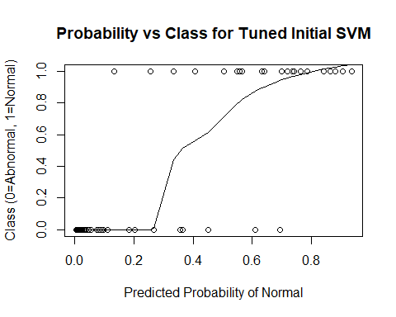

# Initial Model with Cross-Validation

## The following objects are masked from data:  
##   
## cervical_tilt, class, classification,  
## degree_spondylolisthesis, Direct_tilt, lumbar_lordosis_angle,  
## pelvic_incidence, pelvic_radius, pelvic_slope, pelvic_tilt,  
## sacral_slope, sacrum_angle, scoliosis_slope, thoracic_slope

## gamma cost  
## 25 0.1 10

## Confusion Matrix and Statistics  
##   
## Reference  
## Prediction Abnormal Normal  
## Abnormal 186 23  
## Normal 24 77  
##   
## Accuracy : 0.8484   
## 95% CI : (0.8035, 0.8864)  
## No Information Rate : 0.6774   
## P-Value [Acc > NIR] : 5.083e-12   
##   
## Kappa : 0.654   
## Mcnemar's Test P-Value : 1   
##   
## Sensitivity : 0.8857   
## Specificity : 0.7700   
## Pos Pred Value : 0.8900   
## Neg Pred Value : 0.7624   
## Prevalence : 0.6774   
## Detection Rate : 0.6000   
## Detection Prevalence : 0.6742   
## Balanced Accuracy : 0.8279   
##   
## 'Positive' Class : Abnormal   
##

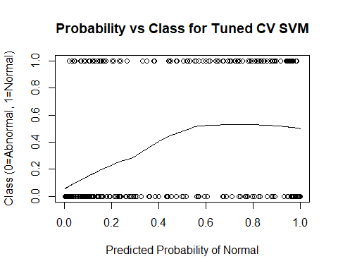

# Add Provided Random Noise

## The following objects are masked from data2 (pos = 3):  
##   
## cervical_tilt, class, classification,  
## degree_spondylolisthesis, Direct_tilt, group,  
## lumbar_lordosis_angle, pelvic_incidence, pelvic_radius,  
## pelvic_slope, pelvic_tilt, rand_int, sacral_slope,  
## sacrum_angle, scoliosis_slope, thoracic_slope

## The following objects are masked from data:  
##   
## cervical_tilt, class, classification,  
## degree_spondylolisthesis, Direct_tilt, lumbar_lordosis_angle,  
## pelvic_incidence, pelvic_radius, pelvic_slope, pelvic_tilt,  
## sacral_slope, sacrum_angle, scoliosis_slope, thoracic_slope

## gamma cost  
## 24 0.01 10

## Confusion Matrix and Statistics  
##   
## Reference  
## Prediction Abnormal Normal  
## Abnormal 184 27  
## Normal 26 73  
##   
## Accuracy : 0.829   
## 95% CI : (0.7824, 0.8692)  
## No Information Rate : 0.6774   
## P-Value [Acc > NIR] : 1.229e-09   
##   
## Kappa : 0.6078   
## Mcnemar's Test P-Value : 1   
##   
## Sensitivity : 0.8762   
## Specificity : 0.7300   
## Pos Pred Value : 0.8720   
## Neg Pred Value : 0.7374   
## Prevalence : 0.6774   
## Detection Rate : 0.5935   
## Detection Prevalence : 0.6806   
## Balanced Accuracy : 0.8031   
##   
## 'Positive' Class : Abnormal   
##

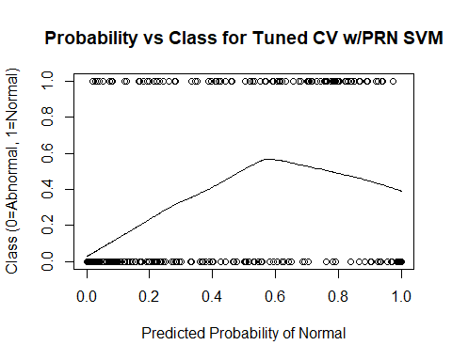

# Add 10 Random Variables

## The following objects are masked from data2 (pos = 3):  
##   
## cervical_tilt, class, classification,  
## degree_spondylolisthesis, Direct_tilt, group,  
## lumbar_lordosis_angle, pelvic_incidence, pelvic_radius,  
## pelvic_slope, pelvic_tilt, pred_class, pred_svm, rand_int,  
## sacral_slope, sacrum_angle, scoliosis_slope, thoracic_slope

## The following objects are masked from data2 (pos = 4):  
##   
## cervical_tilt, class, classification,  
## degree_spondylolisthesis, Direct_tilt, group,  
## lumbar_lordosis_angle, pelvic_incidence, pelvic_radius,  
## pelvic_slope, pelvic_tilt, rand_int, sacral_slope,  
## sacrum_angle, scoliosis_slope, thoracic_slope

## The following objects are masked from data:  
##   
## cervical_tilt, class, classification,  
## degree_spondylolisthesis, Direct_tilt, lumbar_lordosis_angle,  
## pelvic_incidence, pelvic_radius, pelvic_slope, pelvic_tilt,  
## sacral_slope, sacrum_angle, scoliosis_slope, thoracic_slope

## gamma cost  
## 24 0.01 10

## Confusion Matrix and Statistics  
##   
## Reference  
## Prediction Abnormal Normal  
## Abnormal 181 29  
## Normal 29 71  
##   
## Accuracy : 0.8129   
## 95% CI : (0.765, 0.8548)  
## No Information Rate : 0.6774   
## P-Value [Acc > NIR] : 6.441e-08   
##   
## Kappa : 0.5719   
## Mcnemar's Test P-Value : 1   
##   
## Sensitivity : 0.8619   
## Specificity : 0.7100   
## Pos Pred Value : 0.8619   
## Neg Pred Value : 0.7100   
## Prevalence : 0.6774   
## Detection Rate : 0.5839   
## Detection Prevalence : 0.6774   
## Balanced Accuracy : 0.7860   
##   
## 'Positive' Class : Abnormal   
##

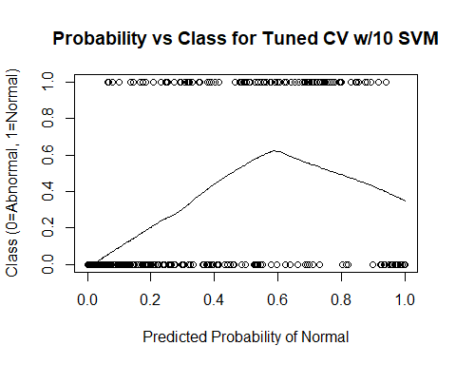

# Add 100 Random Variables

## The following objects are masked from data2 (pos = 3):  
##   
## cervical_tilt, class, classification,  
## degree_spondylolisthesis, Direct_tilt, group,  
## lumbar_lordosis_angle, pelvic_incidence, pelvic_radius,  
## pelvic_slope, pelvic_tilt, pred_class, pred_svm, rand_int,  
## sacral_slope, sacrum_angle, scoliosis_slope, thoracic_slope,  
## X1, X10, X2, X3, X4, X5, X6, X7, X8, X9

## The following objects are masked from data2 (pos = 4):  
##   
## cervical_tilt, class, classification,  
## degree_spondylolisthesis, Direct_tilt, group,  
## lumbar_lordosis_angle, pelvic_incidence, pelvic_radius,  
## pelvic_slope, pelvic_tilt, pred_class, pred_svm, rand_int,  
## sacral_slope, sacrum_angle, scoliosis_slope, thoracic_slope

## The following objects are masked from data2 (pos = 5):  
##   
## cervical_tilt, class, classification,  
## degree_spondylolisthesis, Direct_tilt, group,  
## lumbar_lordosis_angle, pelvic_incidence, pelvic_radius,  
## pelvic_slope, pelvic_tilt, rand_int, sacral_slope,  
## sacrum_angle, scoliosis_slope, thoracic_slope

## The following objects are masked from data:  
##   
## cervical_tilt, class, classification,  
## degree_spondylolisthesis, Direct_tilt, lumbar_lordosis_angle,  
## pelvic_incidence, pelvic_radius, pelvic_slope, pelvic_tilt,  
## sacral_slope, sacrum_angle, scoliosis_slope, thoracic_slope

## gamma cost  
## 23 0.001 10

## Confusion Matrix and Statistics  
##   
## Reference  
## Prediction Abnormal Normal  
## Abnormal 169 55  
## Normal 41 45  
##   
## Accuracy : 0.6903   
## 95% CI : (0.6356, 0.7414)  
## No Information Rate : 0.6774   
## P-Value [Acc > NIR] : 0.3375   
##   
## Kappa : 0.2645   
## Mcnemar's Test P-Value : 0.1846   
##   
## Sensitivity : 0.8048   
## Specificity : 0.4500   
## Pos Pred Value : 0.7545   
## Neg Pred Value : 0.5233   
## Prevalence : 0.6774   
## Detection Rate : 0.5452   
## Detection Prevalence : 0.7226   
## Balanced Accuracy : 0.6274   
##   
## 'Positive' Class : Abnormal   
##

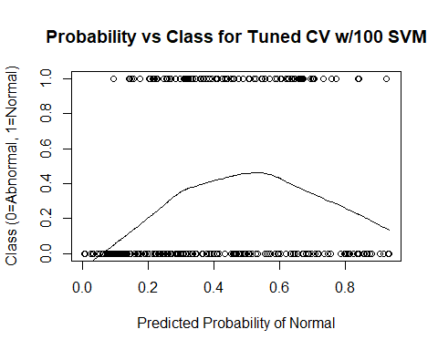

# Add 500 Random Variables

## The following objects are masked from data2 (pos = 3):  
##   
## cervical_tilt, class, classification,  
## degree_spondylolisthesis, Direct_tilt, group,  
## lumbar_lordosis_angle, pelvic_incidence, pelvic_radius,  
## pelvic_slope, pelvic_tilt, pred_class, pred_svm, rand_int,  
## sacral_slope, sacrum_angle, scoliosis_slope, thoracic_slope,  
## X1, X10, X100, X11, X12, X13, X14, X15, X16, X17, X18, X19,  
## X2, X20, X21, X22, X23, X24, X25, X26, X27, X28, X29, X3, X30,  
## X31, X32, X33, X34, X35, X36, X37, X38, X39, X4, X40, X41,  
## X42, X43, X44, X45, X46, X47, X48, X49, X5, X50, X51, X52,  
## X53, X54, X55, X56, X57, X58, X59, X6, X60, X61, X62, X63,  
## X64, X65, X66, X67, X68, X69, X7, X70, X71, X72, X73, X74,  
## X75, X76, X77, X78, X79, X8, X80, X81, X82, X83, X84, X85,  
## X86, X87, X88, X89, X9, X90, X91, X92, X93, X94, X95, X96,  
## X97, X98, X99

## The following objects are masked from data2 (pos = 4):  
##   
## cervical_tilt, class, classification,  
## degree_spondylolisthesis, Direct_tilt, group,  
## lumbar_lordosis_angle, pelvic_incidence, pelvic_radius,  
## pelvic_slope, pelvic_tilt, pred_class, pred_svm, rand_int,  
## sacral_slope, sacrum_angle, scoliosis_slope, thoracic_slope,  
## X1, X10, X2, X3, X4, X5, X6, X7, X8, X9

## The following objects are masked from data2 (pos = 5):  
##   
## cervical_tilt, class, classification,  
## degree_spondylolisthesis, Direct_tilt, group,  
## lumbar_lordosis_angle, pelvic_incidence, pelvic_radius,  
## pelvic_slope, pelvic_tilt, pred_class, pred_svm, rand_int,  
## sacral_slope, sacrum_angle, scoliosis_slope, thoracic_slope

## The following objects are masked from data2 (pos = 6):  
##   
## cervical_tilt, class, classification,  
## degree_spondylolisthesis, Direct_tilt, group,  
## lumbar_lordosis_angle, pelvic_incidence, pelvic_radius,  
## pelvic_slope, pelvic_tilt, rand_int, sacral_slope,  
## sacrum_angle, scoliosis_slope, thoracic_slope

## The following objects are masked from data:  
##   
## cervical_tilt, class, classification,  
## degree_spondylolisthesis, Direct_tilt, lumbar_lordosis_angle,  
## pelvic_incidence, pelvic_radius, pelvic_slope, pelvic_tilt,  
## sacral_slope, sacrum_angle, scoliosis_slope, thoracic_slope

## gamma cost  
## 1 1e-05 0.001

## Confusion Matrix and Statistics  
##   
## Reference  
## Prediction Abnormal Normal  
## Abnormal 210 100  
## Normal 0 0  
##   
## Accuracy : 0.6774   
## 95% CI : (0.6223, 0.7292)  
## No Information Rate : 0.6774   
## P-Value [Acc > NIR] : 0.5271   
##   
## Kappa : 0   
## Mcnemar's Test P-Value : <2e-16   
##   
## Sensitivity : 1.0000   
## Specificity : 0.0000   
## Pos Pred Value : 0.6774   
## Neg Pred Value : NaN   
## Prevalence : 0.6774   
## Detection Rate : 0.6774   
## Detection Prevalence : 1.0000   
## Balanced Accuracy : 0.5000   
##   
## 'Positive' Class : Abnormal   
##

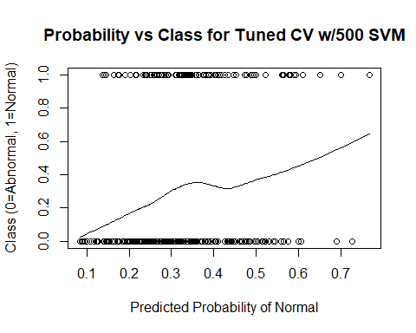

# Add 1000 Random Variables

## The following objects are masked from data2 (pos = 3):  
##   
## cervical_tilt, class, classification,  
## degree_spondylolisthesis, Direct_tilt, group,  
## lumbar_lordosis_angle, pelvic_incidence, pelvic_radius,  
## pelvic_slope, pelvic_tilt, pred_class, pred_svm, rand_int,  
## sacral_slope, sacrum_angle, scoliosis_slope, thoracic_slope,  
## X1, X10, X100, X101, X102, X103, X104, X105, X106, X107, X108,  
## X109, X11, X110, X111, X112, X113, X114, X115, X116, X117,  
## X118, X119, X12, X120, X121, X122, X123, X124, X125, X126,  
## X127, X128, X129, X13, X130, X131, X132, X133, X134, X135,  
## X136, X137, X138, X139, X14, X140, X141, X142, X143, X144,  
## X145, X146, X147, X148, X149, X15, X150, X151, X152, X153,  
## X154, X155, X156, X157, X158, X159, X16, X160, X161, X162,  
## X163, X164, X165, X166, X167, X168, X169, X17, X170, X171,  
## X172, X173, X174, X175, X176, X177, X178, X179, X18, X180,  
## X181, X182, X183, X184, X185, X186, X187, X188, X189, X19,  
## X190, X191, X192, X193, X194, X195, X196, X197, X198, X199,  
## X2, X20, X200, X201, X202, X203, X204, X205, X206, X207, X208,  
## X209, X21, X210, X211, X212, X213, X214, X215, X216, X217,  
## X218, X219, X22, X220, X221, X222, X223, X224, X225, X226,  
## X227, X228, X229, X23, X230, X231, X232, X233, X234, X235,  
## X236, X237, X238, X239, X24, X240, X241, X242, X243, X244,  
## X245, X246, X247, X248, X249, X25, X250, X251, X252, X253,  
## X254, X255, X256, X257, X258, X259, X26, X260, X261, X262,  
## X263, X264, X265, X266, X267, X268, X269, X27, X270, X271,  
## X272, X273, X274, X275, X276, X277, X278, X279, X28, X280,  
## X281, X282, X283, X284, X285, X286, X287, X288, X289, X29,  
## X290, X291, X292, X293, X294, X295, X296, X297, X298, X299,  
## X3, X30, X300, X301, X302, X303, X304, X305, X306, X307, X308,  
## X309, X31, X310, X311, X312, X313, X314, X315, X316, X317,  
## X318, X319, X32, X320, X321, X322, X323, X324, X325, X326,  
## X327, X328, X329, X33, X330, X331, X332, X333, X334, X335,  
## X336, X337, X338, X339, X34, X340, X341, X342, X343, X344,  
## X345, X346, X347, X348, X349, X35, X350, X351, X352, X353,  
## X354, X355, X356, X357, X358, X359, X36, X360, X361, X362,  
## X363, X364, X365, X366, X367, X368, X369, X37, X370, X371,  
## X372, X373, X374, X375, X376, X377, X378, X379, X38, X380,  
## X381, X382, X383, X384, X385, X386, X387, X388, X389, X39,  
## X390, X391, X392, X393, X394, X395, X396, X397, X398, X399,  
## X4, X40, X400, X401, X402, X403, X404, X405, X406, X407, X408,  
## X409, X41, X410, X411, X412, X413, X414, X415, X416, X417,  
## X418, X419, X42, X420, X421, X422, X423, X424, X425, X426,  
## X427, X428, X429, X43, X430, X431, X432, X433, X434, X435,  
## X436, X437, X438, X439, X44, X440, X441, X442, X443, X444,  
## X445, X446, X447, X448, X449, X45, X450, X451, X452, X453,  
## X454, X455, X456, X457, X458, X459, X46, X460, X461, X462,  
## X463, X464, X465, X466, X467, X468, X469, X47, X470, X471,  
## X472, X473, X474, X475, X476, X477, X478, X479, X48, X480,  
## X481, X482, X483, X484, X485, X486, X487, X488, X489, X49,  
## X490, X491, X492, X493, X494, X495, X496, X497, X498, X499,  
## X5, X50, X500, X51, X52, X53, X54, X55, X56, X57, X58, X59,  
## X6, X60, X61, X62, X63, X64, X65, X66, X67, X68, X69, X7, X70,  
## X71, X72, X73, X74, X75, X76, X77, X78, X79, X8, X80, X81,  
## X82, X83, X84, X85, X86, X87, X88, X89, X9, X90, X91, X92,  
## X93, X94, X95, X96, X97, X98, X99

## The following objects are masked from data2 (pos = 4):  
##   
## cervical_tilt, class, classification,  
## degree_spondylolisthesis, Direct_tilt, group,  
## lumbar_lordosis_angle, pelvic_incidence, pelvic_radius,  
## pelvic_slope, pelvic_tilt, pred_class, pred_svm, rand_int,  
## sacral_slope, sacrum_angle, scoliosis_slope, thoracic_slope,  
## X1, X10, X100, X11, X12, X13, X14, X15, X16, X17, X18, X19,  
## X2, X20, X21, X22, X23, X24, X25, X26, X27, X28, X29, X3, X30,  
## X31, X32, X33, X34, X35, X36, X37, X38, X39, X4, X40, X41,  
## X42, X43, X44, X45, X46, X47, X48, X49, X5, X50, X51, X52,  
## X53, X54, X55, X56, X57, X58, X59, X6, X60, X61, X62, X63,  
## X64, X65, X66, X67, X68, X69, X7, X70, X71, X72, X73, X74,  
## X75, X76, X77, X78, X79, X8, X80, X81, X82, X83, X84, X85,  
## X86, X87, X88, X89, X9, X90, X91, X92, X93, X94, X95, X96,  
## X97, X98, X99

## The following objects are masked from data2 (pos = 5):  
##   
## cervical_tilt, class, classification,  
## degree_spondylolisthesis, Direct_tilt, group,  
## lumbar_lordosis_angle, pelvic_incidence, pelvic_radius,  
## pelvic_slope, pelvic_tilt, pred_class, pred_svm, rand_int,  
## sacral_slope, sacrum_angle, scoliosis_slope, thoracic_slope,  
## X1, X10, X2, X3, X4, X5, X6, X7, X8, X9

## The following objects are masked from data2 (pos = 6):  
##   
## cervical_tilt, class, classification,  
## degree_spondylolisthesis, Direct_tilt, group,  
## lumbar_lordosis_angle, pelvic_incidence, pelvic_radius,  
## pelvic_slope, pelvic_tilt, pred_class, pred_svm, rand_int,  
## sacral_slope, sacrum_angle, scoliosis_slope, thoracic_slope

## The following objects are masked from data2 (pos = 7):  
##   
## cervical_tilt, class, classification,  
## degree_spondylolisthesis, Direct_tilt, group,  
## lumbar_lordosis_angle, pelvic_incidence, pelvic_radius,  
## pelvic_slope, pelvic_tilt, rand_int, sacral_slope,  
## sacrum_angle, scoliosis_slope, thoracic_slope

## The following objects are masked from data:  
##   
## cervical_tilt, class, classification,  
## degree_spondylolisthesis, Direct_tilt, lumbar_lordosis_angle,  
## pelvic_incidence, pelvic_radius, pelvic_slope, pelvic_tilt,  
## sacral_slope, sacrum_angle, scoliosis_slope, thoracic_slope

## gamma cost  
## 23 0.001 10

## Confusion Matrix and Statistics  
##   
## Reference  
## Prediction Abnormal Normal  
## Abnormal 209 95  
## Normal 1 5  
##   
## Accuracy : 0.6903   
## 95% CI : (0.6356, 0.7414)  
## No Information Rate : 0.6774   
## P-Value [Acc > NIR] : 0.3375   
##   
## Kappa : 0.06   
## Mcnemar's Test P-Value : <2e-16   
##   
## Sensitivity : 0.9952   
## Specificity : 0.0500   
## Pos Pred Value : 0.6875   
## Neg Pred Value : 0.8333   
## Prevalence : 0.6774   
## Detection Rate : 0.6742   
## Detection Prevalence : 0.9806   
## Balanced Accuracy : 0.5226   
##   
## 'Positive' Class : Abnormal   
##

