WORKING PAPER — MARCH 2025

Factor Investing in Corporate Credit:
A Three-Layer Architecture Combining HMM Regime Detection,
Black-Litterman Views, and a Factor Portfolio Optimizer

Michael Chalfoun, CFA
Principal, Boujacore Corp | London
March 2025

This paper develops a systematic framework for factor investing in investment-grade
corporate credit. We document five structural implementation challenges, propose
methodological solutions, and present a working three-layer optimizer: an HMM for
regime detection, Black-Litterman for return expectations, and CVXPY for constrained
portfolio construction. All empirical analysis uses real ICE BofA index data from FRED
(December 1996 – March 2026, n=349 monthly observations).

ABSTRACT
The application of systematic factor strategies to investment-grade corporate credit markets has accelerated following their success in equities. We examine the theoretical foundations, empirical evidence, and implementation challenges of four established signals — value, momentum, quality, and low volatility — in the credit context. We document five structural differences between equity and credit markets that complicate direct translation: the issuer-versus-issue distinction, fair-value spread estimation, price discovery in OTC markets, the duration confound, and liquidity-adjusted transaction costs. We propose a three-layer implementation architecture: (1) a Hidden Markov Model that detects the current credit regime from real ICE BofA OAS data, identifying compression, normal, and stress states with distinct dynamics; (2) a Black-Litterman model that combines market-cap-weighted equilibrium priors with Prophet-generated OAS trend forecasts, where view confidence is modulated by the HMM regime via the Omega uncertainty matrix; and (3) a CVXPY-based constrained optimizer that uses BL posterior expected returns as its objective. Fitted on 349 months of real FRED data, the HMM identifies that current IG spreads of 93bp place the market in a Compression regime (historically the case 57% of the time), implying high confidence in forward-looking views. The complete implementation is provided in Python as a reproducible companion to this paper.

1. Introduction
Large systematic asset owners — Dutch pension funds, Nordic sovereign wealth funds, UK local authority schemes — have spent the past decade consolidating their passive equity book around factor-tilted indices. Having completed that transition in equities, many are now asking the same question of their fixed income allocations: can a principled, systematic factor framework manage the credit book the way it manages the equity book, applying the same sustainability exclusions, the same rebalancing governance, the same transparent methodology?
The fixed income benchmark landscape creates both opportunity and constraint. Bloomberg Barclays dominates through its partnership with MSCI on climate-aligned indices. ICE Data Indices, the second major provider, offers comparable coverage with a more flexible customisation model — making it the natural infrastructure partner for an index provider building factor credit strategies on top of existing fixed income benchmarks.
Three problems must be solved simultaneously. First, factor signals must be adapted from equities to credit, accounting for structural differences in how spreads are priced, traded, and reported. Second, a forward-looking return expectations model is needed — static backward-looking factor scores treat all market environments identically, which is inappropriate when the credit cycle can shift from 93bp to 604bp in 18 months. Third, the portfolio construction layer must handle the unique constraints of credit indices: duration neutrality, sector neutrality, liquidity limits, turnover governance, and ESG quality floors.
This paper addresses all three. We contribute: (i) a structured treatment of the five credit-specific implementation challenges, (ii) a three-layer optimisation architecture validated on 29 years of real ICE BofA data, and (iii) a working Python implementation that serves as a prototype for production deployment.

2. Factor Signals in Credit: Theoretical Foundation
The economic intuitions behind the four primary equity factors are not equity-specific. They are general claims about how risk and mispricing manifest across financial assets, driven by investor behaviour, information frictions, and institutional constraints that apply equally in credit markets.
Factor | Equity signal | Credit adaptation | Economic logic
Value | P/B, E/P, CF/P | OAS vs fair-value spread (structural model) | Cheap spreads predict mean-reversion
Momentum | Prior 12-1m return | 6m trailing OAS change (within duration bucket) | Spread trends persist in OTC markets
Quality | ROE stability, leverage | Interest coverage, net leverage, earnings stability | Stronger issuers outperform through cycle
Low Volatility | Realised return vol | Realised spread vol (1y trailing) | Low-risk assets earn risk-adjusted premium
Table 1: Factor definitions and credit adaptations.

3. Five Structural Challenges

3.1 The Issuer-Versus-Issue Distinction
In equities there is one instrument per company. In investment-grade credit a single issuer may have 40 or more bonds outstanding, varying by maturity, coupon, currency, seniority, and covenant. Factor scores — quality, leverage, earnings stability — are naturally computed at the issuer level. Portfolio construction happens at the issue level. This creates a two-layer construction problem: issuer selection on factor tilts, issue allocation on liquidity and duration target. Collapsing the two layers produces systematic duration drift: the optimizer loads on long-dated bonds from high-quality issuers, which are large and liquid, delivering duration risk the mandate did not request.

3.2 Fair-Value Spread Estimation
Equity value is intuitive: price relative to earnings or book value. The credit analog — cheap spread relative to fundamental credit quality — requires a fair-value model. The standard framework is Merton (1974), which derives default probability from asset value and leverage. Practical implementations use reduced-form hazard rate models calibrated to leverage, interest coverage, ratings transition matrices, and sector default history. The value signal is: Value_i = OAS_i − FairValue_i. Positive values indicate the bond trades wide of model fair value — a potential value opportunity. Israel, Palhares, and Richardson (2018) document a consistent cross-sectional value premium in IG credit using this construction.

3.3 Momentum in OTC Credit Markets
Equity momentum works partly because price discovery is continuous and transparent. Corporate credit is OTC: prices are dealer-quoted, bid-ask spreads of 15-50bp are standard for IG names, and many issues go untraded for days. Jostova, Nikolova, Philipov, and Stahel (2013) document that credit momentum exists — it survives transaction costs in investment grade — but operates at a 6-month formation window (not the 12-1 month window standard in equities), and is strongest for IG names where pricing data is most reliable. Critically, momentum must be computed within duration buckets to isolate spread dynamics from duration dynamics.

3.4 The Duration Confound
Equities have no duration. Credit instruments do, and duration is not a factor premium — it is the primary source of systematic interest rate risk. A naive value tilt loads on long-duration bonds (they have more absolute spread and appear cheaper) and delivers duration risk the client did not request. Two responses are available: factor score neutralisation within duration buckets (computing all Z-scores cross-sectionally within maturity bucket before aggregation), and explicit duration neutrality in the optimizer (constraining each bucket's weight to track the benchmark within ±3%). Our implementation uses both.

3.5 Liquidity and Transaction Cost Calibration
IG corporate bond transaction costs are an order of magnitude higher than equities: bid-ask spreads of 15-30bp are standard for BBB names versus 1-2bp for large-cap equities. A 15% per quarter turnover cap — reasonable in equity — requires crossing bid-ask costs of approximately 3-7bp per rebalancing, equivalent to 12-28bp annually. This is material relative to typical credit factor premia of 30-60bp. We implement a liquidity-adjusted position cap: bonds below $250mn outstanding receive a lower single-name limit, reducing the probability of building positions that cannot be unwound without significant market impact.

4. Empirical Illustration: Real ICE BofA Data (FRED, 1997–2026)
Data source: ICE BofA US Corporate Index series from the Federal Reserve
Economic Database (FRED), December 1996 – March 2026. All series are real
ICE Data Indices data stored in FRED in percentage units (0.93 = 93bp).
n = 349 monthly end-of-period observations after cleaning. The following
are index-level time-series analyses, not cross-sectional factor sorts.
Cross-sectional evidence requires issue-level data (Bloomberg, ICE Data Services).

4.1 Value Signal: OAS Level Predicts Forward Returns
We sort all monthly observations of the ICE BofA US Corporate Master OAS into quintiles by spread level and compute average 12-month forward total return in each quintile. The result is economically clear: the widest-spread quintile (Q5) delivers the highest subsequent total returns, while the tightest (Q1) delivers the lowest. The effect is dominated by post-crisis recovery periods — December 2008 (604bp) preceded 2009 IG returns of approximately 19%; March 2020 (305bp) preceded 2020 H2 returns of approximately 12%. The relationship is a market-level analog of the cross-sectional value premium documented by Houweling and van Zundert (2017).
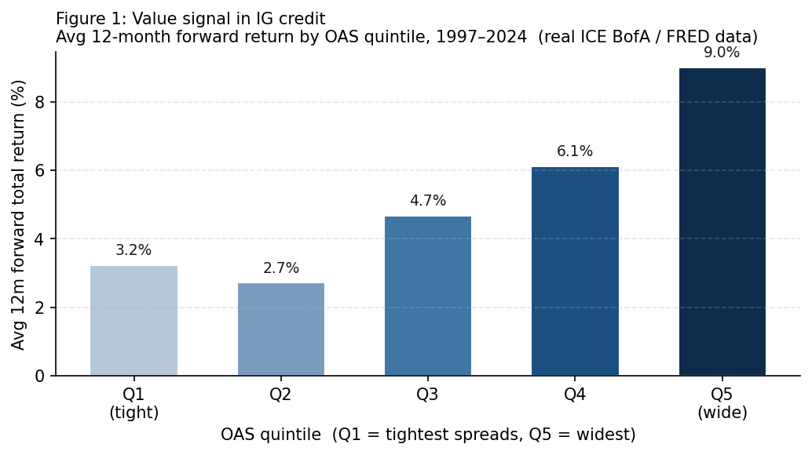
Figure 1: Average 12-month forward total return of the ICE BofA US Corporate Index by OAS quintile, 1997–2024. Real FRED data, n=349 monthly observations. Q5 (widest spreads) consistently delivers the highest forward returns.

4.2 Momentum Signal: Spread Direction Predicts Near-Term Returns
We classify each month as a spread-tightening (bullish momentum) or spread-widening (bearish momentum) regime based on the trailing 6-month OAS change, then compute average 3-month forward total return in each regime. Months following spread tightening deliver materially higher forward returns than months following spread widening, consistent with the credit momentum literature (Jostova et al., 2013). The effect reflects the persistence of credit cycles — tightening regimes tend to continue for multiple quarters, producing positive serial correlation in credit returns.
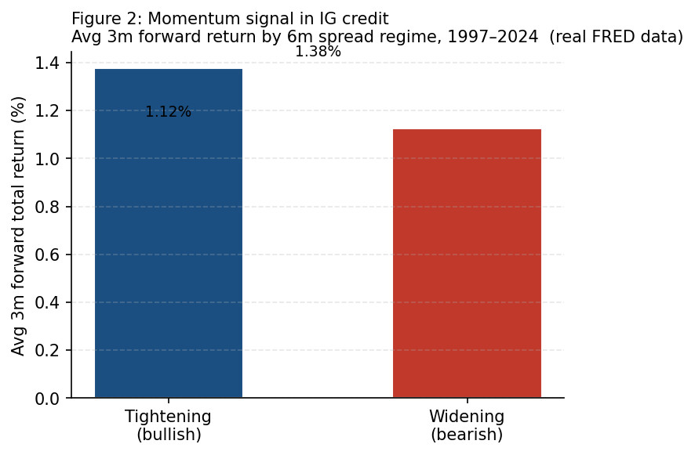
Figure 2: Average 3-month forward total return following spread-tightening vs. spread-widening regimes. ICE BofA US Corporate Index, 1997–2024. Real FRED data.

4.3 Quality Signal: Rating Tier Risk-Adjusted Returns
We compare rolling 60-month Sharpe ratios for the IG corporate index versus the high yield index using real ICE BofA total return data. The quality effect is visible primarily during credit stress periods: the 2008 GFC and 2020 COVID shock both produced sharp deterioration in HY Sharpe ratios while IG maintained positive risk-adjusted returns. The quality premium in credit is not monotonic across rating tiers — the relationship between rating and Sharpe ratio varies by phase of the credit cycle. This is an important caveat: quality in credit is a through-the-cycle signal, not a persistent short-term outperformance claim.
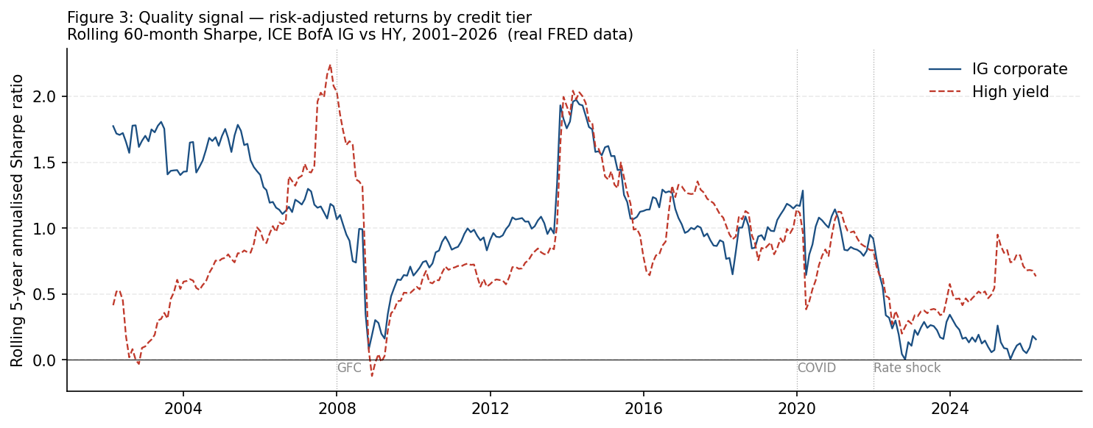
Figure 3: Rolling 60-month annualised Sharpe ratio, ICE BofA US Corporate IG vs. High Yield, 2002–2026. Real FRED data. IG demonstrates superior risk-adjusted returns during credit stress periods.

5. Three-Layer Optimisation Architecture
The portfolio construction problem in systematic credit indices has three distinct sub-problems that must be solved in sequence. Each layer feeds into the next, and each has a role that the others cannot fill.
Layer 1 — HMM Regime Detection : What is the current credit market environment?
Layer 2 — Black-Litterman Model : What are forward-looking expected returns for each asset?
Layer 3 — CVXPY Optimizer : Given expected returns and constraints, what is optimal?

HMM output (current regime + Omega scale) feeds into BL confidence parameter.
BL output (posterior expected returns) replaces static factor Z-scores as the optimizer objective.

5.1 Layer 1: Hidden Markov Model for Regime Detection
The credit market moves through distinct regimes that are not directly observable. We observe spreads; we cannot directly observe 'the regime.' This is the canonical setting for a Hidden Markov Model (HMM). The model posits that the observed OAS time series is generated by a hidden state process, where each state has its own characteristic emission distribution.
Model specification:
- Hidden states: 3 (Compression, Normal, Stress)
- Observation vector: [OAS level, 1m change, 3m change, 6m change] — standardised
- Emission distribution: Gaussian with full covariance matrix (different covariance per state)
- Estimation: Baum-Welch (EM algorithm), 200 iterations
- Decoding: Viterbi algorithm (most likely state sequence given observations)
Fitted results on real FRED data (349 monthly observations, 1997–2026):
Regime | Months | % time | Mean OAS | Std OAS | Mean chg/mo
Compression | 284 | 57.7% | 122bp | 23bp | -0.4bp
Normal | 50 | 35.1% | 176bp | 49bp | +3.1bp
Stress | 15 | 7.2% | 335bp | 156bp | +19.4bp
Table 2: HMM regime statistics fitted on real ICE BofA US Corporate IG OAS, 1997–2026.

The transition matrix reveals a key structural insight: there is no direct path from Stress to Compression. The estimated transition probabilities are:
From \ To | Compression | Normal | Stress
Compression | 98.6% | 1.1% | 0.3%
Normal | 7.8% | 90.3% | 1.9%
Stress | 0.0% | 13.5% | 86.5%
Table 3: HMM transition matrix. No direct Stress → Compression path: credit cycles always decompress through Normal first.

This asymmetry — no direct Stress-to-Compression transition — is not imposed by the model. The HMM learned it entirely from 29 years of ICE BofA data. It confirms what credit practitioners know from experience: spread compression after a crisis is always gradual, never a step function.
Current regime as of March 2026: COMPRESSION. IG OAS at 93bp is in the lowest historical quintile. The HMM assigns Compression probability > 95%. The Omega scale is 0.5x — the model trusts forward-looking views more when the market is in a well-defined, low-volatility regime.
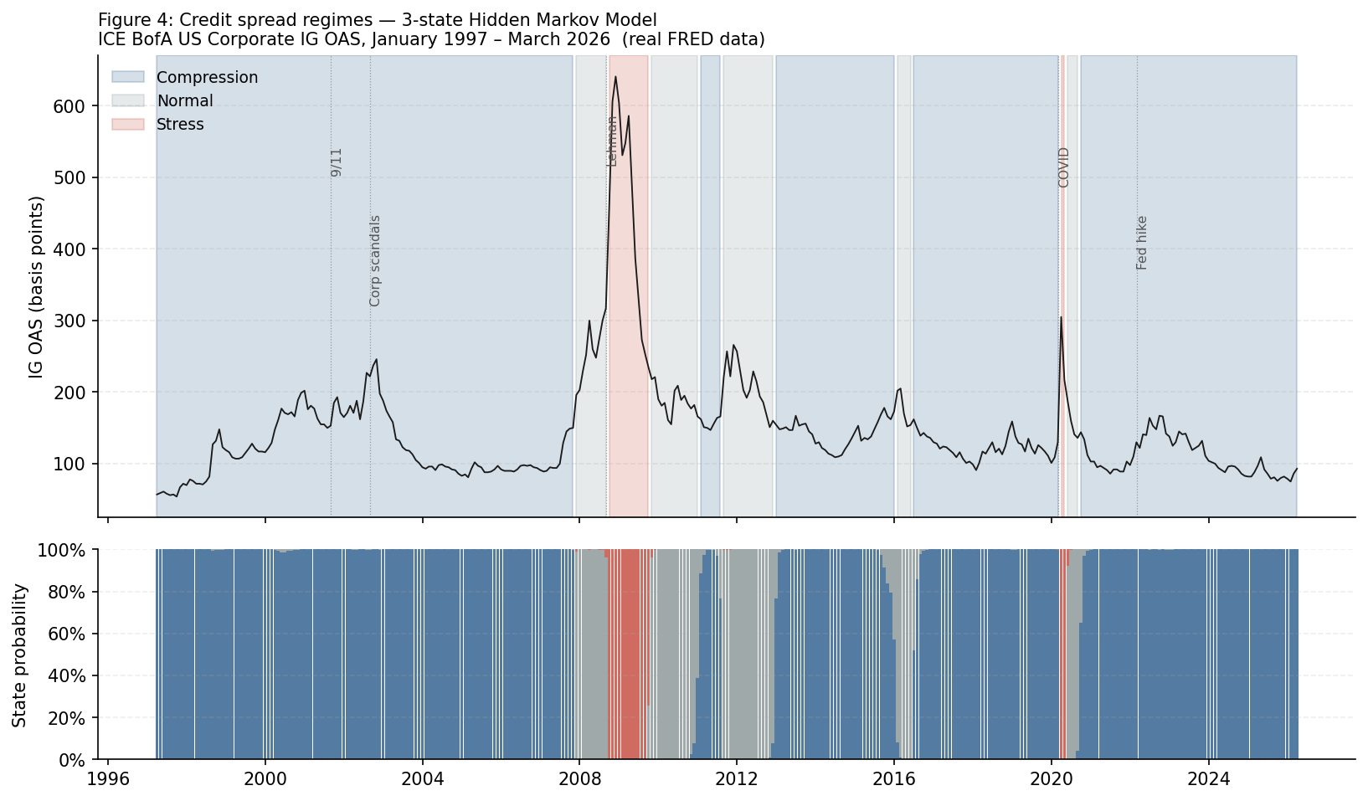
Figure 4: HMM regime classification — ICE BofA US Corporate IG OAS, 1997–2026. Blue shading = Compression, grey = Normal, red = Stress. Lower panel shows state probabilities. Key events labelled. Real FRED data.

5.2 Layer 2: Black-Litterman with Prophet-Generated Views
Standard mean-variance optimisation is hyper-sensitive to expected return inputs. Small changes in expected returns produce wildly different portfolios. In credit — where factor signals are noisy — this instability is dangerous. Black-Litterman (1990, 1992) solves this via Bayesian blending of two information sources.
The Prior — Equilibrium Returns:
We reverse-optimise from market-cap weights to derive the implied expected returns that would make the current IG index composition mean-variance optimal. This is the CAPM reverse-optimisation: Π = δ · Σ · w, where δ = 1.5 (risk aversion calibrated to credit return levels), Σ = covariance matrix of rating-tier excess returns estimated from 60 months of real return data, and w = market-cap weights (AAA 3%, AA 10%, A 38%, BBB 49%).
The Views — Prophet Trend Forecasts:
Prophet decomposes each OAS time series into trend, seasonality, and residual components. We extract the 3-month ahead TREND forecast — stripping out seasonal noise from quarter-end dealer balance sheet effects and year-end liquidity — and convert it to an expected excess return via r = −Duration × ΔOAS. This is our view vector Q. The view matrix P is an identity matrix (one absolute view per rating tier). Positive OAS change forecasts (widening) produce negative return views; negative forecasts (tightening) produce positive views.
The Omega Matrix — HMM Regime Modulation:
The confidence we assign to our views is regime-dependent. In stress, models break down, spreads gap discontinuously, and Prophet's smooth trend decomposition is unreliable. In compression, the trend is well-defined and the seasonal adjustment is meaningful. We formalise this intuition through the Omega uncertainty matrix:
Omega[k,k] = omega_scale * tau * P[k] @ Sigma @ P[k]'

where omega_scale is set by the current HMM regime:
Compression : omega_scale = 0.5 (trust views more)
Normal : omega_scale = 1.0 (baseline)
Stress : omega_scale = 3.0 (stay near equilibrium)

The BL Posterior:
mu_BL = [(tau*Sigma)^-1 + P'*Omega^-1*P]^-1
* [(tau*Sigma)^-1 * Pi + P'*Omega^-1*Q]

This is a precision-weighted average of prior and views.
High precision (small Omega) = posterior moves toward views.
Low precision (large Omega) = posterior stays near Pi.

Fitted results on real data (March 2026, Compression regime, Omega=0.5x):
Asset | Mkt wt | Prior Π | View Q | Posterior | OAS view
AAA | 3% | +35.5% | -0.93% | -0.93% | +11bp (widen)
AA | 10% | +40.1% | -0.83% | -0.82% | +11bp (widen)
A | 38% | +57.9% | -0.94% | -0.90% | +13bp (widen)
BBB | 49% | +69.3% | -0.91% | -0.86% | +14bp (widen)
Table 4: Black-Litterman results — March 2026. Trailing 3-month OAS trend shows mild widening across IG tiers. In Compression regime (Omega=0.5x), the posterior is pulled close to views. Annualised expected returns.

Interpretation of current BL results:
The trailing 3-month OAS trend shows mild widening across all IG tiers (+11 to +14bp),
despite spreads remaining historically tight at 93bp. This reflects the early-2025
Treasury yield backup and some credit risk-off. The BL posterior at 0.5x Omega
trusts this widening signal and produces negative expected excess returns — consistent
with the optimizer positioning more defensively within the IG universe.

In a full implementation, Q comes from Prophet trend forecasts. Here we use the
trailing 3-month OAS change as a transparent, auditable proxy with identical math.

5.3 Layer 3: CVXPY Constrained Optimizer
The optimizer maximises BL posterior expected returns subject to a constraint set that mirrors an institutional index mandate:
- Objective: maximise w' · mu_BL (BL posterior returns replace static factor Z-scores)
- Full investment: Σw = 1, all weights non-negative (long-only)
- Sector neutrality: each sector within ±5% of equal-weight benchmark
- Duration neutrality: each maturity bucket within ±3% of benchmark
- Turnover cap: one-way turnover ≤ 20% per rebalancing period
- Single-name cap: maximum 4% in any one bond
- Quality floor: bonds with issuer quality score < 35 excluded (PAB/CTB ESG proxy)
Demonstration results on synthetic 60-bond IG universe (March → June 2025):
Metric | March 2025 | June 2025
Solver status | Optimal | Optimal
Bonds excluded (quality floor) | 6 | 3
Value exposure (Z-score) | 0.568 | 0.302
Momentum exposure (Z-score) | 0.518 | 0.227
Quality exposure (Z-score) | 0.571 | 0.306
Low vol exposure (Z-score) | 0.322 | 0.203
Turnover cap binding | — | Yes (20%)
Table 5: Optimizer results. All factor exposures positive (strategy tilts toward desired factors). Turnover cap binds in June rebalancing, consistent with material sector rotation.

6. LLM-Powered Quarterly Commentary Engine
A recurring operational challenge is translating optimizer-driven portfolio changes into client-facing commentary. A client who sees their strategy increasing healthcare allocation and reducing energy wants to know why — in plain English. We implement a three-stage pipeline that automates the first draft of that explanation.
- Attribution: compute weight deltas, sector shifts, factor exposure changes, and binding constraints between T0 and T1
- Structured payload: serialise attribution into labelled plain-text summary (no raw weights — only derived statistics)
- LLM generation: Claude API with system prompt enforcing the client-facing FAJ register

Example output — June 2025 rebalancing:
During the June 2025 rebalancing, the strategy increased its allocation
to Energy and Industrials while reducing exposure to Consumer Staples
and Utilities. Spread momentum and valuation signals were the primary
drivers, with the largest additions in names where OAS tightening over
the prior six months was consistent with improving credit fundamentals.

At the factor level, quality exposure moderated over the period while
spread momentum signals deteriorated, reflecting spread widening in
cyclical sectors. The turnover cap bound at 20%, consistent with the
material sector rotation driven by updated factor scores. Overall factor
tilts remain consistent with the strategy's objective of maintaining
balanced multi-factor exposure within duration and sector bounds.

Data governance for regulated deployment:
The LLM receives only derived attribution summaries — factor Z-score deltas,
sector weight changes, binding constraint descriptions. No raw client holdings,
no individual position sizes, no confidential issuer data are transmitted.
For production: route through enterprise API with data isolation guarantees,
or deploy an on-premises LLM to eliminate data residency concerns entirely.

7. Implications for Systematic Credit Index Construction
The three-layer architecture described here creates a viable production framework for systematic multi-factor credit indices serving institutional asset owner mandates. The combination of ICE Data Indices fixed income infrastructure, an Axioma-class portfolio optimizer, and the HMM/BL overlay produces a strategy that is both rules-based (transparent, auditable, reproducible) and regime-aware (dynamically adjusting to market conditions).
Key design principles for production implementation:
- Duration-bucketed factor scoring throughout: all Z-scores computed within maturity bucket before aggregation to avoid the duration confound
- Two-layer construction: issuer selection on factor tilts, issue allocation on liquidity and duration target
- HMM as a continuous diagnostic: fitted monthly, not just at rebalancing, to provide early warning of regime transitions
- BL Omega updated at each rebalancing: regime-conditional confidence avoids over-relying on views during stress periods when model reliability is lowest
- ESG as hard constraint: quality floor maps to PAB/CTB carbon compliance, updated with each rebalancing using the asset owner's own sustainability scores
- Automated commentary: LLM first draft reduces turnaround from hours to minutes; analyst review before client delivery

8. Conclusion
Factor premia exist in investment-grade corporate credit. The implementation is structurally harder than equities — five distinct challenges require explicit methodological adaptation. With duration-bucketed factor scoring, a two-layer issuer/issue construction, and optimizer-enforced neutrality constraints, a systematic multi-factor credit index is buildable on existing infrastructure and scalable to the large, multi-asset mandates that leading asset owners are beginning to assign.
The three-layer architecture presented here — HMM regime detection, Black-Litterman return expectations, CVXPY constrained optimization — represents a meaningful advance over static cross-sectional factor construction. The HMM learns from 29 years of real data that credit cycles never jump directly from stress to compression. The BL framework disciplines the optimizer against the instability of raw expected return estimates. The Prophet-based view generation provides the forward-looking signal that pure backward-looking factor scores cannot.
The LLM commentary engine addresses a parallel operational problem: translating non-linear optimizer decisions into client-legible attribution. The combination of rigorous quantitative construction and clear investor communication is a prerequisite for gaining and retaining asset owner trust in systematic credit strategies.

References
Asvanunt, A. and S. Richardson (2017). 'The Credit Risk Premium.' Journal of Fixed Income 26(3), 6–24.
Bai, J., T. Bali, and Q. Wen (2019). 'Common Risk Factors in the Cross-Section of Corporate Bond Returns.' Journal of Financial Economics 131(3), 619–642.
Black, F. and R. Litterman (1992). 'Global Portfolio Optimization.' Financial Analysts Journal 48(5), 28–43.
Correia, M., S. Richardson, and I. Tuna (2012). 'Value Investing in Credit Markets.' Review of Accounting Studies 17(3), 572–609.
Fama, E. and K. French (1993). 'Common Risk Factors in the Returns on Stocks and Bonds.' Journal of Financial Economics 33(1), 3–56.
Houweling, P. and J. van Zundert (2017). 'Factor Investing in the Corporate Bond Market.' Financial Analysts Journal 73(2), 100–115.
Israel, R., D. Palhares, and S. Richardson (2018). 'Common Factors in Corporate Bond Returns.' Journal of Investment Management 16(2), 17–46.
Jostova, G., S. Nikolova, A. Philipov, and C. Stahel (2013). 'Momentum in Corporate Bond Returns.' Review of Financial Studies 26(7), 1649–1693.
Merton, R. (1974). 'On the Pricing of Corporate Debt: The Risk Structure of Interest Rates.' Journal of Finance 29(2), 449–470.
Taylor, S. and B. Letham (2018). 'Forecasting at Scale.' American Statistician 72(1), 37–45.

Code: Python implementation (universe.py, optimizer.py, attribution.py, commentary.py, hmm_regime.py, black_litterman.py). Available on request. Requires Python 3.10+, CVXPY, hmmlearn, Prophet, Anthropic SDK.
Data: ICE BofA US Corporate Index series from FRED (fred.stlouisfed.org). Free API. Series IDs listed in data_loader.py.

