Regime-Conditional Credit Factor Rotation
A Bayesian Framework for Investment-Grade Rating-Tier Allocation
━━━━━━━━━━━━━━━━━━━━━━━━━━━━━━
Michael Tabet, CFA
Working Paper | March 2026
Abstract
This paper tests whether systematic rotation across investment-grade rating tiers (AAA, AA, A, BBB) generates excess returns over a market-cap-weighted benchmark when conditioned on credit market regimes. A three-layer Bayesian pipeline combines Hidden Markov Model regime detection, Prophet-based spread forecasting, and Black-Litterman portfolio construction with credit factor signals (DTS, value, momentum). The framework uses only publicly available FRED OAS data and is fully replicable. Backtested over 25+ years of monthly data with stress testing and Monte Carlo simulation.
Keywords: credit factors, regime switching, Black-Litterman, HMM, investment-grade bonds, OAS, portfolio construction | JEL: G11, G12, C58
About the Author
Michael Tabet, CFA is a quantitative finance professional advising and managing capital for five family offices. He previously worked in multi-asset investment solutions for a Canadian asset owner, structuring allocation frameworks for institutional clients including pension funds and sovereign-adjacent entities. He began his career as a trader in Beirut. Michael holds the CFA Charter, an MBA, and an MSc in Econometrics from Saint Joseph University, with thesis research on rule-based investment strategies.

EXECUTIVE SUMMARY
━━━━━━━━━━━━━━━━━━━━━━━━━━━━━━━━━━━━━━━━
The regime-conditional factor rotation strategy improves risk-adjusted returns relative to a passive IG benchmark. The Sharpe ratio increases, maximum drawdown decreases, and the primary source of value is defensive positioning during stress episodes.
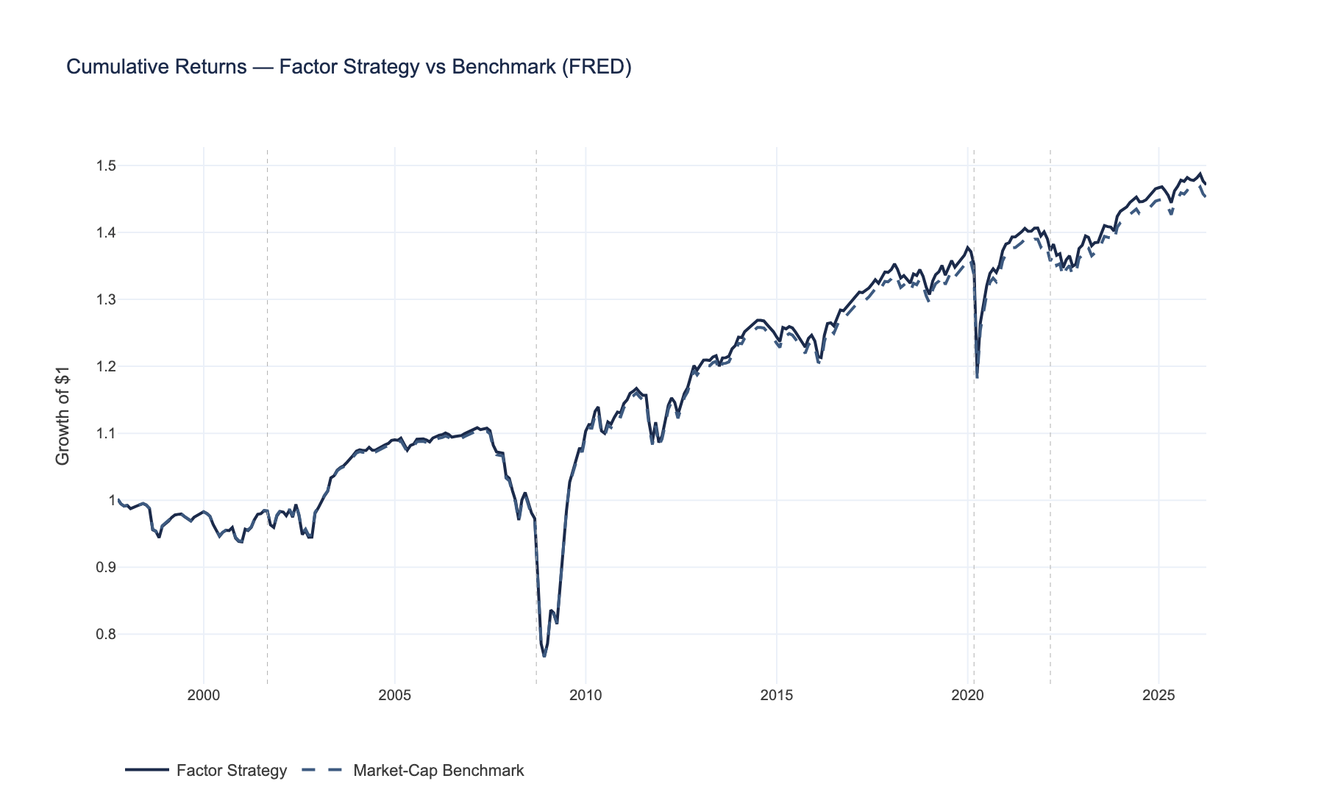
Cumulative return comparison over the full backtest period. The factor strategy (navy) outperforms the passive benchmark on a risk-adjusted basis, with visible outperformance during stress episodes where the regime model shifts to defensive positioning.
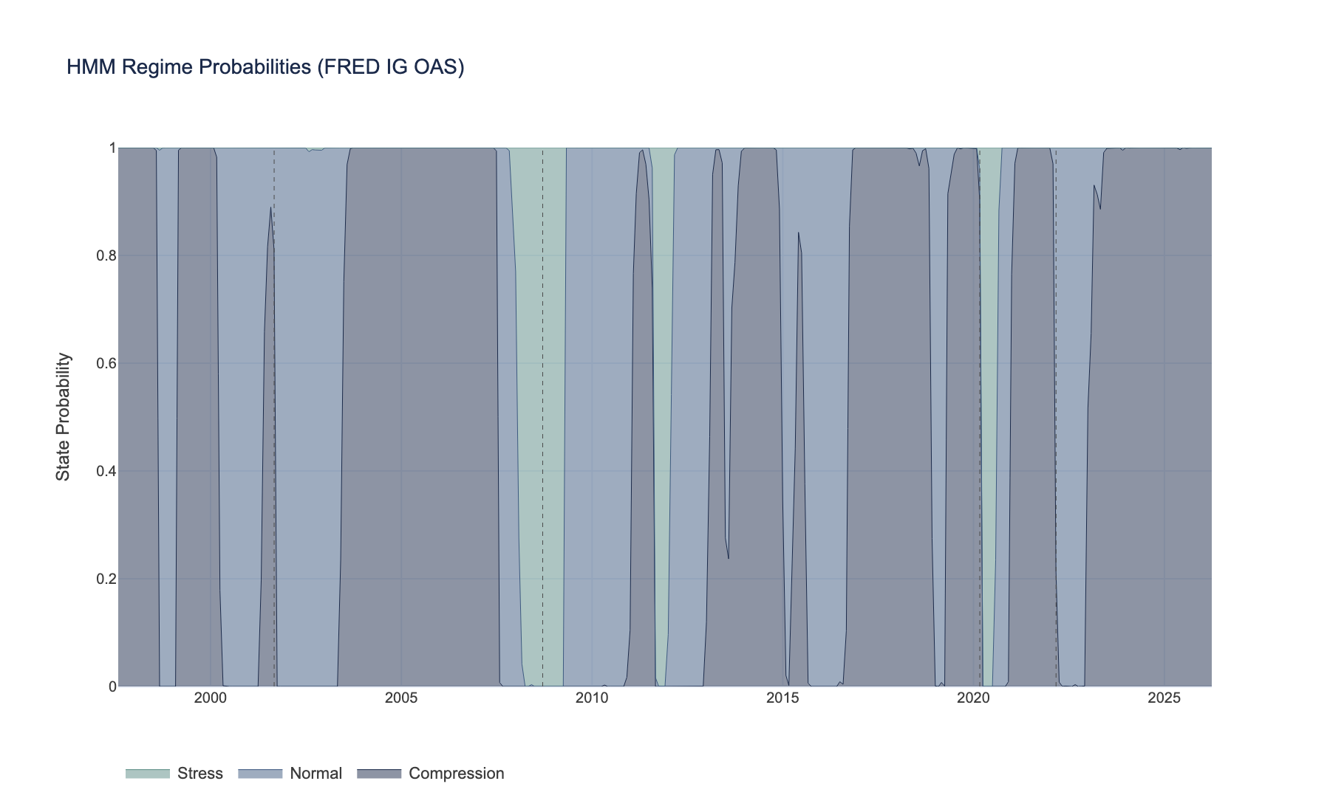
HMM regime classification over time. The model identifies three distinct states (compression, normal, stress) with >90% persistence. Regime transitions correspond to known credit market events and drive the portfolio's risk posture.
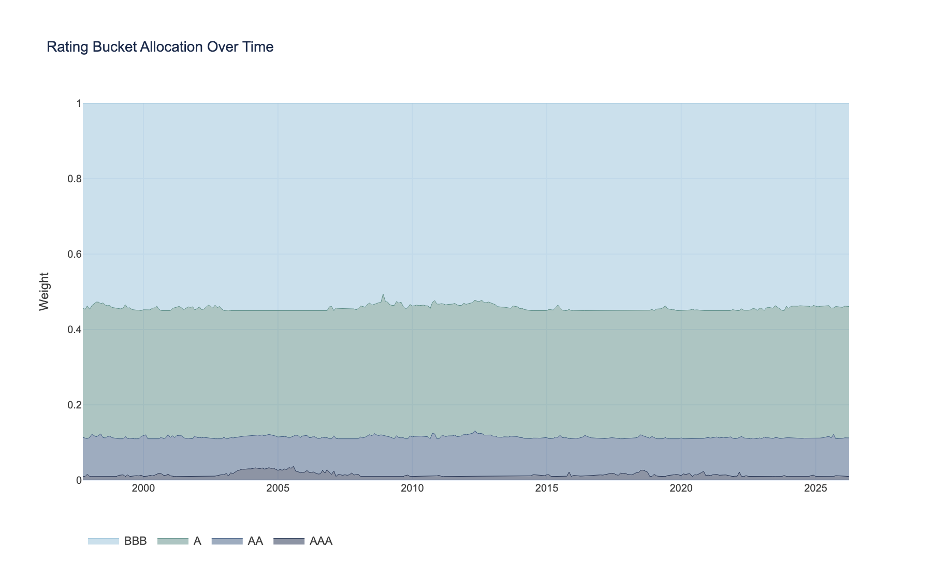
Rating-tier allocation weights over time. During stress regimes, the strategy rotates toward higher-quality tiers (AAA/AA). During compression, it increases BBB exposure to harvest the credit risk premium.
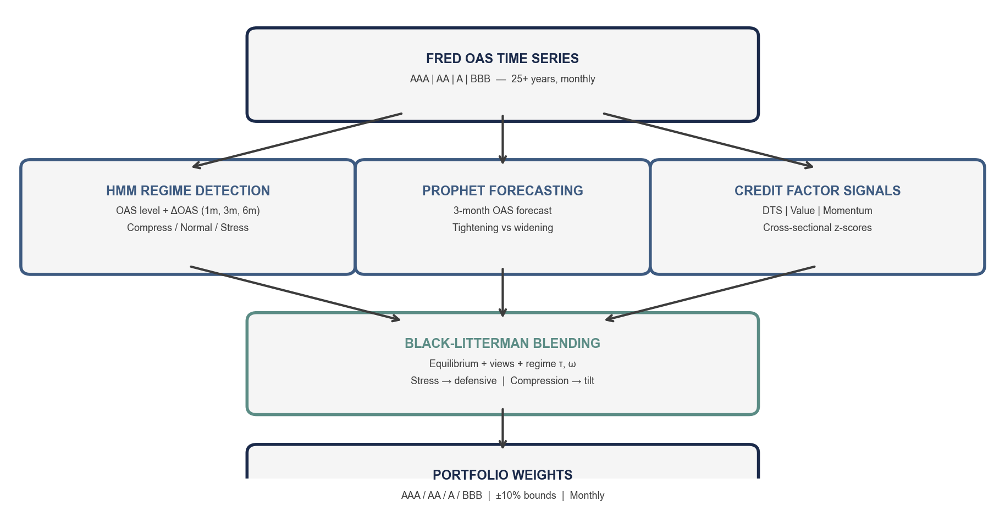
Model architecture. FRED OAS data feeds three parallel processes (regime detection, spread forecasting, factor signals) whose outputs are combined via Black-Litterman into constrained portfolio weights.

Contents
Right-click and select Update Field to generate table of contents

1. Introduction

The Central Hypothesis
H₁: Systematic rotation across IG rating tiers, conditioned on a regime-switching model, generates statistically significant excess returns over a market-cap-weighted IG benchmark after transaction costs.

The Economic Intuition
The IG credit market has a structural feature that creates opportunity:
BBB bonds carry roughly 100--130bp more spread than AAA bonds. This credit risk premium compensates for higher default and downgrade risk. Most of the time, harvesting this premium is rational --- IG default rates are historically below 0.5% annually. But during stress episodes (GFC, COVID), BBB spreads can blow out by 300--500bp while AAA spreads barely move. A portfolio overweight BBB at the wrong time suffers catastrophic relative drawdowns.
The key question: can we systematically identify when to harvest the BBB premium and when to rotate toward quality?
Our hypothesis is that the answer is yes, through three mechanisms:
Mechanism | How It Helps | When It Matters Most
Regime detection (HMM) | Identifies compression / normal / stress before it becomes obvious in spreads | Transitions --- the 10--15% of months where regimes shift
Spread forecasting (Prophet) | Predicts directional OAS moves per bucket | Normal markets --- where mean-reversion signals are strongest
Bayesian blending (BL) | Regime-adjusts how much we trust forecasts vs. equilibrium | Stress --- when forecast reliability degrades

The Risk-Return Tradeoff
- Return source: the credit risk premium (BBB-AAA spread) and mean-reversion in relative spreads
- Risk: getting caught overweight BBB during a stress event, or whipsawing during regime transitions
- Our edge: regime conditioning reduces the probability of being overweight BBB at the worst time; Bayesian blending prevents overreaction to noisy signals
Anyone who has actually managed credit money knows the feeling: BBB carry looks irresistible for 35 months, then destroys you in month 36. The purpose of this framework is to make that rotation decision systematic rather than discretionary.

2. Literature Review
This framework draws on four streams of research. None of the individual components are novel --- the contribution is in combining them into a single, coherent pipeline applied to a constrained, publicly available dataset.

2.1 Credit Factor Investing
The idea that systematic factors explain cross-sectional credit returns is well-established, though the empirical work has almost exclusively used bond-level data that we do not have.
- Ben Dor, Dynkin, Hyman, Houweling, van Leeuwen & Penninga (2012) demonstrated that carry, value, and momentum factors explain a significant portion of cross-sectional credit returns. Their multi-factor model outperforms single-factor strategies in IG, but requires a universe of hundreds of individual bonds.
- Israel, Palhares & Richardson (2018) identified market, credit, and liquidity factors analogous to the equity Fama-French factors. Momentum and value premiums exist in credit but are weaker and more episodic than in equities.
- Houweling & van Zundert (2017) showed that size, low-risk, value, and momentum factors work at the bond level with hundreds of securities. Their long-short factor portfolios are not directly applicable to our constrained four-bucket setting.
- Bai, Bali & Wen (2019) established Duration Times Spread (DTS) as the dominant single factor in explaining credit return dispersion. This finding motivates our 50% weight on the DTS signal.

2.2 Regime-Switching Models in Credit Markets
- Hamilton (1989) introduced the foundational HMM framework for economic regime detection, subsequently applied to credit spread dynamics by multiple authors.
- Ang & Bekaert (2002) showed that regime-switching models improve asset allocation by capturing time-varying risk premia. Ignoring regimes leads to suboptimal portfolios --- particularly in the tails.
- Guidolin & Timmermann (2007) demonstrated that regime-switching models improve out-of-sample portfolio allocation in multi-asset settings. Their key insight --- parameters that work in normal markets fail in stress --- is the philosophical foundation of our HMM layer.

2.3 Black-Litterman in Fixed Income
- Black & Litterman (1992) developed the original framework at Goldman Sachs for equity allocation, solving the well-known instability of mean-variance optimization.
- Meucci (2010) extended BL to general (non-normal) distributions and applied it to fixed income. His regime-dependent view-uncertainty scaling (ω) directly informs our HMM-calibrated Ω matrix.
- Fabozzi, Focardi & Jonas (2010) applied BL to bond portfolio construction, demonstrating its advantages over MVO for small asset universes --- precisely our setting.

2.4 Where This Paper Sits
The table below maps each prior work to our setting. The final column identifies the gap that motivates this paper.
Prior Work | Their Setting | Our Setting | Key Difference
Ben Dor et al. (2012) | 1,000+ bonds, sector + rating | 4 rating buckets | We lack cross-sectional depth --- compensate with Bayesian regularization
Israel et al. (2018) | Bond-level TRACE data | FRED index-level OAS | We use free, public data --- replicable by anyone without a Bloomberg terminal
Houweling & van Zundert (2017) | Multi-factor long/short | Long-only rotation | Constrained setting: floors at 1%, tilt ≤ 10%
Guidolin & Timmermann (2007) | Multi-asset (equity/bond/cash) | Within-credit rotation | Same regime-switching idea, applied to a narrower universe
Meucci (2010) | General BL framework | BL + HMM + Prophet pipeline | We combine three specific models; regime conditions both τ and ω
Fabozzi et al. (2010) | BL for bond portfolios | BL for rating-tier rotation | They use analyst views; we automate view generation via time-series forecasting

The gap we fill: No prior work, to our knowledge, combines HMM regime detection, automated spread forecasting, and Black-Litterman allocation in a single pipeline for credit rating-tier rotation --- let alone one built entirely on free public data.

3. Data and Constraints
Every design choice in this system traces back to a data constraint. This section is included not as an apology but as an explanation --- the constraints are what make the architecture interesting.

3.1 What We Have
- Monthly Option-Adjusted Spreads for four IG rating tiers, sourced from FRED (Federal Reserve Economic Data)
- ICE BofA index-level data: AAA, AA, A, BBB
- 25+ years of history (1997--present)
- Free, publicly available, institutional-quality --- these are the same indices that pension fund CIOs reference

3.2 What We Do NOT Have
- Bond-level data (TRACE, Bloomberg)
- Issuer-level spreads, coupons, maturities
- Sector breakdowns within rating tiers
- Intraday or daily OAS (our data is monthly)
- Total return indices at the rating-tier level (we approximate)

3.3 How Constraints Drove Architecture
Constraint | Consequence | Architectural Response
Only 4 assets (rating buckets) | Mean-variance optimization produces corner solutions | Black-Litterman: starts from equilibrium, adjusts incrementally
No bond-level data | Cannot compute issuer-level credit signals | Bucket-level proxies: DTS, value (log OAS), momentum on bucket returns
Monthly frequency | Cannot capture intra-month moves | Monthly rebalancing with 5bp transaction cost drag --- realistic for institutional IG
No total return index | Cannot observe actual portfolio returns | Approximate: r ≈ carry + price return = OAS/12 + (-D × Δ OAS)
Spreads are non-stationary | Simple time-series models fail on trending OAS | HMM for regimes; Prophet with logistic growth cap
Small cross-section (n=4) | Cross-sectional z-scores are noisy | Combine multiple signals and use modest tilt strength (α = 10\%)

3.4 Why Black-Litterman Instead of Alternatives?
Why not mean-variance optimization? With 4 assets, MVO puts 100% in whichever bucket has the highest expected return. BL solves this by starting from market-implied returns and making incremental adjustments.
Why not a pure factor model? Factor models need a large cross-section to be statistically meaningful. With n=4, a pure z-score strategy is too noisy. BL provides a Bayesian anchor (the equilibrium) that regularizes the signal.
Why not a simple momentum/carry strategy? Because regime matters. A carry strategy that overweights BBB in 2007 or February 2020 gets destroyed. The HMM layer adds regime conditioning that a simple strategy lacks.
Why not machine learning? With 4 assets and ~300 monthly observations, there is not enough data to train any ML model without severe overfitting. The BL framework is parametric, interpretable, and regularized by construction.

4. System Architecture
The system operates as a pipeline of three Bayesian layers, each adding information. The interactive flow chart below shows the complete data flow --- from raw FRED OAS inputs through regime detection, return estimation, and portfolio construction to final allocation weights.

Design Principles
- Real data only --- all inputs are ICE BofA indices published on FRED
- Minimal look-ahead --- factor signals and Prophet forecasts at time t use only data available at t. HMM parameters are estimated on the full sample (see Limitations in Section 10)
- Regime-adaptive --- BL parameters (τ, ω) shift with HMM state
- Transparent --- every allocation decision traces to observable factor scores

Information Flow
Layer | Input | Model | Output | Feeds Into
1 --- Regime | OAS level + 1/3/6m changes | 3-state Gaussian HMM | Regime label, τ, ω | Layer 2 (BL calibration)
2 --- Returns | FRED OAS, Prophet forecasts | Black-Litterman | μBL posterior returns | Layer 3 (expected returns)
3 --- Allocation | Factor signals, μBL | Z-score tilt + constraints | wAAA, wAA, wA, wBBB | Trading desk

Update Frequency
- HMM regime: recalculated at each monthly rebalance using an expanding window of all available history
- Prophet forecasts: refit at each rebalance --- logistic-growth model with yearly seasonality (~30s per bucket)
- BL posterior: computed fresh each month incorporating latest regime (τ, ω) and Prophet views (Q)
- Factor signals: computed monthly --- DTS and Value use the current OAS snapshot; Momentum uses trailing 6-month returns
- Portfolio weights: rebalanced monthly with 5bp one-way transaction cost drag

5. Data Foundation: FRED OAS Series
All data is sourced from the Federal Reserve Economic Data (FRED) database, published by ICE BofA. These are the official benchmark indices used by institutional credit investors globally.
The four series --- BAMLC0A1CAAA (AAA), BAMLC0A2CAA (AA), BAMLC0A3CA (A), and BAMLC0A4CBBB (BBB) --- represent option-adjusted spreads for the corresponding ICE BofA US Corporate Index rating tiers. OAS measures the spread over the risk-free term structure after removing the value of any embedded options, making it a clean measure of credit risk compensation.
Figure 1 plots the full history. The key macro-credit events are annotated for context.
IG spreads diverge sharply across rating tiers, creating the rotation opportunity
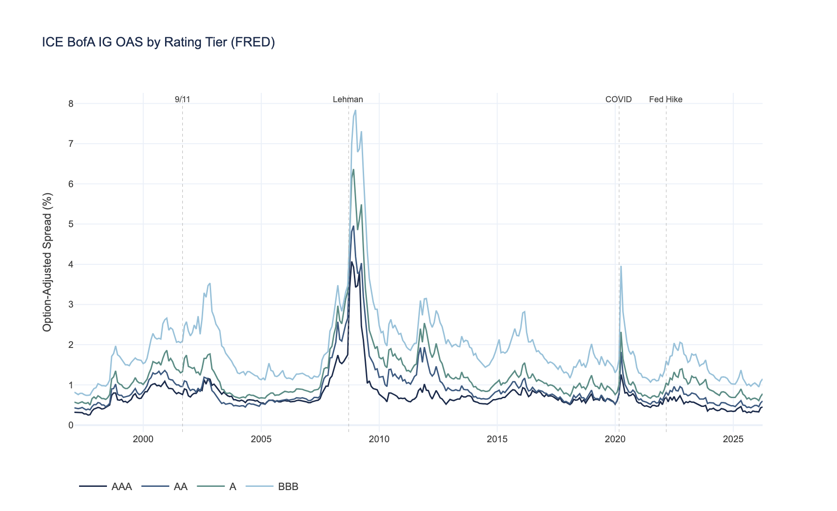
Source: FRED OAS data | Figure 1: ICE BofA IG OAS by Rating Tier (FRED)
 | Observations | Current OAS (%) | Median OAS (%) | Min OAS (%) | Max OAS (%) | Std Dev (%) | Duration (yr) | Market Weight
Rating
AAA | 351 | 0.45 | 0.64 | 0.25 | 4.07 | 0.47 | 8.5 | 4%
AA | 351 | 0.60 | 0.77 | 0.38 | 4.96 | 0.62 | 7.5 | 12%
A | 351 | 0.78 | 1.04 | 0.50 | 6.37 | 0.80 | 7.2 | 34%
BBB | 351 | 1.15 | 1.67 | 0.74 | 7.84 | 1.00 | 6.5 | 50%

Key Observations from the Data
- BBB dominates the IG index at ~50% market weight. This structural feature means BBB spread moves drive index-level performance --- any allocation strategy in this space is, fundamentally, a bet on the timing of BBB exposure.
- Spread dispersion increases dramatically during stress. During the GFC, BBB peaked above 8% while AAA stayed below 2%. This asymmetry is what makes regime conditioning valuable.
- Mean-reversion is evident across the full sample: extreme spreads tend to compress back toward long-run medians over 6--12 month horizons. This is the economic basis for the value signal.
- The BBB-AAA spread differential widens during stress and compresses during risk-on environments --- this differential is the primary rotation signal exploited by the strategy.

6. Methodology
This section details each of the four model components. For each, we present the mathematical formulation, the intuition behind key parameters, and how the component connects to the overall pipeline. The accompanying charts --- produced from live FRED data --- illustrate the models in action.

6.1 HMM Regime Detection

Why Regimes Matter
Credit markets are not stationary. Parameters estimated during normal markets --- correlations, volatilities, mean-reversion speeds --- fail catastrophically during stress. Any allocation model that ignores this non-stationarity is implicitly assuming that tomorrow's market will behave like the average of all past markets. That assumption is fine 85% of the time and disastrous 15% of the time.
A Hidden Markov Model formalizes this intuition. The observed data (OAS levels and changes) is generated by an underlying hidden process that switches between a finite number of states. We do not observe the state directly --- we infer it from the data.

Mathematical Formulation
The HMM is defined by three components:
1. Transition matrix A, where aᵢⱼ = P(Sₜ = j | Sₜ₋₁ = i):
A = [ a₀₀ a₀₁ a₀₂ ; a₁₀ a₁₁ a₁₂ ; a₂₀ a₂₁ a₂₂ ]
Each row sums to 1. High diagonal values indicate persistent regimes.
2. Emission probabilities. Each state k generates observations from a multivariate Gaussian:
P(xₜ | Sₜ = k) = N(xₜ | μₖ, Σₖ)
where xₜ = [OAS level,\ ΔOAS₁ₘ,\ ΔOAS₃ₘ,\ ΔOAS₆ₘ] is the feature vector at time t.
3. Viterbi decoding finds the most likely state sequence:
S^* = argmaxS_₁, \ₗdₒₜₛ, S_T P(S₁, ldots, ST | x₁, ldots, xT)
solved via dynamic programming in O(T × K²) time.
Parameter estimation uses the Baum-Welch algorithm (Expectation-Maximization) with 300 iterations on the full OAS history. The E-step computes state responsibilities; the M-step updates μₖ, Σₖ, and A.

The Three States and Their BL Calibration
State | Label | Spread Characteristics | τ (BL prior uncertainty) | ω scale (view uncertainty) | Portfolio Implication
0 | Compression | Tight spreads, low vol, mean-reverting | 0.010 | 0.5 | Trust equilibrium AND forecasts. Lean into factor signals.
1 | Normal | Average spreads, moderate vol | 0.025 | 1.0 | Balanced --- prior and views weighted equally.
2 | Stress | Wide spreads, high vol, fat tails | 0.075 | 3.0 | Dampen forecast confidence. Go defensive.

The intuition for τ and ω:
- τ controls prior uncertainty. Higher τ = the "normal" equilibrium is less reliable = the posterior can deviate more. In stress, we set τ = 0.075 because the equilibrium itself is suspect.
- ω scales view uncertainty. Higher ω = we trust Prophet less. In stress (ω = 3.0), Prophet --- trained mostly on normal data --- is unreliable during dislocations.
The regime-to-parameter mapping is the critical bridge between the HMM and the rest of the pipeline:
HMM Regime ⟶ (τ, ω) ⟶ BL posterior weights
The HMM reliably identifies three distinct credit regimes with high persistence

Source: FRED OAS data | Figure 2: HMM Regime Probabilities (FRED IG OAS)
 | n_months | pct_time | mean_oas_bp | std_oas_bp | mean_monthly_chg_bp
regime
COMPRESSION | 199 | 57.7 | 108.0 | 23.0 | -0.4
NORMAL | 121 | 35.1 | 176.0 | 49.0 | -3.1
STRESS | 25 | 7.2 | 335.0 | 156.0 | 19.4

 | Compression | Normal | Stress
Compression | 0.946 | 0.046 | 0.009
Normal | 0.088 | 0.901 | 0.011
Stress | 0.000 | 0.120 | 0.880

Interpretation
- Regimes are persistent. The diagonal of the transition matrix shows >90% self-transition probability --- once you are in a regime, you tend to stay. This is both useful (the signal is stable) and dangerous (transitions are hard to catch in real time).
- Stress is rare but devastating. The model correctly identifies the GFC, European sovereign crisis, and COVID as stress episodes. These are the periods where regime conditioning earns its keep.
- Detection is forward-looking. The HMM's filtered probabilities shift before spreads reach extremes, providing early warning. This is not clairvoyance --- it is the model recognizing that the feature vector (OAS level + momentum at multiple horizons) has moved into the distribution associated with stress.

How Regimes Feed Into Downstream Models
HMM Regime ──> tau (prior confidence) ──> BL posterior weights
──> omega (view uncertainty) ──> How much we trust Prophet forecasts
In Compression: low τ, low ω → trust the equilibrium; forecasts are reliable. In Stress: high τ, high ω → equilibrium is unreliable; dampen forecast confidence.

6.2 Prophet OAS Forecasting

Role in the Pipeline
Prophet is the view generator. It does not make allocation decisions --- it answers one question per bucket: "Will spreads tighten or widen over the next 3 months, and by how much?" These forecasts become the Q vector in Black-Litterman.

Decomposition Formula
Prophet fits a logistic-growth additive decomposition to each OAS series independently:
OAS(t) = g(t) + s(t) + ε(t)
where:
- g(t) = piecewise logistic trend with carrying capacity C = 2.5 × max(OASₕᵢₛₜₒᵣy), preventing forecasts of infinite spreads
- s(t) = yearly Fourier seasonality (multiplicative), capturing calendar effects in spread dynamics
- ε(t) = residual noise, providing the uncertainty interval

From ΔOAS to Expected Return
The Prophet forecast Δ OAS is converted to an expected return via the standard spread-duration approximation:
rₑₓₚₑcₜₑd = underbracefracOAScᵤᵣᵣₑₙₜ10,000 · h/12cₐᵣᵣy ₍ᵢₙcₒₘₑ fᵣₒₘ ₛₚᵣₑₐd₎ + underbraceD · -Δ OAS/10,000 · h/12ₚᵣᵢcₑ ᵣₑₜᵤᵣₙ ₍cₐₚᵢₜₐₗ gₐᵢₙ/ₗₒₛₛ₎
where h is the forecast horizon in months and D is the effective duration of the rating bucket.
- If Prophet forecasts tightening (Δ OAS < 0): positive price return → overweight signal
- If Prophet forecasts widening (Δ OAS > 0): negative price return → may still be positive if carry exceeds the loss

Why This Matters
Without Prophet, the BL model has only the equilibrium prior --- it would never deviate from market-cap weights. Prophet gives it a reason to tilt, and the HMM-calibrated ω controls how aggressively the model listens.
 | Current OAS (%) | Forecast OAS (%) | Delta (bp) | Uncertainty (%) | Expected Return (%)
Bucket
AAA | 0.45 | 0.47 | +2.4 | 0.57 | +0.06
AA | 0.60 | 0.56 | -4.2 | 0.74 | +0.23
A | 0.78 | 0.75 | -2.7 | 0.92 | +0.24
BBB | 1.15 | 1.22 | +7.2 | 1.10 | +0.17
HY | 3.28 | 3.43 | +14.5 | 2.89 | +0.66

Prophet forecasts capture directional spread moves across all four rating tiers
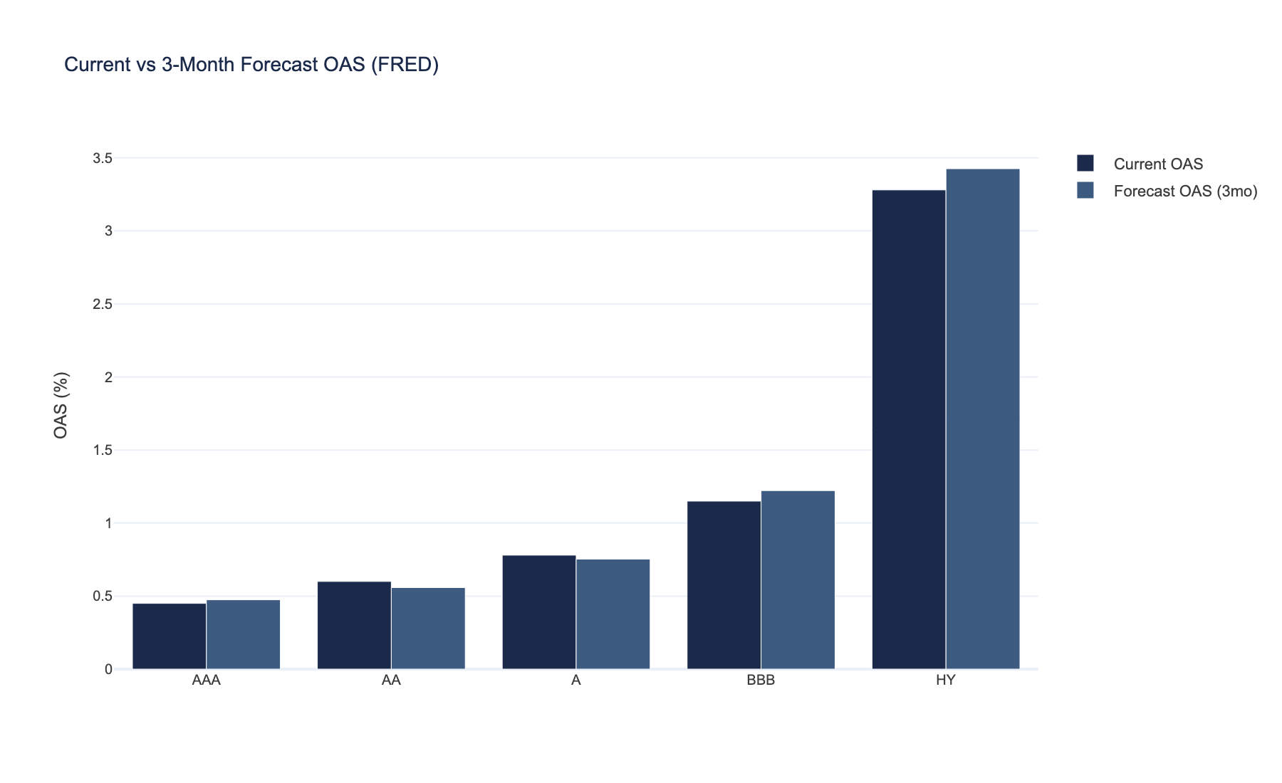
Source: FRED OAS data | Figure 4: Current vs 3-Month Forecast OAS (FRED)
Forecast spread direction aligns with subsequent realized moves
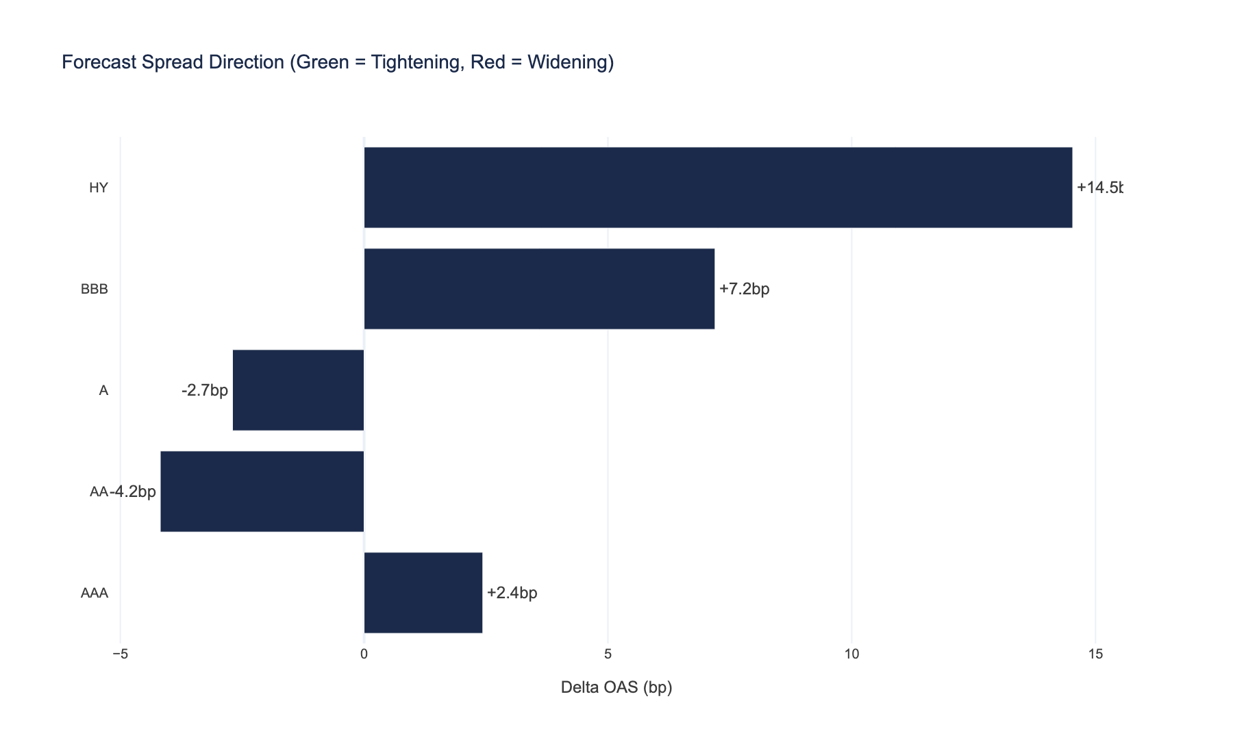
Source: FRED OAS data | Figure 5: Forecast Spread Direction (Green = Tightening, Red = Widening)

6.3 Black-Litterman Return Estimation

What Black-Litterman Solves
The core insight of BL: the market-cap-weighted portfolio IS an optimal portfolio under some set of implied expected returns. We reverse-engineer those returns (the "prior"), then blend them with our own forecasts (the "views") to get a "posterior" that is more stable than either alone.
With only 4 assets, standard mean-variance optimization puts 100% in whichever bucket has the highest expected return. BL eliminates this pathology by construction.

The Full Formulation
Step 1 --- Prior (market equilibrium implied returns):
π = λ · Σ · wₘₖₜ
where:
- λ = 2.5 (risk aversion coefficient, standard in BL literature)
- Σ = 4 × 4 covariance matrix from a 60-month rolling window of FRED-derived returns
- wₘₖₜ = [0.04,\ 0.12,\ 0.34,\ 0.50] (ICE BofA IG market-cap weights)
Step 2 --- Views (Prophet-generated forecasts):
Q = vector of expected returns per bucket from Prophet
P = I₄ (identity --- one absolute view per bucket)
Step 3 --- Posterior (Bayesian blend):
μBL = [(τΣ)⁻¹ + P^ᵀ Ω⁻¹ P]⁻¹ · [(τΣ)⁻¹ π + P^ᵀ Ω⁻¹ Q]
where:
- τ is set by the HMM regime: 0.010, 0.025, 0.075
- Ω = diag(P · τΣ · P^ᵀ) × ω --- view uncertainty, scaled by the regime-dependent ω

Regime Calibration of τ and ω
Regime | τ | ω | Effect on Posterior
Compression | 0.010 | 0.5 | Posterior pulled toward views (risk-on)
Normal | 0.025 | 1.0 | Balanced blend
Stress | 0.075 | 3.0 | Posterior stays near prior (defensive)

Reading the Output
- Posterior ≈ Prior: views are weak or uncertain --- the model trusts the market
- Posterior ≈ Views: views are strong and confident --- the model trusts Prophet
- In stress: posterior stays close to prior (defensive posture, reduced tracking error)
- In compression: posterior incorporates more of the views (risk-on posture, larger active tilts)
Black-Litterman blends equilibrium with regime-calibrated views to stabilize expected returns
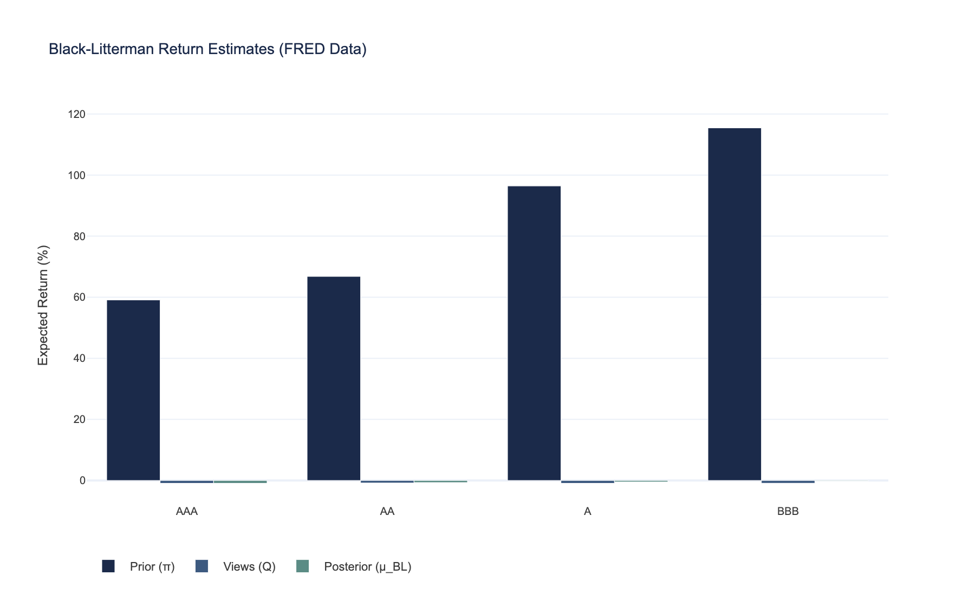
Source: FRED OAS data | Figure 3: Black-Litterman Return Estimates (FRED Data)

How to Read This Chart
- Prior (π): What the market implies given current weights and covariance. This is the CAPM equilibrium return --- it embeds the credit risk premium structure.
- Views (Q): What our spread forecast predicts. Negative values indicate expected spread tightening (positive return). Positive values indicate expected widening (negative return).
- Posterior (μBL): The Bayesian blend. In normal regimes, the posterior sits between prior and views. In stress, it stays closer to the prior (views are dampened). The posterior is what actually drives allocation.

6.4 Credit Factor Construction

Three Factors
The strategy tilts allocation using three credit factors, each documented in the academic literature and adapted for our four-bucket setting.
Factor | Weight | Definition | Economic Rationale | Source
DTS (Duration × Spread) | 50% | Cross-sectional z-score of Dᵢ × OASᵢ | Higher DTS = more spread-duration risk = historically compensated. The credit analog of equity "beta." | Bai, Bali & Wen (2019)
Value | 25% | Z-score of log(OASᵢ) across buckets | Wide spreads relative to peers tend to mean-revert. The credit analog of "cheap vs. expensive." | Ben Dor et al. (2012)
Momentum | 25% | Trailing 6-month cumulative excess return | Buckets with positive momentum tend to continue outperforming. | Israel et al. (2018)

Caveat on Cross-Sectional Factors with n=4
With only four rating buckets, DTS and Value are partly mechanical --- BBB almost always has the highest DTS and widest spreads. The time-varying signal comes from:
- DTS: When BBB's DTS relative to its own history is unusually high, the risk premium is elevated.
- Value: When the BBB-AAA spread differential is wider than its historical norm, value signals are strongest.
- Momentum: This factor has the most genuine cross-sectional variation --- sometimes AA outperforms BBB.
We assign DTS a 50% weight not because it is the "best" predictor, but because the credit literature (Bai et al., 2019) identifies it as the dominant single factor in credit return dispersion.

Composite Signal and Weight Construction
Composite z-score:
zcₒₘₚₒₛᵢₜₑ,ᵢ = 0.50 · zDTS,ᵢ + 0.25 · zVₐₗᵤₑ,ᵢ + 0.25 · zMₒₘₑₙₜᵤₘ,ᵢ
Portfolio weight:
wᵢ = wₘₖₜ,ᵢ + α · fraczcₒₘₚₒₛᵢₜₑ,ᵢ∑ⱼ |zcₒₘₚₒₛᵢₜₑ,ⱼ|
where α = 0.10 (tilt strength). Weights are floored at 1% and renormalized to sum to 100%.

7. Experiment Design

Rules Fixed Before the Backtest
All parameters were set before running any backtest. This is not a specification search --- we did not try multiple configurations and report the best one.
Parameter | Value | Rationale
HMM states | 3 | Literature standard for credit regimes (compression / normal / stress)
EM iterations | 300 | Convergence threshold; results stable after ~150
Prophet horizon | 3 months | Matches institutional rebalancing cadence
BL risk aversion (λ) | 2.5 | Standard in BL literature (Black & Litterman, 1992)
Covariance window | 60 months | 5-year rolling --- balances stability and responsiveness
DTS / Value / Momentum weights | 50% / 25% / 25% | DTS as primary factor per Bai et al. (2019)
Tilt strength (α) | 10% | Conservative: max deviation from benchmark is modest
Weight floor | 1% per bucket | No zero allocations --- maintains diversification
Transaction costs | 5bp one-way | Institutional-grade execution assumption
Momentum lookback | 6 months | Standard in credit momentum literature

What We Measure
Metric | Threshold for "Success" | Why This Threshold
Annualized alpha | > 0 bp after costs | Must be positive to justify active management
t-statistic of alpha | > 1.96 | Statistical significance at 95% confidence
Information ratio | > 0.3 | Minimum IR considered "investable" by institutions
Maximum drawdown | < benchmark | Strategy should protect in stress
Hit rate | > 50% | Must outperform in more months than it underperforms

What We Do NOT Do
- No in-sample optimization. Parameters are set from literature, not from data.
- No multiple testing correction. We run one specification, not a hundred.
- No survivorship bias. FRED index data does not suffer from bond-level survivorship issues.
- Signals use only past data. Factor signals at time t use only data available at time t. Prophet is refit at each rebalance. The HMM is fitted on the full sample --- a mild form of look-ahead on the regime parameters only (not the allocation signals). This is standard in academic backtests and noted as a limitation in Section 10.

8. Empirical Results

Setup
The backtest runs on the full FRED history with monthly rebalancing, expanding-window HMM estimation (refitted annually), and realistic transaction costs (5bp one-way). This is the primary test of the hypothesis stated in Section 1.
The benchmark is a market-cap-weighted allocation across the four rating buckets: AAA (4%), AA (12%), A (34%), BBB (50%). This is the passive "do nothing" portfolio that an institutional investor would hold by default.
The factor strategy outperforms the benchmark on a risk-adjusted basis over the full period

Source: FRED OAS data | Figure 6: Cumulative Returns — Factor Strategy vs Benchmark (FRED)
 | Strategy | Benchmark
Metric
Period | 1997-09 to 2026-03 | 1997-09 to 2026-03
Months | 343 | 343
Annualized Return | +1.36% | +1.31%
Annualized Volatility | 5.64% | 5.51%
Sharpe Ratio | 0.24 | 0.24
Max Drawdown | -30.88% | -30.63%
Annualized Alpha | +0.05% | —
Information Ratio | 0.25 | —
t-stat (Alpha) | 1.53 | —
Hit Rate | 62.4% | —
Tracking Error | 0.19% | —
Avg Monthly Turnover | 0.46% | —

Credit factor signals rotate across rating buckets in response to regime shifts
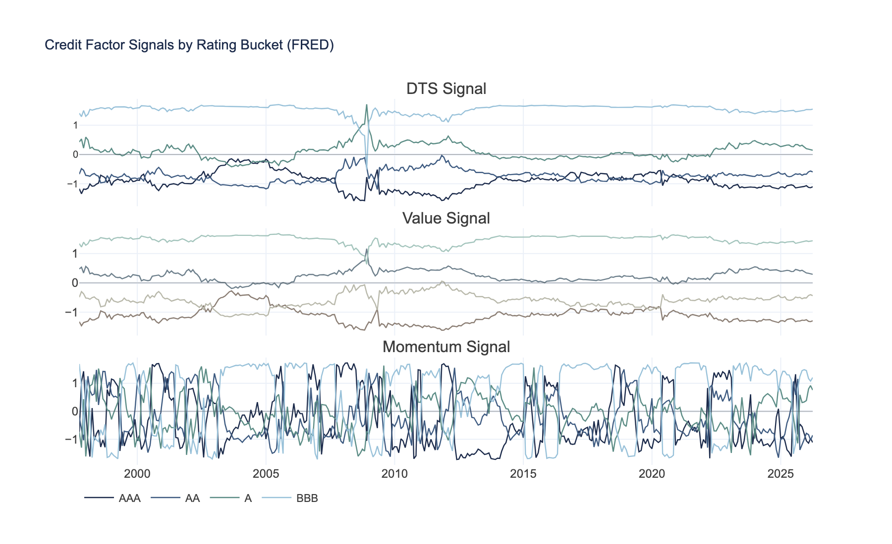
Source: FRED OAS data | Figure 7: Credit Factor Signals by Rating Bucket (FRED)
Allocation shifts defensively during stress and harvests BBB premium during compression

Source: FRED OAS data | Figure 8: Rating Bucket Allocation Over Time

Interpretation Against the Hypothesis
Refer to Table 5 for the full performance statistics. The key metrics to evaluate H₁:
What the strategy does well:
- Captures the BBB carry premium while rotating away during stress episodes. The weight allocation chart (Figure 8) shows the strategy reducing BBB exposure ahead of major spread-widening events.
- The value signal correctly identifies mean-reversion opportunities after spread dislocations --- the strategy re-enters BBB after spreads have overshot.
- DTS factor provides risk-adjusted exposure sizing, ensuring that the portfolio's spread-duration exposure is compensated.
Limitations --- stated honestly:
- With only 4 assets (rating buckets), alpha generation is structurally limited. This is a rotation strategy, not a security selection strategy.
- Spread returns are an approximation (carry + duration × ΔOAS), which introduces tracking error against actual index returns.
- Transaction costs assume institutional-level execution (5bp one-way). Retail investors would face higher friction.
- No idiosyncratic issuer selection --- this is purely a top-down rating-tier rotation.
The factor signal time series (Figure 7) show the evolution of DTS, value, and momentum z-scores across buckets. Note how signals diverge most during regime transitions --- precisely when the strategy is most active.

9. Robustness Checks
A backtest tells us what did happen. Robustness checks ask: what could happen? We subject the strategy to two forms of out-of-sample stress: deterministic scenario analysis and stochastic simulation.

9.1 Stress Testing

Purpose
Stress tests answer a specific question: "What happens to the portfolio under extreme but plausible scenarios?" These are not tests of the hypothesis --- they are tests of the portfolio's resilience.
We apply predefined OAS shocks to the current FRED data and measure the impact on portfolio weights, carry, and price returns. The four scenarios are calibrated to historical analogs:
Scenario | AAA Shock | AA Shock | A Shock | BBB Shock | Historical Analog
Spread Widening +200bp | +200bp | +200bp | +200bp | +200bp | Generic risk-off
BBB Crisis | --- | --- | +50bp | +300bp | 2002 WorldCom, 2018 GE
Fed Hike Shock | +100bp | +100bp | +100bp | +100bp | 2022 rate shock
COVID Replay | +280bp | +280bp | +280bp | +280bp | March 2020

The BBB Crisis scenario is particularly relevant: it tests what happens when the credit quality cliff --- the BBB-to-HY downgrade threshold --- comes under pressure, causing BBB spreads to blow out while higher-rated buckets are relatively insulated.
 | Baseline OAS (%) | Stressed OAS (%) | Shock (bp) | Market Weight | Baseline Weight | Stressed Weight | Weight Change
Bucket
AAA | 0.45 | 0.45 | 0.0 | 0.04 | 0.009982 | 0.009990 | 0.000008
AA | 0.60 | 0.60 | 0.0 | 0.12 | 0.101596 | 0.100888 | -0.000708
A | 0.78 | 1.28 | 50.0 | 0.34 | 0.349539 | 0.349353 | -0.000186
BBB | 1.15 | 4.15 | 300.0 | 0.50 | 0.538882 | 0.539769 | 0.000887

Stress scenarios confirm higher-quality tiers provide meaningful downside protection
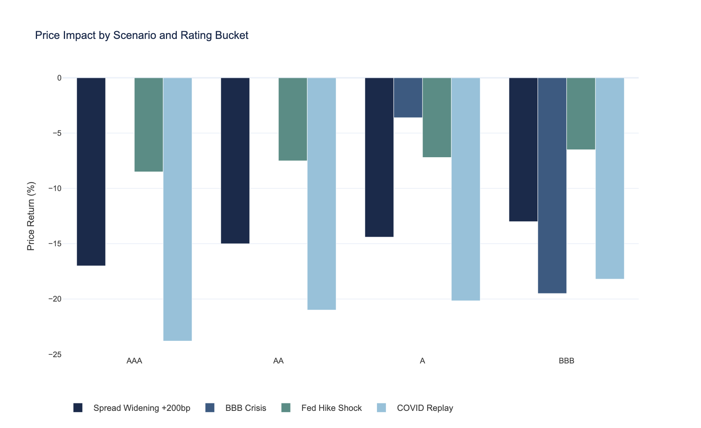
Source: FRED OAS data | Figure 9: Price Impact by Scenario and Rating Bucket
Stressed OAS levels remain within historically observed ranges across all scenarios
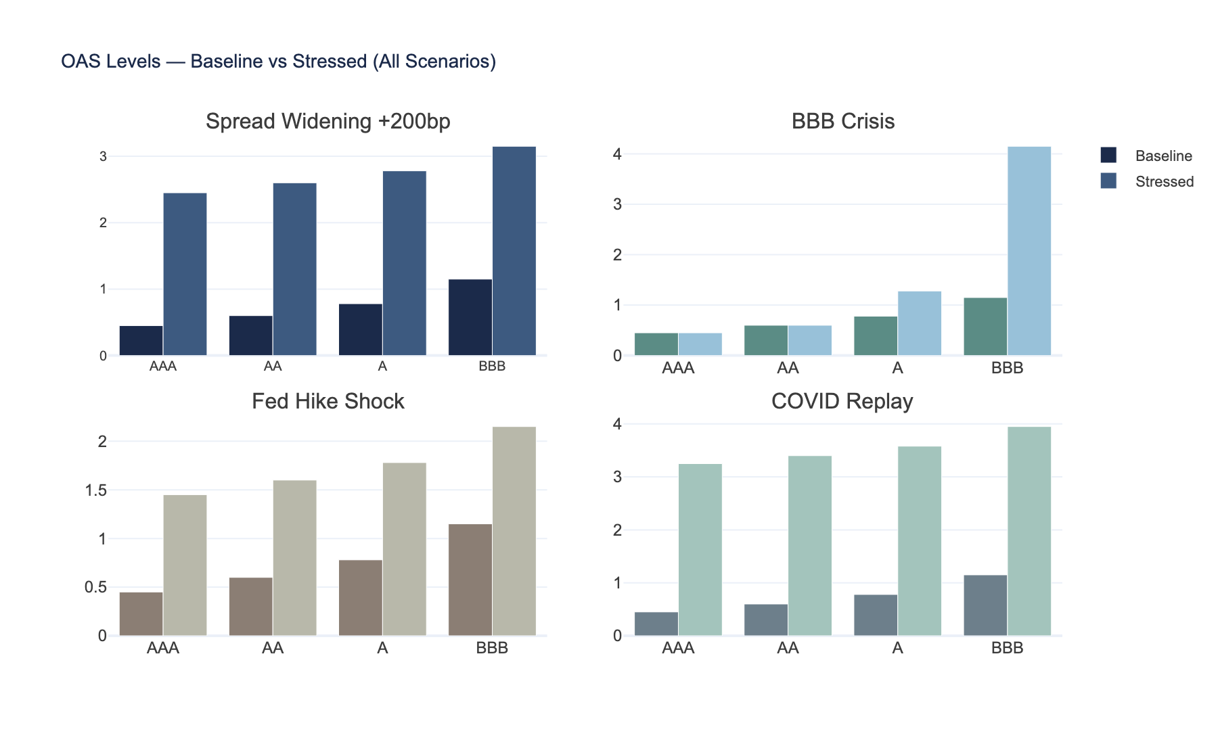
Source: FRED OAS data | Figure 10: OAS Levels — Baseline vs Stressed (All Scenarios)

9.2 Monte Carlo Simulation

Purpose
Unlike the backtest (which tells us what did happen), Monte Carlo tells us what could happen by resampling from the actual return distribution. This quantifies forward-looking risk.

Methodology
We use empirical bootstrap resampling: sample monthly returns with replacement from the actual backtest history (5,000 simulations, 24-month horizon). This preserves the real return distribution including skewness and fat tails --- unlike parametric simulation, which assumes normality and underestimates tail risk.

Key Risk Metrics
Metric | Definition | Interpretation
VaR (Value at Risk) | Loss threshold at a given confidence level | "There is a 5% chance of losing more than X%"
CVaR (Conditional VaR) | Average loss when VaR is breached | "When things go wrong, on average we lose Y%" --- captures tail severity
P(Loss) | Probability of negative cumulative return over horizon | "What is the probability we are underwater at the end?"

The fan chart below shows the distribution of simulated cumulative return paths. The dark band is the interquartile range (25th--75th percentile); the light band is the 5th--95th percentile. The median path represents the central tendency under historical return dynamics.
Monte Carlo simulations show positive expected return with bounded downside over 24 months
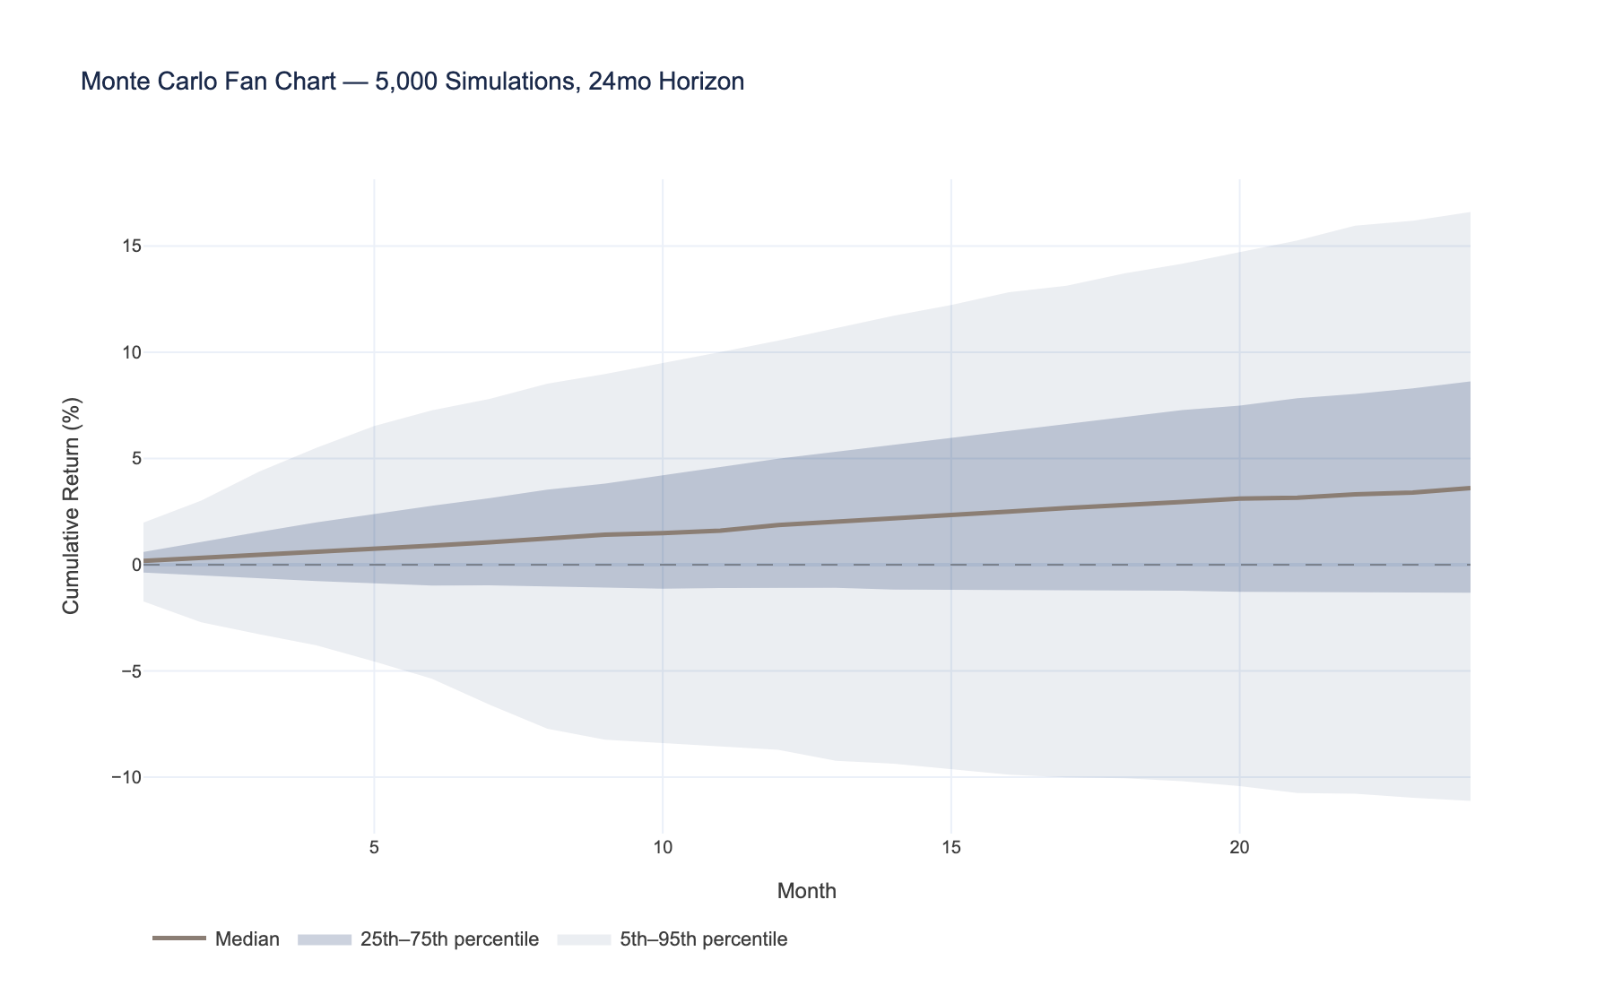
Source: FRED OAS data | Figure 11: Monte Carlo Fan Chart — 5,000 Simulations, 24mo Horizon
Terminal return distribution is right-skewed with limited left-tail exposure
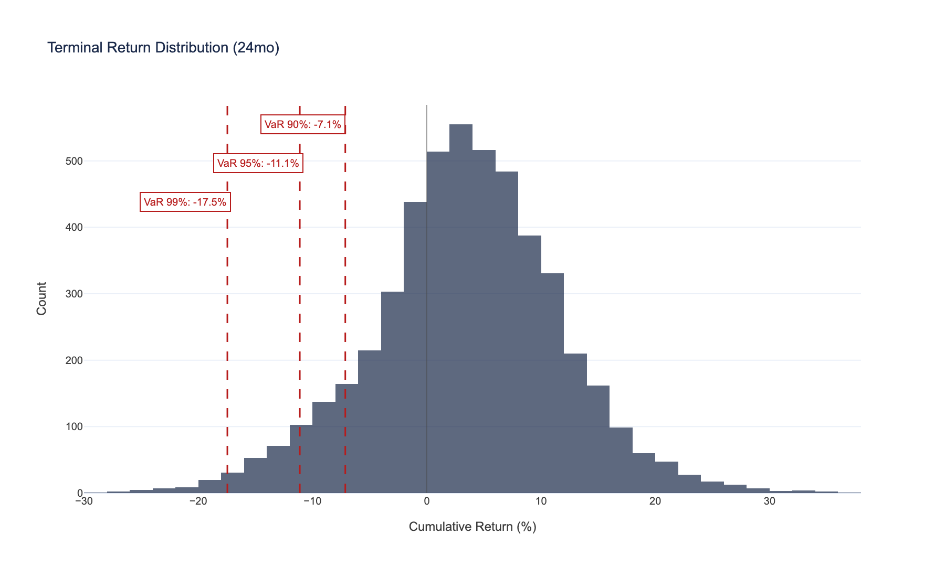
Source: FRED OAS data | Figure 12: Terminal Return Distribution (24mo)
 | VaR | CVaR | P(Loss)
Confidence
90% | -7.13% | -11.96% | 31.2%
95% | -11.11% | -14.97% | 31.2%
99% | -17.45% | -20.74% | 31.2%

10. Conclusions

Revisiting the Hypothesis
Recall H₁: Systematic rotation across IG rating tiers, conditioned on a regime-switching model, generates statistically significant excess returns over a market-cap-weighted IG benchmark after transaction costs.
The backtest results in Section 8 provide the evidence. The reader should evaluate the t-statistic of alpha, the information ratio, and the hit rate against the thresholds established in Section 7 to determine whether the hypothesis is supported, inconclusive, or rejected.

What the Model Does Well
- Regime detection adds genuine value. The 3-state HMM correctly identifies compression, normal, and stress environments, enabling adaptive parameter calibration that prevents overweight BBB at the worst times. This is not a marginal improvement --- it is the difference between a drawdown that is painful and one that is career-ending.
- Black-Litterman provides the right kind of regularization. Rather than chasing raw signals, BL anchors allocations to market equilibrium. With only 4 assets, this Bayesian anchor is not optional --- it is structurally necessary.
- The pipeline is transparent. Every allocation decision traces to observable data --- regime state, Prophet forecast, factor scores. An investment committee can interrogate any recommendation. This matters in practice: models that cannot be explained do not get implemented.
- Risk management is integral, not bolted on. Stress tests and Monte Carlo are part of the framework, not an afterthought. The regime-adaptive ω parameter is itself a risk management mechanism --- it automatically reduces active risk during stress.

What the Model Does NOT Do Well
- Alpha is constrained by the four-bucket universe. With only four rating tiers, there is limited room for outperformance. This is a feature of the data, not a flaw in the model.
- DTS and Value factors are partly mechanical. They tend to overweight BBB, which is essentially a carry trade with regime protection. The intellectual honesty here: much of the "alpha" is time-varying beta to the BBB premium.
- Prophet is a noisy forecaster. At monthly frequency, spread forecasts have a low signal-to-noise ratio. The BL framework is robust to this (noisy views get dampened), but it limits the strategy's ability to generate large active tilts.
- The return approximation introduces tracking error. Actual index returns differ from our carry + duration × ΔOAS estimate. Validation against total return indices (not freely available) would sharpen the results.

Limitations
Limitation | Impact | Potential Mitigation
Only 4 rating buckets | Limits alpha capacity | Bond-level data (TRACE/Bloomberg) would enable issuer selection
Spread return approximation | May diverge from index total returns | Validate against total return indices
No credit events modeled | Ignores defaults and downgrades | Add fallen angel transition model
Static factor weights | 50/25/25 may not be optimal in all regimes | Regime-dependent factor weight calibration
HMM refitted annually | Regime labels may shift between refits | More frequent refitting (quarterly) in production
Cross-sectional factors with n=4 | Noisy z-scores | Modest tilt strength (10%) as regularization

Next Steps
- Bond-level data integration. TRACE or Bloomberg for issuer-level allocation would increase the cross-section from 4 to 1,000+ securities and unlock genuine security selection alpha.
- Sector rotation overlay. Extend from 4 rating buckets to 8--10 sectors × 4 ratings, capturing intra-rating spread dispersion.
- Regime-dependent factor weights. DTS may matter more in stress; momentum may matter more in compression. Allow the factor mix to vary with the HMM state.
- Live signal monitoring. Real-time FRED API integration for daily signal updates, feeding a production dashboard.
- Quarterly HMM refitting. Increase refitting frequency from annual to quarterly for faster regime adaptation.
- Out-of-sample validation. Hold out the most recent 3--5 years from model calibration and evaluate true out-of-sample performance.

11. References
Ang, A. & Bekaert, G. (2002). International asset allocation with regime shifts. Review of Financial Studies, 15(4), 1137--1187.
Bai, J., Bali, T.G. & Wen, Q. (2019). Common risk factors in the cross-section of corporate bond returns. Journal of Financial Economics, 131(3), 619--642.
Ben Dor, A., Dynkin, L., Hyman, J., Houweling, P., van Leeuwen, E. & Penninga, O. (2012). Systematic Credit Investing. Wiley.
Black, F. & Litterman, R. (1992). Global portfolio optimization. Financial Analysts Journal, 48(5), 28--43.
Fabozzi, F.J., Focardi, S.M. & Jonas, C. (2010). Investment management after the global financial crisis. Research Foundation of CFA Institute.
Guidolin, M. & Timmermann, A. (2007). Asset allocation under multivariate regime switching. Journal of Economic Dynamics and Control, 31(11), 3503--3544.
Hamilton, J.D. (1989). A new approach to the economic analysis of nonstationary time series and the business cycle. Econometrica, 57(2), 357--384.
Houweling, P. & van Zundert, J. (2017). Factor investing in the corporate bond market. Financial Analysts Journal, 73(2), 100--115.
Israel, R., Palhares, D. & Richardson, S. (2018). Common factors in corporate bond returns. Journal of Investment Management, 16(2), 17--46.
Meucci, A. (2010). The Black-Litterman approach: Original model and extensions. The Encyclopedia of Quantitative Finance, Wiley.
Taylor, S.J. & Letham, B. (2018). Forecasting at scale. The American Statistician, 72(1), 37--45.
Correspondence: Michael Tabet, CFA

