

New York University

Computer Science Department

Introduction to Software Development

**Homework#0**

**Deadline:** *5:00pm, September 12th, 2015*

**Note:** Please use the following naming convention “ExerciseX.java”, where X is the number of the exercise. Please apply this convention to all coming homework assignments during the semester. Also please attach the snapshots of you code and the output in the same word document where your provide answer to exercise 4 and 5.

Guidelines:

* Compile and run the program for each exercises.
* Make an archive with all the **java files** and post it on NYU Classes (Homework_X.zip)
* Please **do not send the entire project**, the Java file for each exercise is all that we need.
* Attach a word document with answers to the questions of Exercise 5,6 and the .

Exercise 0. (10pts) Write a computer program that displays your first name and your major (each in a separate line) to the screen.

Exercise 1(10pts) Write a java program that display the result of

1+2+3+4+5+6+7+8+9

Exercise 2 (10pts) Write a java program that display the following table to the screen:

A B C

1 5 9

8 7 9

1 6 0

1 7 9

Exercise 3(10pts)

Exercise 1.5 from the book page 30th (10th edition) – Compute Expression.

Exercise 4 (20pts)

Answer the following questions in your own words:

* + What is a computer? and what are the main component of computer hardware?
  + Explain the compilation process.
  + What is the difference between an interpreter and a compiler?
  + What is Java Virtual Machine?
  + Define the following terms:
* High level Language
* Machine Language
* Software Development
* Programming
* Algorithm
* Integrated Development Environment

Exercise 5 (20pts)

Find the compilation errors on the following programs:

**5.1)**

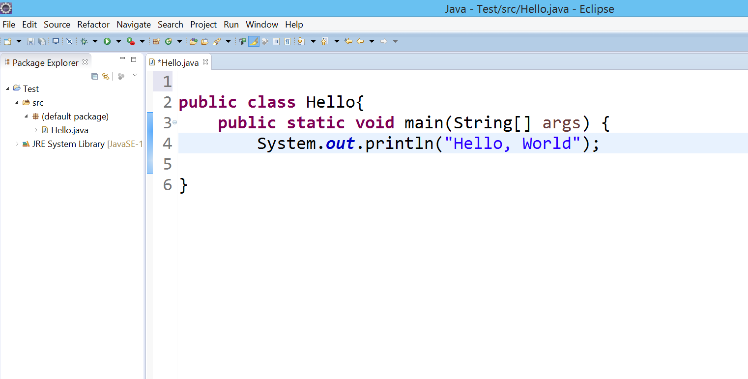

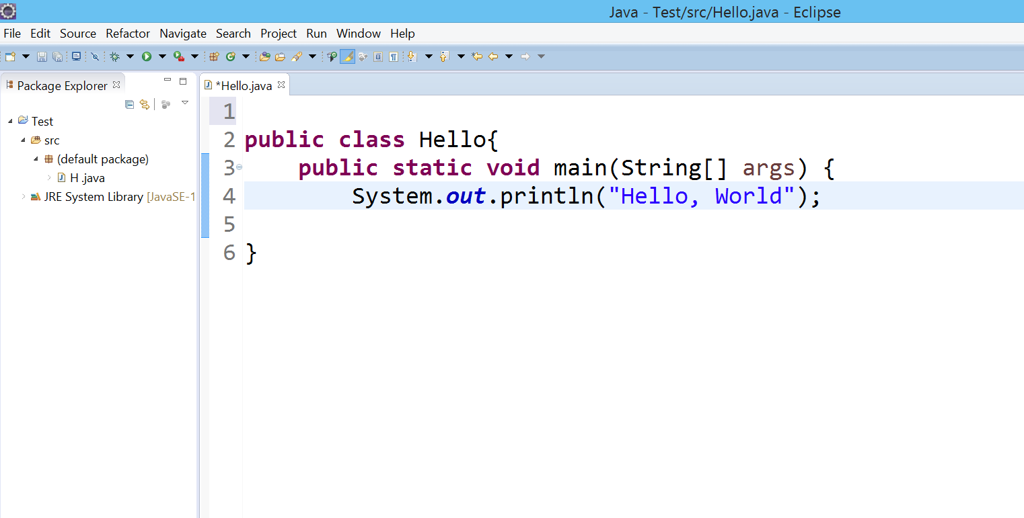**5.2)**

**5.3)**

