Final Year Project Proposal
Michael Dee – K00298934
Technological University of the Shannon – Midwest
BSc. Mobile and Web Computing – Year 4
Indoor AR-Based Mobile Application for Campus Room Navigation Using Marker-Based Positioning and Visual Directional Overlays

Table of Contents
Project Title 3
Abstract 3
Research Context / Background 3
Research Aim(s) 6
Research Objectives 6
Process Flow Diagram 7
Research Questions 8
Proposed Technologies Used 9
System Architecture Diagram 10
Research Methods 11
Bibliography 12

Project Title
Indoor AR-Based Mobile Application for Campus Room Navigation Using Marker-Based Positioning and Visual Directional Overlays

Abstract
This project proposes the design and development of an indoor augmented reality (AR)-based mobile application to help students and visitors navigate to specific rooms within a TUS Moylish campus. Because GPS positioning is unreliable indoors (Bhorkar, 2017), the application will instead use marker-based AR positioning: the user scans a printed AR marker or QR code at the building entrance to anchor an AR session, after which the phone's camera and AR Foundation/ARCore tracking are used to follow the user's movement relative to that anchor point (Gowtham et al., 2025). The application will display visual directional overlays, such as AR arrows, superimposed on the camera view to guide the user to a selected room, supported by optional voice-directed audio prompts.
The core prototype will be scoped to the main building and a small set of rooms, to keep marker placement, floor-plan measurement, and testing manageable within an academic year. A 2D floor-plan fallback view will be provided for situations in which AR guidance is unavailable or unsuitable. As a stretch objective, the project will investigate extending the same directional-overlay approach outdoors, using live GPS positioning to guide users between key campus buildings, with a conventional map-based fallback built using the Google Maps SDK for Android.

Research Context / Background
The TUS Moylish campus contains multiple buildings, and within them, rooms and offices that may be unfamiliar to new students, visitors, and staff. Conventional digital maps can show a building's location, but they typically stop at the building's entrance and do not help a visitor find a specific room once inside. This can make navigation to a lecture room, office, or lab more difficult, particularly for people unfamiliar with a building's internal layout.
Augmented reality provides an alternative way of presenting navigation information by placing digital visual information directly within the user's view of the physical environment, rather than requiring a separate mental translation from a 2D map or floor plan (Azuma, 1997). A systematic review of AR wayfinding research found that AR-based guidance can reduce cognitive load and improve the development of an accurate mental map of an environment, compared with traditional map-based guidance (Qiu, Mostafavi and Kalantari, 2025). In this project, AR directional overlays will be explored as a method of guiding users to a specific room, rather than only to a building.
The proposed system focuses on indoor navigation, where GPS is not a reliable source of position because building structures attenuate satellite signals (Bhorkar, 2017). Marker-based positioning — in which a printed AR marker or QR code at a known location is scanned to anchor the AR session, after which the device's camera and inertial sensors track relative movement — is a well-established approach to this problem in the research literature (Bhorkar, 2017; Qiu, Mostafavi and Kalantari, 2025) and has been shown to work well when implemented with Unity, AR Foundation, and QR code localisation on mobile devices (Gowtham et al., 2025). This project will adopt the same general approach, tailored to a defined pilot set of rooms within a single TUS Shannon building.
This project combines aspects of mobile computing, indoor positioning, and augmented reality. The main technical challenge is to develop a prototype that provides accurate and understandable room-level guidance while recognising the practical limitations of marker-based tracking, such as drift over distance and the need for a device to see a marker before it can anchor its position.

Related Focus and Current Issues
Current mobile navigation applications commonly rely on maps and location markers rather than in-view directional guidance. AR navigation has the potential to make route guidance more intuitive by presenting directional information in the user's view of the real world (Azuma, 1997). For indoor environments specifically, existing research categorises AR positioning approaches into three main groups: marker-based systems, which use QR codes or similar fiducials to anchor tracking; beacon-based systems, which rely on installed Bluetooth or Wi-Fi hardware; and markerless approaches based on Simultaneous Localization and Mapping (SLAM) (Bhorkar, 2017). Marker-based systems offer the simplest deployment, since they need no additional hardware beyond a printed marker, though they can be less robust in cluttered or dynamic spaces.
This project will investigate these issues in the context of a single TUS Moylish main building rather than attempting to solve general-purpose, multi-building indoor navigation. Limiting it to a small, defined set of rooms will allow the marker placement, tracking accuracy, and user experience to be evaluated within a manageable scope for an academic year.
The research will compare the strengths of marker-based AR guidance with the TUS Interactive Campus Map's existing, static, click-based approach to room-level directions (Technological University of the Shannon, n.d.), and will consider the circumstances in which each approach is most useful. The outcome will be a working Android prototype and an evaluation of how effectively AR overlays, anchored using a scanned marker and supported by optional voice-directed prompts, can guide users to specific rooms within a campus building.

Existing Systems and Positioning of This Project
Several comparable systems already exist, and this project has been scoped with reference to them so that it adds something genuinely new rather than reproducing an existing solution.
TUS itself provides an Interactive Campus Map through its website, which allows students and visitors to find directions to a specific room or building (Technological University of the Shannon, n.d.). This tool is a 2D, click-based interface: the user selects a start point and destination on a map, and a route is drawn. It does not track the user's live position once they are inside a building, does not update guidance in real time as they move, and does not present directions from the user's own point of view. This project differs from it by anchoring an AR session to a scanned marker at the building entrance and rendering directional guidance as AR overlays on the camera feed, continuously updated as the user walks, rather than as a static route on a map.
Academic research on marker-based indoor AR navigation provides a strong technical precedent for this approach. A recent study built a comparable indoor AR navigation system using Unity, AR Foundation and QR code localisation, tested with 45 users in a multi-storey university building; it reported an average positioning accuracy of 1.2 metres, a 92% successful-arrival rate, and reductions in both navigation time and wayfinding errors compared with existing indoor navigation approaches (Gowtham et al., 2025). This project will follow a similar technical approach, adapted to the layout and rooms of the TUS Moylish main building, and will independently design, implement and test its own prototype rather than reusing code or content from this or any other existing system.
Comparable outdoor AR-navigation prototypes combining GPS and AR arrows, such as Google Maps Live View, have also been reviewed for context, since outdoor multi-building navigation forms this project's stretch objective (Google, n.d.-b). These systems, along with any other existing AR navigation projects reviewed during background research, were consulted only to identify gaps in existing approaches and to help scope this project's objectives and research questions; no code, design, or written material from any such project will be reused. and any external system referenced during the project will continue to be cited according to standard academic referencing conventions.

Research Aim(s)
The overall aim of this project is to design, develop and evaluate an indoor AR-based mobile navigation application that helps users locate specific rooms within a TUS Moylish campus building using marker-based positioning and visual directional overlays, supported by optional voice-directed prompts and a 2D floor-plan fallback, with outdoor multi-building GPS-based guidance as a stretch objective.

Research Objectives
1) Investigate existing approaches to indoor AR navigation, marker-based positioning, and institutional wayfinding tools (including the TUS Interactive Campus Map), in order to identify gaps this project can address.
2) Identify the functional and usability requirements for guiding users to specific rooms within a campus building.
3) Select a pilot building and a small set of rooms (approximately three to five) suitable for a marker-based AR navigation prototype, and produce a basic floor-plan/waypoint map of the relevant routes.
4) Design the architecture and user interface for an Android-based indoor room-navigation prototype.
5) Implement AR marker/QR code scanning to anchor the AR session at a known starting point, such as the building entrance.
6) Implement in-building route calculation from the anchor point to a selected room, using a simple waypoint graph of the pilot building.
7) Develop AR visual directional overlays, such as arrows, to guide users towards a selected room based on tracked movement from the anchor point.
8) Provide a 2D floor-plan fallback view for use when AR guidance is unavailable or unsuitable.
9) Provide optional voice-directed (audio) turn/direction prompts alongside the AR visual overlays, to increase accessibility and reduce reliance on constantly viewing the screen.
10) Test the prototype in the pilot building and evaluate positioning accuracy, usability and technical limitations, such as tracking drift.
11) Analyse the results and identify recommendations for future development and improvement.
12) (Stretch objective, time permitting) Extend the application outdoors, using live GPS positioning and a Google Maps SDK-based fallback to guide users between key campus buildings, reusing the AR overlay and voice-prompt design developed for the indoor prototype.

Research Questions
Marker-Based AR Positioning:
1) How can a scanned AR marker or QR code be used to reliably anchor an AR session at a known indoor starting point?
2) What system architecture is suitable for combining marker-based anchoring with continuous AR device tracking (ARCore/AR Foundation) to follow a user's movement indoors?
3) How much does tracked position drift from the true position as a user moves further from the last scanned marker, and what does this mean for marker placement within a building?
Indoor Wayfinding and AR Overlay Design:
4) How can directional information be represented as visual AR overlays that are understandable to users navigating indoors?
5) What in-building route-calculation approach (e.g. a simple waypoint graph) is suitable for guiding users from an entrance to a specific room?
Voice-Directed Guidance:
6) To what extent does adding voice-directed audio guidance alongside AR visual overlays improve the usability of indoor room navigation?
Comparison with Existing Navigation Tools:
7) How effectively can marker-based AR room navigation support users compared with the college's existing, static, click-based interactive map?
8) What usability and navigation difficulties do users experience when finding a specific room in an unfamiliar building?
9) How accurate and useful is the prototype when guiding users to selected rooms?
10) In what situations is the 2D floor-plan fallback preferable to AR guidance?
Stretch Objective: Outdoor Extension:
11) What would be required to extend the marker-anchored AR overlay and voice-prompt design developed indoors to GPS-based outdoor guidance between key campus buildings?

Proposed Technologies Used
1) Unity – to develop the AR-based mobile application prototype and manage 3D directional content (Unity Technologies, n.d.-a).
2) AR Foundation – to provide a framework for building augmented reality features that can work with supported AR platforms, including image/marker tracking (Unity Technologies, n.d.-a).
3) ARCore – to provide Android augmented reality capabilities and device/environment tracking used to follow the user's movement after a marker is scanned (Google, n.d.-a).
4) AR Foundation Image Tracking (ARTrackedImageManager) – to detect and recognise the printed AR marker/QR code at the building entrance and anchor the AR session to that known position (Gowtham et al., 2025).
5) Android Studio – supports Android project development, configuration, testing and deployment (Android Developers, n.d.-a).
6) Android Text-to-Speech (TTS) – to generate the optional voice-directed audio prompts that accompany the AR visual overlays.
7) Unity UI (floor-plan fallback) – to display a simple 2D floor-plan view with a "you are here" marker when AR guidance is unavailable or unsuitable; built directly in Unity rather than a separate mapping SDK, since it only needs to show a static, pre-drawn plan of the pilot building.
8) (Stretch objective) Android / Google location services and GPS – to obtain the user's approximate outdoor position for the multi-building extension (Android Developers, n.d.-b).
9) (Stretch objective) Google Maps SDK for Android – to build a conventional map-based fallback for the outdoor extension, including markers for key campus buildings and a rendered route/polyline (Google, n.d.-c). This was chosen over alternatives such as Mapbox for its tight integration with the Android/Google location stack, its free development quota for educational use, and its extensive documentation.

System Architecture Diagram
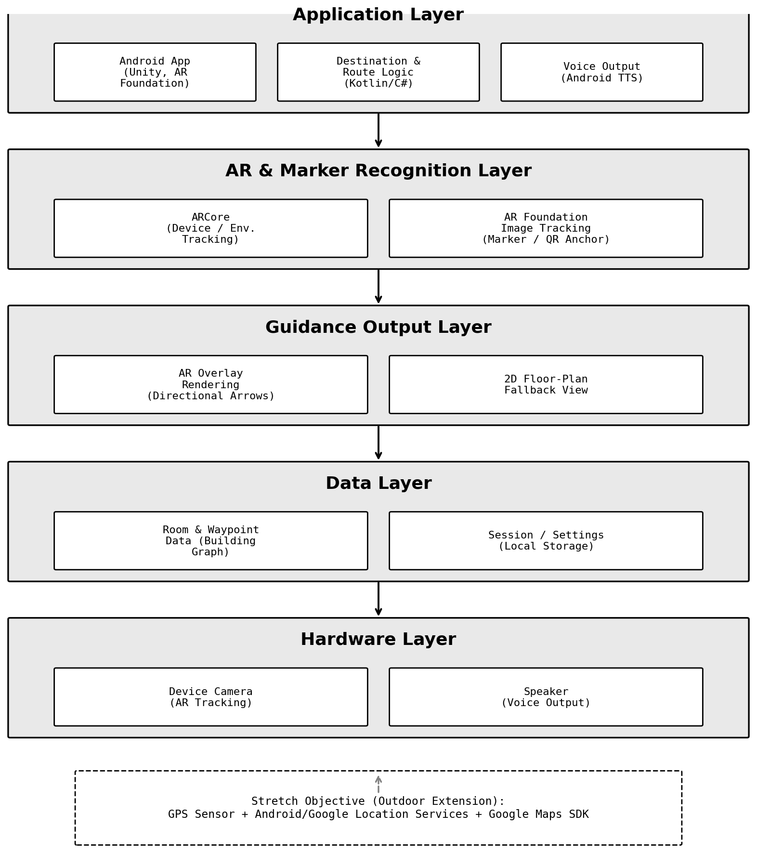
Figure 2. System Architecture Diagram (Rendered Using Claude AI)

Research Methods
Analysis of Existing Systems: Existing indoor AR-navigation research (Bhorkar, 2017; Qiu, Mostafavi and Kalantari, 2025; Gowtham et al., 2025) and institutional tools such as the TUS Interactive Campus Map (Technological University of the Shannon, n.d.) will be analysed to identify useful techniques, interface patterns and limitations. This method will support Research Questions 1–3 and 7 and inform the requirements and design of the prototype.
Prototype Development: An iterative development approach will be used to design and implement the application. Features will be developed and tested incrementally, including marker scanning, AR-anchored tracking, in-building route calculation, AR arrows, voice-directed prompts, and the 2D floor-plan fallback. This method will directly address Research Questions 1, 2 and 4.
Functional and Technical Testing: The application will be tested in the pilot building to assess whether the marker anchors correctly, whether rooms can be selected, and whether the system provides consistent directional guidance. Testing will also measure tracking drift as a user moves further from the last scanned marker, addressing Research Question 3.
Usability Evaluation: A small-scale evaluation of the completed prototype will be used to gather feedback on the clarity, ease of use and perceived usefulness of the room-level guidance, including the voice-directed prompts, compared with the existing TUS map tool. This method will primarily address Research Questions 6 and 8–10.
Results Analysis: Findings from testing and evaluation will be analysed to determine the strengths and weaknesses of the proposed approach and to identify recommendations for future work, including the feasibility of the outdoor stretch objective.

Bibliography
1. Android Developers (n.d.-a) Meet Android Studio. Android Developers. Available at: https://developer.android.com/studio/intro
2. Android Developers (n.d.-b) Request location updates. Android Developers. Available at: https://developer.android.com/training/location/request-updates
3. Azuma, R.T. (1997) 'A Survey of Augmented Reality', Presence: Teleoperators and Virtual Environments, 6(4), pp. 355–385. doi: 10.1162/pres.1997.6.4.355.
4. Bhorkar, G. (2017) A Survey of Augmented Reality Navigation. arXiv:1708.05006. Available at: https://arxiv.org/abs/1708.05006
5. Google (n.d.-a) ARCore Documentation. Google for Developers. Available at: https://developers.google.com/ar
6. Google (n.d.-b) Use Live View on Google Maps. Google Maps Help. Available at: https://support.google.com/maps/answer/9332056
7. Google (n.d.-c) Maps SDK for Android overview. Google for Developers. Available at: https://developers.google.com/maps/documentation/android-sdk/overview
8. Gowtham, V., Hrithick Ram, M., Jayasudhan, S., Dhanasekar, J. and Kiruthika, V. (2025) 'Augmented Reality Indoor Navigation Using Unity and QR Code Localization for Cross-Platform Mobile Applications', in Proceedings of the 1st International Conference on Research and Development in Information, Communication, and Computing Technologies (ICRDICCT '25), Vol. 2. SCITEPRESS. Available at: https://scitepress.org/PublishedPapers/2025/138863
9. Qiu, Z., Mostafavi, A. and Kalantari, S. (2025) 'Use of augmented reality in human wayfinding: a systematic review', Virtual Reality, 29(4). doi: 10.1007/s10055-025-01226-w.
10. Technological University of the Shannon (n.d.) Interactive Campus Maps. TUS. Available at: https://tus.ie/smarter-travel/maps/
11. Unity Technologies (n.d.-a) AR Foundation. Unity Documentation. Available at: https://docs.unity3d.com/Packages/com.unity.xr.arfoundation@latest

