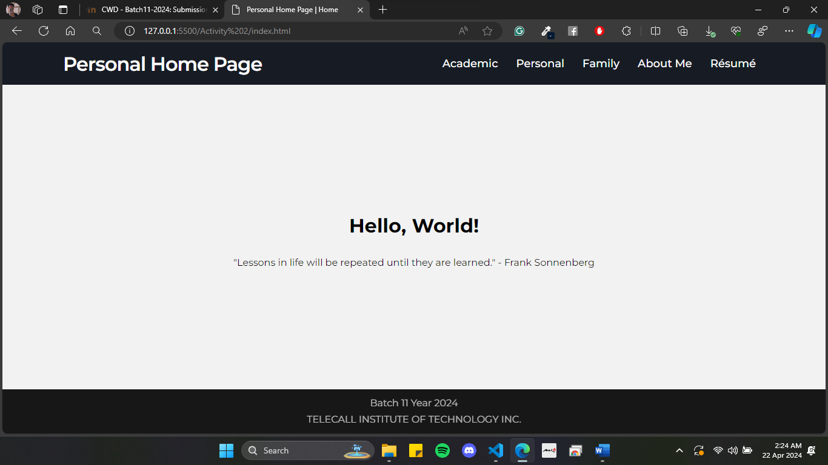

*Upon opening, this is the default or the home page of the HTML Webpage. There’s a navigation bar and it contains hyperlinks to go to another HTML page. It is also having a footer on every HTML page.*

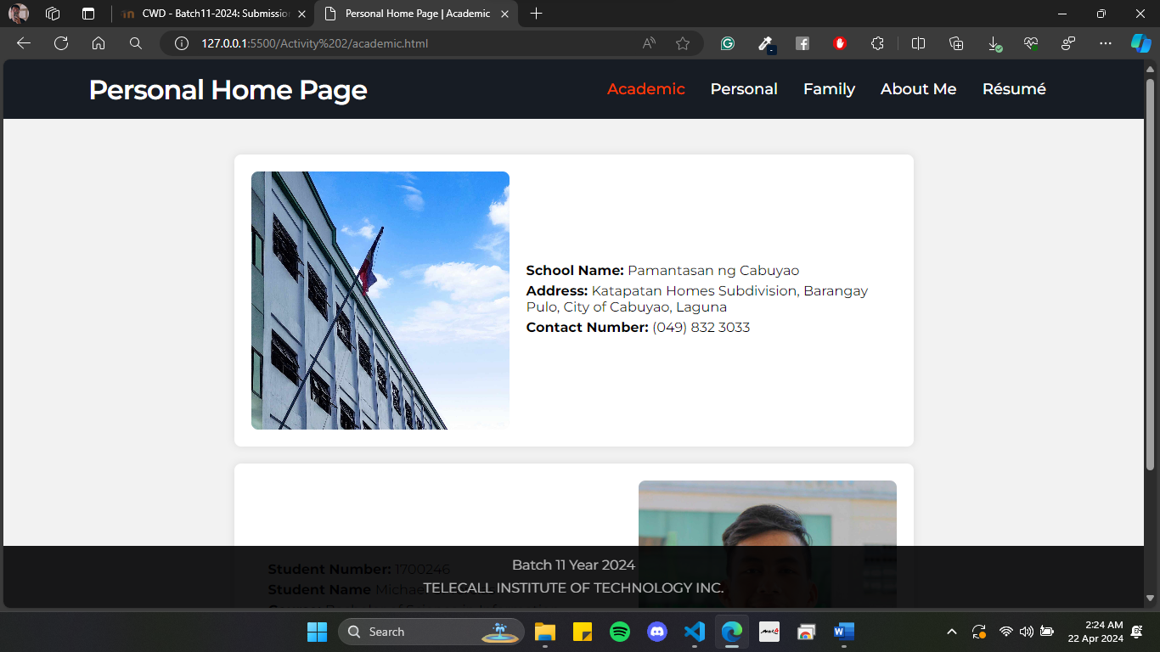

*This is the Academic Information page. It contains a photo and basic information of the school and the student.*

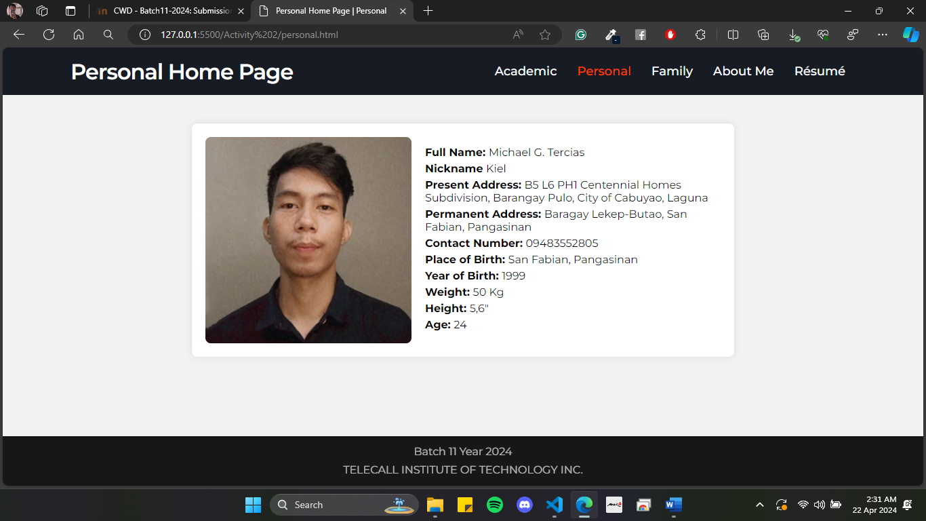

*Personal Information page, contains a photo and personal information of the student.*

*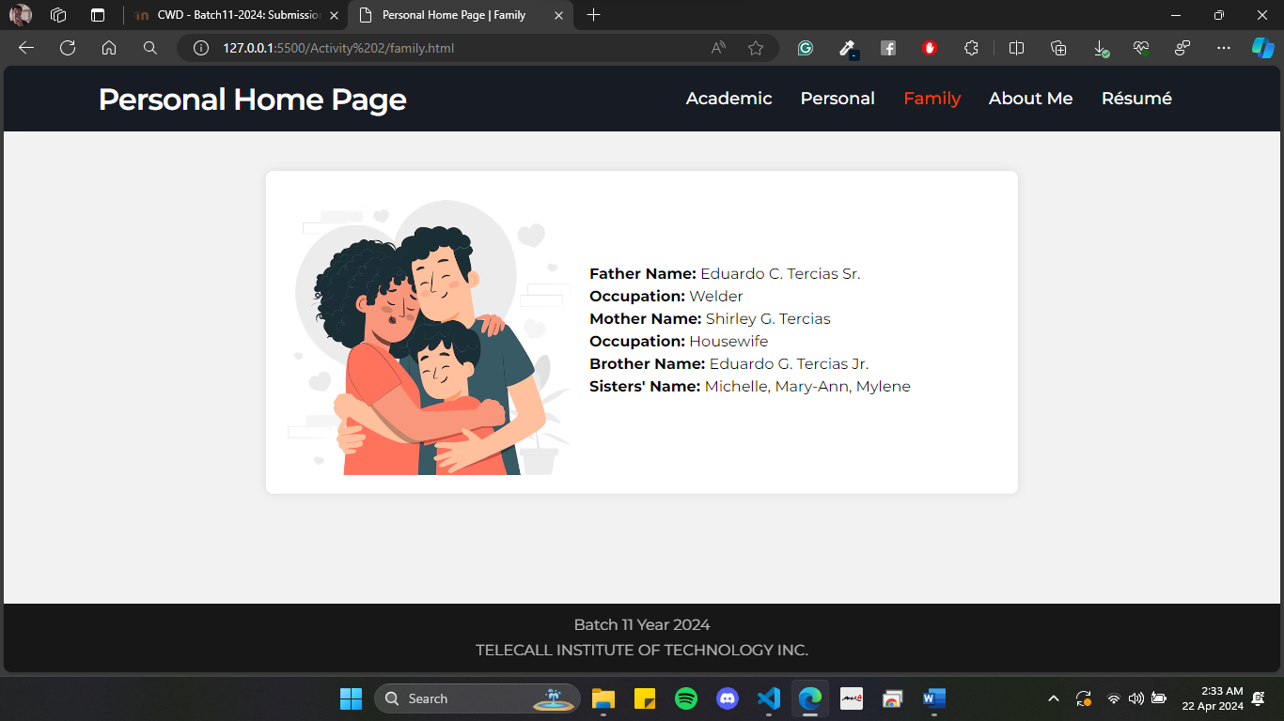*

*Contains parents’ and siblings’ information.*

*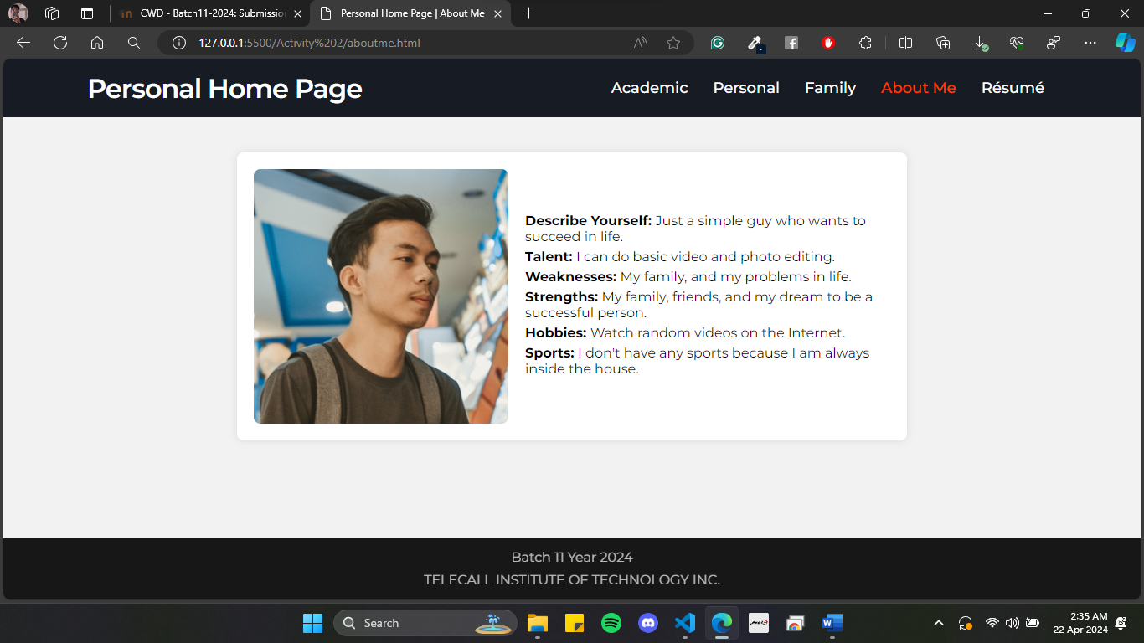*

*The About Me page contains information about myself.*

*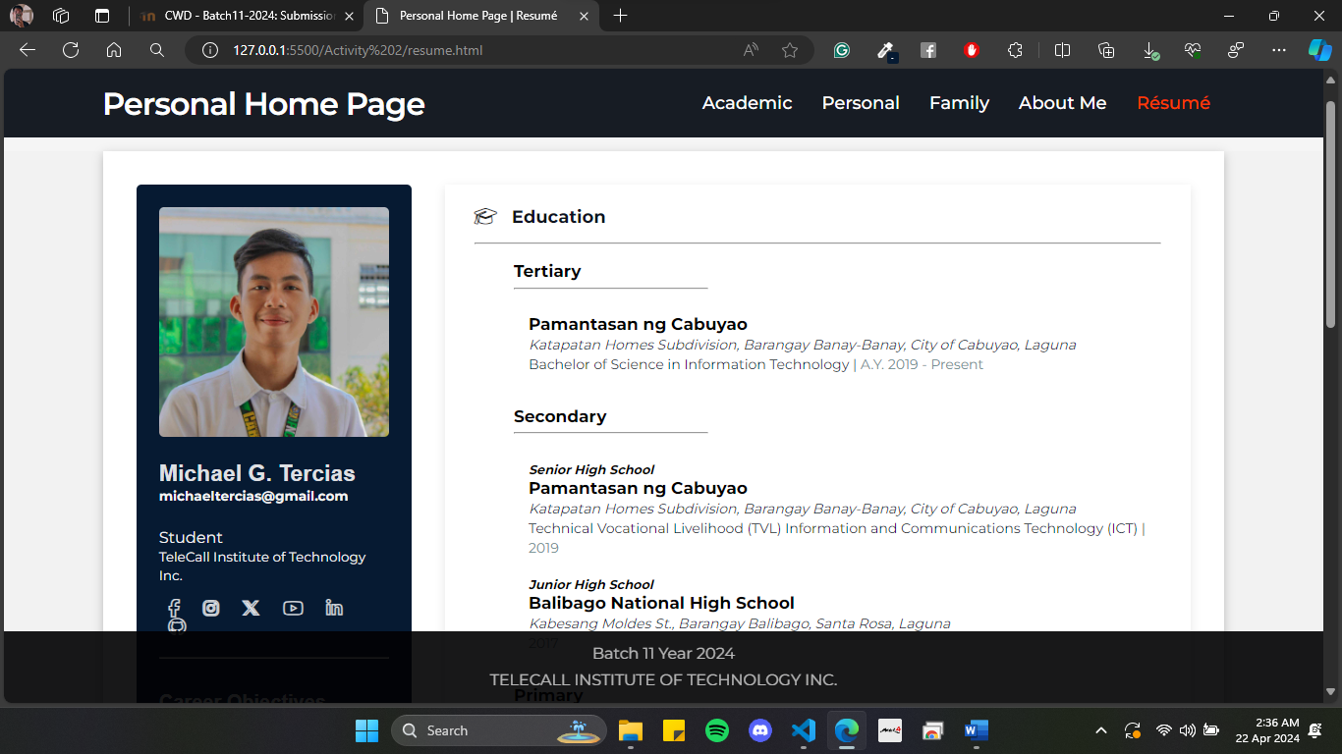*

*This page displays my resume from the previous activity. All the HTML pages can go to Home by clicking the “Personal Home Page” text on the Navigation Bar.*

All I can say is my brain and knowledge has been refreshed by this activity. I really love designing and creating websites. I am looking forward for more activities so that can I gain new knowledge and skills throughout the training.