

*Upon opening, this is the default or the home page of the HTML Webpage. There’s a navigation bar and it contains hyperlinks to go to another HTML page. It is also having a footer on every HTML page.*



*This is the Qualification page. It contains cards that shows the courses being offered by TeleCall.*

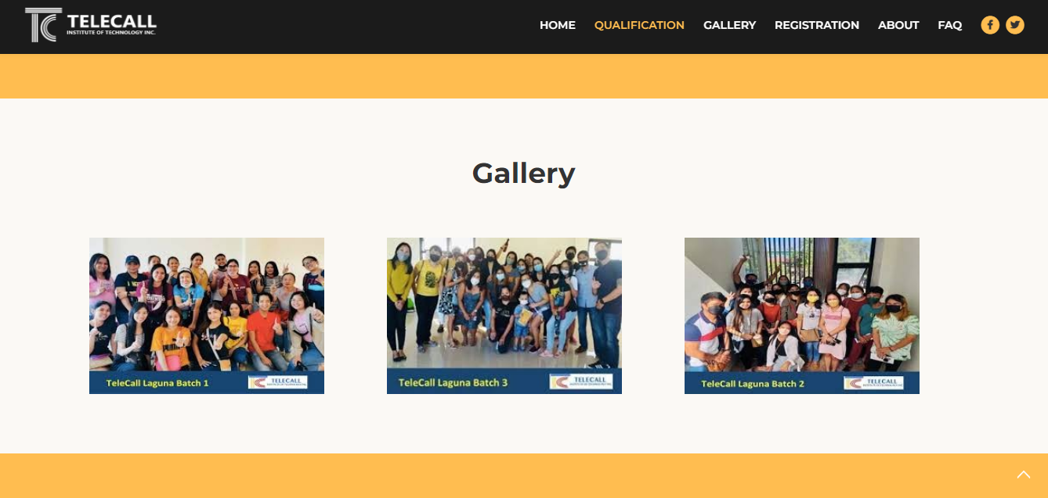

*Gallery section where images is being showcased.*

*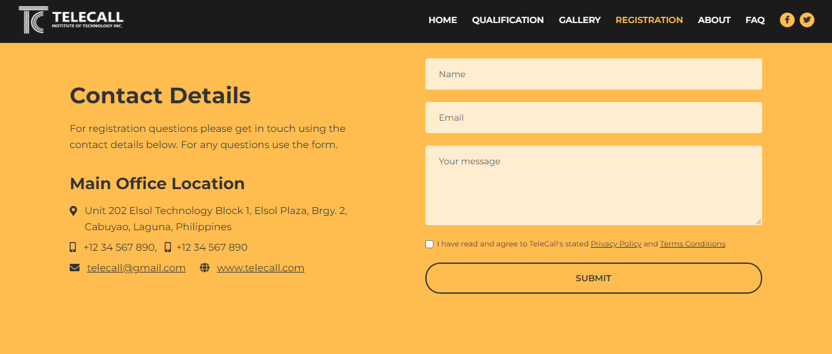*

*This is the Registration page and it contains some details from TeleCall and information from the user.*

*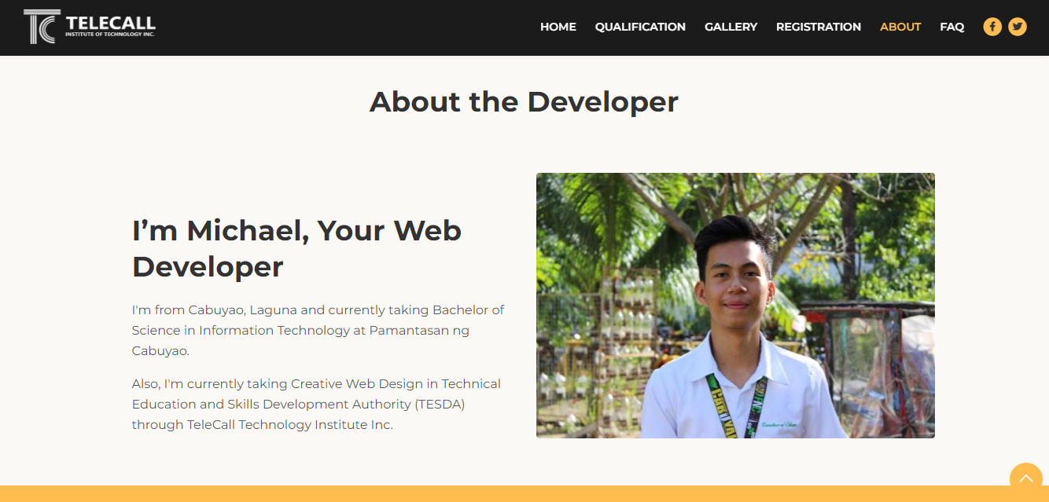*

*This is the about page that contains information about the developer of the website.*

*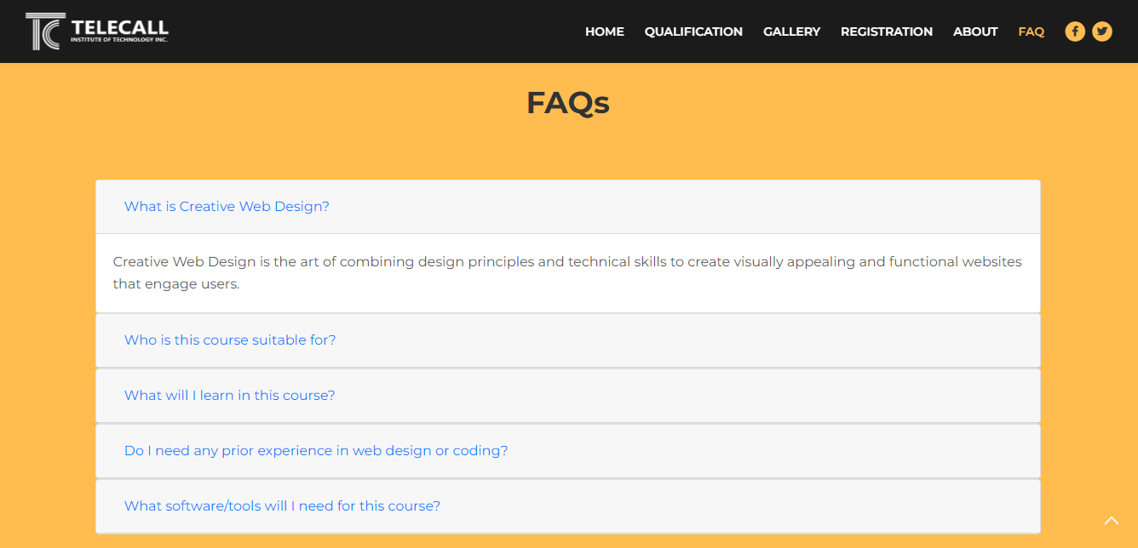*

*The FAQ or Frequently Asked Questions page contains questions that is commonly asked by the people regarding creative web design.*

*Upon developing this website, I discovered new things that I can use in my future projects.*