 | 
MagnaTayISU
A project report submitted in
partial fulfillment of the course
ITAPPDEV 3 – Mobile Applications
Prepared by
Michael M. Tolentino
Mobile App Developer, BSIT
DR. ERICK R. ABUZO
IT Consultant

PRODUCT REQUIREMENT DOCUMENT
Product Requirements Document (PRD)
Project Title: MagnaTayISU – Daily Step Tracking and Food Calorie Monitoring
Developer: Michael M. Tolentino
Academic Consultant: Dr. Erick R. Abuzo
Target Platform: Android mobile application (MIT App Inventor 2) Document Version: 1.0
Date: 20 October 2026
1. Product Vision & Executive Summary
MagnaTayISU is a student-built Android app for keeping a simple daily record of steps and meals. The Dashboard brings together today’s saved step count, a personal step goal, estimated walking distance and calories, food entries, and a date-based history. The food list and its basic calorie calculations are stored locally so that normal food logging does not require an internet connection.
This is a personal tracking aid, not a medical or nutrition service. The app keeps food calories consumed separate from estimated calories burned while walking. It does not calculate a calorie deficit, diagnose health conditions, or recommend a weight-loss target. Step, distance, and calorie values are estimates and depend on the phone sensor, stride setting, portion size, and recipe.
2. Target Audience & Core Use Cases
The primary users are students who want one place to review daily walking activity and record meals without creating an account. A user can check the Dashboard before or after a walk, enter a meal by choosing a food and serving amount, and later select a date in History to review what was saved.
A student uses the Step Tracker in the foreground to watch a count rise while walking.
A student searches the offline starter-food list and saves a meal with a serving amount.
A user changes the goal, stride length, or optional weight estimate in Settings.
A user checks saved steps and meals for an earlier date.

The project uses five screens: Screen1 (Dashboard), StepTracker, FoodLog, History, and Settings. A separate background-service AIA
variant adds Itoo support; the stock project remains a
foreground-oriented version.
3. Detailed Feature Specifications
3.1 Main Screen (Dashboard)
Feature | Displayed content | Action
Daily activity | Date, steps, goal, progress, estimated distance, estimated walking kcal. | Open Step Tracker to start or pause a foreground  session.
Food summary | Food kcal consumed and number of logged entries, kept separate from walking kcal. | Open Food Log to search and save a meal.
Navigation | Buttons for Steps, Food, History, and Settings. | Select the screen needed; Dashboard refreshes on return.
Daily summary: The Dashboard reads the current date and that date’s step tag, then totals food entries saved for the same day. An empty state shows zero steps and no meals; sample activity is not inserted.
3.2 Step Tracker
Start and pause controls operate the Pedometer session. The stock AIA shows steps counted while the tracker screen is open; it should not be described as guaranteed background tracking.
The saved count at the start of a session is combined with the session count. The cumulative sensor value is assigned, not added repeatedly on every event.
A personal goal can be changed. Reset Today asks for confirmation and is intended to clear today’s step value without deleting older daily step records.

3.3 Food Log
FoodLog seeds an 18-item starter list on first use and allows custom foods to be added for reuse. It does not download a database. Food name, category, serving unit, serving description, and reference kcal per serving are stored locally. The user searches the list, chooses a meal label, enters servings, and reviews the estimate before saving.
Meals are grouped as Breakfast, Lunch, Dinner, or Snack. The daily view shows entry details, meal subtotals, and a food-calorie total.
Estimated entry kcal = the food’s kcal per serving multiplied by servings. Example: the built-in Cooked White Rice item is 200 kcal per cup; two servings calculate to 400 kcal.
A user can add a custom food with a name and kcal value greater than zero, then select a saved entry to update or delete it.
3.4 History & Weekly Summary
History uses a date picker to show the saved step count and meal entries for the selected day. If no record exists for that date, it should show an empty-state message. The weekly panel totals the recorded walking values for the recent seven-day window, calculates an average, and counts days on which the goal was met.
3.5 Settings
The user can change the step goal, stride length, and optional weight used by the walking estimate. The project defaults are 8,000 steps, a 76 cm stride, and weight 0 (not set). The current settings screen validates the goal (500–50,000 steps), stride (40–120 cm), and weight (0 or 20–300 kg). Clear All App Data asks for confirmation.
3.6 Safety and interface limits
Food and walking calorie values are displayed separately and are estimates. Food values can vary by local recipe and portion. A step count can vary with phone placement, sensor availability, and Android background limits. Use of the ISU name and logo in the student interface does not mean this is an official university app or that the university endorses it.

4. Scope, Constraints, and Acceptance Criteria
4.1 In Scope
Offline food search, meal entry, custom food values, and locally saved history.
Foreground step counting in the stock project with personal goal, estimated distance, and estimated walking calories.
A separately packaged Itoo background-service variant that still requires a real-phone test.
A static landing page with an APK download link, a supplied AAB link, and clearly labeled HTML-preview images.
4.2 Out of Scope and Operating Constraints
No account, cloud sync, server-side meal storage, GPS route tracking, or cross-device history.
No medical diagnosis, nutrition prescription, calorie-deficit calculation, or promise of weight loss.
No claim of verified background step detection for the stock App Inventor Pedometer.
No Google Play publication or permanent public webpage URL is claimed in this report.
4.3 Acceptance Criteria
ID | Acceptance condition | Status
AC-01 | Fresh install shows a clear empty state; no fabricated meal or activity. | Pending device test
AC-02 | Rice at 200 kcal × 2 servings previews and saves as 400 kcal. | Pending  installed-app test
AC-03 | Blank, zero, or negative servings do not save an entry. | Pending  installed-app test
AC-04 | Edit/delete changes only the selected food record and totals. | Pending  installed-app test
AC-05 | History date change does not overwrite another date’s record. | Pending  installed-app test

TECHNICAL REQUIREMENT DOCUMENT
Project Title: MagnaTayISU – Daily Step Tracking and Food Calorie Monitoring
Developer: Michael M. Tolentino
Academic Consultant: Dr. Erick R. Abuzo
Framework: MIT App Inventor 2 / Android visual-block architecture
Target Build: Android package; separate stock and Itoo AIA variants
1. System Architecture & Tech Stack
+------------------------------------------------------------+ | MagnaTayISU Mobile App | +------------------------------------------------------------+ | Screen1 | StepTracker | FoodLog | History | Settings | +----------------------------+-------------------------------+ | App Inventor events: Pedometer, Clock, Notifier, buttons | +----------------------------+-------------------------------+ | TinyDB local store | Offline food list | +----------------------------+-------------------------------+ | Itoo foreground service (background AIA variant only) | +------------------------------------------------------------+
Development Environment: MIT App Inventor 2 Designer and Blocks editor. The project files are.aia archives containing screen layouts, block definitions, and assets.
Data Persistence: TinyDB with namespace MagnaTayISU_DB. Food and records, settings, per-date step counts remain on the device.
Network Use: Normal food logging and local summaries are designed to work offline. The inspected AAB contains an INTERNET permission; no network-traffic audit was performed.
2. Project Variants
MagnaTayISU.aia is the stock version. It uses App Inventor built-in components and a Pedometer on the StepTracker screen.
MagnaTayISU_Background.aia is a separate version that adds the Itoo 4.5.0 foreground-service extension and background Pedometer event handling. The stock AIA is kept separate and unchanged.

2.1 Visible Components (MIT App Inventor Layout Structure)
Screen1 (Dashboard): Title arrangement, app title label, dashboard ISU logo image, date, step/goal labels, distance and walking-calorie estimate, food-calorie total, meal count, summary, and navigation buttons.
StepTracker: Labels for daily/session steps and estimates; save goal, start/pause, reset buttons; goal text box; Pedometer; TinyDB; Clock; Notifier.
FoodLog: Search text box, food ListView, meal Spinner, serving text box, preview label, add/update/delete buttons, custom-food fields, today’s entry ListView, subtotal labels, TinyDB, Clock, and Notifier.
History: DatePicker, selected-date and daily total labels, per-day and ListView, weekly summary labels, TinyDB, Clock, a back button.
Settings: Goal, stride, and optional weight text boxes; save and note; clear-data buttons; validation TinyDB and Notifier.
2.2 Non-visible and Extension Components
The stock version uses TinyDB for local records, Clock for date keys and timestamps, Notifier for confirmations or input messages, and Pedometer for step events. The background AIA adds Itoo 4.5.0 on Screen1. In Itoo
4.5, background callbacks use the Pedometer1_WalkStep naming
convention; the project does not rely on the removed RegisterEvent block.
2.3 Asset Files
The Dashboard logo asset is packaged in the App Inventor project. It appears to the right of MagnaTayISU on the Dashboard only; the small top-bar ISU mark/label is not used in the app screens.
The five mobile screen images in the report are preview.html browser captures and are not evidence from an installed Android device.

3. Application Workflow & Event Handling
3.1 Application Start
Each screen obtains the date using yyyy-MM-dd and reads shared TinyDB values. Screen1 reads goal, stride, optional weight, the step key for today, and food entries. It filters meals to the current date, sums food calories, and refreshes after another screen closes.
3.2 Step Session (Stock AIA)
When the user starts a session, the app saves the current daily value as savedAtStart and resets the session counter.
The Pedometer event updates the session reading. Total today is savedAtStart plus the current session count; the same cumulative event count is not repeatedly added.
When paused or saved, the total is written to the steps_yyyy-MM-dd TinyDB tag. Reset Today confirms before writing zero for the current day.
3.3 Food Entry
FoodLog reads food_db; if the list is empty, it seeds the 18 built-in food rows. Custom foods are added to that list and stored locally.
Before saving, the app requires a selected food and a positive serving amount. It creates an entry with ID, date, meal, food name, servings, unit, kcal per serving, and rounded total kcal.
Update and delete operate on the selected saved entry; the list and daily totals are refreshed after a change.
3.4 History and Settings
History selects a date-specific steps_ key and filters food_entries by date. Settings validates values before writing goal, stride_cm, or weight_kg. The app has no account-based identity or remote synchronization.

4. Data Storage & Local Persistence
The normal screens share the TinyDB namespace MagnaTayISU_DB. Data are stored locally on the Android device. The background service uses separate Itoo string properties to coordinate its daily count and reset state.
Database key | Type | Purpose
goal | Number | Personal step goal; default 8,000.
stride_cm | Number | Stride length in centimetres; default 76.
weight_kg | Number | Optional weight for the estimate; 0 means not set.
food_db | List | 18 built-in foods and user-added custom foods.
food_entries | List of  records | Food ID, date, meal, name, servings, unit, reference kcal, and entry total.
steps_yyyy-MM-dd | Number | Saved step count for a specific date.
bg_reset_pending | Text flag | Set during reset for background-service synchronization.
Background service properties (Itoo variant)
bg_date: Date currently tracked by the service.
bg_day_steps: Confirmed daily total.
bg_pending: Steps waiting for a walking bout to be committed.
bg_last_ms: Time of the last accepted event.
bg_last_walksteps: Last cumulative Pedometer reading seen by the service.

5. Calculations, Background Task, and Platform Limits
5.1 Estimate Formulas
Food kcal: reference kcal per serving × servings. Example: 200 kcal for rice × 2 servings = 400 kcal.
Distance: steps × stride_cm ÷ 100,000 = kilometres. The initial stride is 76 cm and can be adjusted.
Walking kcal (weight set): weight_kg × distance_km × 0.53, rounded to a whole number.
Walking kcal (weight not set): steps × 0.04, rounded to a whole number. These simple project formulas produce estimates only; they are not individually calibrated or clinically validated. Food calories consumed remain separate from estimated walking calories burned. No calorie deficit or total daily energy expenditure is calculated.
5.2 Itoo Background Filter (Separate AIA)
The background variant filters events less than 280 ms apart, ignores a single jump larger than five steps, and commits a bout after at least 10 pending steps. Pending steps are discarded after a gap longer than four seconds. This heuristic can miss short walks and may still react to phone handling or vibration. It has not been checked across phone models.
5.3 Permissions and Runtime Conditions
The supplied Drive AAB manifest includes activity-recognition, notification, foreground-service/health, wake-lock, boot-receiver, and other Android/App Inventor permissions. Android prompts vary by OS version. The Itoo variant needs a compiled APK, a persistent foreground-service notification, and a phone configuration that permits background operation. The stock Pedometer is foreground-oriented.
When a sensor is unavailable or permission is denied, food logging and history should remain usable. The app must not add invented step counts or meals to fill an empty screen.

6. Quality Assurance & Testing Matrix
Test ID | Scenario  description | Action / input | Expected result | Pass/Fail
TC-01 | Fresh installation | Install APK and  open Dashboard on a test phone. | App opens; today  shows zero steps and no meals until  entered. | Pending  device test
TC-02 | Foreground step count | Start Step Tracker and walk 100  manually counted steps. | Displayed count changes and is  compared with manual count. | Pending  device test
TC-03 | Pause and resume | Start, pause while walking, then  resume. | Count stops while  paused and continues after resume without double addition. | Pending  device test
TC-04 | Serving  calculation | Choose Cooked White Rice, enter two servings. | Preview and saved total show 400 kcal estimate. | Pending  installed-app test
TC-05 | Invalid servings | Try blank, zero, negative, and text input. | Entry is rejected; no record is added. | Pending  installed-app test

6. Quality Assurance & Testing Matrix (continued)
Test ID | Scenario  description | Action / input | Expected result | Pass/Fail
TC-06 | Meal  update/delete | Add, select, edit, and delete one  saved meal. | Only the selected  entry changes;  subtotals recalculate. | Pending app test
TC-07 | History date isolation | Log today, then select yesterday. | Other dates remain unchanged; missing date shows an empty state. | Pending app test
TC-08 | Offline food list | Turn on airplane mode and open Food Log. | Starter list and basic calculations remain available. | Pending app test
TC-09 | Background service | Use Itoo APK, lock screen and swipe  app away. | Record phone model and compare with a manual walk count. | Pending  phone test
TC-10 | Landing page assets | Open local landing page and test five preview image  paths. | Page and preview  assets load in the local browser. | Pass —  local check
TC-11 | APK download link | Use landing page download link  locally. | Link points to the  packaged .apk file, not the AAB. | Pass —  local check
The two “Pass” entries above are limited to local website and file-link checks.
No physical-device installation, pedometer accuracy, background-service
reliability, or in-app food/history test is claimed as completed.
Device test record
Phone model / Android version:
Tester / date:

Observed step count and notes:

User’s Manual
Mobile App Assets
Webpage URL: Pending public hosting; the static page source is LandingPage/index.html.
Download asset: LandingPage/MagnaTayISU.apk is a test-signed not a demonstration package, production release key build.
Drive file: The supplied file is MagnaTayISU.aab, not a public webpage or

Webpage preview
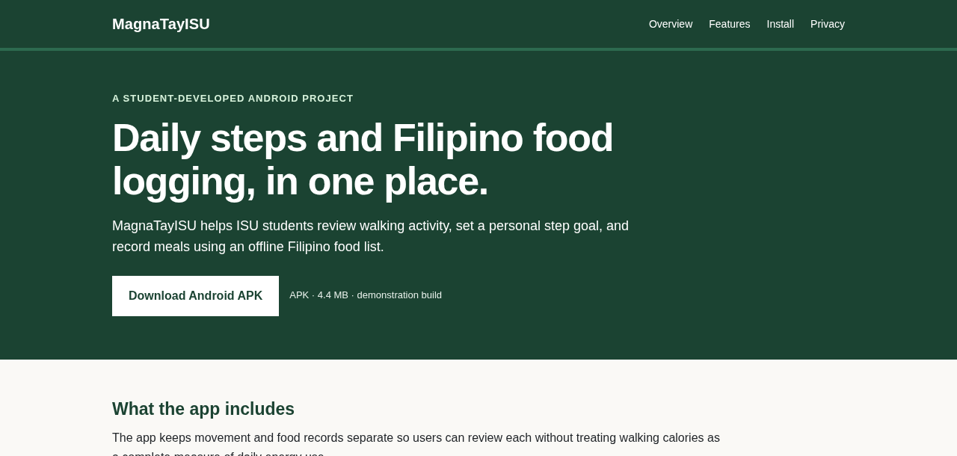
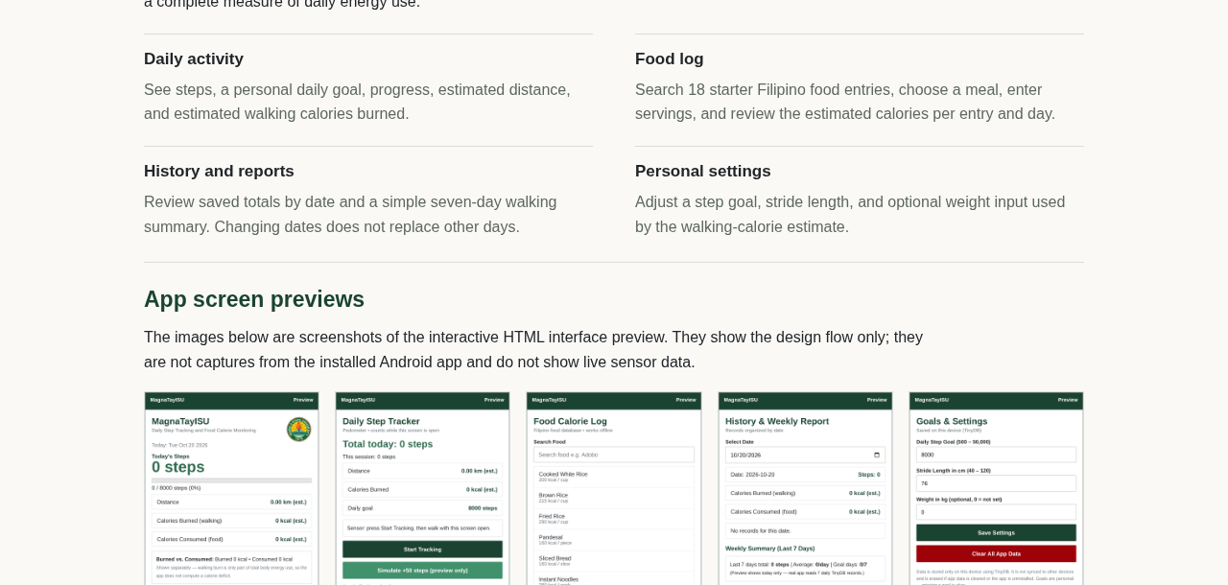

I. Administrator’s Manual
1. Project archive and import
The developer maintains two separate MIT App Inventor project archives. Import only one variant at a time and keep the stock file unchanged when building the background-service variant.
Stock build: MagnaTayISU.aia. Import through Projects →Import project (.aia), inspect Screen1, StepTracker, FoodLog, History, and Settings in Designer and Blocks.
Background build: MagnaTayISU_Background.aia. Import into an App Inventor environment that includes the Itoo 4.5.0 extension; inspect Screen1 Blocks and confirm the Itoo component resolves before building.
2. Build and release
Build an APK from the chosen AIA. The Itoo service needs a compiled APK and cannot be validated through a visual browser mock-up.
The current website APK was extracted from the supplied AAB and test-signed with a temporary key. It is not signed with the developer’s production release key and is not Google Play ready.
For a public release, rebuild from the final AIA, sign with the developer’s protected release key, and verify installation, permissions, and update behavior on target phones.
Keep the signing key private and backed up. Replacing an app signed by a different key may require uninstalling the earlier test build and can remove local TinyDB data.
3. Hosted files
Upload index.html, MagnaTayISU.apk, the screenshots folder, and
README_DEPLOY.txt to the same static-hosting structure. Keep the relative APK filename correct. After a public URL exists, replace “Pending public hosting” in the report with that URL and test the link on Android.

Feature Image 1 — Dashboard
The Dashboard presents today’s steps, goal progress, separate food and walking calorie estimates, and the main navigation. The zero steps and empty food log shown are preview content, not a phone reading.
Source: interactive HTML simulation (preview.html). This is not a screenshot from an installed Android app.
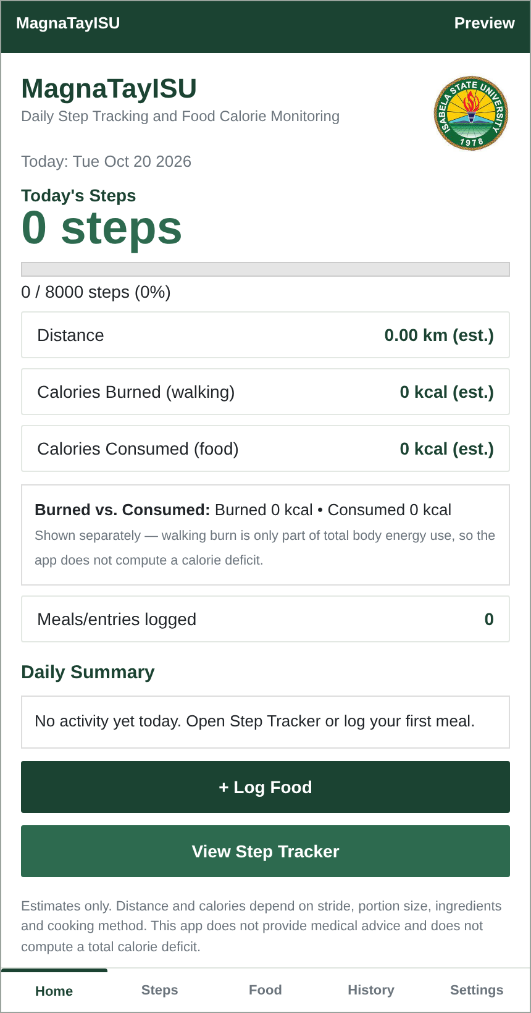

II. User Manual for MagnaTayISU
Feature Image 2 — Step Tracker
The screen shows the foreground tracking controls, a daily goal, and estimated distance and walking calories. The “Simulate +50 steps” control belongs only to the HTML preview.
Source: interactive HTML simulation (preview.html). This is not a screenshot from an installed Android app.
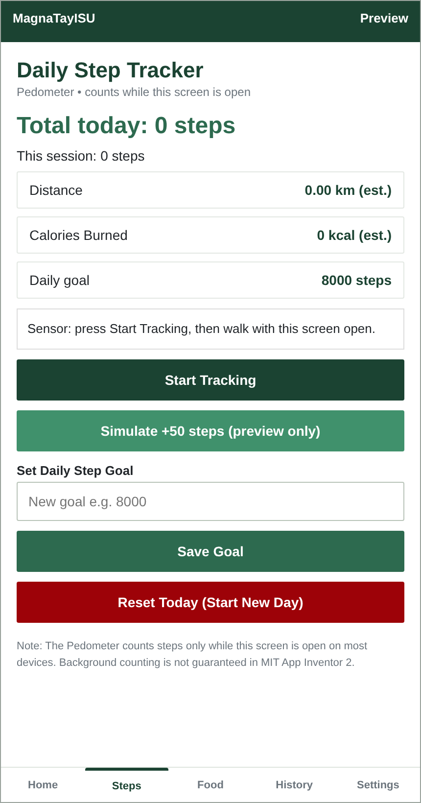

Feature Image 3 — Food Log
The preview shows search, meal selection, serving entry, and the offline starter-food list. No meal is shown as saved; the calorie figures are reference estimates.
Source: interactive HTML simulation (preview.html). This is not a screenshot from an installed Android app.
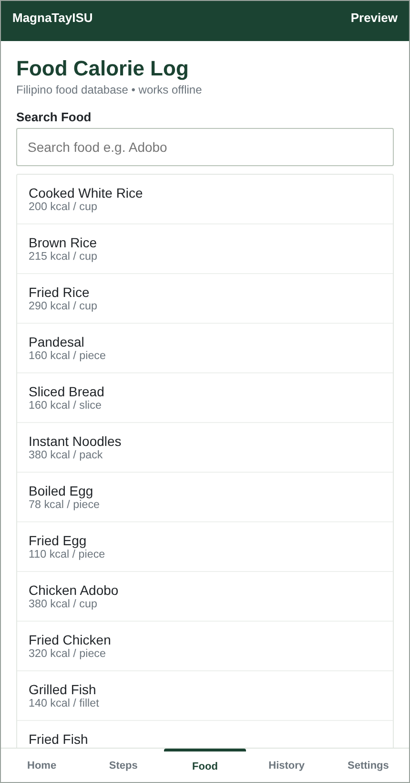

Feature Image 4 — History
The History preview shows the date selector and summary areas. It does not demonstrate a verified TinyDB history record from an installed APK.
Source: interactive HTML simulation (preview.html). This is not a screenshot from an installed Android app.
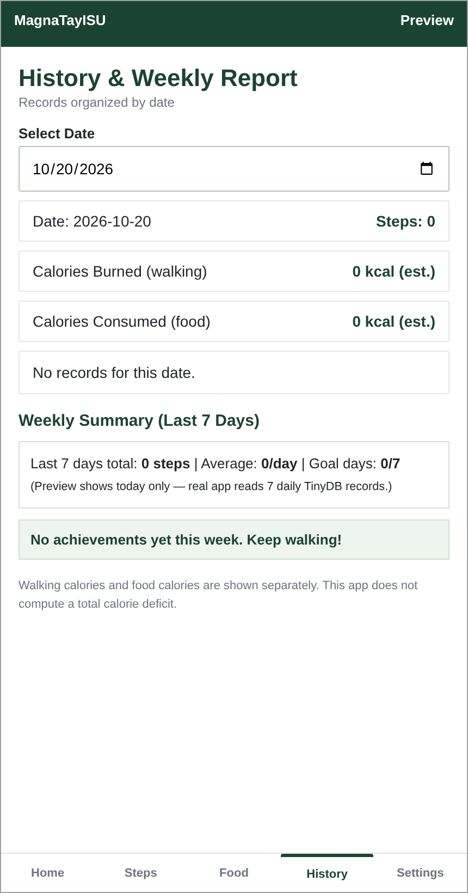

Feature Image 5 — Settings
The Settings preview shows the default goal, stride, and optional-weight fields. These are HTML preview values, not saved phone settings.
Source: interactive HTML simulation (preview.html). This is not a screenshot from an installed Android app.
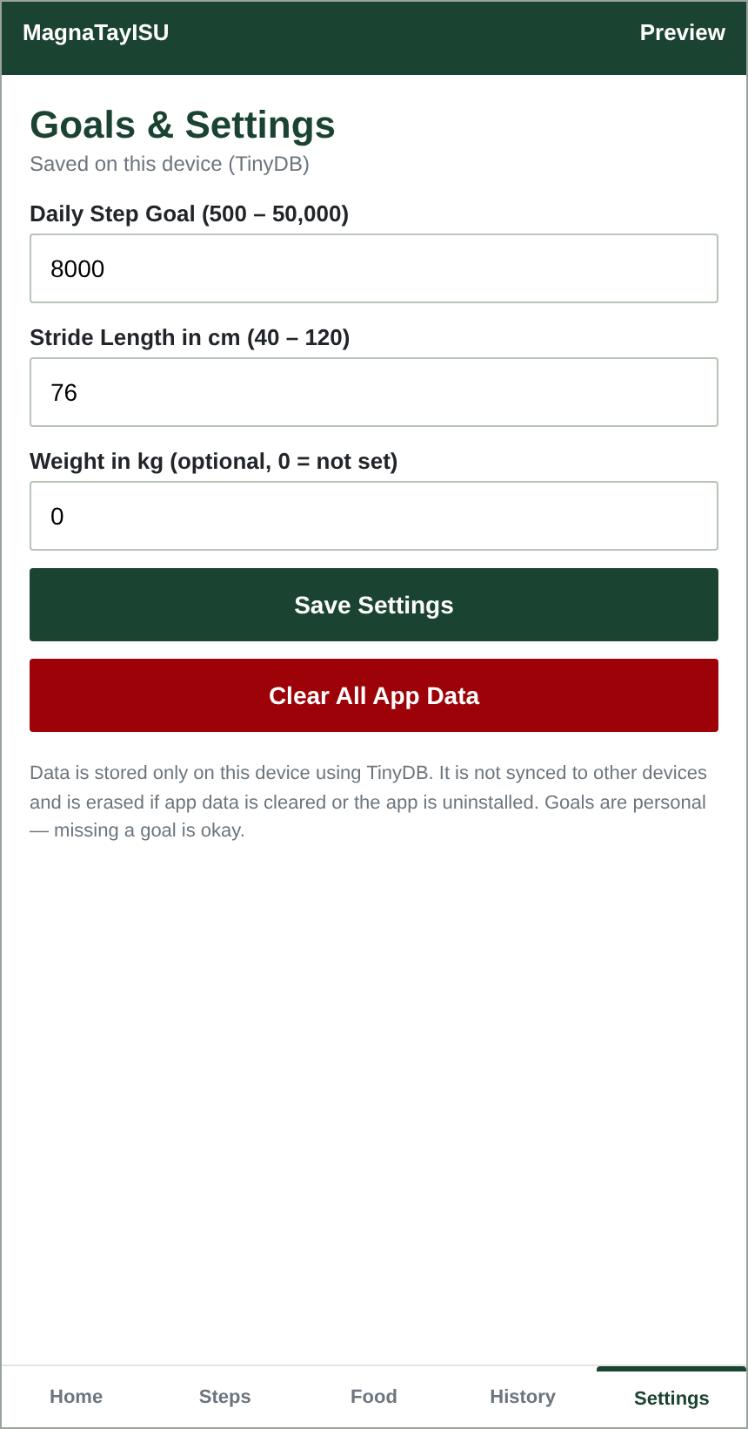

II. User Manual for MagnaTayISU (continued)
1. Install and open
Download the APK only from a source you trust. Open the downloaded file and follow Android’s install prompt. The available website APK is a test-signed demonstration package; a public release should use the developer’s final signed build. If Android asks for Activity Recognition access, allow it for step counting.
2. Use the Dashboard and Step Tracker
The Dashboard summarizes today’s saved values. In the stock build, open Step Tracker and start the session before walking; keep the screen active while testing. Pause when finished. Keep the phone in a consistent pocket location for a more repeatable reading. Compare the value with a manual count before relying on it.
3. Log a meal
Open Food Log, search for a food, select the meal, and enter servings greater than zero.
Review the estimate before saving. Two servings of Cooked White Rice at 200 kcal per serving calculate to 400 kcal.
Use the custom food fields when a food is missing. Select a saved entry before updating or deleting it.
4. Review records and change settings
Select a date in History to review that day’s recorded steps and meals. In Settings, change the goal, stride length, or optional weight only within the displayed ranges. Clearing app data or uninstalling may erase local records. Food calories and walking calories are estimates and should not be treated as medical advice.

I. Administrator’s Manual (continued)
4. Background-service variant
The background project is separate from the stock AIA and uses Itoo 4.5.0 to keep a foreground service while the app is not visible. Build the background AIA into an APK, grant Android permissions when requested, and leave the persistent notification active during testing. On phones with aggressive battery management, the administrator may need to allow unrestricted battery use for this app.
5. Device verification
Record the phone manufacturer/model and Android version. Test in a normal walking scenario and compare with a manual 100-step count.
Check the service after the screen is locked and after the app is swiped away; do not use Force Stop during this test.
Record false counts from shaking, handling, or vehicle vibration, and missed short walks. Do not generalize results from one phone to all devices.
Test local food add/edit/delete, invalid servings, goal validation, date selection, and persistence after closing and reopening the app.
6. Current verification status
The background AIA was confirmed to import and open in the App Inventor
Blocks editor. The AAB manifest identifies
appinventor.ai_snipperm30.MagnaTayISU, version 1.0, and declares an Itoo service. These file/import checks do not verify sensor accuracy, service reliability, or installation on a physical device.

Physical-Device Test Record
Complete this record after installing the final developer-signed APK. Write observed results in the last column; do not copy the expected result as if it had been measured.
ID | Test action | Expected observation | Observed result
T-01 | Install and open Dashboard. | No crash; honest empty state.
T-02 | Walk 100 manually counted steps. | Compare app reading to manual count.
T-03 | Pause while walking; resume. | No increase while paused; resumes after.
T-04 | Log rice × 2 servings. | Preview/save shows 400 kcal estimate.
T-05 | Try zero/negative servings. | No invalid record is saved.
T-06 | Change selected History date. | Other date’s data remain unchanged.
T-07 | Lock screen with Itoo variant. | Record count and device settings.
Phone model / Android version:
Tester / date:
Battery / permission notes:

MagnaTayISU Privacy Policy
Privacy Policy
Effective Date: 20 October 2026
Last Updated: 20 October 2026
1. Overview
MagnaTayISU is a student project for local step and food logging. This notice describes the current App Inventor project and supplied AAB. It should be revised if the app later adds accounts, analytics, remote services, or new data uses.
2. Information Stored on the Device
Step totals by date and daily tracking values.
Food entries, including date, meal, name, servings, unit, reference kcal per serving, and estimated total.
Settings for step goal, stride length, and optional weight.
Custom food names and calorie values entered by the user.
3. Information the App Does Not Request
The current design has no sign-in account and does not ask for contacts,
payment details, or GPS routes. The app does not provide cloud
synchronization. This report is not an independent security or network-traffic audit.

4. Data Storage & Local Persistence
TinyDB records remain on the device until cleared or until Android removes the app’s local data. Uninstalling the app or clearing storage can erase records. The current project design does not upload meal or step records to a MagnaTayISU server or synchronize them to another phone.
5. Permissions and Background Service
The supplied AAB manifest includes Activity Recognition, notifications,
foreground-service/health, wake lock, boot receiver, and other
Android/App Inventor permissions. Android prompts differ by version and phone manufacturer. The background variant uses the third-party Itoo extension. It has not been independently security-audited for this report, and its tracking behavior has not been physically verified here.
6. Internet and Third-Party Components
Food logging and local summaries are designed to work offline. The inspected AAB includes an INTERNET permission, which may be present because of the framework or extension. The project has no cloud-sync feature. No network-traffic audit was performed.
7. User Choices and Contact
Users may clear data after the app’s confirmation prompt or remove the app; either action can delete local records. No support email is configured in the project. Questions can be directed to the student developer through the course instructor. MagnaTayISU is not a medical or nutrition service.
8. University Affiliation
The project is a student submission. The ISU name or dashboard logo is
not a statement of official university sponsorship, approval, or
endorsement.

Appendix A: Starter Filipino Food Database
The following rows match the built-in starter list in the current AIA project. The kcal values are estimates per serving; actual values vary with portion, recipe, ingredients, and cooking method.
Food | Category | Serving description | kcal
Cooked White Rice | Rice and Staples | 1 cup cooked | 200
Brown Rice | Rice and Staples | 1 cup cooked | 215
Fried Rice | Rice and Staples | 1 cup sinangag | 290
Pandesal | Rice and Staples | 2 pieces | 160
Sliced Bread | Rice and Staples | 2 slices | 160
Instant Noodles | Rice and Staples | 1 pack cooked | 380
Boiled Egg | Protein and Ulam | 1 large | 78
Fried Egg | Protein and Ulam | 1 large fried | 110
Chicken Adobo | Protein and Ulam | 1 cup with sauce | 380
Fried Chicken | Protein and Ulam | 1 thigh piece | 320
Grilled Fish | Protein and Ulam | 100g fillet | 140
Fried Fish | Protein and Ulam | 100g piece | 210
Pork Adobo | Protein and Ulam | 1 cup with sauce | 450
Banana | Fruits and Vegetables | 1 medium | 105
Apple | Fruits and Vegetables | 1 medium | 95
Papaya | Fruits and Vegetables | 1 cup cubed | 62
Boiled Vegetables | Fruits and Vegetables | 1 cup boiled | 60
Vegetable Dish | Fruits and Vegetables | 1 cup pinakbet-style | 130

