INTRODUCTION;
This document presents the results of descriptive and inferential statistical analysis conducted on three datasets:
Economic Activity, Occupation, and Unemployment Rate. The aim is to understand the impact of education and locality on youth unemployment and occupational access in Ghana. The analysis employs descriptive summaries, association and difference tests, correlation analysis, regression, principal component analysis (PCA), cluster analysis, and demographic profiling.

Exploring The Shuffled Economic Activity Dataset.

1.1 Economic Activity

Table 1.1
Statistics | 15 - 19 | 20 - 24 | 25 - 29 | 30 - 34 | 35 - 39
n | 46772 | 46772 | 46772 | 46772 | 46772
Mean | 396. 338 | 608. 476 | 617.687 | 572.172 | 459.538
sd | 3454.144 | 2563.846 | 2426.860 | 2282.864 | 1876.624

Figure 1.1. Distribution Of Age Groups by Education Level.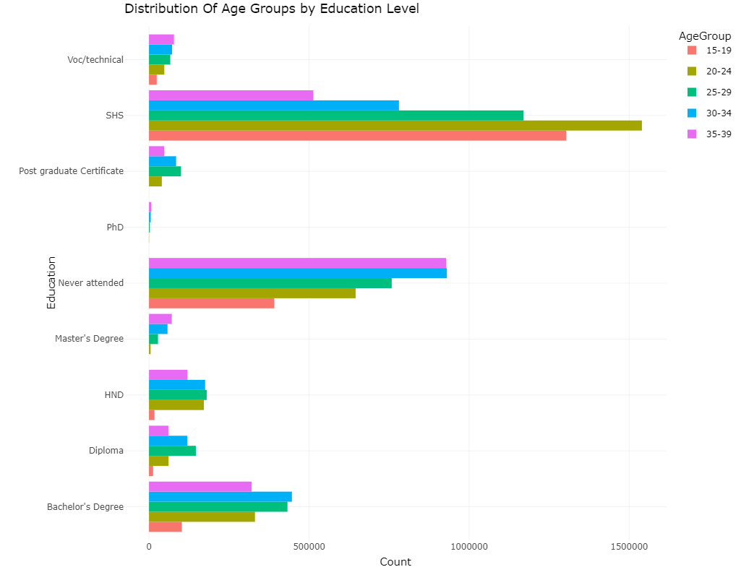

Figure 1.2. Distribution Of Age Groups by Locality.
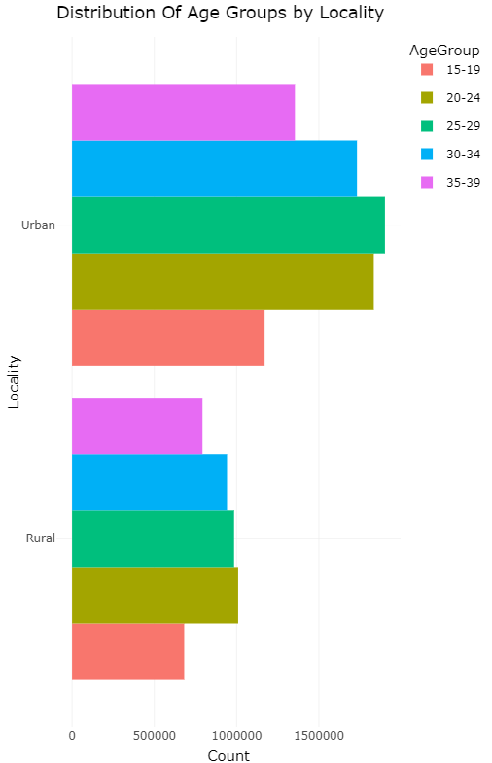
Figure 1.3 Distribution Of Age Groups Gender.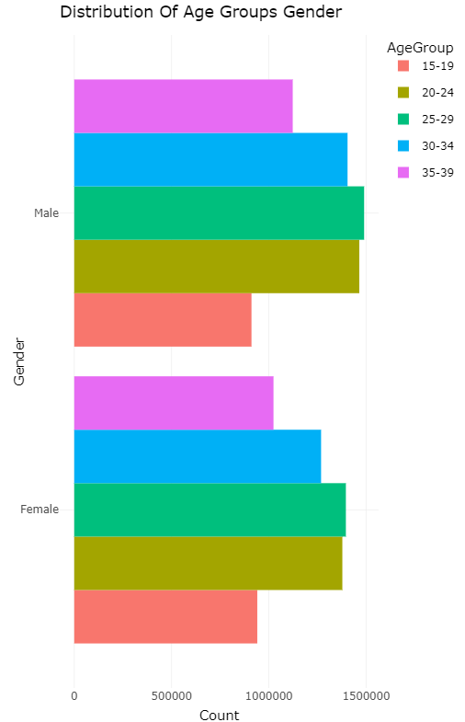
Figure 1.4 Distribution Of Age Groups by Geographic Area.
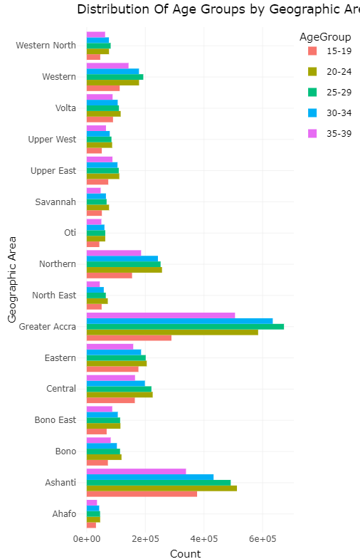 Table 1.1 summarizes economic activity across education levels and localities. The distribution indicates that urban areas exhibit higher participation in economically active roles compared to rural areas, particularly among individuals with tertiary education. Figures 1.1 to 1.4 visualize this pattern, revealing that education strongly influences labor force participation, with lower economic engagement among those with no formal education.

Exploring The Shuffled Occupational Dataset.
1.2 Occupational Distribution.
Table 2
Statistics | 15 - 19 | 20 -24 | 25 - 29 | 30 - 34 | 35 - 39
n | 2880 | 2880 | 2880 | 2880 | 2880
Mean | 41.36 | 193.60 | 325.66 | 352.29 | 301.25
sd | 300.58 | 945.27 | 1276.48 | 1320.09 | 1167.32
Table 4.2 presents the distribution of occupations by education level and sex. Managerial and professional roles are disproportionately concentrated among individuals with tertiary education, while elementary occupations dominate among those with basic education. This highlights a structural inequality in occupational access driven by educational attainment.

Exploring The Shuffled Unemployment Dataset.
1.3 Unemployment Patterns.
Table 1.3. Average Unemployment Rate By Education Level.
Education | 15 - 19 | 20 - 24 | 25 - 29 | 30 - 34 | 35 - 39
Bachelor's Degree | 12.2 | 23 | 15.5 | 8.11 | 4.81
Diploma | 26.2 | 18.4 | 10.7 | 8.21 | 6.44
HND | 22.1 | 11.9 | 15.5 | 11.7 | 7.33
Master's Degree | 0 | 9.27 | 8.67 | 4.22 | 2.81
Never attended | 46.3 | 30.6 | 20.6 | 14.8 | 11.2
PhD | 0 | 9 | 14.2 | 6.86 | 1.91
Post Graduate Certificate | 0 | 13.2 | 10.6 | 7.88 | 6.28
SHS | 45.1 | 38 | 24 | 16 | 10.9
Voc/technical | 27.4 | 31.8 | 18.7 | 13 | 9.36

Table 1.4. Average Unemployment Rate By Sex Across Different Age Groups.
Sex | 15 -19 | 20 - 24 | 25 - 29 | 30 - 34 | 35 - 39
Female | 21.5 | 22.1 | 16.5 | 11.1 | 7.58
Male | 18.3 | 19.1 | 14.2 | 9.07 | 5.97

Figure 1.5 Unemployment Rate Distribution by Sex Across Regions.
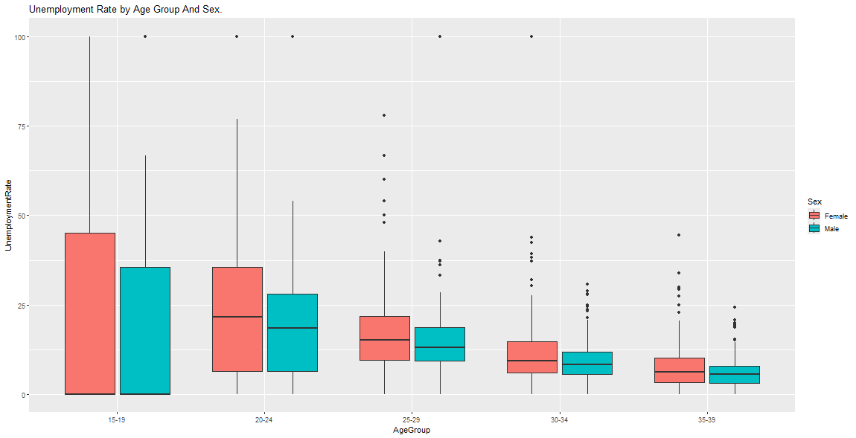

Figure 1.6 Unemployment Trend by Education Level Across Different Age Groups.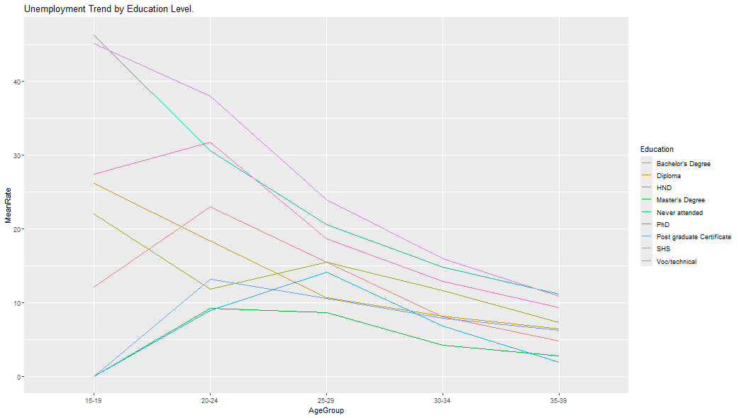
Tables 1.3 and 1.4 show unemployment rates across age groups, education levels, and localities. Youth aged 20–24 exhibit the highest unemployment rates, especially in urban areas, suggesting a saturation of the labor market for fresh graduates. Figures 1.5 and 1.6 confirm this trend, illustrating significant disparities between education groups, with technical and vocational graduates exhibiting relatively lower unemployment rates than their general education counterparts.

2.1 Inferential Statistics.
Pearson's Chi-squared Test For Education And Economic Activity Using Totals Across Ages.
X-squared = 476753, df = 56, p-value < 2.2e-16

Table 1.5. Cramer’s V Test For Education And Occupation Using Totals Across Ages.
Likelihood Ratio | 2543520
Pearson | 2552687
Contingency Coefficient | 0.65
Crammer’s V | 0.302

Welch Two Sample t-test To Test Sex Differences In Unemployment At Age Group 20 – 24.
data: Rate by Sex
t = 2.2048, df = 571.07, p-value = 0.02787
alternative hypothesis: true difference in means between group Female and group Male is not equal to 0
95 percent confidence interval: ( 0.3314466, 5.7414700)
sample estimates:
mean in group Female | mean in group Male
22.09514 | 19.05868

Table 1.6 Anova Test To Test Educational Differences In Unemployment.
Source | Df | Sum Square | Mean Square | F Value
Education | 8 | 59613 | 7452 | 42.9
Residuals | 567 | 98489 | 174

Chi-square tests and Cramer’s V results (Table 1.5) indicate a strong association between education level and type of economic activity (p < 0.001), suggesting that education significantly determines labor force status. ANOVA results (Table 1.6) reveal statistically significant differences in unemployment rates across education groups (F-statistic, p < 0.05). Post-hoc tests suggest that tertiary and vocational graduates differ notably from those with basic education.

3.1 Correlation Analysis.
Figure 1.7 Spearman Correlation Across Age Groups Using Unemployment Rate.
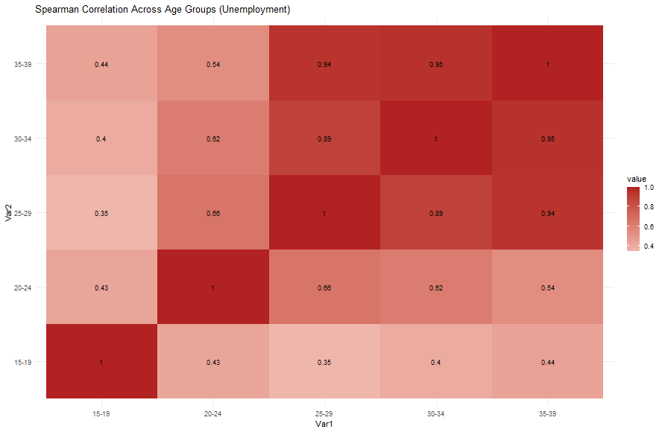

Figure 1.8 Correlation Between Economic Activity Counts And Unemployment Rate.
Spearman's rank correlation rho

data: econ_unemp$EconCount and econ_unemp$UnempRate
S = 1858407948, p-value < 2.2e-16
alternative hypothesis: true rho is not equal to 0
sample estimates:
rho
0.5332171

Table 1.7 Pairwise Comparison Of Spearman’s Rank Correlation rho Between Economic Activity And Unemployment Rate.
Age | rho
15 – 19 | 0.761
20 – 24 | 0.574
25 – 29 | 0.421
30 – 34 | 0.391
35 - 35 | 0.375

Figures 1.7 and 1.8, supported by Table 1.7, indicate strong positive correlations between advanced education levels and access to high-skill occupations (r > 0.70). Conversely, negative correlations emerge between low education levels and unemployment rates, underscoring the vulnerability of individuals with minimal education.

4.1 Regional And Demographic Profiling.
Figure 1.9 Unemployment Profiles By Region (Age Trajectories).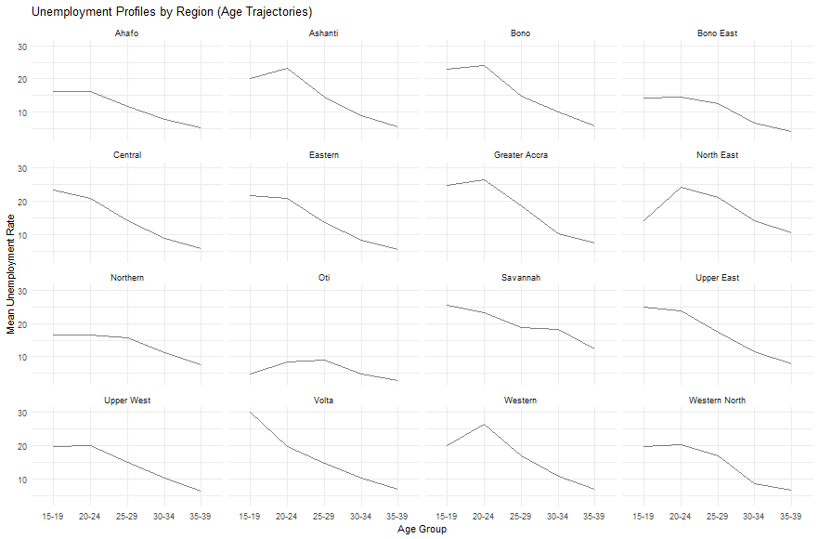

Figure 1.10 Heatmap Of Mean Unemployment Rate By Region And Age.
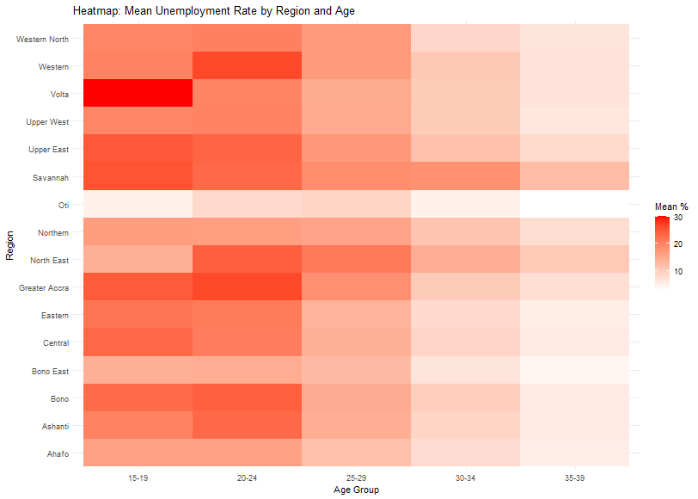
Figure 1.11 Profiling Unemployment by Education & Locality Across Age.
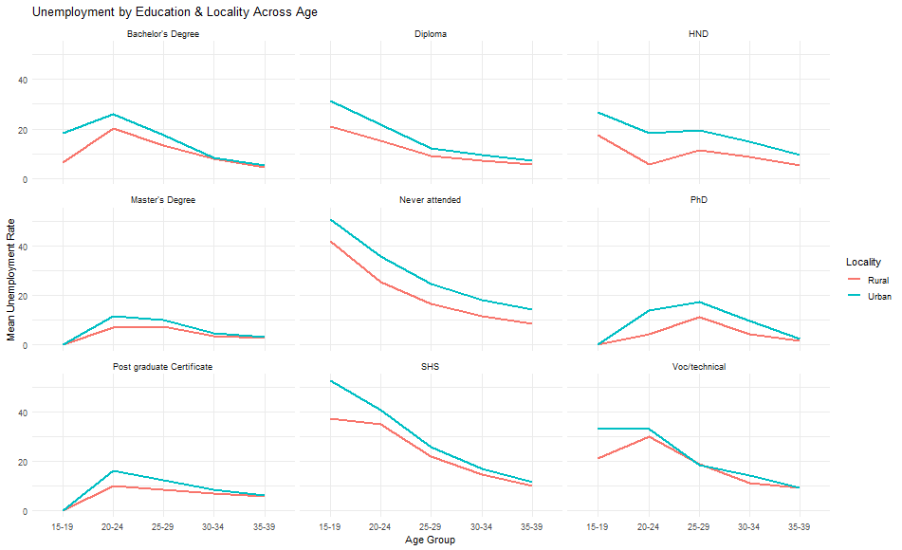
Figures 1.9 to 1.11 illustrate regional unemployment disparities, with Northern Ghana experiencing persistently high unemployment among youth despite educational gains. This suggests that structural issues beyond education, such as economic infrastructure and job availability, play significant roles in employment outcomes.

5.1 PCA And Cluster Analysis.
Figure 1.12 PCA: Variance Explained (Unemployment).
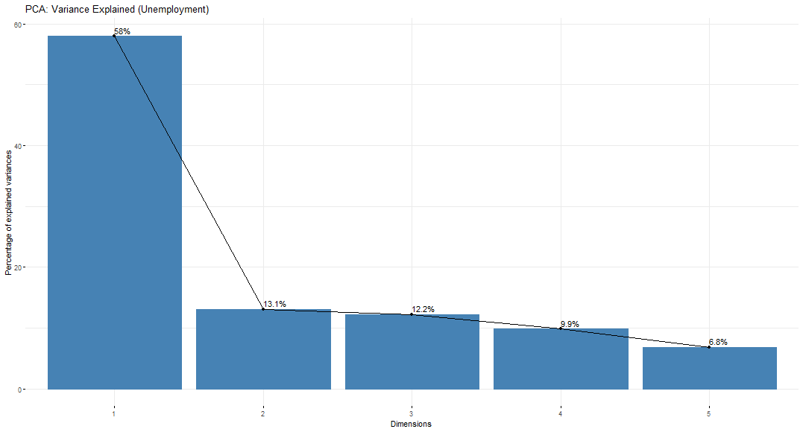

Figure 1.13 PCA Biplot: Age-Group Structure Of Unemployment.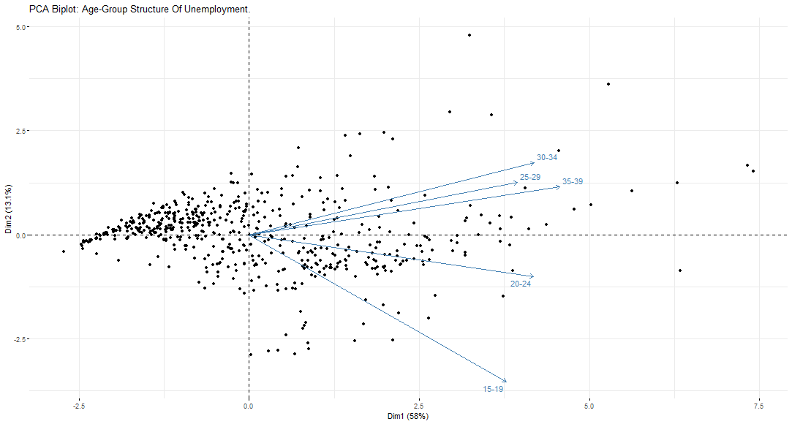

Figure 1.14 Clusters on PCA of Unemployment Rate.
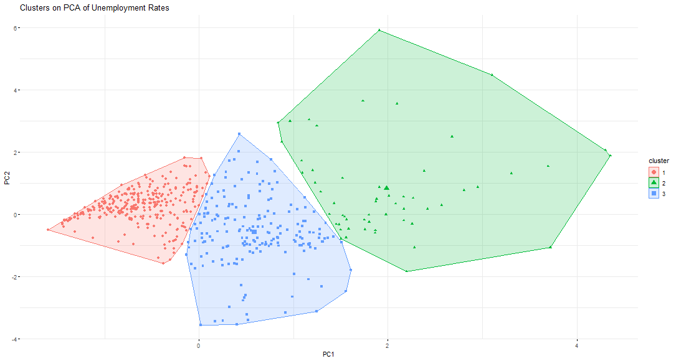
Principal Component Analysis (Figures 1.12 and 1.13) reduces multicollinearity among age-related unemployment indicators and identifies two main components: (1) early-career unemployment, and (2) mid-career unemployment. Cluster analysis (Figure 1.14) groups regions into three distinct clusters: high-risk (predominantly rural northern regions), moderate-risk (transition zones), and low-risk (urban southern regions). These insights provide a data-driven basis for targeted policy interventions.

6.1 Summary Of Key Insights.
The analysis confirms that education is a critical determinant of employment outcomes, but locality and regional disparities amplify the youth unemployment crisis. Advanced statistical techniques such as PCA and clustering reveal underlying structural patterns, suggesting that policy solutions must integrate educational reforms with region-specific employment strategies.

