Video Service Documentation
Terms:
- Video Server: A Vivotek device that takes the output of the cameras and outputs a H.264 video stream.
- H.264: Video compression format that is used to distribute video/audio data.
- RTSP: Real Time Streaming Protocol, protocol that streams multimedia data via TCP. For the Elixys video streaming service, RTSP sends a H.264 video stream via TCP to a computer.
- TCP: Transmission Control Protocol, protocol that allows an ordered stream of data between two computers. TCP is used as it prevents data from becoming out of sync.
- RTMP: Real Time Messaging Protocol, used to take a TCP connection via a specified port and stream the data over the internet.
- FLV: Flash Video, container file format used by Adobe Flash to deliver video over the Internet.
- AVCONV/FFMPEG: Transcoder, used to convert video and audio files to a certain format. Since Adobe Flash doesn't accept H.264, AVCONV/FFMPEG is used to convert the video stream to a readable format for the Client. ACONV/FFMPEG is used also to convert protocols from RTSP to TCP.
- CRTMP Server: Streams the RTMP/FLV data.

Summary:
A vital part of the Elixys software was the ability for the Client to stream in real time the contents of the Hot Cell in which the Elixys robot would perform the unit operations of a sequence. Adobe Flash products cannot read H.264 format video streams and a transcoder was needed to view the live stream video produced by the hardware cameras.
In the diagram below, the H.264 video stream sent to the Elixys server machine via the RTSP (protocol). The server machine receives the H.264 via RTSP and uses a unix command (avconv) or FFMPEG transcoder to take an input of the video stream. The transcoder outputs the H.264 as a FLV video stream and converts the RTSP to TCP (protocol). RTMP obtains the TCP data and streams it to the CRTMP Server. CRTMP streams the RTMP/FLV data to the client in a client-readable format.

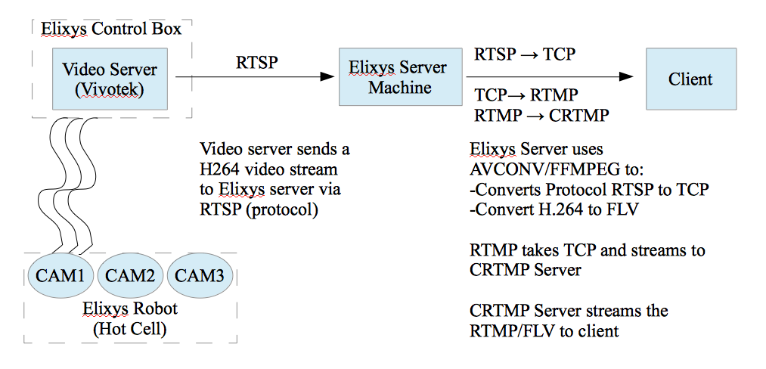
Diagram:

